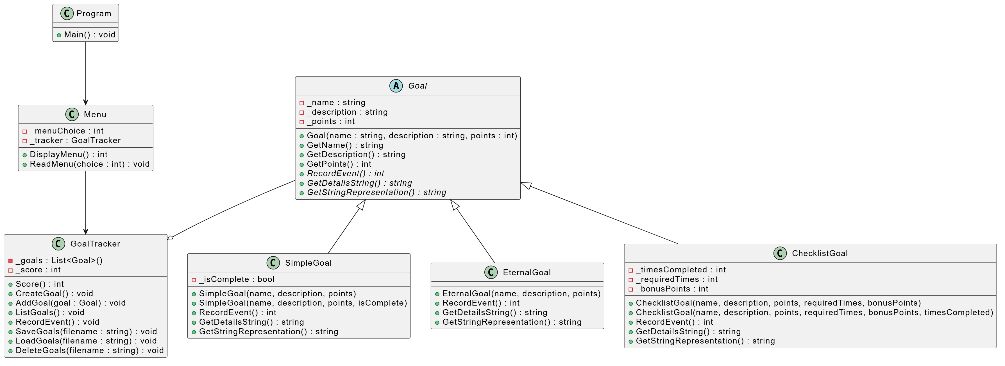
Program uses Menu. Menu uses GoalTracker, which in turn has a list of the superclass Goal. The three subclasses inherit from the Goal.

