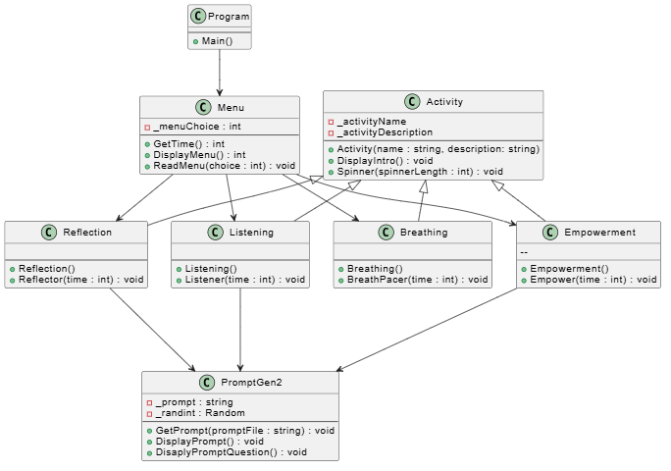
The Program class serves as the entry point of the application, which runs the Menu class that controls the flow of the program. The Menu class is responsible for launching the four activity classes: Breathing, Reflection, Listening, and Empowerment. All four of these activity classes inherit from the Activity base class, which holds the shared attributes and behavior that every activity needs. Of the four activities, Reflection, Listening, and Empowerment each depend on the PromptGen2 class to retrieve a random prompt for the user, while Breathing handles its own logic independently.

