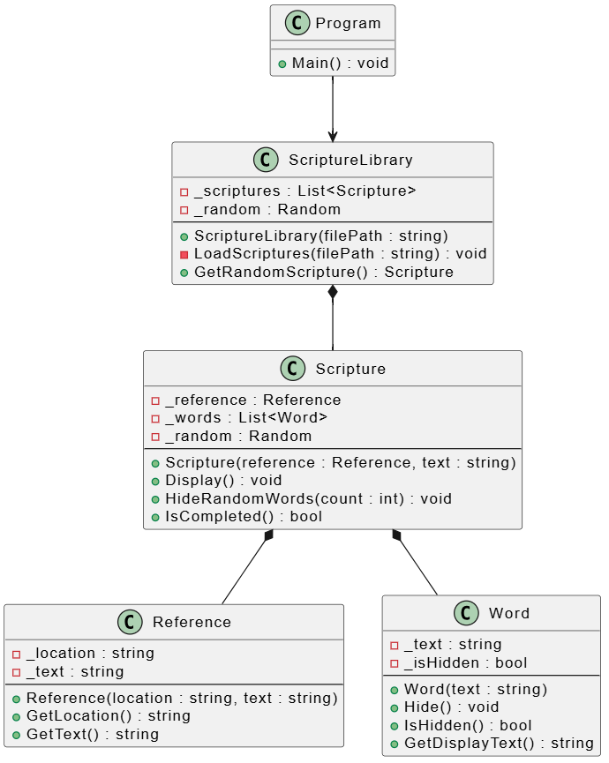

Program creates a new instance of Scripture Library and then starts a loop. ScriptureLibrary create a list of scriptures from a .txt file located in the bin. Scripture class owns one Reference and creates a list of Word objects from the Word class. The Scripture class is what uses the randomizer and hider bool variable in order to hide the words in each scripture. Reference class holds data about the scripture like its location and text. Word class in in charge of what is hidden and what is not hidden.

