EPC ERP PLATFORM
Backend Architecture, Data Model & Frontend UX Blueprint
3 Modules · One Unified Database · One Navigable Application
Sales & CRM · Project Management · Inventory & Warehouse Management
Prepared for: Automystics Technologies Pvt. Ltd.
Anandakumar M, Founder & Director
July 2026

Table of Contents
1. Executive Summary
2. System Architecture
3. Unified Data Model — The Golden Thread
4. Module-by-Module Architecture
4.1 Sales & CRM
4.2 Project Management
4.3 Inventory & Warehouse Management
5. Frontend UI/UX Architecture & Navigation
6. End-to-End Business Process Flow
7. Device Compatibility
8. Replit AI — Module Build Prompts
8.0 Foundation (build first)
8.1 Sales & CRM
8.2 Project Management
8.3 Inventory & Warehouse Management

1. Executive Summary
This document is the architecture blueprint for a single, tightly-integrated EPC (Engineering-Procurement-Construction) ERP spanning the 3 operational modules requested: Sales & CRM, Project Management, and Inventory & Warehouse Management.
The design follows one non-negotiable principle: every module shares one database and one identity/permission model. A client's enquiry becomes a quotation; the client confirms by issuing their own Purchase Order (logged here as the Client PO); that single event becomes a project in Project Management — which then plans it, resources it, raises Material Requests through a full quotation-collection → L1 approval → PO flow, receives goods against those POs in Inventory & Warehouse Management, and bills the client back in CRM as milestones complete. Every downstream record — a vendor PO, a GRN, a payment, an escalation — carries a project_id back to that same origin. This is what makes the three modules feel like one tightly coupled system instead of three separate apps stitched together, and it is what makes navigation between them feel like moving between tabs, not between systems.
The document covers, in order: the backend architecture and technology stack, the unified data model that threads every module together, a detailed breakdown of each module (entities, APIs, business process flow, screens, and how it connects to its neighbors), the frontend UI/UX navigation model, the end-to-end business process across the full project lifecycle, device compatibility across web and mobile, and a ready-to-use Replit AI build prompt for every module.

2. System Architecture

2.1 Architecture Principles
- Single unified database, not per-module databases — every module reads and writes to one PostgreSQL instance (schema-per-domain for organization, not isolation), so cross-module joins and real-time reporting need no ETL.
- Modular monolith at launch, service-ready by design — code is organized as domain modules with clean boundaries (CRM, Project, Procurement...) inside one deployable Node.js application; any module can be extracted into its own microservice later without a data-model rewrite, because module boundaries already match service boundaries.
- Golden-thread foreign keys — project_id, party_id and organization_id are the three keys that appear on almost every table in the system, which is what lets the frontend build a single Project Workspace that aggregates Project Management's and Inventory & Warehouse Management's data for one project_id, with CRM's Client PO as the origin record.
- Configurable workflow over hard-coded logic — approvals (quotations, budgets, POs, drawings), notifications and escalation rules are data-driven (a Workflow & Approval Engine), so a customer can change a 3-level PO approval to a 2-level one without a code deployment.
- API-first — every screen, web or mobile, is a client of the same REST/GraphQL API; there is no server-rendered-only path, which is what allows the two mobile apps and the customer/vendor portals to reuse 100% of backend logic.
- Offline-first field apps — the Field Team App queues writes locally and syncs when connectivity returns, because DPR, site surveys and GRNs are frequently captured with poor network coverage.

2.2 Recommended Technology Stack
Layer | Technology | Why
API & backend services | Node.js + NestJS (TypeScript) | Opinionated module/DI structure maps directly to the 3 ERP domains; strong REST + GraphQL support
Primary database | PostgreSQL 16 | ACID transactions for financial data, JSONB for flexible checklist/form fields, native row-level security for multi-tenant rights
Cache / queues / real-time | Redis + BullMQ | Background jobs (notifications, MIS report generation, escalation checks), pub/sub for live dashboard updates
Search | PostgreSQL full-text / OpenSearch (optional, scale-up) | Lead, document and inventory search across large datasets
File / document storage | S3-compatible object storage | Contracts, POs, invoices, GRN photos and quotation documents — referenced by URL from Postgres
Web frontend | React + Next.js, Tailwind, shared component library | Server-side rendering for dashboards, one design system reused by every module screen
Mobile apps | React Native (Field Team App, Management App) | Single codebase per app, shares TypeScript models/validation with the web frontend
API contract | REST (resource CRUD) + GraphQL (dashboards / cross-module aggregation) | REST keeps module APIs simple and cache-friendly; GraphQL serves the Project Workspace and Reports screens that need many modules in one call
Authentication | OAuth2 / JWT with refresh tokens, SSO-ready (SAML/OIDC) | Single sign-on across web, mobile and partner portals
Integration layer | Dedicated Integration Hub service (webhooks + scheduled sync) | Isolates Tally/SAP/IndiaMART/WhatsApp connectors so core modules never depend on a third-party API being up

2.3 High-Level Architecture

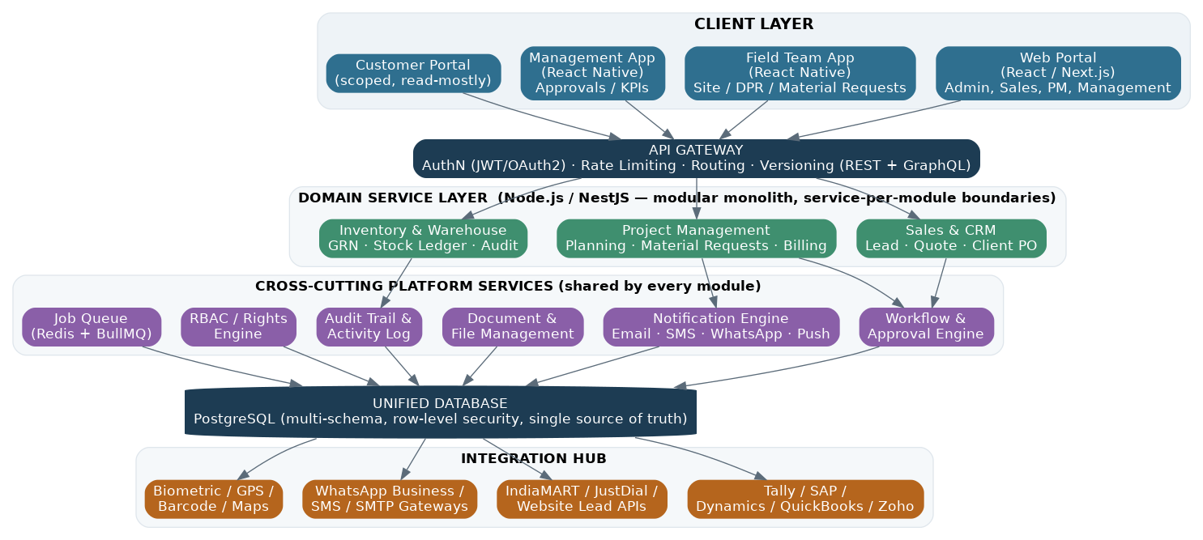
Figure 1 — Layered system architecture: client apps → API gateway → domain services → cross-cutting platform services → unified database → integration hub.

2.4 Layered Architecture — Responsibilities
Layer | Responsibility
Client layer | Web portal (desktop-first roles: admin, sales, PM, management), Field Team App (mobile, offline-capable), Management App (mobile, approvals & KPIs), Customer portal (scoped, read-mostly)
API gateway | Single entry point: authentication, rate limiting, request routing to domain services, REST + GraphQL versioning, request/response logging
Domain service layer | One NestJS module per ERP domain (grouped in the diagram for readability); owns its entities, business rules and REST controllers; calls other domains only through their public service interface, never their tables directly
Cross-cutting platform services | Workflow & Approval Engine, Notification Engine, Document Management, Audit Trail, RBAC/Rights Engine, Job Queue — used by every domain module so approval logic, notifications and audit logging are implemented once
Unified database | PostgreSQL — one physical database, logically organized by schema per domain group, with row-level security enforcing tenant/rights isolation
Integration hub | Adapters for Tally/SAP/Dynamics/QuickBooks/Zoho (accounting sync), IndiaMART/JustDial/website (lead capture), WhatsApp/SMS/SMTP (communication), biometric/GPS/barcode/maps (field devices)

2.5 Security, Rights & Multi-Tenancy
- Role & rights-based access control (RBAC) at three levels: module-level (can this role see Project Management's Material Requests at all), record-level (can this role see this project's records), and field-level (can this role see the margin column on a quotation).
- Row-level security in PostgreSQL enforces the record-level rule at the database layer, not just in application code, so a bug in one API endpoint can't leak cross-project data.
- Every write is stamped with actor, timestamp and before/after values in the Audit Trail service — required for L1 approval, vendor payment and Inventory Audit compliance evidence.
- Channel partner, customer and vendor portal logins use the same identity system but a deliberately narrow rights profile — they authenticate against the same API but see a purpose-built subset of screens.
- Multi-tenancy (if the platform is offered to multiple EPC companies, not just one) is implemented as an organization_id on every table plus RLS, keeping the single-database benefit without cross-tenant leakage.

2.6 Cross-Cutting Platform Services
- Workflow & Approval Engine — a configurable, multi-level approval graph (used by Quotations, Budgets, Vendor Quotations/L1 Approvals, Vendor Invoices); business users configure thresholds and approver chains without a code change.
- Notification Engine — a single service fanning out to Email, SMS, WhatsApp Business and mobile push, driven by event subscriptions raised by any domain module (e.g., "quotation.approved", "po.overdue", "escalation.raised").
- Document Management — one storage/versioning service for contracts, POs, invoices and photos, so every module gets version history and access control for free instead of re-implementing file handling.
- Audit Trail — append-only log of every state change, queryable per record; this is what makes L1 approvals, vendor payments and Inventory Audits "audit-ready" without extra engineering per module.
- Job Queue — background processing for scheduled report generation, escalation sweeps (overdue tasks, ageing invoices, expiring quotations) and third-party sync retries.

3. Unified Data Model — The Golden Thread
The single most important architectural decision in this ERP is that a project is not just a Project Execution record — it is the anchor that every other module's records point back to. The diagram below traces one deal from first enquiry through to operational handover, showing the actual sequence of record creation across modules.

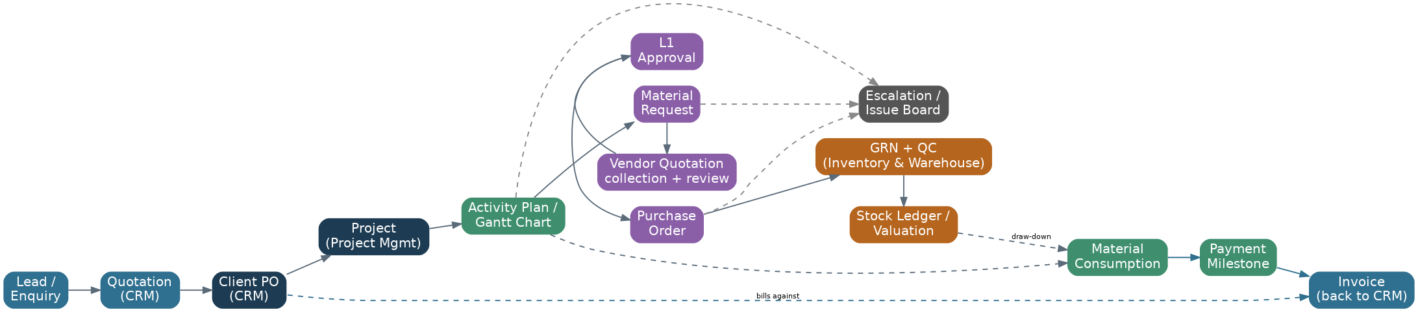
Figure 2 — The golden thread: how a single opportunity flows from CRM through Project Management into Inventory & Warehouse Management, and how the Combined CRM + Project Dashboard reads across all of it.

3.1 Core Shared Entities
These entities are referenced (by foreign key) from all 3 modules and should be modeled once, centrally, rather than duplicated per module.
Entity | Purpose | Referenced by
Organization | Tenant/company record (for multi-tenant deployments) | Every table (organization_id)
User / Role | Identity, role assignment, rights profile | CRM, Project Management, Inventory & Warehouse (owner_id, approver_id, assigned_to)
Party (Customer / Vendor / Contractor) | Single contact/company registry shared across CRM (customers) and Project Management (vendors, contractors) | CRM, Project Management
Project | The execution hub; anchors budget, schedule, site(s) | Project Management, Inventory & Warehouse Management
Document | Versioned file record (contract, PO, invoice, photo) | CRM, Project Management
Task | Universal action item with owner/due-date/status | CRM, Project Management
Approval / Workflow Instance | Generic multi-level approval record | CRM (quotation), Project Management (budget, vendor quotation L1, PO, vendor invoice)
Notification | Outbound event record (email/SMS/WhatsApp/push) | Every module, via the Notification Engine
Audit Log Entry | Immutable change record | Every table, via the Audit Trail service

4. Module-by-Module Architecture
Each module below follows the same structure: purpose, key entities and fields, core API endpoints, the business process flow end to end, the primary UI screens, and — critically — how it is wired to its neighboring modules. This consistency is deliberate: it is what makes 3 modules feel like one product rather than three separate products.

4.1 Sales & CRM
Lead-to-cash CRM for EPC selling: capture, quote, close — with its own tasks, reports, dashboards and escalations built in, so the sales team never leaves this module for day-to-day follow-up.

Key Entities
Entity | Key Fields | Notes
Lead | lead_id, source (IndiaMART/JustDial/Website/Referral/Card-scan), owner_id, territory, product_interest, score, status | Auto-assigned via rule engine; scored on source, budget, timeline
Quotation | quotation_id, lead_id (FK), boq_json, version, markup_pct, approval_status, valid_till | Full revision history; margin locked at approval
Client PO | client_po_id, quotation_id (FK), client_po_number, client_po_file, contract_value, payment_terms, status | The customer's own Purchase Order document, logged against our quotation — this is our order-confirmation record. Logging it is the single trigger that creates a Project in Project Management
Document | document_id, linked_entity_type, linked_entity_id, category, version, file_url, approval_status | Contracts, client correspondence and quotation attachments — versioned, shared platform service
Invoice | invoice_id, client_po_id (FK), project_id (FK, optional), type (tax/proforma), amount, tax_details, due_date, payment_status | Raised against the Client PO directly, or against a Payment Milestone fired from Project Management
Task | task_id, source_ref_id, title, owner_id, priority, due_date, status | CRM follow-up/reminder tasks — shared Task engine, CRM-scoped view
Escalation | escalation_id, source_entity_type, source_entity_id, raised_by, reason, severity, assigned_to, status | A stale quotation, an overdue follow-up, or an ageing unpaid invoice raises here
Custom Report | report_id, name, data_source, filters_json, columns_json, schedule | Ad-hoc report builder, savable and schedulable by email
Dashboard Widget | widget_id, role_scope, kpi_source, config_json | Role-based widgets rendered on the CRM home dashboard

Core APIs
Method | Endpoint | Description
POST | /api/v1/leads | Create lead (manual, API capture, or card-scan OCR)
GET | /api/v1/leads?stage=&owner=&territory= | List/filter leads for pipeline views
POST | /api/v1/leads/{id}/assign | Apply auto-assignment / lead-scoring rule
POST | /api/v1/leads/{id}/quotations | Generate a quotation against a lead
POST | /api/v1/quotations/{id}/approve | Route through configurable approval workflow
POST | /api/v1/quotations/{id}/log-client-po | Record the client's Purchase Order (number + scanned file) against the quotation; auto-creates the Project in Project Management
GET | /api/v1/documents?entity_type=&entity_id= | Fetch versioned documents attached to a lead/quotation/PO
POST | /api/v1/invoices | Raise a tax/proforma invoice against a Client PO or Payment Milestone
POST | /api/v1/invoices/{id}/mark-paid | Record invoice payment status
POST | /api/v1/tasks | Create a CRM follow-up task (manual or auto-scheduled)
POST | /api/v1/escalations | Raise an escalation (stale quote, overdue invoice)
POST | /api/v1/escalations/{id}/resolve | Close or resolve an escalation
GET | /api/v1/reports/custom?report_id= | Run a saved custom report
GET | /api/v1/dashboards/crm?role= | Role-based CRM dashboard data

Business Process Flow
- Lead enters via IndiaMART/JustDial/website webhook, manual entry, or visiting-card scan (OCR) — this is effectively the client's request for a quotation.
- Auto-assignment engine routes the lead by territory/product rule and computes a lead score.
- A Quotation is prepared against the lead with a BOQ/pricing line-up and markup applied.
- Quotation runs through a configurable multi-level approval workflow, with supporting Documents (technical notes, terms) attached and versioned.
- Approved quotation is sent to the client; follow-up Tasks and reminders are auto-scheduled until the client responds.
- If a quotation goes stale past its SLA, an Escalation is raised automatically so it doesn't silently die in someone's inbox.
- Client confirms the order by issuing their own Purchase Order — this Client PO (number + document) is logged against the quotation.
- Logging the Client PO auto-creates the Project record in Project Management — this is the one event that hands the deal from sales to execution.
- Tax/proforma Invoices are raised against the Client PO, and later against Payment Milestones fired back from Project Management as execution progresses; overdue invoices raise an Escalation.
- Reports & Dashboards (standard and Custom Reports) give funnel, conversion, invoicing and escalation visibility to owners and management, with Notifications keeping every step visible without anyone needing to check manually.

Primary UI Screens
- Lead inbox (list + Kanban)
- Lead 360° detail (timeline, notes, tasks, documents)
- Quotation builder (line-item editor)
- Client PO log (number + document upload)
- Document library
- Invoice list & detail
- Task board (My Tasks / team)
- Escalation board
- Custom report builder
- CRM dashboard (role-based, with saved widgets)

Screen Mockup
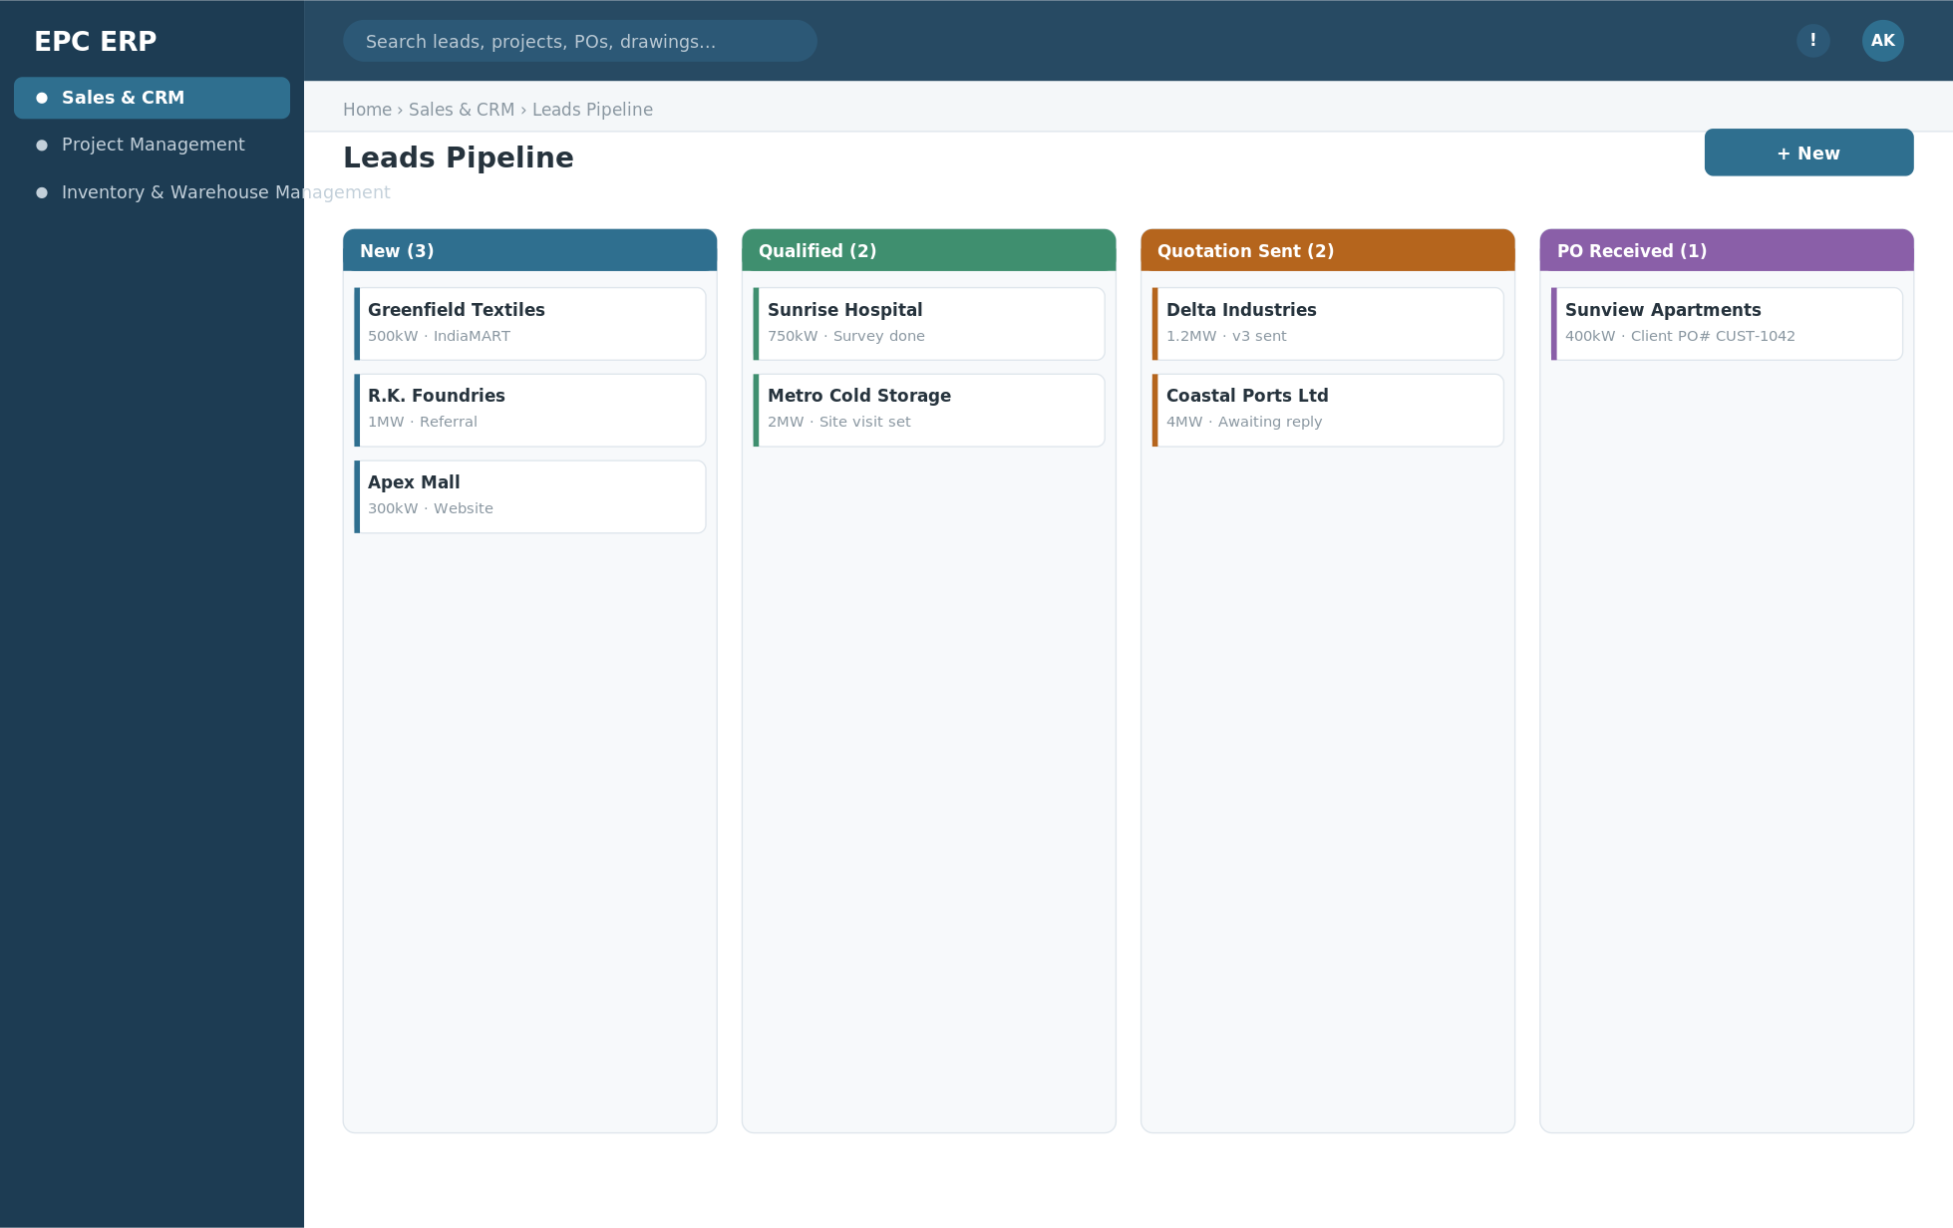
Wireframe — Leads Pipeline (Kanban view) — Sales & CRM. Indicative layout only; final visual design is up to the build team.

Module Relationships
- Logging a Client PO is the single trigger that creates a Project in Project Management — the golden-thread handoff between the two modules.
- Documents, Tasks, Escalations and Notifications here reuse the same shared platform services that Project Management also uses — one engine, a CRM-scoped view.
- Payment Milestones fired from Project Management as work completes come back here as Invoices — CRM never re-keys a billing amount, it only records what execution has already earned.

4.2 Project Management
The project's entire lifecycle in one system: plan it, resource it, buy for it, receive against it, bill it and monitor it — end to end, with one dashboard and one issue board for the project owner.

Key Entities
Entity | Key Fields | Notes
Project | project_id, client_po_id (FK), name, site_location, pm_owner_id, start_date, planned_end, status, parent_project_id (nullable) | Created automatically the moment CRM logs a Client PO, or manually via Create Project; parent_project_id makes a project a Sub Project of a larger one
Activity | activity_id, project_id (FK), wbs_code, name, planned_start, planned_end, actual_start, actual_end, dependency_ids[], percent_complete, status | Activity Planning & Tracking — the record set that renders as the Gantt Chart
Resource Allocation | allocation_id, project_id (FK), activity_id (FK), resource_type (labour/equipment/contractor), resource_id, allocated_from, allocated_to, allocation_pct | Assigns labour, equipment and contractors against specific activities
Contractor | contractor_id, name, trade, contract_value, contact, rating, assigned_project_ids[] | Onboarded once, assigned across projects and activities
Budget | budget_id, project_id (FK), cost_head, budgeted_amount, committed_amount, actual_amount, revision_no | Three-way tracking — budgeted vs committed vs actual — is the input to Project Profitability
Expense | expense_id, project_id (FK), category, amount, incurred_by, date, receipt_url, approval_status | Non-material costs: travel, site facilities, contractor mobilization
Payment Milestone | milestone_id, project_id (FK), milestone_name, trigger_condition, amount, due_date, status, invoice_ref | Fires automatically as linked activities complete; the trigger for a CRM Invoice
Material Request (MR) | mr_id, project_id (FK), activity_id (FK), raised_by, item_list[], required_by_date, status | The starting point of the full procurement flow below — every material purchase for the project starts here
Vendor Quotation | vendor_quotation_id, mr_id (FK), vendor_id (FK), quotation_number, quoted_amount, item_price_breakup[], validity_date, quotation_file | One row per vendor response — quotations are collected from multiple vendors for the same Material Request before any decision is made
L1 Approval | l1_approval_id, vendor_quotation_id (FK), manager_remarks, md_remarks, approver_id, status, decided_at | Manager, and Managing Director for higher-value requests, review every collected quotation; the recommended one must clear this dedicated checkpoint before it can become a PO
Purchase Order (PO) | po_id, vendor_quotation_id (FK), vendor_id (FK), po_number, po_date, expected_delivery_date, amount, delivery_terms, status | Generated only after L1 approval; references the approved quotation number directly — price and terms are never re-typed
Vendor Invoice | invoice_id, po_id (FK), invoice_number, scanned_file_url, invoice_amount, invoice_date, due_date, approval_status | Scanned and attached by the manager once material is received; due_date is auto-computed from the vendor's credit terms
Payment | payment_id, vendor_invoice_id (FK), amount_paid, payment_date, credit_term_days, status | Payment/credit tracking — tracked against the vendor's credit terms so exposure never silently exceeds what's approved
Material Consumption | consumption_id, project_id (FK), grn_ref (FK, Inventory & Warehouse), item_id, qty_issued, qty_consumed, consumed_by, date, wastage_pct | Site draw-down against stock received via GRN in the Inventory & Warehouse Management module
DPR (Daily Progress Report) | dpr_id, project_id (FK), report_date, submitted_by, work_summary, manpower_count, weather, photos[] | One per site per day; rolls planned-vs-actual % into the Gantt/S-curve automatically
Escalation | escalation_id, project_id (FK), source_ref, raised_by, severity, assigned_to, status (pending/in-progress/resolved), resolved_at | Anything blocked or overdue anywhere in the project's chain lands here for the owner to close or escalate
Site Warehouse | warehouse_id, project_id (FK), location, custodian_id, capacity | The project's own register of its site warehouse(s); day-to-day stock operations against it are run in the Inventory & Warehouse Management module
Customer Portal Access | access_id, project_id (FK), client_user_id, permissions[], last_login | Read-scoped client login — progress %, milestone status, documents, and a ticket button that raises an Escalation

Core APIs
Method | Endpoint | Description
POST | /api/v1/projects | Create project — manually (Create Project), or auto from a CRM Client PO
POST | /api/v1/projects/{id}/activities | Add an activity with dependencies (Activity Planning & Tracking)
GET | /api/v1/projects/{id}/gantt | Gantt Chart / critical-path data
POST | /api/v1/projects/{id}/resource-allocations | Allocate labour/equipment/contractor to an activity
POST | /api/v1/contractors | Register/update a contractor
GET | /api/v1/projects/{id}/budget-vs-actual | Budgeting + Project Profitability variance view
POST | /api/v1/expenses | Submit a project expense for approval
GET | /api/v1/projects/{id}/payment-milestones | Payment milestone schedule & status
POST | /api/v1/payment-milestones/{id}/trigger | Mark milestone complete; fires the billing event to CRM
POST | /api/v1/material-requests | Raise a Material Request against a project/activity
POST | /api/v1/material-requests/{id}/vendor-quotations | Log a vendor's quotation — the quotation-collection step
POST | /api/v1/vendor-quotations/{id}/review | Record Manager / Managing Director review remarks and a recommendation
POST | /api/v1/vendor-quotations/{id}/approve-l1 | L1 approval checkpoint on the recommended quotation
POST | /api/v1/po | Generate a PO from the L1-approved vendor quotation (auto-carries price, terms, quotation number)
GET | /api/v1/po/{id}/delivery-status | PO tracking: received vs pending qty against expected delivery date (reads GRNs from Inventory & Warehouse)
POST | /api/v1/po/{id}/invoice | Attach the scanned vendor invoice against the PO
POST | /api/v1/invoices/{id}/approve | Route vendor invoice through multi-level payment approval
POST | /api/v1/invoices/{id}/payment | Record payment against the vendor's credit terms
POST | /api/v1/material-consumption | Log site consumption against a GRN
POST | /api/v1/dpr | Submit daily progress report (mobile)
GET | /api/v1/projects/{id}/escalations?status=pending|resolved | Project escalation/issue board
POST | /api/v1/escalations/{id}/escalate | Escalate an issue to a manager/department head
POST | /api/v1/projects/{id}/sub-projects | Create a Sub Project (parent_project_id link)
POST | /api/v1/projects/{id}/site-warehouse | Register the project's site warehouse
POST | /api/v1/projects/{id}/customer-portal-access | Grant the client a scoped portal login
GET | /api/v1/dashboards/combined?scope=crm+project | Combined CRM + Project dashboard — pipeline and execution in one view
GET | /api/v1/projects/{id}/dashboard | Real-time single-project KPI dashboard

Business Process Flow
- Create Project: a project is created automatically the instant CRM logs a Client PO, or a PM starts one directly — either path lands in the same Project entity.
- Activity Planning & Tracking: the PM breaks the project into activities with dependencies; the Gantt Chart renders directly from this plan and updates live as work proceeds.
- Resource Allocation assigns labour, equipment and Contractors to specific activities; Contractors are onboarded once and reused across projects.
- Site teams file a DPR each day (progress %, manpower, weather, photos), which rolls planned-vs-actual straight into the Gantt/S-curve — no separate spreadsheet.
- Material Request is raised from an activity when a shortfall is identified.
- Quotation collection: quotations are gathered from multiple vendors against that Material Request.
- Vendor review: the Manager, and the Managing Director for higher-value requests, review every collected quotation side by side and leave a joint recommendation.
- L1 approval: the recommended quotation clears a dedicated Level-1 approval checkpoint — nothing proceeds to a PO before this.
- Purchase order: once L1-approved, a PO is generated automatically, referencing the approved quotation number and carrying its price and terms without re-keying.
- The PO is tracked against its expected delivery date; goods are received at the project's Site Warehouse and logged as a GRN in the Inventory & Warehouse Management module — the full GRN concept, with partial deliveries tracked until the PO is fully closed.
- Material Consumption is logged as site draws down the received stock against activities, with wastage/variance tracked against what was issued.
- Invoice handling: once material is received, the manager scans and attaches the vendor's invoice; it is reconciled against the PO and GRN quantities before routing through payment approval levels.
- Payment/credit tracking: approved invoices are scheduled per the vendor's credit terms, and outstanding payables vs. credit limit are tracked so exposure never silently runs over.
- Expense Management handles non-material project costs (travel, site facilities, mobilization) on a separate approval path from material spend.
- Budgeting continuously compares budgeted vs committed vs actual (material + expenses + contractor cost); Project Profitability is computed live from that same variance.
- Payment Milestones fire automatically as linked activities complete, generating the billing event that CRM turns into a client Invoice.
- Escalations: anything blocked or overdue — a stuck L1 approval, an overdue GRN, an unresolved site issue — is flagged as pending; the project owner works it to resolved, or escalates it to a manager/department head with one action that raises priority and notifies the new owner.
- Sub Projects: a large multi-phase site (e.g., a multi-block solar installation) is split into linked sub-projects, each with its own Gantt and budget rolling up to the parent.
- Customer Portal gives the client a read-only view of progress %, milestones and documents, with a ticket button that raises straight into the Escalation board.
- The Project Dashboard (single project) and the Combined CRM + Project Dashboard (pipeline plus execution together) give real-time visibility to the project owner and management, with Notifications keeping every owner informed at each step above.

Primary UI Screens
- Project Workspace (tabbed hub)
- Create Project form
- Activity Planning / Gantt Chart view
- Resource allocation grid
- Contractor list & detail
- Material Request list/detail (quotation comparison + L1 approval + PO inline)
- PO delivery & GRN status tracker
- Material consumption log
- DPR entry (mobile) & planned-vs-actual chart
- Budget vs actual dashboard (Project Profitability)
- Expense submission & approval inbox
- Payment milestone tracker
- Escalation / issue board (pending, in-progress, resolved, escalated)
- Sub-project tree view
- Site warehouse register
- Customer Portal (client-facing, read-scoped)
- Combined CRM + Project dashboard
- Project KPI dashboard

Screen Mockup
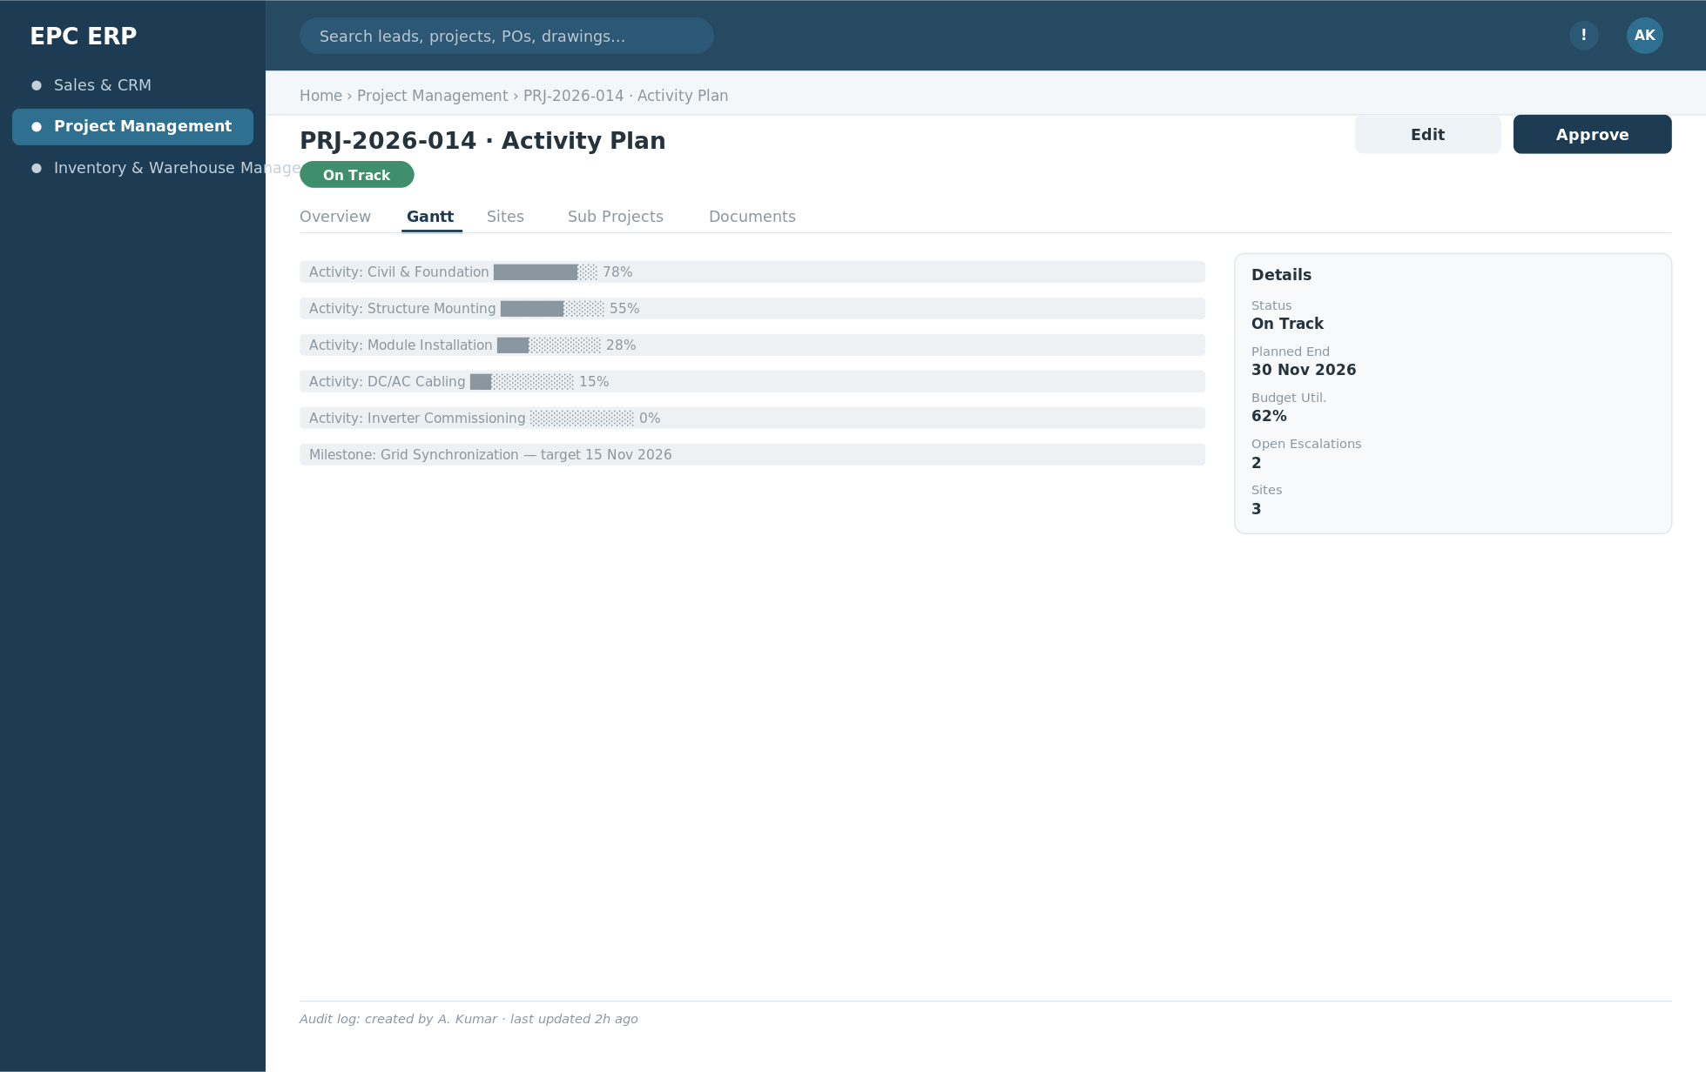
Wireframe — Activity Planning / Gantt Chart — Project Management. Indicative layout only; final visual design is up to the build team.

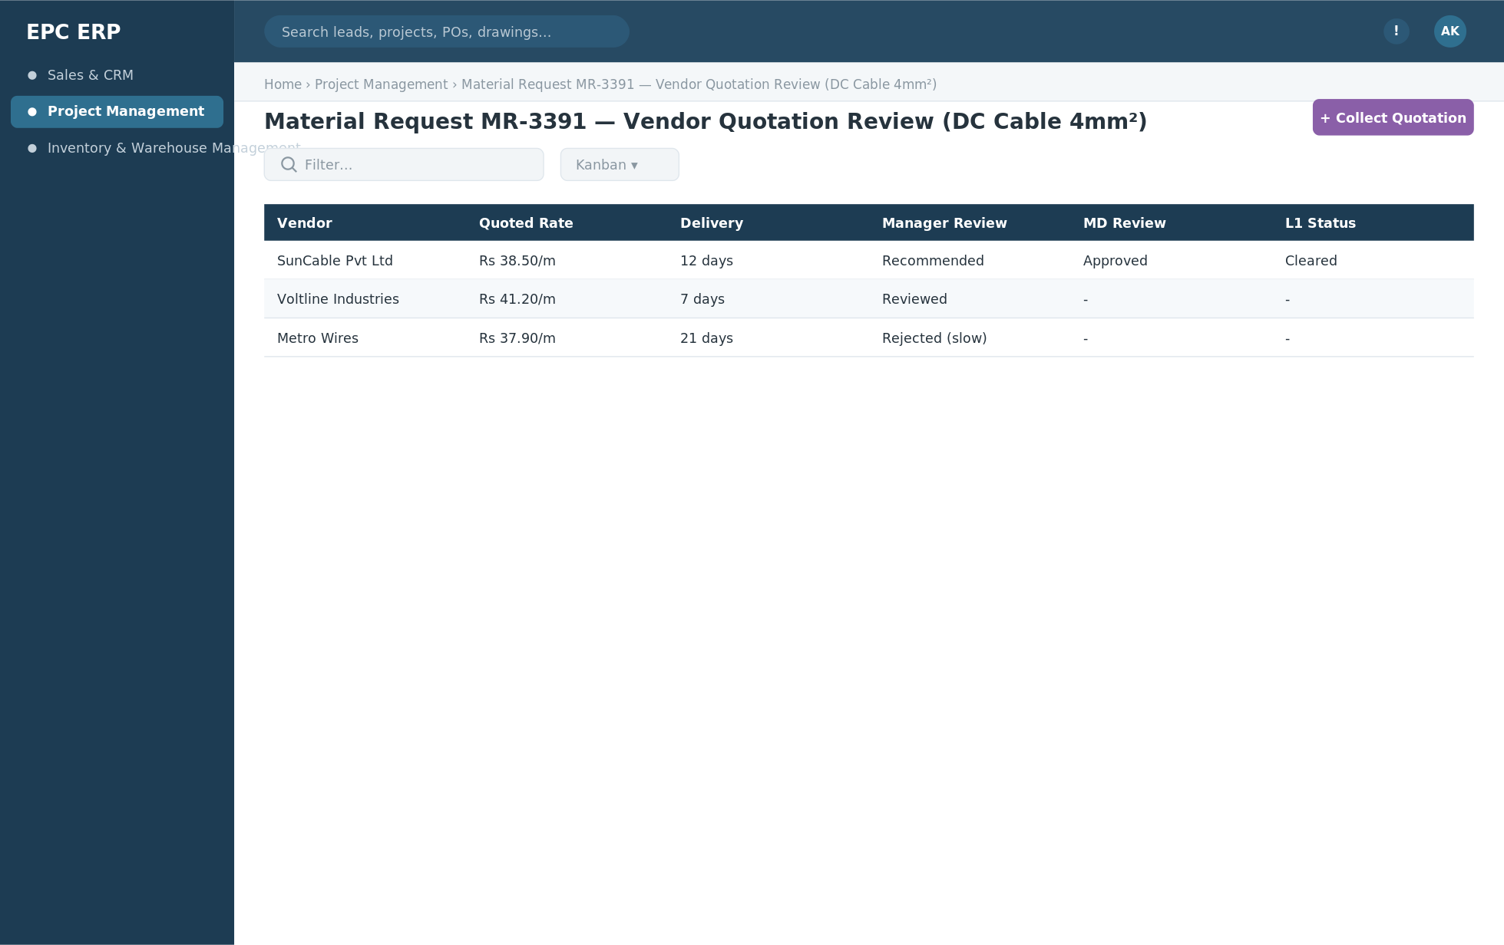
Wireframe — Material Request — vendor quotation comparison, Manager/MD review + L1 approval. Indicative layout only; final visual design is up to the build team.

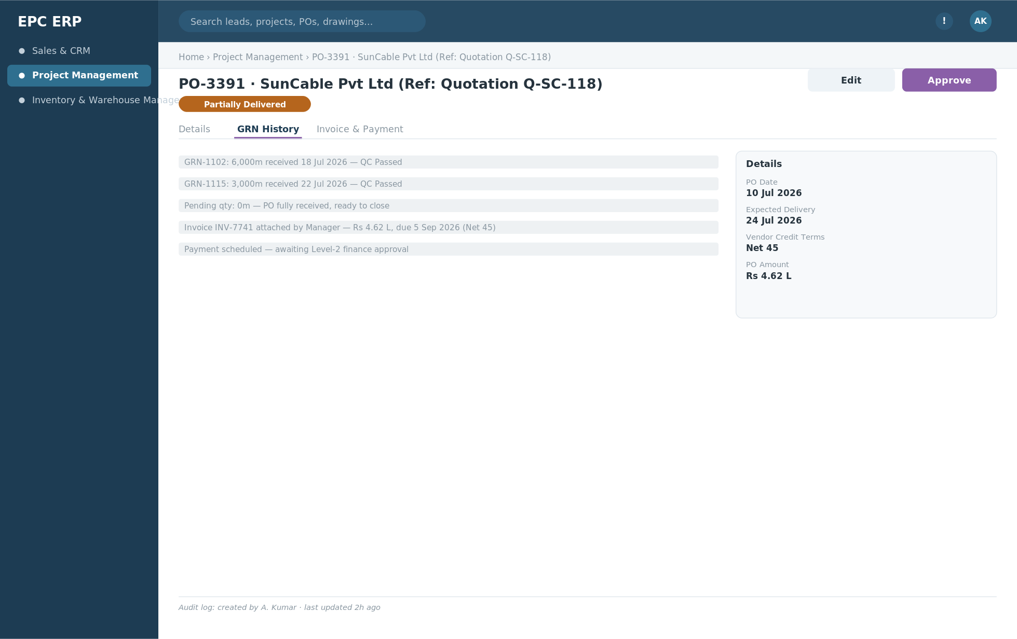
Wireframe — PO delivery tracking, invoice & payment tracking. Indicative layout only; final visual design is up to the build team.

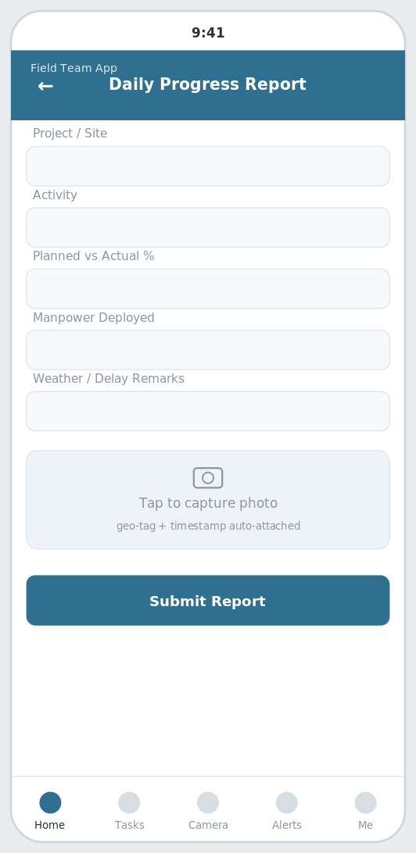
Wireframe — Mobile DPR capture — Field Team App. Indicative layout only; final visual design is up to the build team.

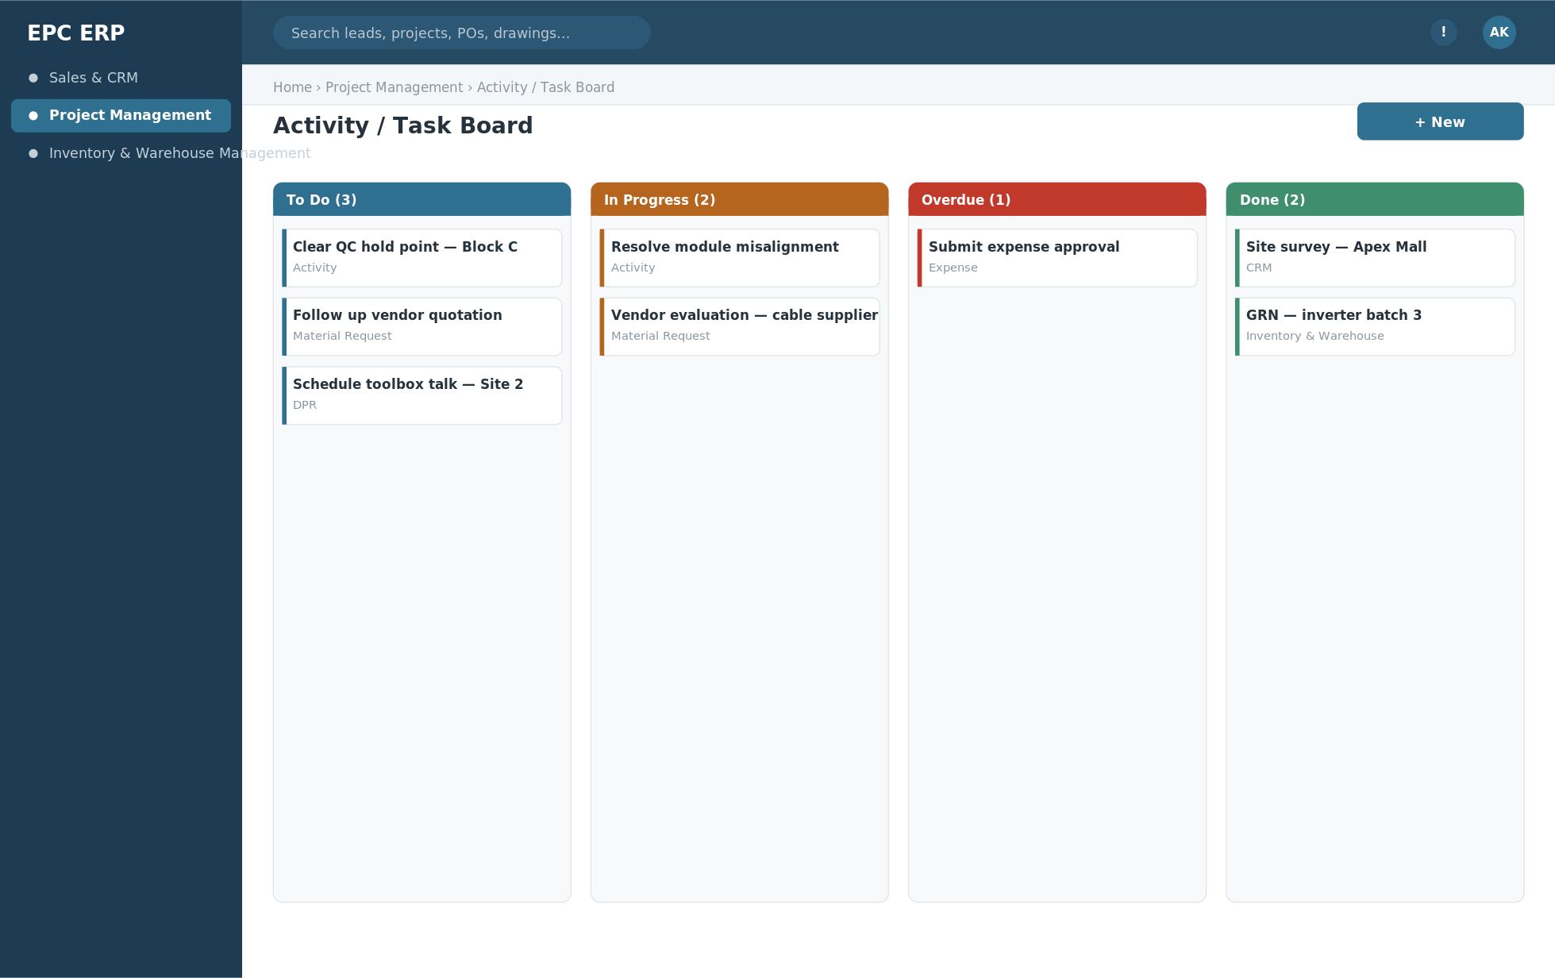
Wireframe — Activity / task board. Indicative layout only; final visual design is up to the build team.

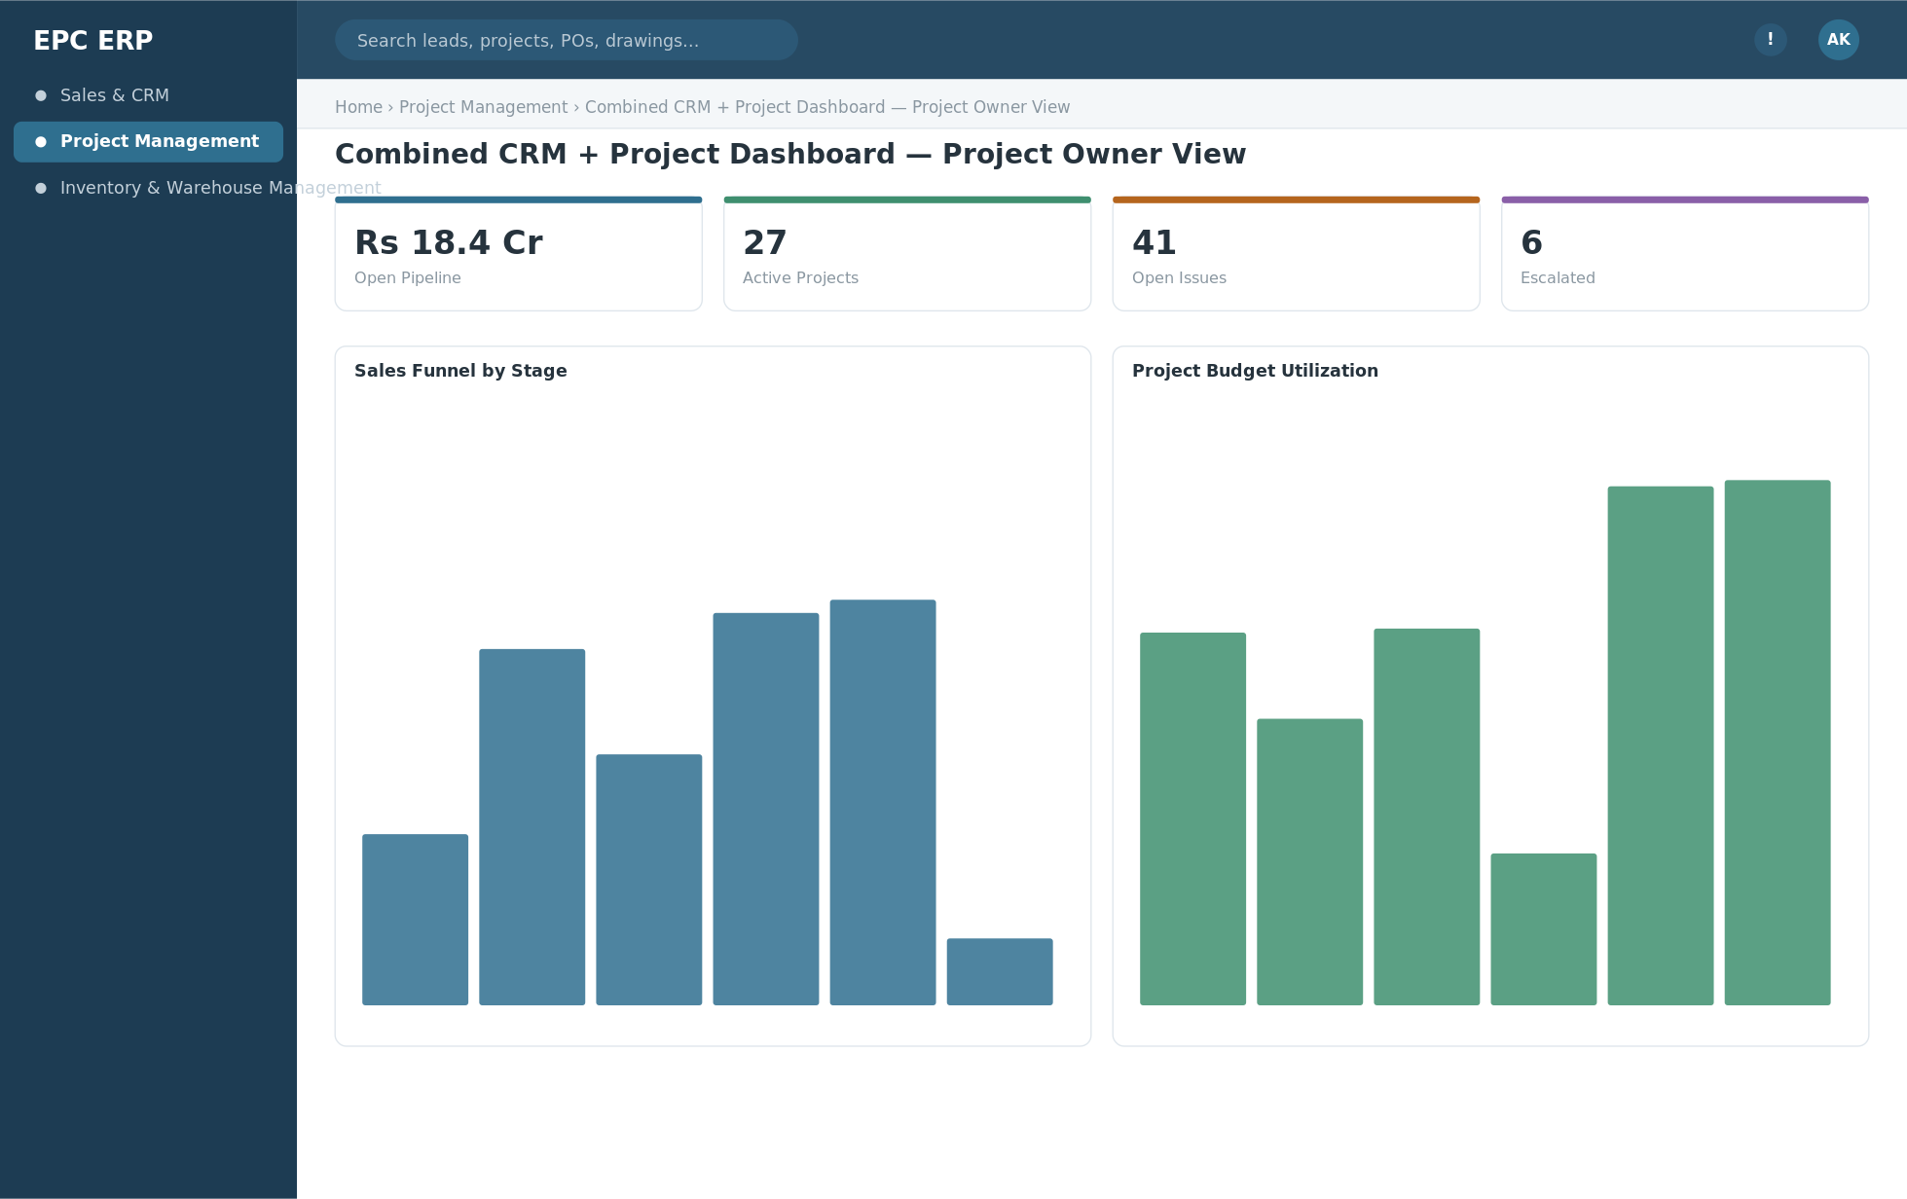
Wireframe — Combined CRM + Project dashboard — project owner view. Indicative layout only; final visual design is up to the build team.

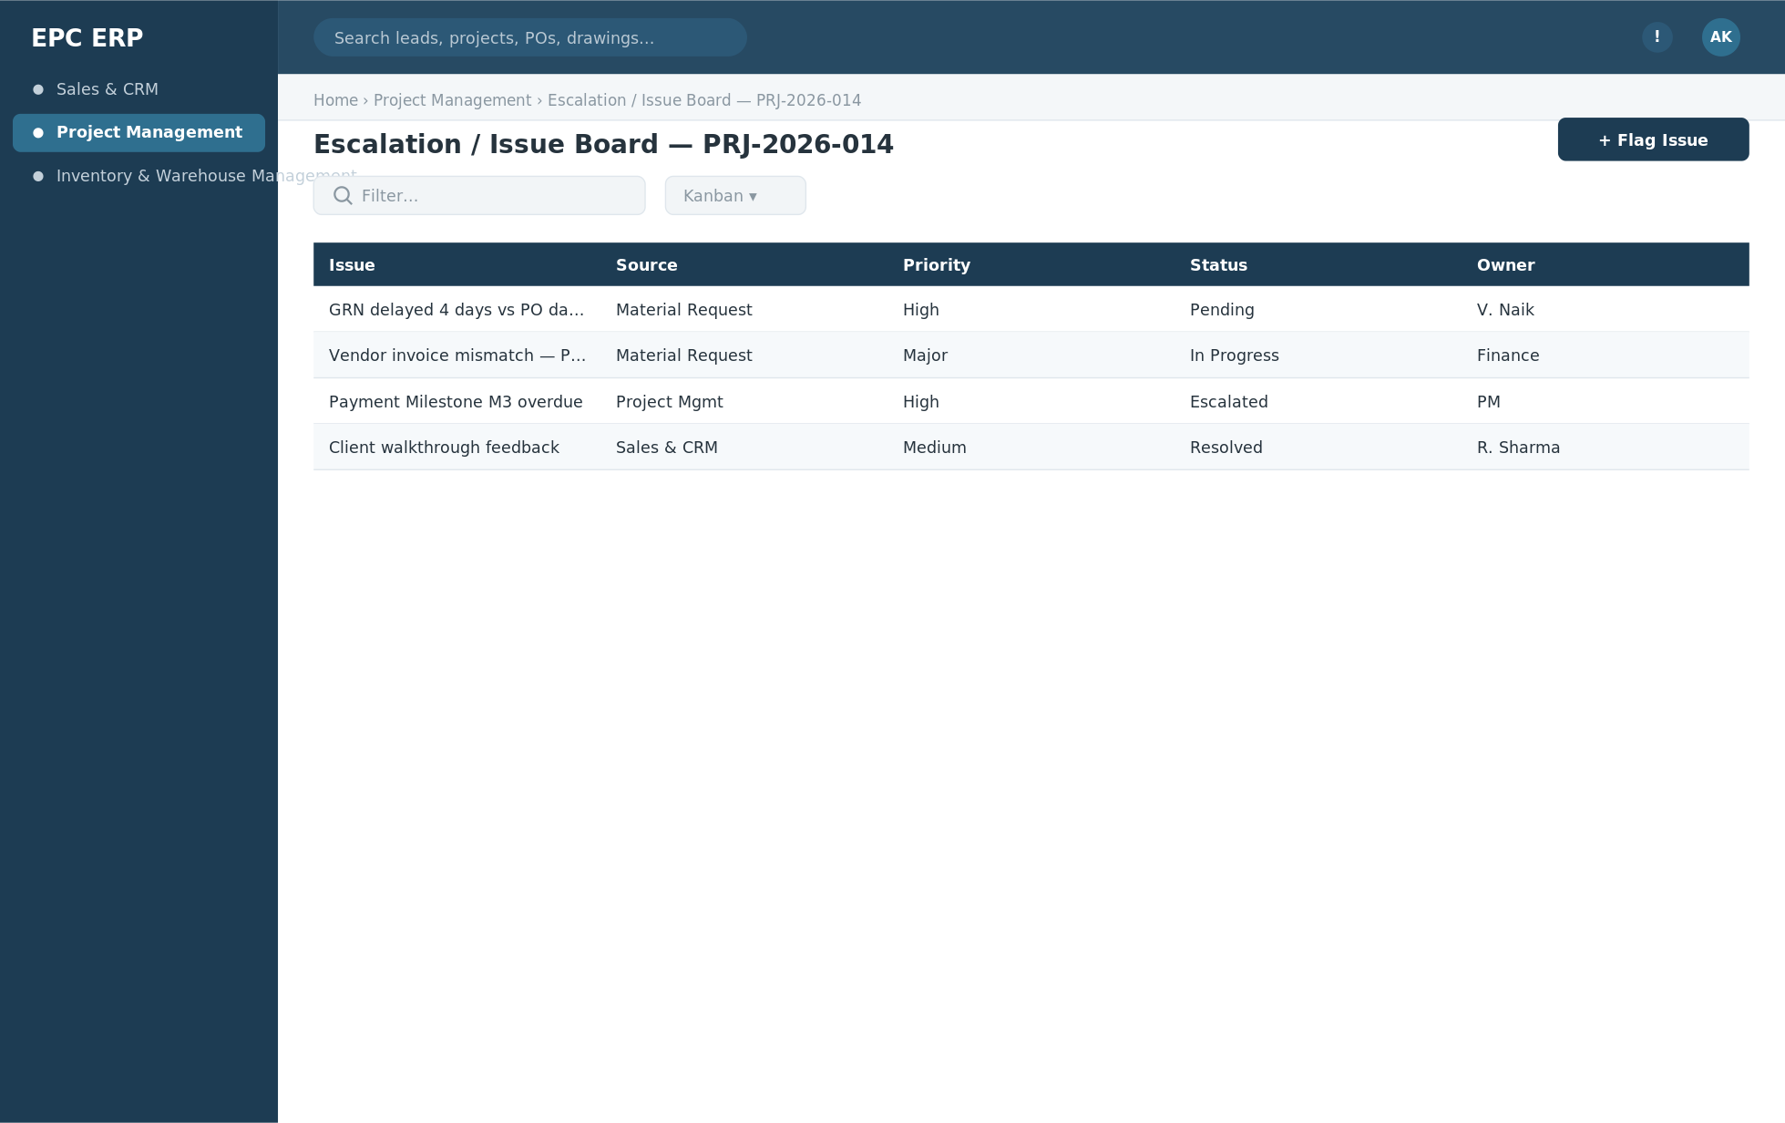
Wireframe — Escalation / issue board — pending, in-progress, resolved, escalated. Indicative layout only; final visual design is up to the build team.

Module Relationships
- A Project is created directly from CRM's Client PO — the golden-thread handoff between the two modules — and its Payment Milestones write the billing event back into CRM as an Invoice, closing the loop between execution and revenue.
- The Material Request → Vendor Quotation → L1 Approval → PO chain lives entirely here; once goods arrive, the PO is fulfilled as a GRN inside Inventory & Warehouse Management — Material Consumption reads that same GRN record rather than duplicating it.
- Documents, Escalations and Notifications reuse the same shared platform services CRM uses — one engine, a project-scoped view; the Combined CRM + Project Dashboard is a read-only view over both modules' data, not a new data store.

4.3 Inventory & Warehouse Management
Real-time stock across every project's site warehouse — receive against a PO, quality-check it, locate it, issue it, value it and audit it, without a spreadsheet in sight.

Key Entities
Entity | Key Fields | Notes
Warehouse | warehouse_id, name, project_id (FK, nullable for central), location, custodian_id, capacity | Warehouse Management — a project's Site Warehouse or a central store, registered once and operated here
Warehouse Location | location_id, warehouse_id (FK), zone, rack, bin | Bin-level put-away location, so every item is locatable, not just "in stock somewhere"
GRN (Goods Receipt Note) | grn_id, po_id (FK, Project Management), warehouse_id (FK), grn_number, received_date, line_items[{item, po_qty, received_qty, pending_qty}], qc_status | Inward-GRN — one PO can span several GRNs for partial/staggered deliveries; the PO stays open until every line's pending_qty reaches zero
Inward Quality Check | qc_id, grn_id (FK), inspected_by, checklist_json, accepted_qty, rejected_qty, rejection_reason, status | Runs before received quantity is accepted into stock; rejections are flagged back rather than silently absorbed
Delivery Challan / Outward Note | challan_id, warehouse_id (FK), project_id (FK), issued_to, line_items[], issued_date, purpose (site-issue/return/transfer), reference_doc | Outward — Delivery Challan/Note documents every material movement out of a warehouse
Stock Ledger Entry | ledger_id, warehouse_id (FK), item_id, txn_type (inward/outward/transfer/adjustment), qty, balance_qty, ref_doc_type, ref_doc_id, date | Every inward, outward, transfer and adjustment posts here — the single source of truth for what's on hand and where
Stock Valuation Summary | valuation_id, warehouse_id (FK), item_id, valuation_method (FIFO/weighted-avg), unit_value, total_value, as_of_date | Periodic valuation feeds Project Management's Budgeting and Project Profitability with real material cost
Inventory Audit | audit_id, warehouse_id (FK), audit_date, auditor_id, system_qty, physical_qty, variance_qty, variance_value, status | Reconciles system quantity against a physical count per warehouse; variances are logged for investigation

Core APIs
Method | Endpoint | Description
POST | /api/v1/warehouses | Register/update a warehouse (site or central)
POST | /api/v1/warehouses/{id}/locations | Define a zone/rack/bin location
POST | /api/v1/grn | Record a goods receipt (full or partial) against a Project Management PO
POST | /api/v1/grn/{id}/qc-check | Inward quality check before stock acceptance
GET | /api/v1/po/{id}/grn-history | Full GRN history and pending quantity for a PO
POST | /api/v1/delivery-challan | Generate an outward delivery challan/note
GET | /api/v1/stock-ledger?item=&warehouse=&from=&to= | Query the stock ledger
GET | /api/v1/stock-valuation?warehouse=&as_of= | Stock valuation summary report
POST | /api/v1/inventory/audit | Record a physical audit / cycle count
POST | /api/v1/inventory/audit/{id}/reconcile | Reconcile variance and close the audit

Business Process Flow
- A PO raised in Project Management's Material Request flow arrives at a project's Site Warehouse, or a central Warehouse.
- Inward-GRN is recorded against the PO, capturing received quantity per line item; pending_qty is recalculated automatically against the ordered quantity — one PO can span several GRNs for partial or staggered deliveries.
- Inward Quality Check runs on the received goods before they're accepted into stock; rejected quantities are flagged back to the vendor/PM rather than silently absorbed.
- Accepted quantities post to the Stock Ledger as an inward transaction, updating the running balance for that item at that warehouse.
- Warehouse Location assigns a zone/rack/bin for put-away as part of Warehouse Management, so every item is locatable inside the warehouse.
- When Project Management logs Material Consumption at site, it is recorded here as an Outward Delivery Challan/Note against the warehouse, decrementing the ledger.
- The Stock Ledger reflects every inward, outward, transfer and adjustment transaction with a running balance per item per warehouse — the single source of truth for what's on hand and where.
- Stock Valuation Summary periodically values on-hand stock (FIFO or weighted-average) so material cost feeds correctly into Project Management's Budgeting and Project Profitability.
- Inventory Audit periodically reconciles system quantity against a physical count per warehouse, logging any variance for investigation before it silently becomes a write-off.

Primary UI Screens
- GRN entry & list (against PO)
- Inward Quality Check form
- Delivery Challan/Outward Note list & detail
- Warehouse register
- Warehouse Location map / bin grid
- Stock Ledger view (item / warehouse / date filter)
- Stock Valuation Summary report
- Inventory Audit worksheet

Screen Mockup
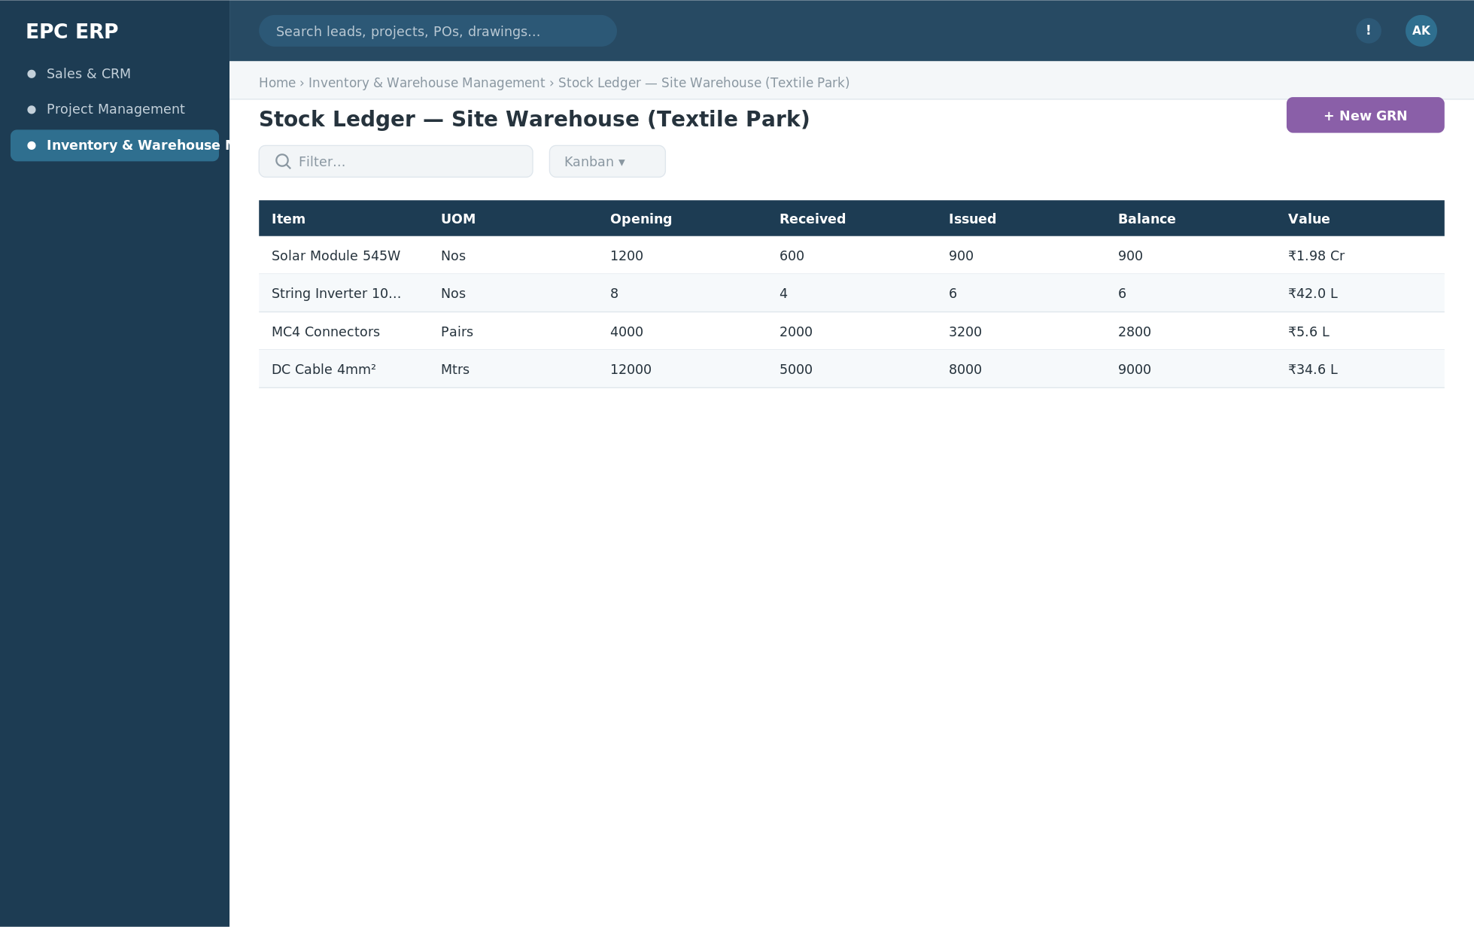
Wireframe — Stock Ledger — Inventory & Warehouse Management. Indicative layout only; final visual design is up to the build team.

Module Relationships
- Receives its PO reference directly from Project Management's Material Request → L1 Approval → PO chain; the GRN recorded here is the same event that closes the PO's "pending" status back in Project Management.
- Outward Delivery Challans reconcile against Project Management's Material Consumption log — one physical movement, one record, viewed from two sides.
- Stock Valuation Summary feeds Project Management's Budgeting and Project Profitability with an accurate material cost figure instead of a PO-price estimate.

5. Frontend UI/UX Architecture & Navigation
The frontend is built as one application shell with all 3 modules mounted inside it — never as separate apps linked by URL. The same global shell, the same detail-screen pattern and the same Project Workspace hub are reused everywhere, so a user who has learned Sales & CRM already knows most of how to use Project Management or Inventory & Warehouse Management.

5.1 Navigation Model
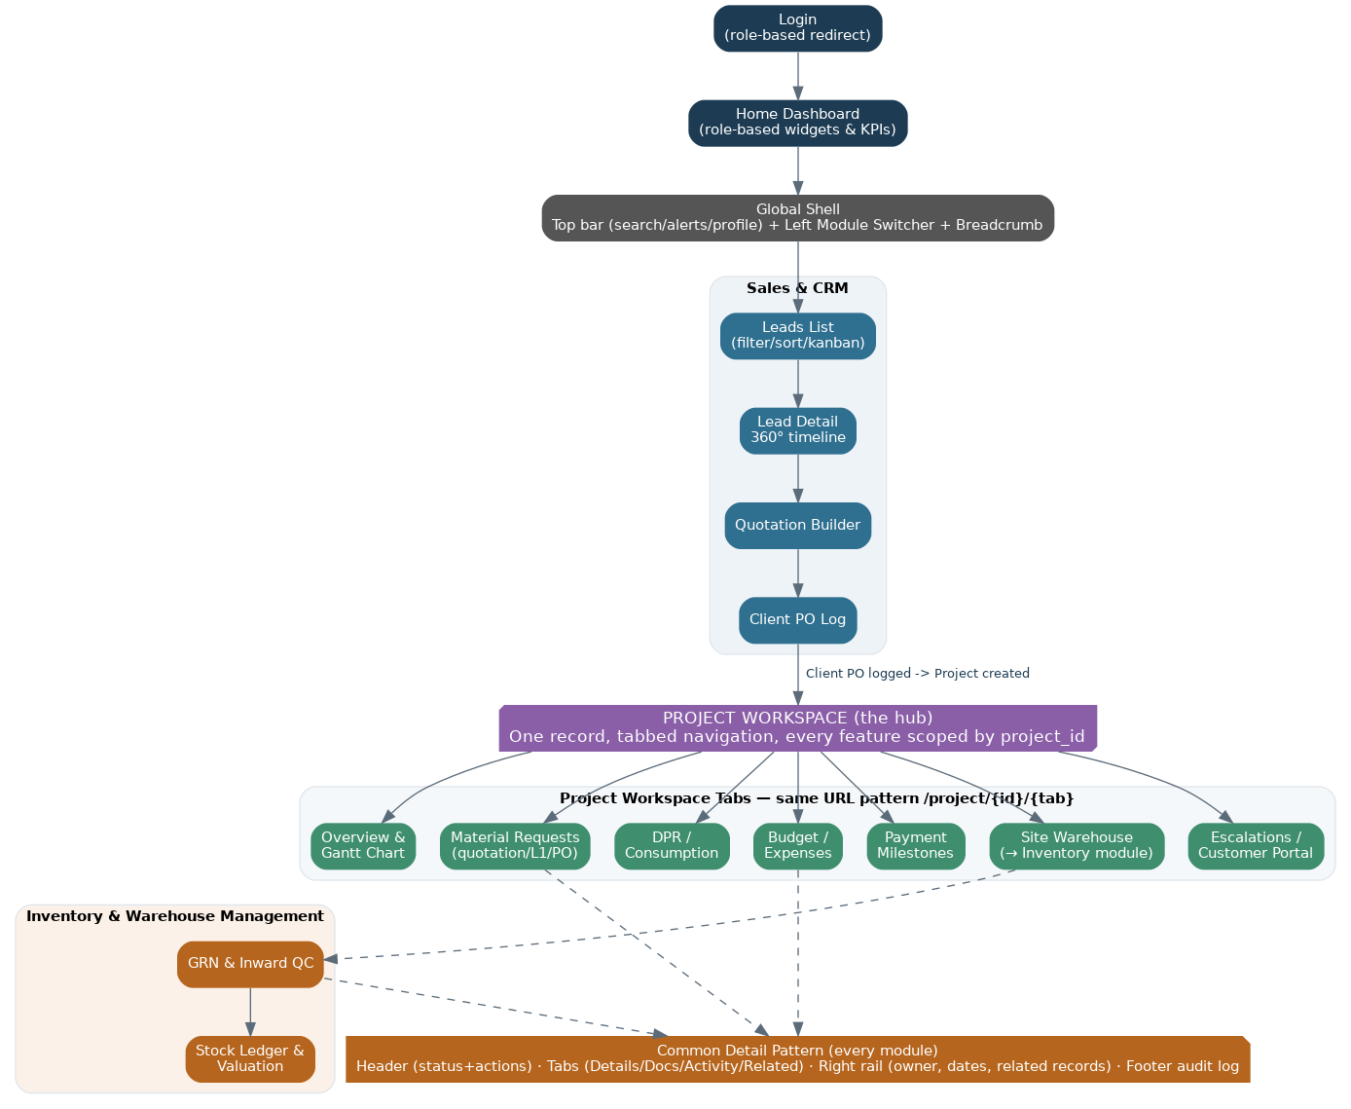
Figure 3 — Navigation flow from login to a fully cross-linked Project Workspace.
- Global shell — persistent top bar (global search, notifications, profile/org switcher) and a left-hand Module Switcher; a breadcrumb always shows the path back to the record's owning project.
- Home dashboard — role-based on login: a sales rep sees the funnel, a PM sees active projects and budget variance, a director sees the portfolio dashboard.
- Project Workspace — the architectural centerpiece of the UX. Once a Client PO becomes a Project, every feature that scopes to that project — Overview & Gantt, Material Requests (quotation → L1 approval → PO), DPR, Budget & Expenses, Payment Milestones, Site Warehouse (reading live into Inventory & Warehouse Management), Escalations, Sub Projects, Customer Portal — appears as a tab inside one workspace, at a consistent URL pattern (/project/{id}/{tab}). The user never leaves the project's context to check its material requests, then its stock position, then its open issues.
- Deep linking — any record (a PO, a GRN, an escalation) can be opened directly from a notification or a dashboard drill-down, always landing inside the correct Project Workspace tab, never a dead-end page.

Screen Mockup — Role-Based Home Dashboard
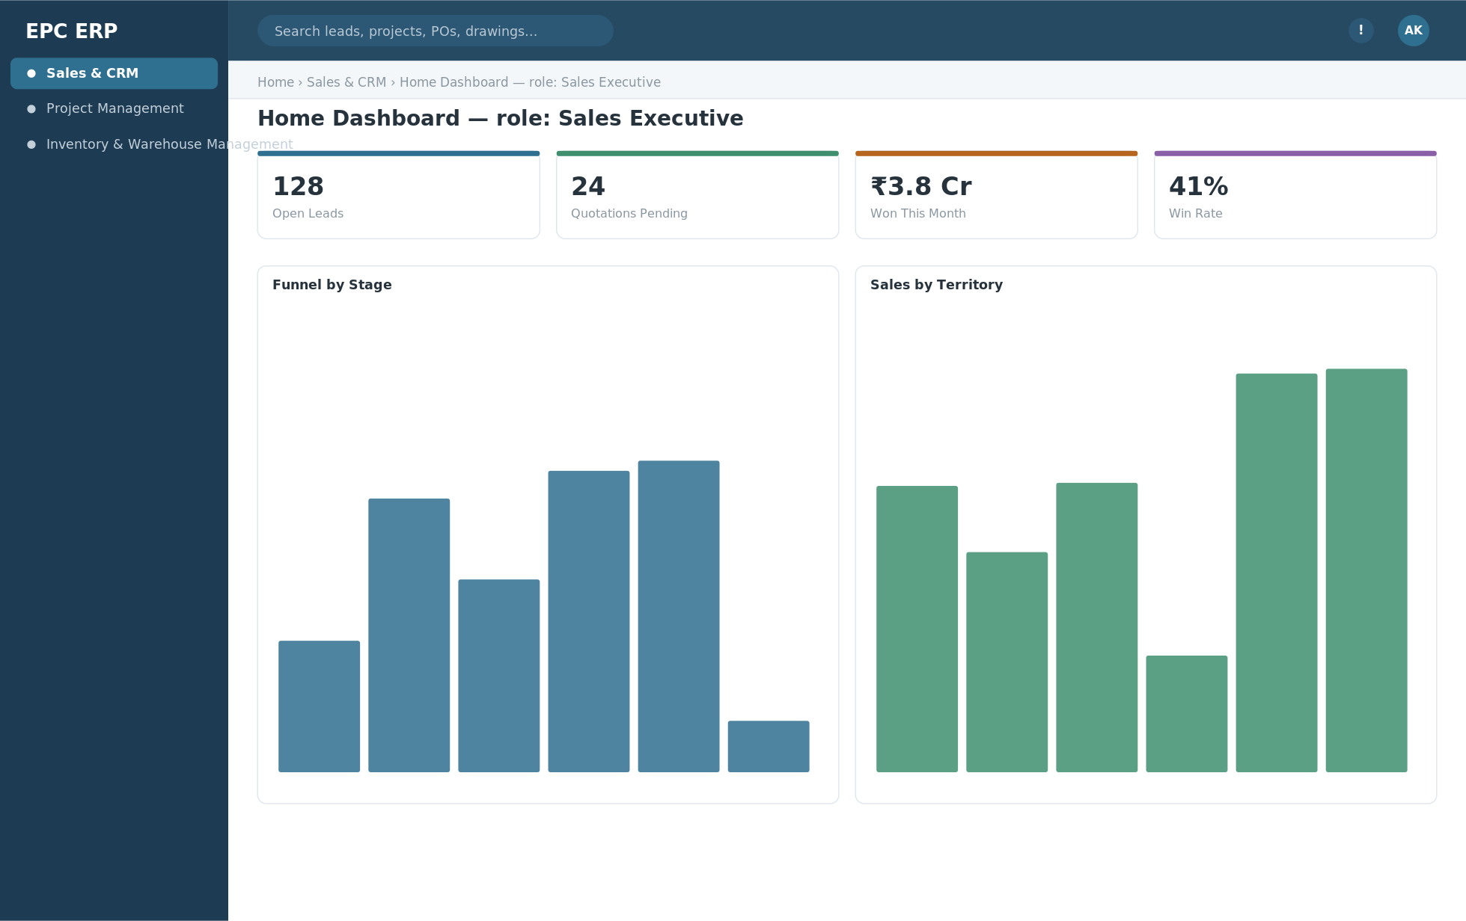
Wireframe — Home Dashboard as seen by a Sales Executive. Every role sees the same shell with different widgets.

Screen Mockup — Project Workspace Hub
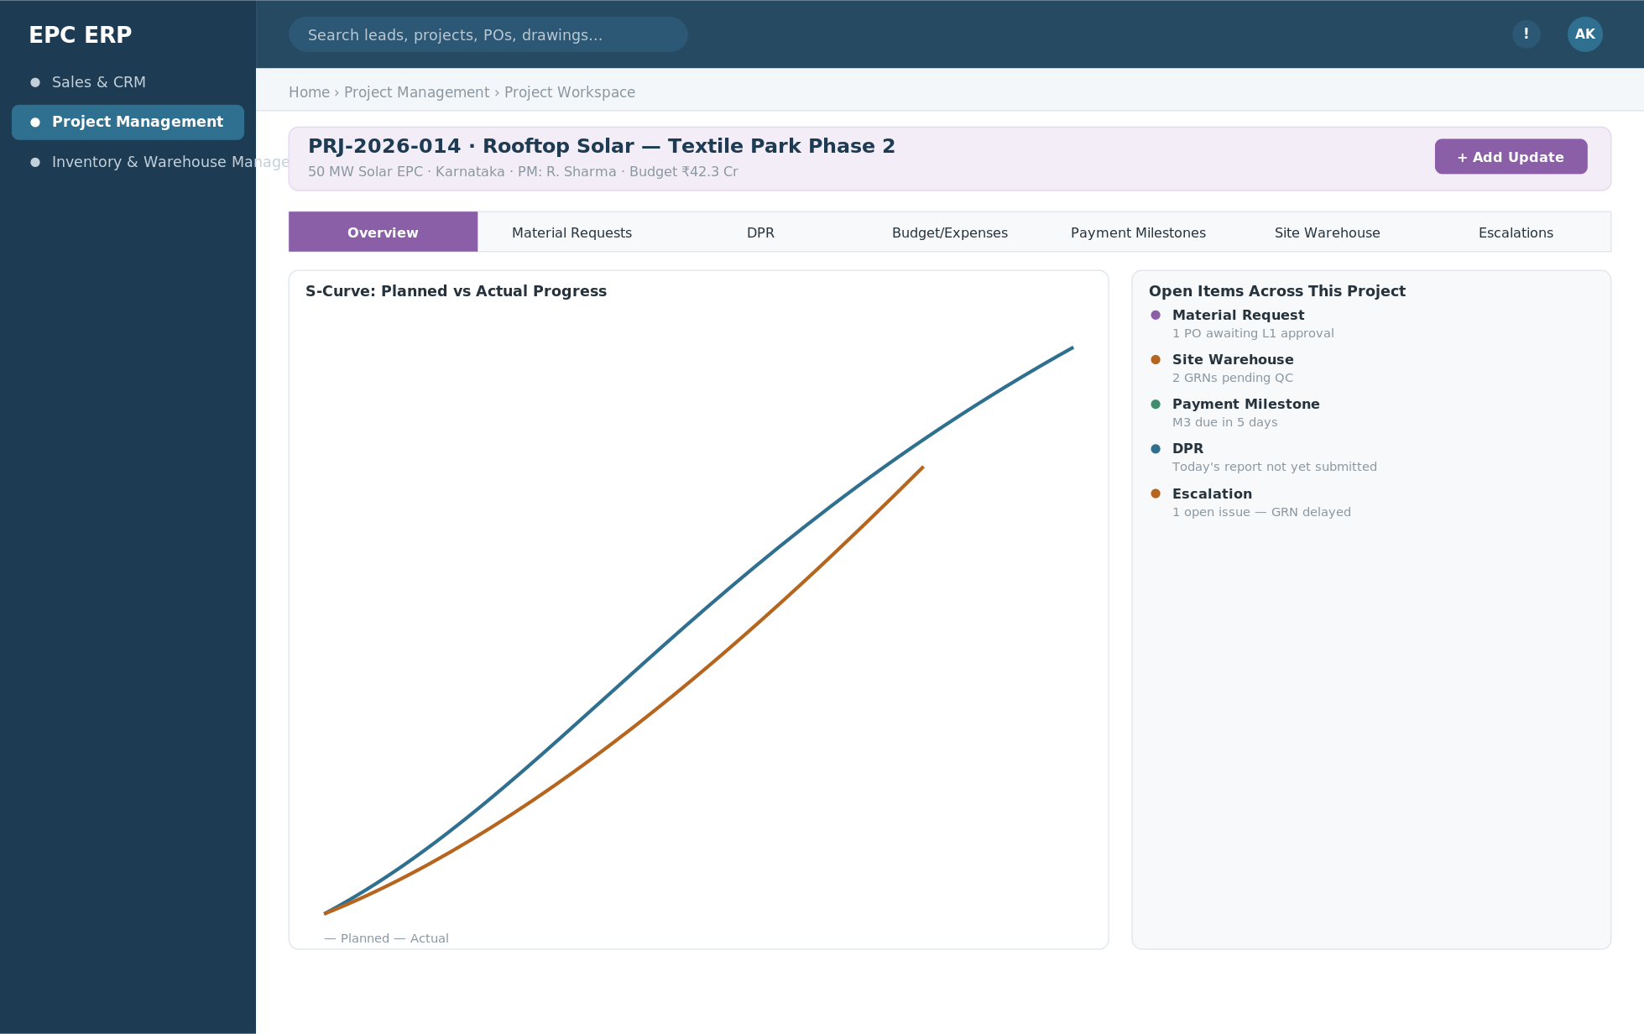
Wireframe — the Project Workspace hub: one project record, every module reachable as a tab, S-curve and cross-module open items visible at a glance.

5.2 Common Screen Patterns
Pattern | Used for | Structure
List / Kanban toggle | Leads, Activities, Material Requests, Escalations | Filterable list view with a one-click switch to a status-based Kanban board
Record detail | Every module's primary entity | Header (status + primary actions) → Tabs (Details / Documents / Activity / Related Records) → right rail (owner, key dates, linked records) → footer audit log
Approval inbox | Quotations, Budgets, Vendor Quotations (L1), Vendor Invoices, Expenses | A single, unified "My Approvals" screen aggregates pending approvals from every module the workflow engine touches
Wizard / builder | Quotation builder, Material Request builder, Custom Report builder | Multi-step form with running totals/validation, autosave, and a review step before submit
Dashboard | CRM home, Project Workspace overview, Combined CRM + Project dashboard | Widget grid, each widget drillable to the underlying list/detail screen
Mobile capture form | DPR, GRN, Site survey, Activity/task update | Large touch targets, camera/photo attach, geo-tag, offline queue indicator

5.3 Cross-Module Navigation Example
A concrete walk-through, showing how tightly modules are coupled in the UI, not just the database:
- A sales rep logs the client's Purchase Order against an accepted Quotation (CRM screen). One click.
- The system opens the newly created Project Workspace automatically — no separate "go find your project" step — with the budget baseline already carried over from the quotation.
- Inside the workspace, the PM builds the activity plan, then raises a Material Request from the Activities tab; it lands directly in the Material Requests list, pre-filled with the project and activity context.
- Vendor quotations are collected against that request, reviewed, and cleared through L1 approval — from there, one click generates the PO, referencing the approved quotation number automatically.
- When the PO's goods arrive, the site team logs a GRN; it shows up automatically inside this same Project Workspace's Site Warehouse tab and updates the PO's delivery status without anyone re-opening Inventory & Warehouse Management separately.

5.4 Mobile App UX
App | Primary users | Core screens
Field Team App | Site engineers, technicians, sales field staff | Attendance & activity updates, site survey & photos, material requests, GRN capture, DPR entry & issue reporting — all offline-capable with a sync queue
Management App | PMs, directors, department heads | Mobile approvals (quotations, vendor quotations/L1, POs, budgets, expenses), dashboard KPIs & reports, project monitoring, escalation tracking & alerts

Screen Mockup — Field Team App Home
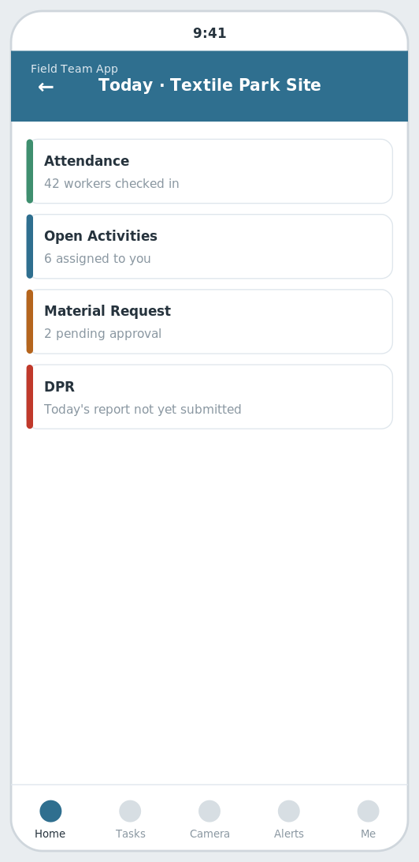
Wireframe — Field Team App home screen: today's attendance, tasks, material requests and safety checklist status.

Screen Mockup — Management App Approvals
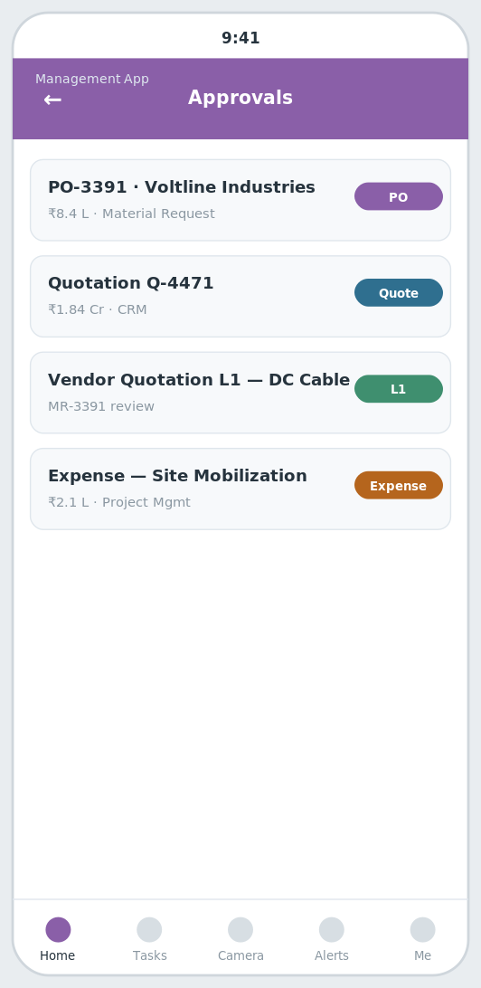
Wireframe — Management App approvals queue: quotations, POs, drawings and budget revisions awaiting sign-off, from any module.

6. End-to-End Business Process Flow
This is the same golden thread as Section 3, viewed as a business process rather than a data model — organized by the team responsible for each phase, across the 3 modules end to end.

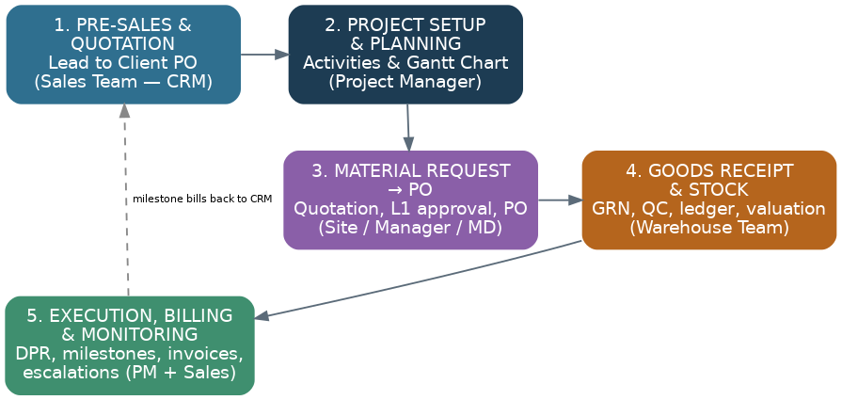
Figure 4 — Lead to closeout: phase-by-phase business process with responsible teams.

Phase | Owner | Trigger in → Trigger out
1. Pre-Sales & Quotation | Sales Team (CRM) | Lead source (IndiaMART/JustDial/website/card-scan) in → Approved quotation sent, Client PO logged out
2. Project Setup & Planning | Project Manager (Project Management) | Client PO logged in → Baselined project with activity plan / Gantt Chart out
3. Material Request → PO | Site team, Manager, Managing Director (Project Management) | Material Request raised in → L1-approved Purchase Order issued out
4. Goods Receipt & Stock | Warehouse team (Inventory & Warehouse Management) | PO issued in → GRN posted, quality-checked, stock ledger and valuation updated out
5. Execution, Billing & Monitoring | PM + Sales (Project Management + CRM) | Ongoing DPR / consumption / vendor invoices in → Payment milestones triggered, client invoices raised, escalations resolved out

7. Device Compatibility
One shared API and one shared design system (Section 5) serve three surfaces — the web portal, the Field Team App, and the Management App. This section defines exactly what each surface is expected to run on.

7.1 Web Platform — Responsive Breakpoints
Breakpoint | Device Class | Layout Behavior
Desktop — 1280px+ | Laptop / desktop monitors (primary surface for office roles) | Full shell: persistent left module sidebar, multi-column dashboards, detail screens with side-by-side main content + right rail
Tablet — 768–1279px | iPad / Android tablets, landscape (site engineers, inspectors) | Sidebar collapses to a collapsible icon rail; dashboards reflow to 2 columns; approval and detail screens stack the right rail below the main content
Mobile web — 320–767px | Phone browser (fallback only) | Single column; sidebar becomes a bottom/hamburger menu; treated as read-mostly — day-to-day field data entry goes through the native Field Team App, not a phone browser

7.2 Web Platform — Browser Support
Browser | Minimum Supported Version
Chrome | Last 2 major versions
Edge (Chromium) | Last 2 major versions
Safari (macOS & iPadOS) | Last 2 major versions
Firefox | Last 2 major versions
Internet Explorer (any version) | Not supported

7.3 Native Mobile Apps
App | Platform | Minimum OS | Notes
Field Team App | iOS | iOS 14+ | Camera, GPS and biometric APIs required for site survey, DPR and attendance capture
Field Team App | Android | Android 8.0 (API 26)+ | Validated against common rugged/site-hardware Android handsets, not just flagship phones
Management App | iOS | iOS 14+ | Push notifications required for real-time approvals
Management App | Android | Android 8.0 (API 26)+ | Push notifications delivered via FCM

7.4 Offline & Responsive Behavior
- Offline-first field capture — DPR, site survey, GRN and incident-report screens queue writes locally on the Field Team App and sync automatically when connectivity returns; conflicting edits are flagged for the PM to resolve, never silently overwritten.
- Minimum supported viewport is 360px wide; narrower screens are out of scope.
- Quotations, POs and reports render as PDF for printing/sharing, independent of the screen size they were generated on.
- The same component language (DataTable, KanbanBoard, DetailHeader, TabStrip, RightRailCard, DashboardKpiCard — Section 8.0) is shared across breakpoints, so a screen never behaves differently by accident between desktop, tablet and mobile web.

8. Replit AI — Module Build Prompts
Everything above this point is the reference specification. The prompts in this section turn that specification into a build sequence you can paste directly into Replit's AI Agent (or any similar AI coding tool), one module at a time. Build Section 8.0 first — it lays the shared foundation every module depends on. Then build 8.1 through 8.16 strictly in order: each prompt only builds its own module and explicitly reuses what earlier prompts already built, so later modules never duplicate or break earlier ones.
- Paste one prompt box at a time into Replit AI — do not paste multiple modules in the same request.
- After each module is built, run the app and verify its acceptance checklist below before moving to the next prompt.
- If Replit AI proposes changing a file that belongs to an earlier module, stop and re-read the "Do Not Touch" list in that prompt — the fix almost always belongs in the new module instead.
- Each prompt is self-contained: it names the tech stack, what already exists, and what to build now, so it works even if pasted into a fresh Replit AI chat session.

8.0 Foundation — Build This First
This is not one of the 3 modules — it is the shared platform every module below plugs into. Skipping it will cause every later prompt to rebuild auth, navigation and workflow logic slightly differently each time, which is exactly what breaks module-to-module consistency.
ROLE
You are setting up the foundation of a new EPC (Engineering-Procurement-Construction) ERP web application. Nothing exists yet — this is the first prompt in a sequence that will add 3 modules one at a time in later prompts.
TECH STACK
Backend: Node.js + NestJS (TypeScript), PostgreSQL 16, Redis + BullMQ for background jobs. API style: REST (resource CRUD) with a GraphQL endpoint reserved for later cross-module dashboards.
Frontend: React + Next.js, Tailwind CSS. Mobile apps are out of scope for this prompt (built later as a separate React Native project).
BUILD THIS NOW
1. Database — create migrations for these shared tables (every later module will add its own tables plus a foreign key back to these):
organization(id, name, ...) | user(id, org_id FK, name, email, role, rights_profile)
project(id, org_id FK, name, site_json, status, pm_owner_id FK, start_date, planned_end)
document(id, org_id FK, project_id FK nullable, category, version, file_url, approval_status)
task(id, org_id FK, source_module, source_ref_id, title, owner_id FK, priority, due_date, status)
approval_instance(id, org_id FK, entity_type, entity_id, workflow_def, current_step, status)
notification(id, org_id FK, user_id FK, channel, payload_json, sent_at)
audit_log(id, org_id FK, table_name, record_id, actor_id FK, before_json, after_json, at)
2. Auth — JWT-based login/refresh, role & rights-based access control (RBAC) middleware, row-level scoping by organization_id on every query.
3. Cross-cutting services (implement as separate, reusable NestJS modules — every future module prompt will import these, never re-implement them):
- WorkflowService: create/advance/approve a multi-level approval_instance for any entity_type
- NotificationService: send(userId, channel, template, data) — stub email/SMS/WhatsApp/push behind one interface
- DocumentService: upload/version/fetch a document, independent of which module owns it
- AuditService: auto-log before/after state on any tracked entity's create/update
- TaskService: create a task from any module via source_module + source_ref_id
4. Frontend app shell — build once, reused by every module screen from here on:
- Top bar: logo, global search input, notification bell, profile menu
- Left sidebar: static list of all 3 module names (routes can 404 for now — modules are built one at a time next); highlight the active module
- Breadcrumb bar under the top bar: Home > {Module} > {Screen}
- A role-based Home Dashboard route (/) with an empty widget grid — modules will register their own widgets later
- Reusable UI primitives: DataTable (sortable, filterable), KanbanBoard, DetailHeader (title+status pill+action buttons), TabStrip, RightRailCard, DashboardKpiCard — every module screen below is built by composing these, not by writing new layout code
DO NOT
Do not build any of the 3 domain modules yet (no leads, no projects-as-a-feature, no material requests). This prompt is infrastructure only.
ACCEPTANCE CHECKLIST
[ ] Can create an organization, a user, and log in and get a JWT
[ ] Shared tables above exist as migrations and run cleanly
[ ] WorkflowService/NotificationService/DocumentService/AuditService/TaskService exist as importable modules with a minimal working method each
[ ] App shell renders: top bar, sidebar with 3 module names, breadcrumb, empty home dashboard
[ ] Reusable UI primitives (DataTable, KanbanBoard, DetailHeader, TabStrip, RightRailCard, DashboardKpiCard) exist and are used nowhere yet except a demo/storybook route

8.1 Sales & CRM — Build Prompt
ROLE
You are adding the "Sales & CRM" module to an existing EPC ERP application (Node.js/NestJS + PostgreSQL backend, React/Next.js frontend). Only the Section 8.0 foundation exists so far (auth, shared tables, shared services, app shell).
Reuse the existing app shell (top bar, sidebar, breadcrumb), the shared UI primitives (DataTable, KanbanBoard, DetailHeader, TabStrip, RightRailCard, DashboardKpiCard), and the shared services (WorkflowService, NotificationService, DocumentService, AuditService, TaskService). Do not re-implement any of them.
BUILD ONLY THIS MODULE
1. Database — add migrations for these tables under a "sales-crm" namespace (add project_id / org_id foreign keys as shown; do not alter any other module's tables):
Lead(lead_id, source (IndiaMART/JustDial/Website/Referral/Card-scan), owner_id, territory, product_interest, score, status)
Quotation(quotation_id, lead_id (FK), boq_json, version, markup_pct, approval_status, valid_till)
Client PO(client_po_id, quotation_id (FK), client_po_number, client_po_file, contract_value, payment_terms, status)
Document(document_id, linked_entity_type, linked_entity_id, category, version, file_url, approval_status)
Invoice(invoice_id, client_po_id (FK), project_id (FK, optional), type (tax/proforma), amount, tax_details, due_date, payment_status)
Task(task_id, source_ref_id, title, owner_id, priority, due_date, status)
Escalation(escalation_id, source_entity_type, source_entity_id, raised_by, reason, severity, assigned_to, status)
Custom Report(report_id, name, data_source, filters_json, columns_json, schedule)
Dashboard Widget(widget_id, role_scope, kpi_source, config_json)
2. Backend API — implement these endpoints (additive routes only, under this module's own controller):
POST /api/v1/leads — Create lead (manual, API capture, or card-scan OCR)
GET /api/v1/leads?stage=&owner=&territory= — List/filter leads for pipeline views
POST /api/v1/leads/{id}/assign — Apply auto-assignment / lead-scoring rule
POST /api/v1/leads/{id}/quotations — Generate a quotation against a lead
POST /api/v1/quotations/{id}/approve — Route through configurable approval workflow
POST /api/v1/quotations/{id}/log-client-po — Record the client's Purchase Order (number + scanned file) against the quotation; auto-creates the Project in Project Management
GET /api/v1/documents?entity_type=&entity_id= — Fetch versioned documents attached to a lead/quotation/PO
POST /api/v1/invoices — Raise a tax/proforma invoice against a Client PO or Payment Milestone
POST /api/v1/invoices/{id}/mark-paid — Record invoice payment status
POST /api/v1/tasks — Create a CRM follow-up task (manual or auto-scheduled)
POST /api/v1/escalations — Raise an escalation (stale quote, overdue invoice)
POST /api/v1/escalations/{id}/resolve — Close or resolve an escalation
GET /api/v1/reports/custom?report_id= — Run a saved custom report
GET /api/v1/dashboards/crm?role= — Role-based CRM dashboard data
3. Business logic — implement this workflow end to end:
1. Lead enters via IndiaMART/JustDial/website webhook, manual entry, or visiting-card scan (OCR) — this is effectively the client's request for a quotation.
2. Auto-assignment engine routes the lead by territory/product rule and computes a lead score.
3. A Quotation is prepared against the lead with a BOQ/pricing line-up and markup applied.
4. Quotation runs through a configurable multi-level approval workflow, with supporting Documents (technical notes, terms) attached and versioned.
5. Approved quotation is sent to the client; follow-up Tasks and reminders are auto-scheduled until the client responds.
6. If a quotation goes stale past its SLA, an Escalation is raised automatically so it doesn't silently die in someone's inbox.
7. Client confirms the order by issuing their own Purchase Order — this Client PO (number + document) is logged against the quotation.
8. Logging the Client PO auto-creates the Project record in Project Management — this is the one event that hands the deal from sales to execution.
9. Tax/proforma Invoices are raised against the Client PO, and later against Payment Milestones fired back from Project Management as execution progresses; overdue invoices raise an Escalation.
10. Reports & Dashboards (standard and Custom Reports) give funnel, conversion, invoicing and escalation visibility to owners and management, with Notifications keeping every step visible without anyone needing to check manually.
4. Frontend screens — build these using the existing shared UI primitives and app shell (do not create a new shell or new base layout):
- Lead inbox (list + Kanban)
- Lead 360° detail (timeline, notes, tasks, documents)
- Quotation builder (line-item editor)
- Client PO log (number + document upload)
- Document library
- Invoice list & detail
- Task board (My Tasks / team)
- Escalation board
- Custom report builder
- CRM dashboard (role-based, with saved widgets)
5. Cross-module wiring — respect these relationships to modules already built (call their existing services/APIs; do not copy their logic):
- Logging a Client PO is the single trigger that creates a Project in Project Management — the golden-thread handoff between the two modules.
- Documents, Tasks, Escalations and Notifications here reuse the same shared platform services that Project Management also uses — one engine, a CRM-scoped view.
- Payment Milestones fired from Project Management as work completes come back here as Invoices — CRM never re-keys a billing amount, it only records what execution has already earned.
DO NOT TOUCH
Do not modify the Section 8.0 foundation tables/services/shell — only consume them.
ACCEPTANCE CHECKLIST
[ ] All tables above exist with the listed fields and foreign keys
[ ] All endpoints above return correct data and are protected by the existing RBAC middleware
[ ] All screens above are reachable from the sidebar under "Sales & CRM"
[ ] Every module built in earlier prompts still runs and its existing tests/screens are unaffected

8.2 Project Management — Build Prompt
ROLE
You are adding the "Project Management" module to an existing EPC ERP application (Node.js/NestJS + PostgreSQL backend, React/Next.js frontend). The Section 8.0 foundation, plus these modules, already exist and must not be modified: Sales & CRM.
Reuse the existing app shell (top bar, sidebar, breadcrumb), the shared UI primitives (DataTable, KanbanBoard, DetailHeader, TabStrip, RightRailCard, DashboardKpiCard), and the shared services (WorkflowService, NotificationService, DocumentService, AuditService, TaskService). Do not re-implement any of them.
BUILD ONLY THIS MODULE
1. Database — add migrations for these tables under a "project-management" namespace (add project_id / org_id foreign keys as shown; do not alter any other module's tables):
Project(project_id, client_po_id (FK), name, site_location, pm_owner_id, start_date, planned_end, status, parent_project_id (nullable))
Activity(activity_id, project_id (FK), wbs_code, name, planned_start, planned_end, actual_start, actual_end, dependency_ids[], percent_complete, status)
Resource Allocation(allocation_id, project_id (FK), activity_id (FK), resource_type (labour/equipment/contractor), resource_id, allocated_from, allocated_to, allocation_pct)
Contractor(contractor_id, name, trade, contract_value, contact, rating, assigned_project_ids[])
Budget(budget_id, project_id (FK), cost_head, budgeted_amount, committed_amount, actual_amount, revision_no)
Expense(expense_id, project_id (FK), category, amount, incurred_by, date, receipt_url, approval_status)
Payment Milestone(milestone_id, project_id (FK), milestone_name, trigger_condition, amount, due_date, status, invoice_ref)
Material Request (MR)(mr_id, project_id (FK), activity_id (FK), raised_by, item_list[], required_by_date, status)
Vendor Quotation(vendor_quotation_id, mr_id (FK), vendor_id (FK), quotation_number, quoted_amount, item_price_breakup[], validity_date, quotation_file)
L1 Approval(l1_approval_id, vendor_quotation_id (FK), manager_remarks, md_remarks, approver_id, status, decided_at)
Purchase Order (PO)(po_id, vendor_quotation_id (FK), vendor_id (FK), po_number, po_date, expected_delivery_date, amount, delivery_terms, status)
Vendor Invoice(invoice_id, po_id (FK), invoice_number, scanned_file_url, invoice_amount, invoice_date, due_date, approval_status)
Payment(payment_id, vendor_invoice_id (FK), amount_paid, payment_date, credit_term_days, status)
Material Consumption(consumption_id, project_id (FK), grn_ref (FK, Inventory & Warehouse), item_id, qty_issued, qty_consumed, consumed_by, date, wastage_pct)
DPR (Daily Progress Report)(dpr_id, project_id (FK), report_date, submitted_by, work_summary, manpower_count, weather, photos[])
Escalation(escalation_id, project_id (FK), source_ref, raised_by, severity, assigned_to, status (pending/in-progress/resolved), resolved_at)
Site Warehouse(warehouse_id, project_id (FK), location, custodian_id, capacity)
Customer Portal Access(access_id, project_id (FK), client_user_id, permissions[], last_login)
2. Backend API — implement these endpoints (additive routes only, under this module's own controller):
POST /api/v1/projects — Create project — manually (Create Project), or auto from a CRM Client PO
POST /api/v1/projects/{id}/activities — Add an activity with dependencies (Activity Planning & Tracking)
GET /api/v1/projects/{id}/gantt — Gantt Chart / critical-path data
POST /api/v1/projects/{id}/resource-allocations — Allocate labour/equipment/contractor to an activity
POST /api/v1/contractors — Register/update a contractor
GET /api/v1/projects/{id}/budget-vs-actual — Budgeting + Project Profitability variance view
POST /api/v1/expenses — Submit a project expense for approval
GET /api/v1/projects/{id}/payment-milestones — Payment milestone schedule & status
POST /api/v1/payment-milestones/{id}/trigger — Mark milestone complete; fires the billing event to CRM
POST /api/v1/material-requests — Raise a Material Request against a project/activity
POST /api/v1/material-requests/{id}/vendor-quotations — Log a vendor's quotation — the quotation-collection step
POST /api/v1/vendor-quotations/{id}/review — Record Manager / Managing Director review remarks and a recommendation
POST /api/v1/vendor-quotations/{id}/approve-l1 — L1 approval checkpoint on the recommended quotation
POST /api/v1/po — Generate a PO from the L1-approved vendor quotation (auto-carries price, terms, quotation number)
GET /api/v1/po/{id}/delivery-status — PO tracking: received vs pending qty against expected delivery date (reads GRNs from Inventory & Warehouse)
POST /api/v1/po/{id}/invoice — Attach the scanned vendor invoice against the PO
POST /api/v1/invoices/{id}/approve — Route vendor invoice through multi-level payment approval
POST /api/v1/invoices/{id}/payment — Record payment against the vendor's credit terms
POST /api/v1/material-consumption — Log site consumption against a GRN
POST /api/v1/dpr — Submit daily progress report (mobile)
GET /api/v1/projects/{id}/escalations?status=pending|resolved — Project escalation/issue board
POST /api/v1/escalations/{id}/escalate — Escalate an issue to a manager/department head
POST /api/v1/projects/{id}/sub-projects — Create a Sub Project (parent_project_id link)
POST /api/v1/projects/{id}/site-warehouse — Register the project's site warehouse
POST /api/v1/projects/{id}/customer-portal-access — Grant the client a scoped portal login
GET /api/v1/dashboards/combined?scope=crm+project — Combined CRM + Project dashboard — pipeline and execution in one view
GET /api/v1/projects/{id}/dashboard — Real-time single-project KPI dashboard
3. Business logic — implement this workflow end to end:
1. Create Project: a project is created automatically the instant CRM logs a Client PO, or a PM starts one directly — either path lands in the same Project entity.
2. Activity Planning & Tracking: the PM breaks the project into activities with dependencies; the Gantt Chart renders directly from this plan and updates live as work proceeds.
3. Resource Allocation assigns labour, equipment and Contractors to specific activities; Contractors are onboarded once and reused across projects.
4. Site teams file a DPR each day (progress %, manpower, weather, photos), which rolls planned-vs-actual straight into the Gantt/S-curve — no separate spreadsheet.
5. Material Request is raised from an activity when a shortfall is identified.
6. Quotation collection: quotations are gathered from multiple vendors against that Material Request.
7. Vendor review: the Manager, and the Managing Director for higher-value requests, review every collected quotation side by side and leave a joint recommendation.
8. L1 approval: the recommended quotation clears a dedicated Level-1 approval checkpoint — nothing proceeds to a PO before this.
9. Purchase order: once L1-approved, a PO is generated automatically, referencing the approved quotation number and carrying its price and terms without re-keying.
10. The PO is tracked against its expected delivery date; goods are received at the project's Site Warehouse and logged as a GRN in the Inventory & Warehouse Management module — the full GRN concept, with partial deliveries tracked until the PO is fully closed.
11. Material Consumption is logged as site draws down the received stock against activities, with wastage/variance tracked against what was issued.
12. Invoice handling: once material is received, the manager scans and attaches the vendor's invoice; it is reconciled against the PO and GRN quantities before routing through payment approval levels.
13. Payment/credit tracking: approved invoices are scheduled per the vendor's credit terms, and outstanding payables vs. credit limit are tracked so exposure never silently runs over.
14. Expense Management handles non-material project costs (travel, site facilities, mobilization) on a separate approval path from material spend.
15. Budgeting continuously compares budgeted vs committed vs actual (material + expenses + contractor cost); Project Profitability is computed live from that same variance.
16. Payment Milestones fire automatically as linked activities complete, generating the billing event that CRM turns into a client Invoice.
17. Escalations: anything blocked or overdue — a stuck L1 approval, an overdue GRN, an unresolved site issue — is flagged as pending; the project owner works it to resolved, or escalates it to a manager/department head with one action that raises priority and notifies the new owner.
18. Sub Projects: a large multi-phase site (e.g., a multi-block solar installation) is split into linked sub-projects, each with its own Gantt and budget rolling up to the parent.
19. Customer Portal gives the client a read-only view of progress %, milestones and documents, with a ticket button that raises straight into the Escalation board.
20. The Project Dashboard (single project) and the Combined CRM + Project Dashboard (pipeline plus execution together) give real-time visibility to the project owner and management, with Notifications keeping every owner informed at each step above.
4. Frontend screens — build these using the existing shared UI primitives and app shell (do not create a new shell or new base layout):
- Project Workspace (tabbed hub)
- Create Project form
- Activity Planning / Gantt Chart view
- Resource allocation grid
- Contractor list & detail
- Material Request list/detail (quotation comparison + L1 approval + PO inline)
- PO delivery & GRN status tracker
- Material consumption log
- DPR entry (mobile) & planned-vs-actual chart
- Budget vs actual dashboard (Project Profitability)
- Expense submission & approval inbox
- Payment milestone tracker
- Escalation / issue board (pending, in-progress, resolved, escalated)
- Sub-project tree view
- Site warehouse register
- Customer Portal (client-facing, read-scoped)
- Combined CRM + Project dashboard
- Project KPI dashboard
5. Cross-module wiring — respect these relationships to modules already built (call their existing services/APIs; do not copy their logic):
- A Project is created directly from CRM's Client PO — the golden-thread handoff between the two modules — and its Payment Milestones write the billing event back into CRM as an Invoice, closing the loop between execution and revenue.
- The Material Request → Vendor Quotation → L1 Approval → PO chain lives entirely here; once goods arrive, the PO is fulfilled as a GRN inside Inventory & Warehouse Management — Material Consumption reads that same GRN record rather than duplicating it.
- Documents, Escalations and Notifications reuse the same shared platform services CRM uses — one engine, a project-scoped view; the Combined CRM + Project Dashboard is a read-only view over both modules' data, not a new data store.
DO NOT TOUCH
Do not modify tables, services, or screens belonging to: Sales & CRM. If something there seems wrong, flag it — don't silently change it.
ACCEPTANCE CHECKLIST
[ ] All tables above exist with the listed fields and foreign keys
[ ] All endpoints above return correct data and are protected by the existing RBAC middleware
[ ] All screens above are reachable from the sidebar under "Project Management" and render inside the Project Workspace hub as tabs
[ ] Every module built in earlier prompts still runs and its existing tests/screens are unaffected

8.3 Inventory & Warehouse Management — Build Prompt
ROLE
You are adding the "Inventory & Warehouse Management" module to an existing EPC ERP application (Node.js/NestJS + PostgreSQL backend, React/Next.js frontend). The Section 8.0 foundation, plus these modules, already exist and must not be modified: Sales & CRM, Project Management.
Reuse the existing app shell (top bar, sidebar, breadcrumb), the shared UI primitives (DataTable, KanbanBoard, DetailHeader, TabStrip, RightRailCard, DashboardKpiCard), and the shared services (WorkflowService, NotificationService, DocumentService, AuditService, TaskService). Do not re-implement any of them.
BUILD ONLY THIS MODULE
1. Database — add migrations for these tables under a "inventory-warehouse-management" namespace (add project_id / org_id foreign keys as shown; do not alter any other module's tables):
Warehouse(warehouse_id, name, project_id (FK, nullable for central), location, custodian_id, capacity)
Warehouse Location(location_id, warehouse_id (FK), zone, rack, bin)
GRN (Goods Receipt Note)(grn_id, po_id (FK, Project Management), warehouse_id (FK), grn_number, received_date, line_items[{item, po_qty, received_qty, pending_qty}], qc_status)
Inward Quality Check(qc_id, grn_id (FK), inspected_by, checklist_json, accepted_qty, rejected_qty, rejection_reason, status)
Delivery Challan / Outward Note(challan_id, warehouse_id (FK), project_id (FK), issued_to, line_items[], issued_date, purpose (site-issue/return/transfer), reference_doc)
Stock Ledger Entry(ledger_id, warehouse_id (FK), item_id, txn_type (inward/outward/transfer/adjustment), qty, balance_qty, ref_doc_type, ref_doc_id, date)
Stock Valuation Summary(valuation_id, warehouse_id (FK), item_id, valuation_method (FIFO/weighted-avg), unit_value, total_value, as_of_date)
Inventory Audit(audit_id, warehouse_id (FK), audit_date, auditor_id, system_qty, physical_qty, variance_qty, variance_value, status)
2. Backend API — implement these endpoints (additive routes only, under this module's own controller):
POST /api/v1/warehouses — Register/update a warehouse (site or central)
POST /api/v1/warehouses/{id}/locations — Define a zone/rack/bin location
POST /api/v1/grn — Record a goods receipt (full or partial) against a Project Management PO
POST /api/v1/grn/{id}/qc-check — Inward quality check before stock acceptance
GET /api/v1/po/{id}/grn-history — Full GRN history and pending quantity for a PO
POST /api/v1/delivery-challan — Generate an outward delivery challan/note
GET /api/v1/stock-ledger?item=&warehouse=&from=&to= — Query the stock ledger
GET /api/v1/stock-valuation?warehouse=&as_of= — Stock valuation summary report
POST /api/v1/inventory/audit — Record a physical audit / cycle count
POST /api/v1/inventory/audit/{id}/reconcile — Reconcile variance and close the audit
3. Business logic — implement this workflow end to end:
1. A PO raised in Project Management's Material Request flow arrives at a project's Site Warehouse, or a central Warehouse.
2. Inward-GRN is recorded against the PO, capturing received quantity per line item; pending_qty is recalculated automatically against the ordered quantity — one PO can span several GRNs for partial or staggered deliveries.
3. Inward Quality Check runs on the received goods before they're accepted into stock; rejected quantities are flagged back to the vendor/PM rather than silently absorbed.
4. Accepted quantities post to the Stock Ledger as an inward transaction, updating the running balance for that item at that warehouse.
5. Warehouse Location assigns a zone/rack/bin for put-away as part of Warehouse Management, so every item is locatable inside the warehouse.
6. When Project Management logs Material Consumption at site, it is recorded here as an Outward Delivery Challan/Note against the warehouse, decrementing the ledger.
7. The Stock Ledger reflects every inward, outward, transfer and adjustment transaction with a running balance per item per warehouse — the single source of truth for what's on hand and where.
8. Stock Valuation Summary periodically values on-hand stock (FIFO or weighted-average) so material cost feeds correctly into Project Management's Budgeting and Project Profitability.
9. Inventory Audit periodically reconciles system quantity against a physical count per warehouse, logging any variance for investigation before it silently becomes a write-off.
4. Frontend screens — build these using the existing shared UI primitives and app shell (do not create a new shell or new base layout):
- GRN entry & list (against PO)
- Inward Quality Check form
- Delivery Challan/Outward Note list & detail
- Warehouse register
- Warehouse Location map / bin grid
- Stock Ledger view (item / warehouse / date filter)
- Stock Valuation Summary report
- Inventory Audit worksheet
5. Cross-module wiring — respect these relationships to modules already built (call their existing services/APIs; do not copy their logic):
- Receives its PO reference directly from Project Management's Material Request → L1 Approval → PO chain; the GRN recorded here is the same event that closes the PO's "pending" status back in Project Management.
- Outward Delivery Challans reconcile against Project Management's Material Consumption log — one physical movement, one record, viewed from two sides.
- Stock Valuation Summary feeds Project Management's Budgeting and Project Profitability with an accurate material cost figure instead of a PO-price estimate.
DO NOT TOUCH
Do not modify tables, services, or screens belonging to: Sales & CRM, Project Management. If something there seems wrong, flag it — don't silently change it.
ACCEPTANCE CHECKLIST
[ ] All tables above exist with the listed fields and foreign keys
[ ] All endpoints above return correct data and are protected by the existing RBAC middleware
[ ] All screens above are reachable from the sidebar under "Inventory & Warehouse Management"
[ ] Every module built in earlier prompts still runs and its existing tests/screens are unaffected

