Blender setup:
the same way as in the repo just more detailed:
use Blender 2.82 (sub 7)
https://www.youtube.com/watch?v=oropR7wp4Ls

Date Generation:
https://www.youtube.com/watch?v=5nsmXLyDaU4
the simplest way, using labeld images,
structure your folder like this:
training_data
example_training_data_from_roboflow/
├── test
│ ├── images
│ └── labels
├── train
│ ├── images
│ └── labels
└── valid
├── images
└── labels
explanation of the format of the label .txt files in the folders:
https://blog.paperspace.com/train-yolov7-custom-data/
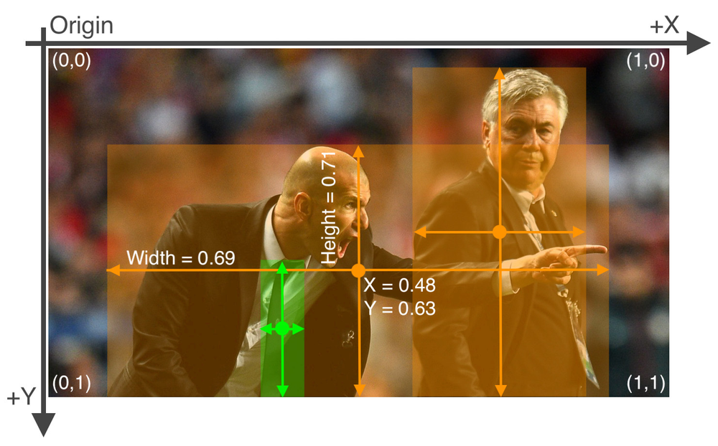
https://machinelearningprojects.net/train-yolov7-on-the-custom-dataset/
https://medium.com/augmented-startups/yolov7-training-on-custom-data-b86d23e6623

Train YOLOv7 on Custom Data:
The steps for custom training are as follows:
1- collect data
2- label data
3- split data (train & test)
4- create config files
5- start training
Step-1: We need to create a dataset for YOLOv7 custom training. if you have no data, You can use the dataset from openimages database.
YOLOv7 takes label data in the text(.txt) file and has the following format:
<object-class-id> <x> <y> <width> <height>
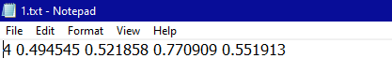
Step-2: For labeling on custom data, check out my article, Labelling data for object detection (Yolo).
Step-3: Once you have labeled your data, we now need to split our data into train and test folders. The split ratio will be dependent on the user while the normally preferable split is (80–20)%, which means 80% of data is used for the training while 20% of data is used for testing. *The Store images and labels with mentioned folder architecture.
*For splitting of data, you can take a look at python-library that will split your data randomly into the train, test, and validation.
Folder structure:
├── yolov7
## └── train
####└── images (folder including all training images)
####└── labels (folder including all training labels)
## └── test
####└── images (folder including all testing images)
####└── labels (folder including all testing labels)
Step-4: Now we need to create a custom configuration file. (make sure to set the correct path), because the training process will totally dependent on that file.
create file having filename “custom. yaml”, inside (yolov7/data) folder. paste the below code in that file. set correct path of dataset folder, change no of classes and their names, then save it.
train: (Complete path to dataset train folder)
test: (Complete path to dataset test folder)
valid: (Complete path to dataset valid folder)#Classes
nc: 1 # replace according to your number of classes#classes names
#replace all class names list with your classes namesnames: ['person', 'bicycle', 'car', 'motorcycle', 'airplane', 'bus', 'train', 'truck', 'boat', 'traffic light',
'fire hydrant', 'stop sign', 'parking meter', 'bench', 'bird', 'cat', 'dog', 'horse', 'sheep', 'cow',
'elephant', 'bear', 'zebra', 'giraffe', 'backpack', 'umbrella', 'handbag', 'tie', 'suitcase', 'frisbee',
'skis', 'snowboard', 'sports ball', 'kite', 'baseball bat', 'baseball glove', 'skateboard', 'surfboard',
'tennis racket', 'bottle', 'wine glass', 'cup', 'fork', 'knife', 'spoon', 'bowl', 'banana', 'apple',
'sandwich', 'orange', 'broccoli', 'carrot', 'hot dog', 'pizza', 'donut', 'cake', 'chair', 'couch',
'potted plant', 'bed', 'dining table', 'toilet', 'tv', 'laptop', 'mouse', 'remote', 'keyboard', 'cell phone',
'microwave', 'oven', 'toaster', 'sink', 'refrigerator', 'book', 'clock', 'vase', 'scissors', 'teddy bear',
'hair drier', 'toothbrush']
Step-5: All preprocessing steps are done, it’s time to start training. open the terminal in the main “yolov7”, activate the virtual environment, and run the mentioned commands below.
source yolov7training/bin/activatepython train.py --weights yolov7.pt --data "data/custom.yaml" --workers 4 --batch-size 4 --img 416 --cfg cfg/training/yolov7.yaml --name yolov7 --hyp data/hyp.scratch.p5.yamlorpython3 train.py --weights yolov7.pt --data "data/custom.yaml" --workers 4 --batch-size 4 --img 416 --cfg cfg/training/yolov7.yaml --name yolov7 --hyp data/hyp.scratch.p5.yaml --epochs 50
-- img = size of images on which model will train, the default value is 640.
-- batch-size = batch size used in training.
-- epochs = number of training epochs
-- data = path of custom config file
-- weights = pre-trained weights (yolov7.pt / yolov7x.pt / yolov7-w6.pt / yolov7-e6.pt)
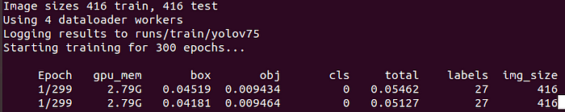
Note: Training will not start if any image is corrupt, If some label file will be corrupted so there will be no issue in training because yolov7 will ignore that image and label files.
Wait for training to complete, and then do inference with newly created weights. Custom-trained weights will be saved in the folder path mentioned below.
[yolov7/runs/train/yolov7/weights/best.pt]
Inference with Custom Weights
Once training will complete, go to the terminal and run mentioned command below for detection on custom weights.
python detect.py --weights runs/train/yolov7/weights/best.pt --source "path to your testing image"

assignment of ID to object: https://github.com/robocup-at-work/atwork-commander/blob/master/atwork_commander_msgs/msg/Object.msg
# Object.msg
uint16 object
uint16 target
bool decoy
uint16 EMPTY = 0
# atwork
uint16 ATWORK_START = 11
uint16 F20_20_B = 11
uint16 F20_20_G = 12
uint16 S40_40_B = 13
uint16 S40_40_G = 14
uint16 M20_100 = 15
uint16 M20 = 16
uint16 M30 = 17
uint16 R20 = 18
uint16 ATWORK_END = 18
# advanced
uint16 ADVANCED_START = 20
uint16 Axis2 = 20
uint16 Bearing2 = 21
uint16 Housing = 22
uint16 Motor2 = 23
uint16 Spacer = 24
uint16 Screwdriver = 25
uint16 Wrench = 26
uint16 Drill = 27
uint16 AllenKey = 28
uint16 ADVANCED_END = 28
# rockin
uint16 ROCKIN_START = 30
uint16 BEARING_BOX = 31
uint16 BEARING = 32
uint16 AXIS = 33
uint16 DISTANCE_TUBE = 34
uint16 MOTOR = 35
uint16 ROCKIN_END = 35

