Electromagnetism
Early on, electricity and magnetism were considered different. Hanschristian Ørsted discovered that the two were related – electric currents give rise to magnetism. Michael Faraday discovered the inverse, magnetism could induce electric currents, and James Clerk Maxwell created a unified theory of electromagnetism. Maxwell's equations further indicated that electromagnetic waves existed, and the experiments of Heinrich Hertz confirmed this, making radio possible. Maxwell also realized that light was a form of electromagnetic wave, EM includes the study of optics. Radio waves differ from light only in that the wavelength of the former is much longer than the latter. Albert Einstein showed that the magnetic field arises through the relativistic motion of the electric field and thus magnetism is merely a side effect of electricity. The modern theoretical treatment of electromagnetism is as a quantum field in quantum electrodynamics represented through Feynman diagrams.

Electrostatics deals only with stationary electric charges so magnetic fields do not arise and are not considered.

There are four foces: Electromagnetism, gravity, the strong force and the weak force. Whereas gravity acts on all things that have mass, electromagnetism acts on all things that have electric charge. Both mass and charge are conserved. The conservation of charge which means that the charge in a closed system (where no charges are leaving or entering) must remain constant. Coulomb's law is the fundamental law that describes the force that charged objects exert on one another. It is given by the formula
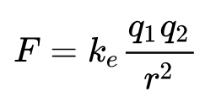
where F is the force, ke is the Coulomb constant, q₁ and q₂ are the magnitudes of the two charges, and r² is the square of the distance between them. Like charges repel one another, opposite charges attract one another, the stronger the charges of the particles, the stronger the force they exert on one another. The law is an inverse square law which means that as the distance between two particles is doubled, the force on them is reduced by a factor of four.

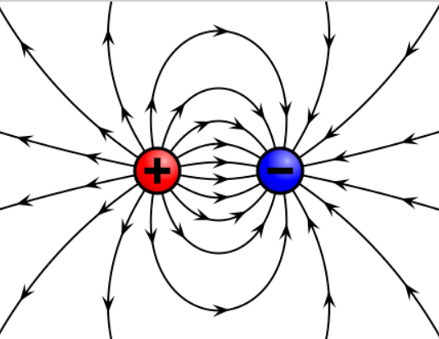
Fields are entities that interact with matter and can be described by assigning a value to each point in space and time. These vector fields are fields have both a numerical value and a direction at each point. Electric charges gives us an electric field (vector). The numerical value of the electric field, also called the electric field strength, determines the strength of the electric force that a charged particle will feel in the field and the direction of the field determines which direction the force, the direction of the electric field is the same as the direction of the force on positive charges and opposite to the direction of the force on negative charges. Because positive charges are repelled by other positive charges and are attracted to negative charges, this means the electric fields run from positive to negative.

Charged particles will produce a magnetic field when they are in a state of motion that will be felt by other charges that are in motion. The direction of the force on a moving charge from a magnetic field is perpendicular to both the direction of motion and the direction of the magnetic field lines.

If there is no charge enclosed by a closed surface, then the amount of electric field flowing into it must exactly cancel with the electric field flowing out of it. The flow of magnetic fields in and out of closed surfaces cancel, giving us North and South poles, that cannot be separated into monopoles. The Lorentz Force is the combination of the electric and magnetic forces on a charged particle.

Maxwell Equations for Electro-Magnetism (EM)

Maxwell's equations are a set of coupled partial differential equations that, together with the Lorentz force law, form the foundation of classical electromagnetism, classical optics, and electric circuits. The equations provide a mathematical model for electric, optical, and radio technologies, such as power generation, electric motors, wireless communication, lenses, radar etc. They describe how electric and magnetic fields are generated by charges, currents, and changes of the fields. The equations are named after the physicist and mathematician James Clerk Maxwell, who, in 1861 and 1862, published an early form of the equations that included the Lorentz force law. Maxwell first used the equations to propose that light is an electromagnetic phenomenon.

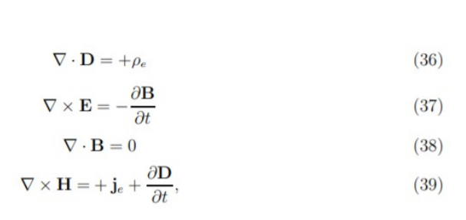
Maxwell’s equations as we understand them today were abridged by Heaveside. The original Maxwell equations comprised dozens of equations, which were simplified by Heaveside to the four main equations. Here I list the Maxwell Equations for reference. These equations are taken from Gravitational Physicist Raymond Chiao of the University of California at Merced.

where ρe is the electrical free charge density (here, the charge density of Cooper pairs), and je is the electrical current density (due to Cooper pairs), D is the displacement field, E is the electric field, B is the magnetic induction field, and H is the magnetic field intensity

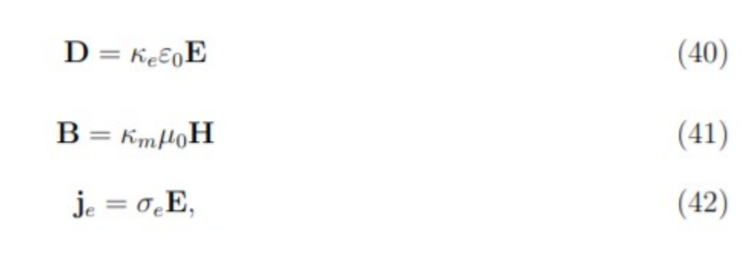
where κ_{e} is the dielectric constant of the medium, κ_{m} is its relative permeability, and σ_{e} is its electrical conductivity (Chiao et al, 2002) For clarification the field we are mainly interested in is the B (magnetic) Field, which in the quaternion version of the Maxwell Equations of Whittaker is the scalar magnetic Φ usually annotated (A, Φ) for both the scalar part and the vector part.

Lorentz Force

The combination of electric and magnetic force on a point charge due to electromagnetic fields is the Lorentz Force. A particle of charge q moving with a velocity v in an electric field E and a magnetic field B experiences a force of
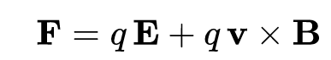
It says that the electromagnetic force on a charge q is a combination of a force in the direction of the electric field E proportional to the magnitude of the field and the quantity of charge, and a force at right angles to the magnetic field B and the velocity v of the charge, proportional to the magnitude of the field, the charge, and the velocity.

Gravitational Maxwell Equations
The Soviet researchers learned that there is a conversion between Electromagnetic Waves and Gravitational Waves. Which explains the Soviets focus on Gravitational Wave based non-local cybernetic experiments as early as 1967 (McCarron, 2023, Ch. 6 ‘Physics of Neuroweapons’). A Russian researcher, V. Samokhvalov, continuing on the earlier Soviet research in this area, explains the subtle energies which could be overlooked, he comments:

According to Einstein’s general theory of relativity, the rotating mass field differs from nonrotating mass field by additional, so-called, gravimagnetic forces , which affect rotating objects . Taking this fact into consideration, it is assumed that gravimagnetic forces act only if they are close to large masses or in presence of masses moving at relativistic speed, and they do not exhibit themselves in nature because of their extremely small values. However, many researchers in their works mentioned facts, which showed significant non-electromagnetic interaction of small objects, rotating at low speeds, with each other and with the objects, surrounding them. One of the first evidences of such kind was the experiments of Professor N.P. Myshkin, which were carried out at the beginning of the XX century. The effect of change in weight of rotating objects (gyroscopes) and their non-electromagnetic interaction with other objects are described in works by N.A. Kozyrev, V.V. Roshin and S.M. Godin, S.V. Plotnikov, etc. The experimental research...also showed that in nature there is a significant value contactless interaction of rotating small masses and their force effect on closely located objects (masses) at relatively small rotary and linear speeds of rotation. The value of occurring mass-dynamic forces is by 20 orders more than the value of gravimagnetic forces, which act in this case according to general theory of relativity.[see Persinger observation of 20x greater entanglement reactions in his experiments of non-local entanglement] Experimentally determined non-electromagnetic interaction was called mass-dynamic interaction, because it is determined by dynamic mass rotation, having a variable quadrupole [see Einstein’s Gravitational Quadropole equation below] moment. The research, which was carried out, showed non-electromagnetic nature of force interaction, i.e. independence of interaction force effects from electrical conductivity of disc materials and dependence of force interaction value on their rotation frequency. (Samokhvalov, 2016)

Chiao has written of the conversion from Maxwell Equations to Gravitomagnetic Maxwell Equations.

“The gravitoelectric field EG, which is identical to the local acceleration due to gravity g, is analogous to the electric field E, and the gravitomagnetic field BG, which is identical to the Lense-Thirring field (Poynting Vector of Magnetic flux), is analogous to the magnetic field B; they are related to the vector potential h in the radiation gauge as follows:

