PRODUCT & COMMERCIAL REQUIREMENTS DOCUMENT
AUTOSECURE 2.0
The Complete Vehicle Security, Care and Service Platform

PREPARED FOR | DOCUMENT VERSION | DATE
AUTOSECURE Limited | Version 1.0 | 2 September 2026

01 • EXECUTIVE OVERVIEW

Product Vision
One app that protects the vehicle, remembers its care needs, connects documentation and helps customers find trusted automotive services.
AUTOSECURE 2.0 upgrades the present tracking application into a broader vehicle ownership platform. The new product keeps the existing security functions available, embeds the current dashcam experience inside the AUTOSECURE app, adds a vehicle-care memory system, connects to the separate AutoDoc application, and introduces a verified service marketplace called Finder.
Core principle
Security remains accessible in the free version. The paid plan monetises the wider vehicle-care, reminder and convenience experience without removing the customer’s essential tracker or dashcam controls.

Business Objectives
OBJECTIVE | EXPECTED OUTCOME
Increase recurring revenue | Introduce monthly, half-year and yearly premium subscriptions.
Increase customer retention | Make AUTOSECURE useful beyond theft prevention through maintenance reminders and history.
Create marketplace revenue | Earn vendor subscription fees and commission from completed in-app bookings.
Strengthen ecosystem value | Connect tracker, dashcam, AutoDoc, Finder, payments and loyalty in one experience.
Improve trust | Admit only vendors that pass identity and business verification before activation.

Delivery Status at a Glance
AREA | CURRENT POSITION | AUTOSECURE 2.0 ACTION
Tracker | Present app capability | Retain and improve the interface.
Dashcam | A tab exists; current screens supplied | Embed the demonstrated functions in the app.
Theft Trigger | UI work already in progress | Connect UI to secure event and control workflows.
AutoDoc | Separate app already designed | Integrate by secure sign-in, deep link and/or API.
Vehicle Care + Finder | New modules | Design, build, test and launch.

02 • PRODUCT SCOPE

AUTOSECURE 2.0 Ecosystem
MODULE | PURPOSE | PRIMARY USERS
My Vehicle | Vehicle profile, mileage and ownership dashboard. | Customers
Care Memory | Oil, brakes, tyres, battery, service history and fuel usage. | Customers
Security | Location, playback, shutdown, call vehicle and theft trigger. | Customers / Support
Dashcam | Live video, recordings, emergencies, capture and settings. | Customers
AutoDoc | Connect to the separate vehicle-documentation and renewal app. | Customers
Finder | Discover verified parts sellers, car washes and mechanics. | Customers / Vendors
Bookings & Payments | Book services, pay vendors and calculate commission. | Customers / Vendors / Admin
Coins | Reward completed in-platform payments and permit redemption. | Customers / Admin
Subscriptions | Manage free and premium access and automatic downgrade. | Customers / Admin
Admin Console | Manage users, vendors, verification, payments and content. | AUTOSECURE Team

Recommended Main Navigation
TAB | CONTENTS
Home | Vehicle status, urgent alerts, next maintenance items and shortcuts.
Security | Tracker controls, theft trigger, live location and trip playback.
Camera | Embedded dashcam live video, playback, emergencies and albums.
Finder | Verified nearby vendors, search, booking, payment and reviews.
My AUTOSECURE | Vehicle records, AutoDoc access, coins, subscription and settings.

Key User Roles
ROLE | CORE PERMISSIONS
Customer | Manage own vehicles/devices, use security tools, record maintenance, book vendors, pay and use coins.
Vendor | Maintain verified business profile, services, prices, availability, bookings and settlement information.
Admin | Approve vendors, manage subscriptions, commissions, coins, disputes, device access and reporting.
Support Agent | Assist customers with controlled, logged access approved by AUTOSECURE policy.

03 • VEHICLE CARE MEMORY

The App Remembers What the Vehicle Needs
This module converts maintenance activity into clear records, reminders and an ownership history.
CARE ITEM | DATA TO CAPTURE | REMINDER / OUTPUT
Oil Change | Date, mileage, oil type, workshop, amount and note | Next date and/or mileage due
Brake Service | Service type, parts changed, date, mileage, vendor and cost | Inspection/service reminder
Tyre Replacement | Tyre position, brand/specification, install date, mileage and cost | Age/mileage replacement reminder
Battery | Brand/specification, purchase date, warranty, vendor and cost | Warranty and replacement reminder
Service History | Service category, diagnosis, work done, parts, vendor, cost and attachments | Searchable vehicle timeline
Mileage | Current odometer and/or tracker-supplied distance | Mileage trend and service triggers
Fuel Usage | Date, litres, amount, odometer and station/receipt | Consumption and spending summary

Functional Requirements
- Customers can add records manually and edit or delete their own records, subject to an audit history.
- The app can use both time and mileage to calculate the next due reminder.
- Reminder channels should support in-app notifications, push notifications and optional email/SMS where configured.
- Service records can include receipts, images and vendor booking references.
- A customer with more than one vehicle sees separate records and reminders for each vehicle.
- Dashboard states should clearly show Due Soon, Due Now and Overdue items.

Suggested Reminder Logic
STATE | RULE | CUSTOMER EXPERIENCE
Upcoming | Future due date/mileage outside warning window | Neutral card with next due information
Due Soon | Inside configurable warning window | Amber reminder and booking shortcut
Due | Due date reached or mileage threshold met | Prominent action card
Overdue | Due point passed without a completed record | Red status until completed or rescheduled

Data quality requirement
Mileage may come from the tracker when technically available. Manual mileage must remain available as a fallback and should record who entered it and when.

04 • SECURITY & THEFT RESPONSE

Tracker Functions
The following essential security functions remain available in the free version:
FUNCTION | EXPECTED BEHAVIOUR
Live Location | Display the latest vehicle position, timestamp, status and speed where available.
Playback | Show historical routes and journeys for the permitted retention period.
Remote Shutdown | Send a controlled immobilisation request with strong confirmation and visible result status.
Call Vehicle | Initiate the supported vehicle call/voice-monitoring workflow.
Theft Trigger System | Start the dedicated theft-response workflow and retain a secure event record.

Car Theft Trigger Workflow
STEP | SYSTEM ACTION
1. Trigger | Customer activates the theft alert from the selected vehicle screen.
2. Verify | Require PIN or biometric confirmation to prevent accidental activation.
3. Observe | Present live location, current status, dashcam shortcut and call-vehicle shortcut.
4. Act | Allow authorised controls, including remote shutdown, only under the device’s safety rules.
5. Record | Log trigger time, user, vehicle, commands, responses and status changes.
6. Resolve | Permit the customer/support team to close the event with a resolution note.

Safety control
Remote shutdown must use strong confirmation, clear command status and device-level safeguards. The action should not be presented as successful until the platform receives a confirmed response.

Security Controls
- Biometric/PIN confirmation for theft trigger, shutdown and sensitive account changes.
- Device ownership and sharing permissions must be enforced server-side.
- Every security command must have a timestamp, initiator, delivery status and device response.
- Sensitive video, location and voice access must follow the company privacy policy and applicable consent requirements.
- Session timeout, suspicious-login alerts and account recovery controls are required.
05 • EMBEDDED DASHCAM INTEGRATION

Integration Objective
Use the existing AUTOSECURE dashcam tab as the entry point and embed the functions demonstrated in the supplied screens.
CAPABILITY | REQUIRED EXPERIENCE
Live Video | Stream the connected front and rear/cabin cameras and allow camera switching.
Map + Status | Show vehicle location, timestamp and speed alongside the live camera view.
Playback | Browse front and rear recordings by date and time.
Emergencies | Provide a separate list of protected/event recordings.
Capture | Take an in-app snapshot from the active camera feed.
Album | Organise loop recordings, event recordings, snapshots and recorded clips.
Find My Car | Open the vehicle’s current location and navigation context.
Geofence + Trajectory | Retain the shortcuts already demonstrated in the camera experience.
Device Controls | Device name, network, sharing, SD card, device information, restart and unbind.
Device Pairing | Bind a camera/device through QR code, barcode or supported manual entry.

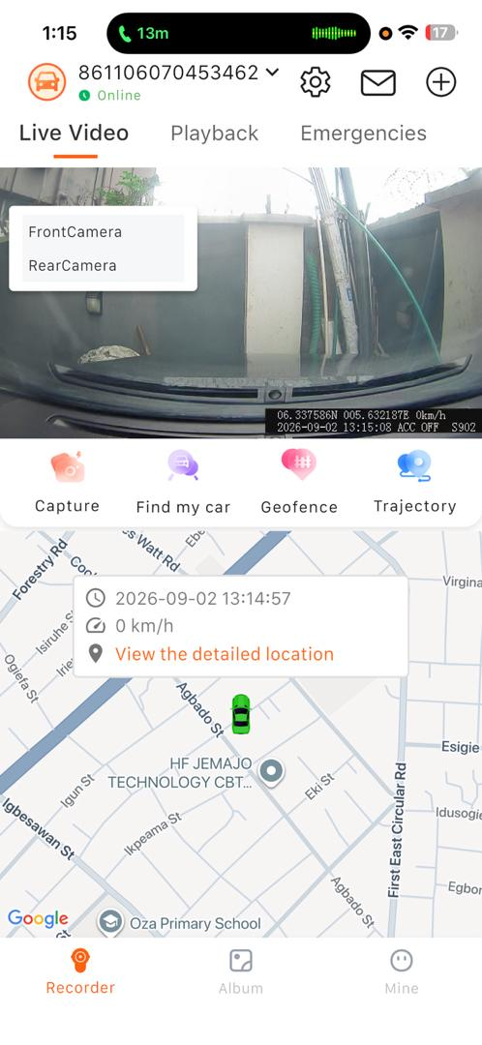  Front camera + live map | 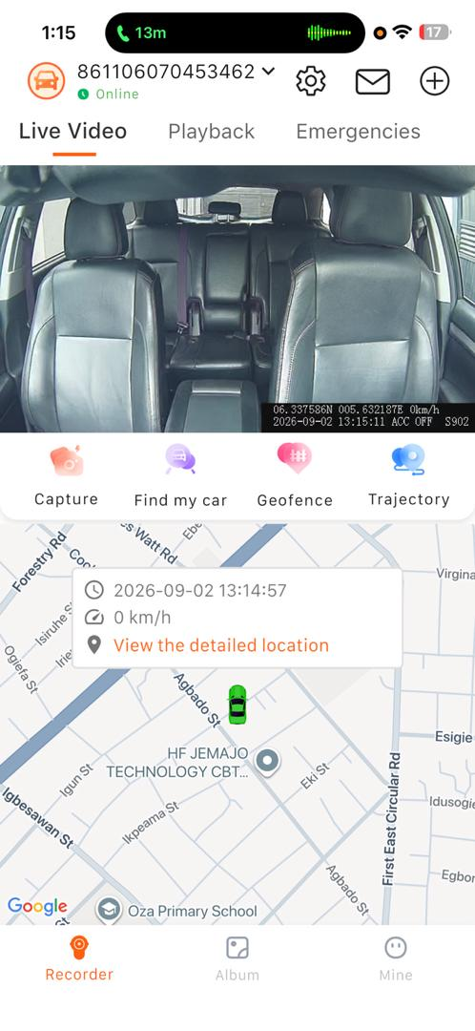  Rear/cabin camera + live map | 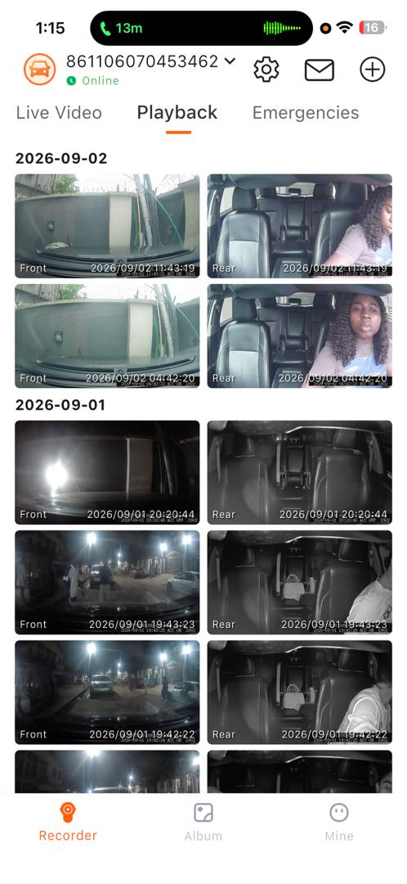  Front/rear playback library
Reference: current dashcam application screens supplied by AUTOSECURE.

Technical Integration Requirements
- Use the dashcam provider’s supported SDK/API or an approved embedded module; avoid duplicating customer sign-in where secure token exchange is available.
- Preserve camera/device identifiers and map them to the correct AUTOSECURE customer and vehicle.
- Show clear loading, offline, no-file, permission-denied and stream-failed states.
- Do not expose streaming credentials or permanent device tokens in the mobile client.
- Confirm iOS and Android support for live streaming, playback, downloading/sharing policy and background behaviour.
06 • AUTODOC INTEGRATION

A Connected but Separate Application
AutoDoc has already been designed as a separate application for vehicle documentation and renewal reminders. AUTOSECURE 2.0 should connect users to AutoDoc without merging the two products into one codebase unless management later approves a consolidation project.

Recommended Integration Levels
LEVEL | DESCRIPTION | RECOMMENDATION
1. Deep Link | Open the relevant AutoDoc vehicle/document screen from AUTOSECURE. | Minimum launch requirement
2. Shared Sign-In | Allow the same verified user to move between both apps without a second login. | Preferred when supported
3. Reminder Summary API | Display the next document renewal items in AUTOSECURE while management remains in AutoDoc. | Recommended phase 2

Information to Synchronise
DATA | SYSTEM OF RECORD | RULE
Customer identity | Identity service / approved master profile | Use one stable customer ID across both apps.
Vehicle | AUTOSECURE or shared vehicle service | Match by internal vehicle ID; plate number alone is not sufficient.
Document status | AutoDoc | AUTOSECURE displays a summary; AutoDoc controls editing and renewal.
Renewal reminders | AutoDoc | Avoid duplicate notifications unless the user chooses both.

Product boundary
The AUTOSECURE interface may show a document-renewal summary and open AutoDoc. Full document entry, renewal processing and document administration remain inside the separate AutoDoc application.

Acceptance Requirements
- A signed-in customer can open the correct AutoDoc account or vehicle context.
- If AutoDoc is not installed, the customer is directed to the official store or approved web journey.
- Expired sessions and unmatched vehicles return clear recovery instructions.
- Consent and data-sharing rules are displayed where information crosses between the two apps.
07 • FINDER MARKETPLACE

Find Trusted Automotive Services
Finder connects customers to verified automotive vendors and gives AUTOSECURE two new revenue channels: vendor subscriptions and booking commissions.

Initial Vendor Categories
CATEGORY | CUSTOMER CAN
Auto Parts Sellers | Search by part/category, vehicle compatibility, location, availability and price where supplied.
Car Washes | View service packages, location, opening hours, price and available booking slots.
Mechanics | Search by specialty, supported vehicle types, location, availability and service options.

Customer Journey
- Select a vehicle and choose the required service or product.
- Search or browse verified vendors; filter by category, location, rating, price or availability.
- Open a vendor profile and review verification status, services, pricing and policies.
- Choose a service/item, date or fulfilment method, then confirm the booking/order.
- Pay through the platform using the supported payment options.
- Receive confirmation, status updates, receipt and loyalty coins after the transaction qualifies.
- Rate the completed service and report a problem where necessary.

Vendor Profile Requirements
PROFILE AREA | REQUIRED INFORMATION
Identity | Business/trading name, owner or authorised representative and verified contact details.
Location | Physical address, service radius, map position and operating hours.
Offerings | Category, services/products, description, prices, duration, availability and images.
Operations | Booking rules, cancellation policy, settlement account and support contact.
Trust | Verification badge/status, customer ratings, reviews and platform performance.

08 • VENDOR, BOOKING & LOYALTY ENGINE

Vendor Verification Before Activation
STAGE | CHECK | ADMIN RESULT
Application | Business and representative details submitted | Pending review
Identity | Approved identification and contact verification | Pass / needs update / reject
Business | Registration details where applicable and service-category evidence | Pass / needs update / reject
Location | Address and service location validation | Pass / needs update / reject
Payout | Settlement account name and payment-provider verification | Pass / needs update / reject
Approval | Terms accepted and annual subscription confirmed | Activate verified profile
Monitoring | Complaints, cancellations, ratings and suspicious activity | Retain / suspend / remove

Commercial Rules
REVENUE ITEM | PROPOSED RULE | CONFIGURATION NEEDED
Vendor Subscription | ₦12,000–₦15,000 per vendor per year | Management to approve final fee or vendor tiers.
Booking Commission | Deduct commission from qualifying completed in-app transactions | Define percentage/flat fee by category and applicable taxes.
Customer Premium | ₦4,200 monthly with discounted longer plans | Configure plan, renewal and grace-period rules.

Loyalty Points — “Coins”
Customers who pay participating vendors inside the platform earn Coins. The wallet must use a transaction ledger so every earning, reversal, redemption and expiry is traceable.
COIN EVENT | BUSINESS RULE
Earn | Award Coins only after the platform confirms a qualifying vendor payment or completed transaction.
Pending | Hold Coins until the booking is completed and outside any configured dispute/cancellation window.
Reverse | Reverse Coins automatically when a payment is refunded, reversed or found ineligible.
Redeem | Allow eligible Coins to reduce AUTOSECURE re-subscription, spare-parts purchases or car-wash payments.
Balance | Show available, pending, redeemed and expired balances with a full activity history.

Decision required before development
Approve the earning rate, Naira value per Coin, minimum redemption, maximum percentage payable with Coins, expiry period, refund treatment and whether Coins can be transferred. These rules must be configurable from Admin.

09 • CUSTOMER SUBSCRIPTION MODEL

Freemium Platform
Customers retain essential tracker and dashcam access on the free plan. Premium unlocks the vehicle-care and integrated ownership tools that create recurring value.
PLAN | PRICE | DISCOUNT | CUSTOMER PAYS
Monthly | ₦4,200 | None | ₦4,200 per month
Half-Year | ₦25,200 | 5% recommended | ₦23,940 for 6 months
Yearly | ₦50,400 | 10% recommended | ₦45,360 for 12 months

Pricing interpretation: ₦50,400 is the undiscounted annual equivalent of ₦4,200 × 12. The half-year and yearly discount rates are recommendations within the requested 5–10% range and require management approval.

Feature Entitlements
FREE VERSION | PREMIUM VERSION
Live vehicle location | Everything in Free
Route/trip playback | Oil-change records and reminders
Remote shutdown | Brake-service records and reminders
Call vehicle / supported voice monitoring | Tyre-replacement records and reminders
Car theft trigger system | Battery records, warranty and reminders
All supported dashcam access | Complete service history and attachments
Finder browsing, booking and in-platform payment | Mileage and fuel-usage records/insights
Earn Coins on qualifying in-platform payments | AutoDoc connection and renewal summary where enabled

Payment Default and Downgrade Rules
EVENT | SYSTEM BEHAVIOUR
Renewal reminder | Notify the customer before the renewal date using configured channels.
Payment failure | Notify the customer and retry only according to the approved payment policy.
Grace period | Keep premium access for the management-approved grace period, if any.
Unresolved default | Downgrade the account to Free; do not disable the listed tracker or dashcam security functions.
Data retention | Preserve premium records securely while access is restricted; restore access after successful renewal.
Reactivation | Re-enable premium features immediately after confirmed payment and entitlement update.

Important entitlement rule
Subscription status must be checked on the server. A customer who defaults is downgraded to Free, but the defined core tracker, theft trigger and dashcam functions remain accessible.

10 • ADMINISTRATION & TECHNICAL REQUIREMENTS

Admin Console
AREA | ADMIN CAPABILITY
Customers & Vehicles | View status, manage support cases, device links and approved account actions.
Vendors | Review applications, approve/reject, suspend, renew, categorise and audit verification.
Bookings | Monitor status, cancellations, disputes, refunds and commission.
Payments & Settlements | Reconcile customer payments, vendor payouts, fees, refunds and exceptions.
Subscriptions | Configure plans, discounts, grace periods, entitlements and promo codes.
Coins | Configure earn/redeem rules and review the complete transaction ledger.
Content | Manage Finder categories, help content, notification templates and policies.
Reports | Track subscriptions, churn, bookings, revenue, vendors, Coins and feature usage.

Core Data Objects
OBJECT | KEY RELATIONSHIPS
User | Owns vehicles, subscriptions, bookings and a Coins wallet.
Vehicle | Linked to tracker, dashcam, care records, AutoDoc reference and bookings.
Device | Tracker or dashcam identity, status, permissions and command history.
Maintenance Record | Vehicle, category, date, mileage, vendor, cost and attachments.
Vendor | Verification, categories, listings, bookings, fees and settlement account.
Booking / Order | Customer, vehicle, vendor, item/service, status, payment and commission.
Wallet Transaction | Coin earn, pending, redeem, reverse or expire event.
Subscription | Plan, entitlement, period, payment, renewal and downgrade state.
Theft Event | Trigger, customer, vehicle, device events, commands and resolution.

Non-Functional Requirements
- Mobile support: confirm target iOS and Android versions and test on common device/network conditions in Nigeria.
- Performance: dashboard and security status should load quickly; video must adapt to available bandwidth.
- Reliability: use retries and idempotency for payments, device commands, webhooks and Coin awards.
- Security: encryption in transit and at rest, least-privilege access, secure token storage and audit logging.
- Privacy: clear consent, retention controls and access logging for location, voice, camera and documentation data.
- Observability: monitor integrations, stream failures, command failures, payment exceptions and notification delivery.
11 • DELIVERY PLAN & ACCEPTANCE

Recommended Phased Delivery
PHASE | SCOPE | EXIT CONDITION
1. Discovery & Architecture | Confirm APIs/SDKs, current codebase, user roles, pricing rules, data ownership and UX map. | Approved scope, architecture and integration feasibility.
2. Security + Dashcam Foundation | Retain tracker functions, complete theft trigger, embed current dashcam functions and device binding. | Core Free security experience passes acceptance tests.
3. Vehicle Care Premium | Build care records, reminders, service history, mileage, fuel and premium entitlements. | Premium purchase, access and downgrade work end-to-end.
4. AutoDoc Connection | Deep link/shared sign-in and renewal summary subject to available integration. | Correct user/vehicle context opens reliably.
5. Finder Marketplace | Vendor onboarding, verification, search, booking, payment, commission and reviews. | Verified vendor transaction completes and reconciles.
6. Coins + Optimisation | Wallet ledger, earning, redemption, reversal, reporting and launch hardening. | Coin balances reconcile and production-readiness checks pass.

Minimum Acceptance Criteria
- A customer can register/sign in, add/select a vehicle and see only vehicles they are authorised to access.
- All Free security and dashcam entitlements remain available after premium expiry or payment default.
- Every sensitive command displays pending, successful or failed status based on a real system response.
- Maintenance records generate correct time/mileage reminders and remain separated by vehicle.
- Only approved vendors are publicly searchable and able to accept bookings or payments.
- Payments, commission, settlements and refunds reconcile to a single booking/order reference.
- Coins are awarded once per eligible transaction, reversed correctly and cannot produce a negative or duplicated balance.
- Admin changes to pricing and entitlement rules are logged and require appropriate permissions.

Launch Metrics
AREA | INITIAL METRIC
Subscription | Free-to-premium conversion, renewal rate and payment-failure recovery
Engagement | Monthly active vehicles and care records/reminders completed
Security | Command success rate, alert response and dashcam stream availability
Marketplace | Verified vendors, bookings, completion rate, GMV and commission
Loyalty | Coins earned, redemption rate, reversals and liability balance

12 • DECISIONS REQUIRED BEFORE BUILD

Management & Technical Sign-Off List
# | DECISION | WHY IT IS REQUIRED
1 | Final vendor annual fee: ₦12,000, ₦15,000 or defined tiers | Needed for onboarding, billing and renewal logic.
2 | Booking commission: percentage/flat fee by vendor category | Needed for checkout, settlement and reporting.
3 | Coin earn and redemption values, limits and expiry | Needed for the loyalty ledger and financial liability.
4 | Half-year and yearly discounts; grace period and retry policy | Needed for subscription pricing and downgrade behaviour.
5 | Dashcam provider SDK/API rights, documentation and test credentials | Needed to confirm embedded streaming and playback feasibility.
6 | Tracker command API behaviour and shutdown safety rules | Needed for accurate command states and theft response.
7 | AutoDoc integration method and shared identity/vehicle mapping | Needed to prevent duplicate accounts and incorrect document data.
8 | Vendor verification documents and operating policy | Needed for approval workflow and trust badge rules.
9 | Payment gateway, vendor settlement schedule and refund ownership | Needed for marketplace reconciliation.
10 | Privacy, data retention, consent and support-access policy | Needed because the platform handles video, location, voice and documents.

Definition of Project Success
AUTOSECURE 2.0 succeeds when...
A customer can protect a vehicle, view its cameras, remember its maintenance, access vehicle documentation, find a verified service provider, pay securely and receive useful loyalty value — all through one coherent AUTOSECURE experience.

Immediate Next Actions
- Approve this product and commercial scope.
- Hold a technical discovery session with the present app, tracker, dashcam, AutoDoc and payment teams.
- Resolve the ten sign-off decisions above and freeze the first-release feature list.
- Produce final user journeys, UI screens, API specification, delivery estimate and milestone plan.
Prepared for AUTOSECURE Limited • AUTOSECURE 2.0 • Version 1.0

APPENDIX A • DASHCAM SCREEN REFERENCES

Current Embedded Function Reference
Screens supplied for the present dashcam experience. These guide functional parity and UI integration; the AUTOSECURE 2.0 visual design should still follow the approved AUTOSECURE design system.
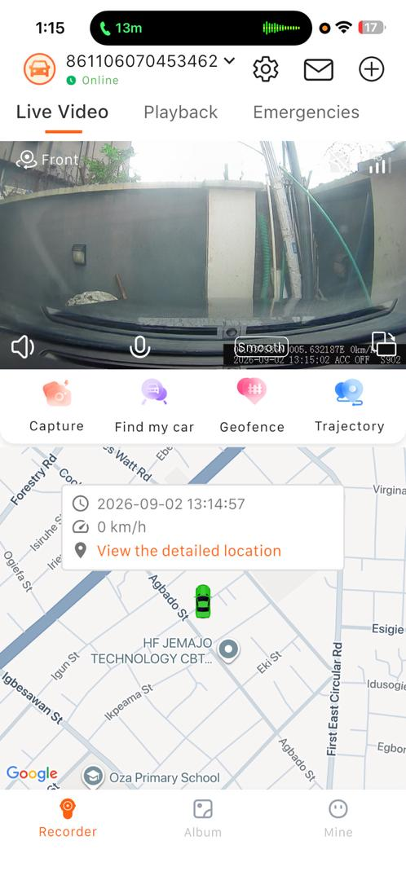  Live stream controls | 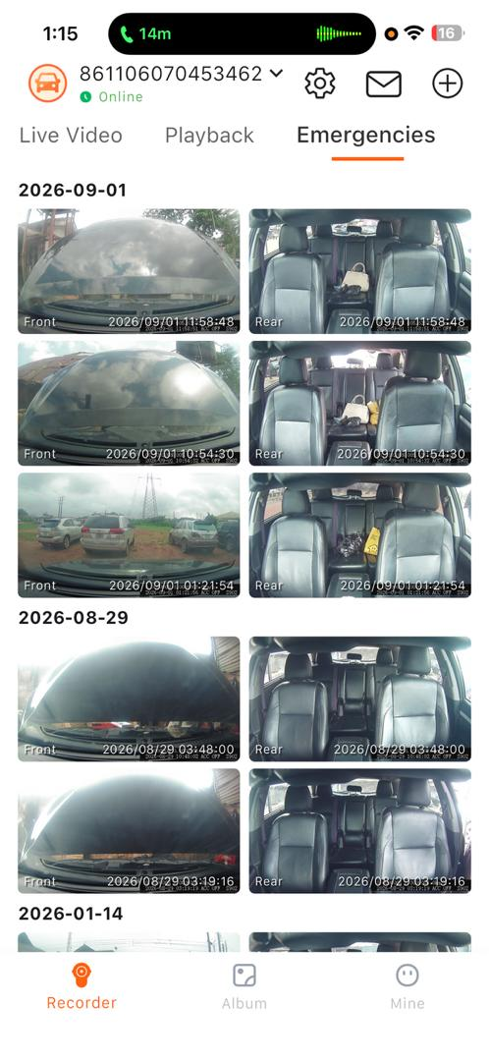  Emergency recordings | 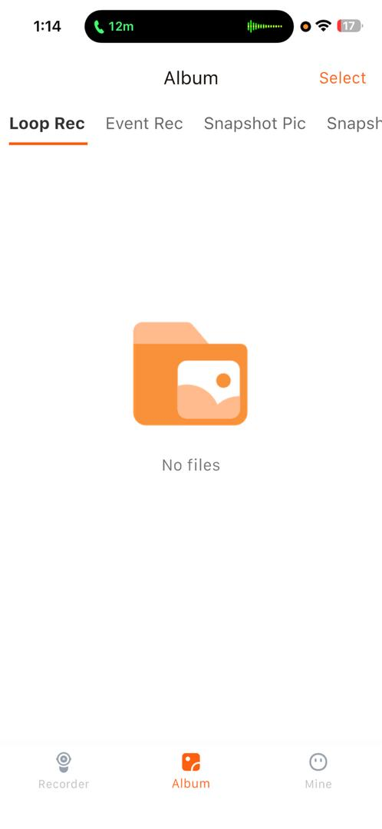  Album categories

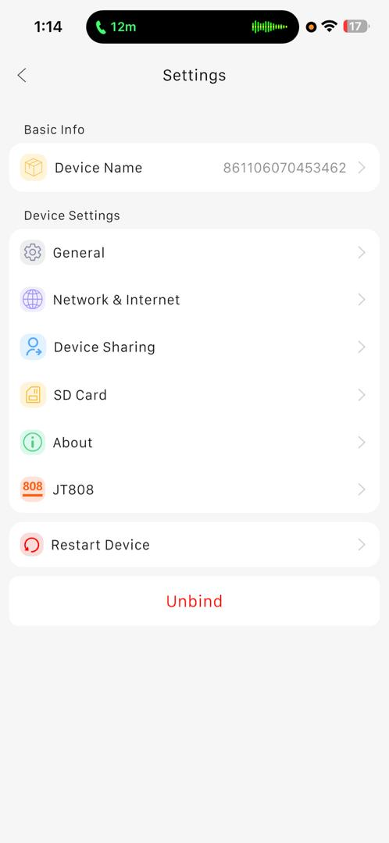  Device settings | 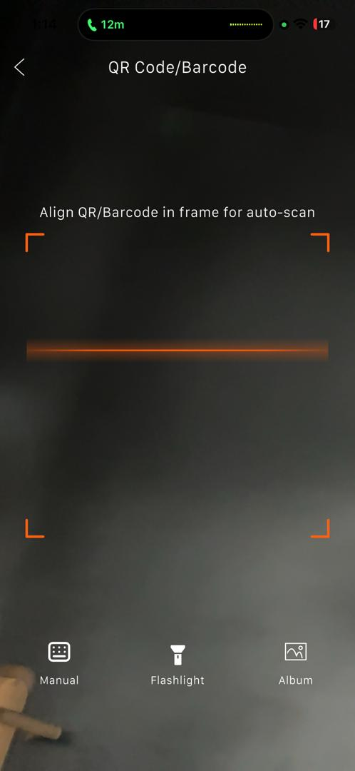  QR/barcode pairing | 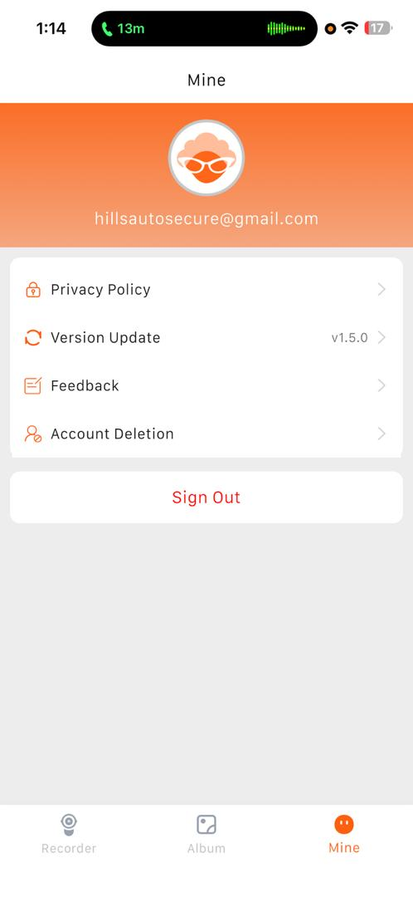  Account controls
End of document

