EE441000 林祐安 110061622 HW2 05/19/2022

Part 1.

(a)

|  |  |
| --- | --- |
| Real part | Imaginary part |
|  |  |

(b)



Due to the DC offset, the image in the spatial domain has an impulse at the original point.

(c)

Supposedly, we know there is an uniform and consistent noise around k-space. It can be subtracted by a constant over the whole k-space, that is “KspaceData - mean(mean(KspaceData))

”. Finally, an image without noise is shown below.



(d)

As we learned that reducing k-space interval would give rise to time domain aliasing if the sampling rate in k-space is NOT enough. Hence, we downsample along ky direction by a factor of 2, while the resultant image is aliasing. Specifically, top and bottom part are overlapped.



(e)

|  |  |
| --- | --- |
| # 129 phase encoding = 0 | # 1 phase encoding = 0 |
|  |  |

The right figure indicates that it is similar to the original one, but the left one seems to become dim and have some offset signal outside the contour of sagittal slice. The reason may be due to the zero values of DC component along ky-direction, that contributes to reduce the intensity of the whole picture. However, the first phase encoding set as zero doesn’t affect significantly because it is the highest frequency component. There are still other high frequency components preserving the edge features.

(f)



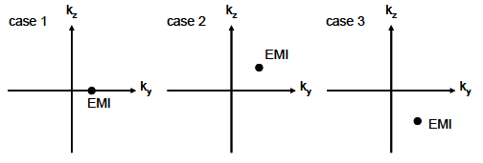

An pulse in the frequency domain is actually an exponential wave in the spatial domain, and hence we can see there is a sinusoidal wave around the output image. Additionally, its direction is depending on the sign of pulse.

(g)

As we know that real signal has conjugate-symmetry property in frequency domain. However, 2D-DFT is required to consider not only fx but also fy direction. It says that





(h)

T1 for fat, T2 for water.

脊椎後方的脊髓液並沒有特別明亮，脊髓液主要是水份，若是T2 weighted image的話理論上要亮起來，因此可以合理推斷這張圖片是T1 weighted image.

(i)

Since the detected signal is depending on the gradient of magnetic field, any different gradient along specific direction can lead to similar effect of gradient coil as well. Hence, there is no any difference if you change the current waveform.

Part 2

(a)

Contrast factor:

TE and TR -> include T1, T2 and PD.

PD weighted image: long TR with short TE,

T2 weighted image: long TR with proper TE,

T1 weighted image: proper TR with short TE.

spatial resolution:

x-direction: bandwidth, field of view along x, number of samples along x



y-direction: field of view along y, number of samples along y

2022/5/18

z-direction: bandwidth

temporal resolution:

TR * # of B1 pulse * NEX

(b)

gamma = 2.765*10^4

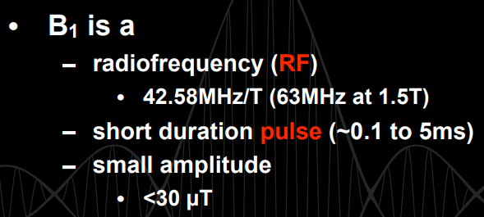 [ref](https://mrrl.ucla.edu/file/20712/M219_2017_Lecture03_MRI_Systems_II_B1.pdf)

Under 1.5T superconducting, gradient strengths in the range of 30-45mT/m. Rise time is typically in the range of 0.1~0.3 ms. [ref](https://mriquestions.com/gradient-specifications.html)

