The insight toolkit image registration framework

Outline

* Motivate
* Background
* Core software components
* Purpose
* Interpolation methods
* reference

Motivation

* The software was selected randomly by me initially. I finally decided to introduce the topic because it utilizes python language which is slightly familiar to me. In fact, I haven’t used python since last semester and almost forgot how to do.
* However, ITK doesn’t provide any visualization functionalities. If applications requires visualization, we need to additionally install another software, such as 3D Slicer, The Visualization Toolkit (VTK),and etc. Accidently, I found an easy-to-start software based on ITK, SimpleITK, which supports image IO, basic image manipulation, ITKv4 registration framework, and so on.
* SimpleITK can easily visualize image using Jupyter notebook without installing additionally toolkit.
* There are many tutorial videos about how to use python packages SimpleITK on the official YouTube’s channel named SimpleITK. Furthermore, most of examples on official ITK website are programmed in C++.
* I only want to demonstrate simple image registrations with light weight operations.

Background

* Insight Toolkit(ITK) is an open-source, cross-platform library that provides developers with an extensive suite of software tools for image analysis.  Developed through extreme programming methodologies, ITK builds on a proven, spatially-oriented architecture for processing, segmentation, and registration of scientific images in two, three, or more dimensions.
* The latest version is 5.1.2 (12/8 2020)
* language：c++, python, javascript

Core software components

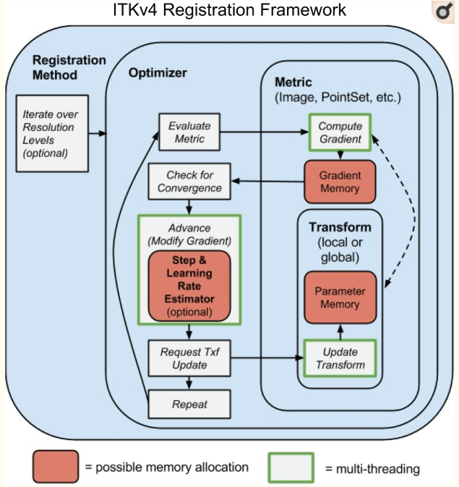

simpleITK

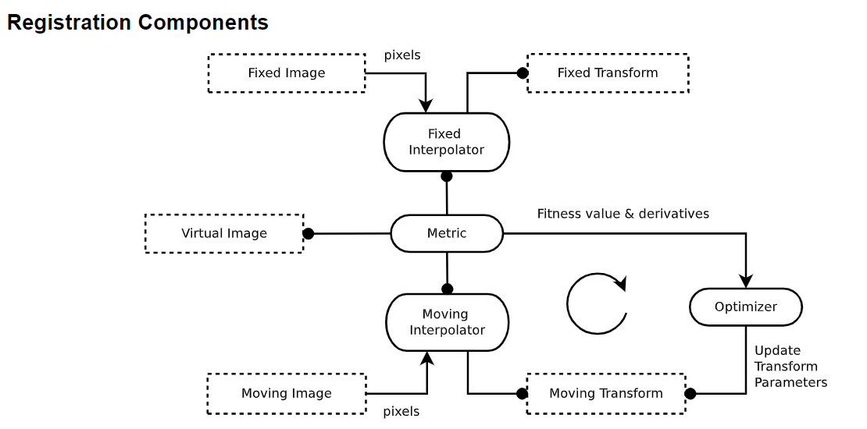

Purpose

* Each ITK4 transform now has either global support (affine transform) or local support (a displacement field transform). If any map in a composite transform has global support then the composite transform has global support.
* Affine and deformable similarity metrics should look as similar as possible. Users should be able to combine multiple similarity metrics, some of which may operate on different data types
* Both “fixed” and “moving” images may have initial transforms. This allows one to reduce “registration bias” that may be induced by asymmetric interpolation.

1. local and global

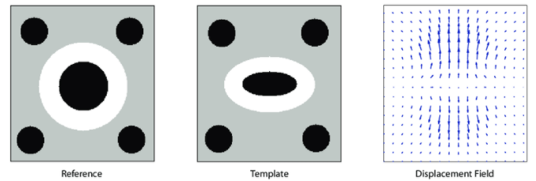

(local deformation)

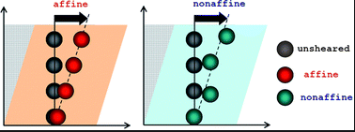

(global deformation)

Global transformations affect the whole region of image, but local transformations only deform it partially.

1. similarity metrics

Similarity metrics are used to measure the “similarity” between template and reference image, and quantify the accuracy of image registration. There are three common ways：

1. mean squares
2. Mattes mutual information
3. Normalized correlation coefficient
4. initial transformation

Setting an appropriate initial transformation may accelerate training and reduce the registration bias. There are some ways：

1. do nothing
2. centered transform：the function is Intended to initialize the center of rotation and the translation of transforms having the center of rotation among their parameters.
3. manual initialization
4. optimizer
5. exhaustive：Given boundary then randomly branching out to find all possible choices until the loss , i.e. metric value, is low enough.
6. gradient descent：is one of the popular optimization used in machine learning to update parameters. For image registration, gradient descent is also used to do the same work iteratively in order to obtain the best transformation.
7. registration bias

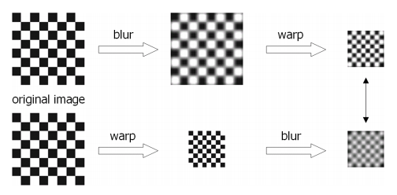

Although using the same original image, the sequence of transformations give rise to distinct results.

Interpolation methods

* Scene-based
  + Intensity-based or spline-based methods
  + Simple and fast but accuracy is low and without considering the shape feature deformation. Hence, the resultant in-between slices have blurring effects at the object boundary.
* Object-based method
  + Extract not only intensity but also some additional information from images, such as features or contours, to help guide the interpolation.
  + Shape-based, morphology-based, registration-based ,and B-spline based methods. Furthermore, registration-based and B-spline based methods are very complex but that can effectively remove the bias .Accordingly, ones are still popular in recent years due to high performance.
  + For real images, Reference14 utilized the scene-based interpolation method as shown below figure. First row：resultant images obtained by traditional linear interpolation(scene-based). Second row：in-between images using their registration-based method.

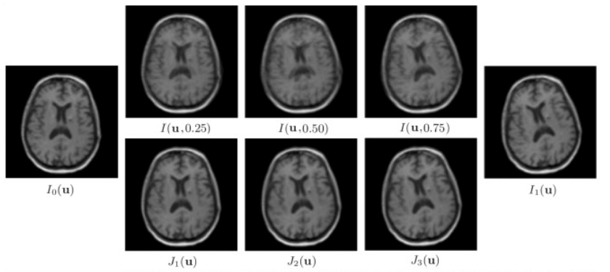

Obviously, the sequence images on the first row are blur when changing the weight of Io(u) and I1(u). The example can be viewed as another form of registration bias. On the contrary, the sequence images on the second row is neat and clear.

Reference

1. SimpleITK github

<https://github.com/SimpleITK>

1. The Insight ToolKit image registration framework

<https://pubmed.ncbi.nlm.nih.gov/24817849/>

1. Displacement field

<https://www.researchgate.net/figure/The-concept-of-displacement-fields-A-displacement-field-gives-for-every-pixel_fig1_267946997>

1. Affine

<https://pubs.rsc.org/en/content/articlelanding/2012/sm/c2sm25364j#!divAbstract>

1. How to measure the similarity between two images

<https://datascience.stackexchange.com/questions/48642/how-to-measure-the-similarity-between-two-images>

1. Similarity metrics

<https://itk.org/Doxygen413/html/ImageSimilarityMetricsPage.html>

1. Correlation

<https://towardsdatascience.com/convolution-vs-correlation-af868b6b4fb5>

1. Image registration using gradient descent

<https://cs.stackexchange.com/questions/105705/image-registration-using-gradient-descent>

1. Optimizer

<https://serokell.io/blog/ml-optimization>

1. The Asymmetry of Image Registration and its Application to Face Tracking

<http://goksel-dedeoglu.com/asymmetry/asymmetry.pdf>

1. Medical image interpolation based on multi-resolution registration

<https://www.sciencedirect.com/science/article/pii/S0898122113002538>

1. Slice thickness vs slice spacing

<https://forum.dcmtk.org/viewtopic.php?t=2179>

1. Morphology-Based Three-Dimensional Interpolation

<https://www.researchgate.net/profile/Tong-Yee_Lee/publication/3221119_Morphology-based_three-dimensional_interpolation/links/00b49537b5f336f06c000000/Morphology-based-three-dimensional-interpolation.pdf>

1. Medical image interpolation based on multi-resolution registration

<https://www.sciencedirect.com/science/article/pii/S0898122113002538#br000090>

1. Morphology-based three-dimensional interpolation

<https://ieeexplore.ieee.org/document/875193/metrics#metrics>

1. Registration-based interpolation

<https://ieeexplore.ieee.org/document/1309715>

1. B-spline interpolation

<https://zhuanlan.zhihu.com/p/50626506>

1. Cubic spline interpolation

<https://mropengate.blogspot.com/2015/04/cubic-spline-interpolation.html>

1. Flexible Algorithms for Image Registration

<https://archive.siam.org/books/fa06/Modersitzki_FAIR_2009_FA06.pdf>