**Title of Your Abstract Here**

Jane Doe1, John Doe2, Maggie Smith1, 1Institution, City, Country, 2Institution, City, Country *(list of authors)*

**Background, Motivation and Objective**

*Your text explaining what has been done previously and why this work is of importance.*

**Statement of Contribution/Methods**

*Description of equipment, methods used*.

**Results/Discussion**

*Presentation of the results obtained and discussion of the results.*

*Text may be completed with a clearly readable image if needed to better describe the work. (Example image)*

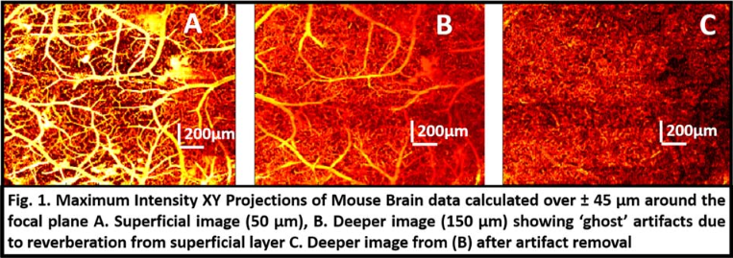

*Recommendation:*

*Abstract without image: Text should be less than 2500 characters excluding spaces, title, author names, and affiliations.*

*Abstract with an image: Text with an image should be less than 2000 characters excluding spaces, title, author names, and affiliations.*