**Phase-Aberrated Ultrasound Point Spread Function Estimation from Baseband Beamformed Signal Using Complex-valued Convolutional Neural Network**

Yu-An Lin1, Wei-Hsiang Shen1, Meng-Lin Li1,2, 1Department of Electrical Engineering, National Tsing Hua University, Hsinchu, Taiwan, 2Institute of Photonics Technologies, National Tsing Hua University, Hsinchu, Taiwan.

**Background, Motivation and Objective**

*The quality of clinical ultrasound images can be improved by many methods such as deconvolution with the point spread function (PSF). However, typical systems cannot estimate PSF accurately because the unknown property of inhomogeneous sound velocity in human tissue leads to phase-aberrated PSF. Moreover, most PSF estimation methods are designed for RF signal, but clinical systems hardly access to it. In this work, we introduce a promising way to estimate spatially-invariant, phase-aberrated PSFs using beamformed baseband patches. The estimated PSFs are more helpful to enhance imaging quality comprehensively and this method can be further applied on common scanning systems.*

**Statement of Contribution/Methods**

*We train a complex-valued convolutional neural network (CNN) as estimator which takes the beamformed baseband patches in some speckle regions as inputs and predicts the corresponding phase-aberrated PSFs. Complex-valued mean squared error loss function and Adam optimizer are utilized to update parameters and reduce pixel-wise difference respectively. Based on near field phase screen model, the RF channel data is simulated from Field II toolbox of the different points at axial and lateral direction using synthetic aperture focusing beamforming technique. These aberrated patches are generated by randomly distributed scatterers convolving with RF PSFs of different phase-aberration profiles, and then beamformed, demodulated and applied a lowpass filter to baseband. The maximum phase aberration profiles are arbitrary in the range of [0, π/2] and have correlation length of 5 mm. In comparison, RF training pairs were further employed in another real-valued CNN with the same architecture and physically receptive field, whereas the baseband training pairs have half data size due to decimation by a proper factor.*

**Results/Discussion**

*Fig. 1 shows the results of two kinds of neural networks. They are tested by unseen patch and predict an asymmetric PSF with associated data type. It appears that the complex-valued network produces an aberrated PSF with a high similarity near the location of main lobe referred to the RF-based model. Both models approach to the ground-truth PSF. Specifically, we propose a blind phase-aberrated PSF estimation that not only requires much lower data size and cost at front-end but also achieves even equivalent performance.*

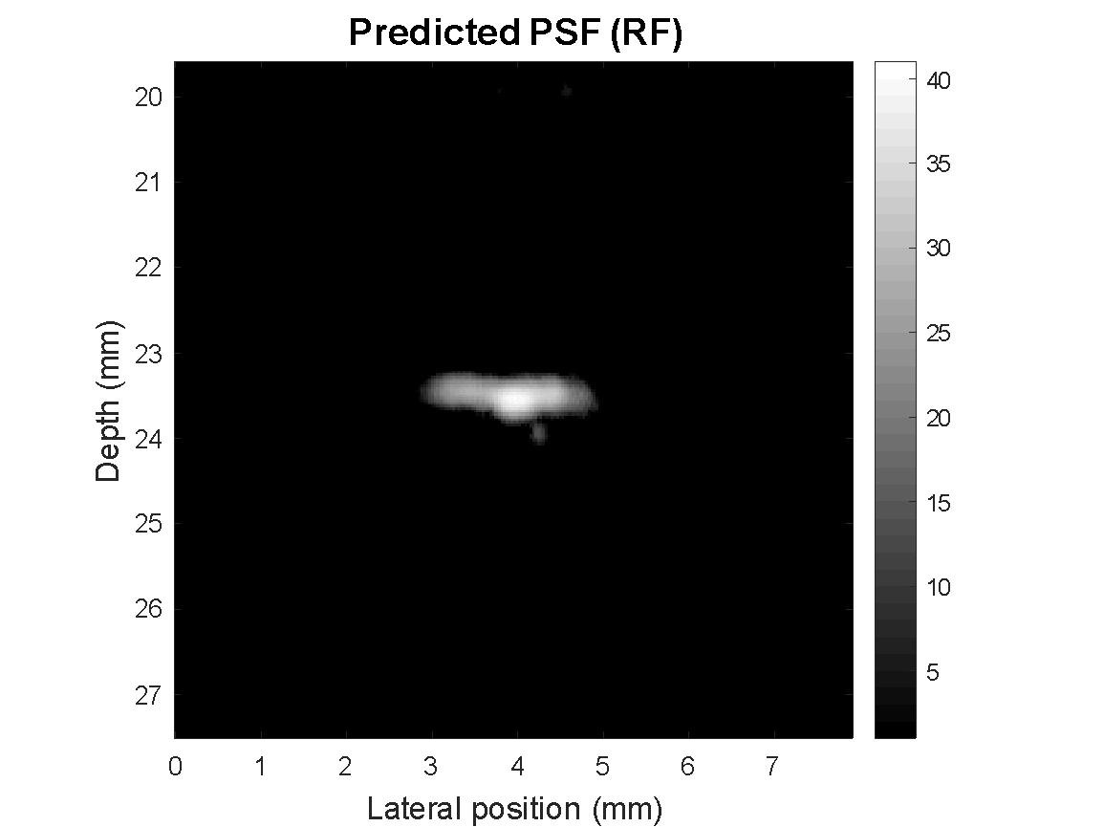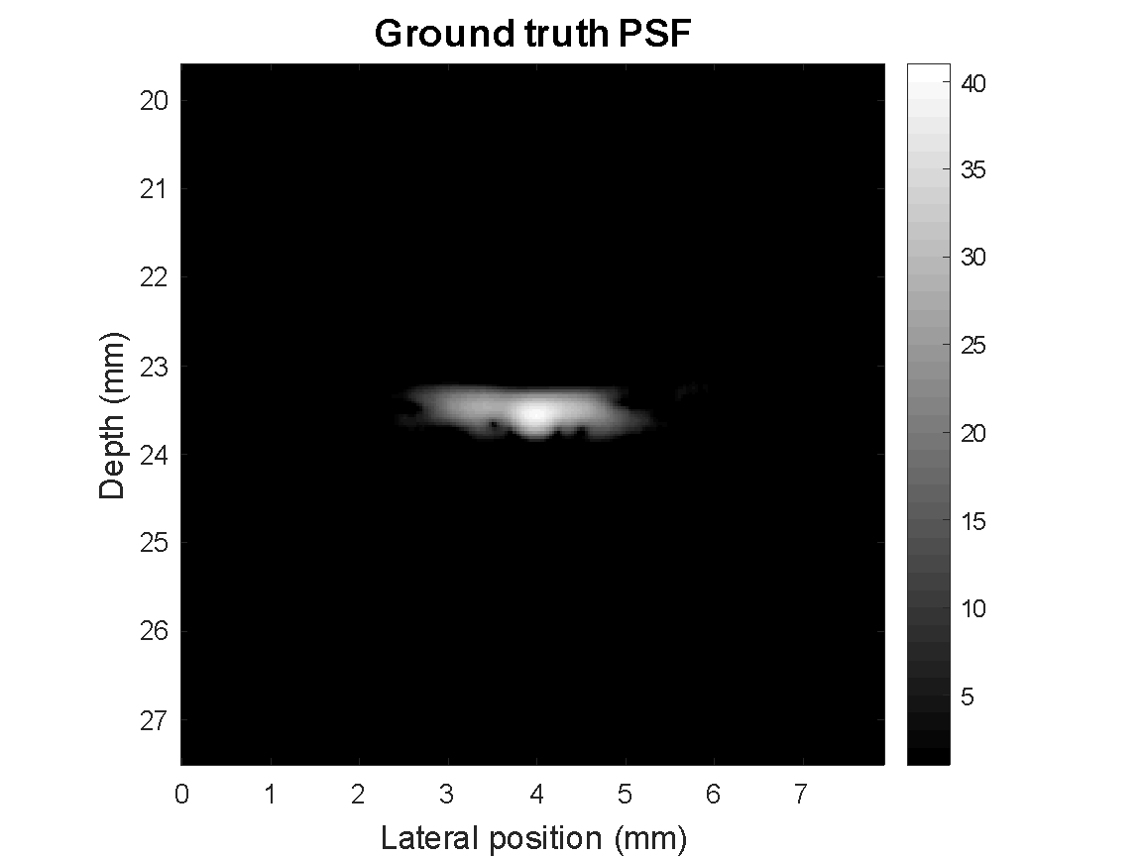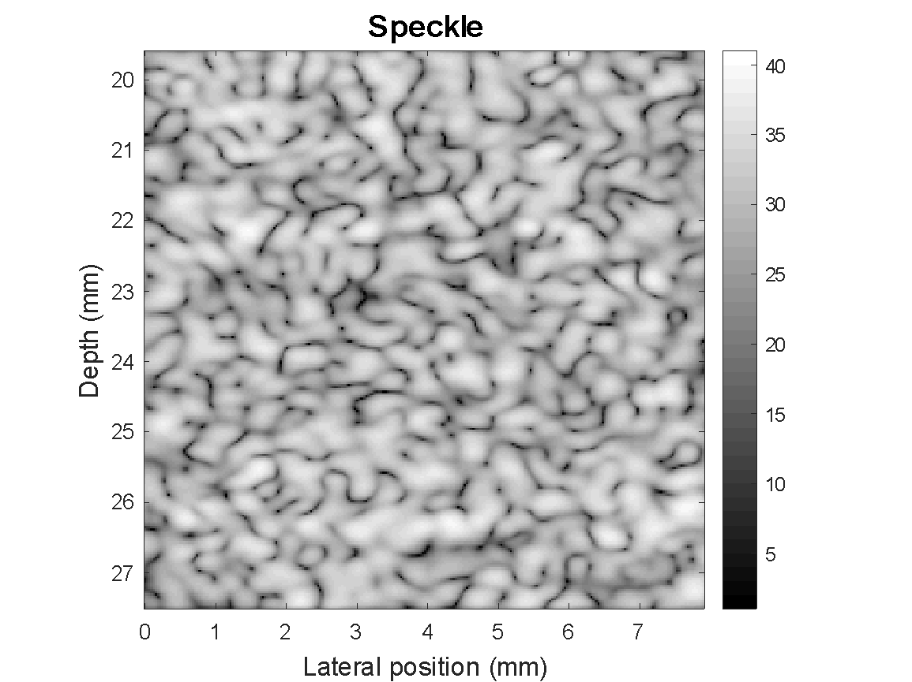

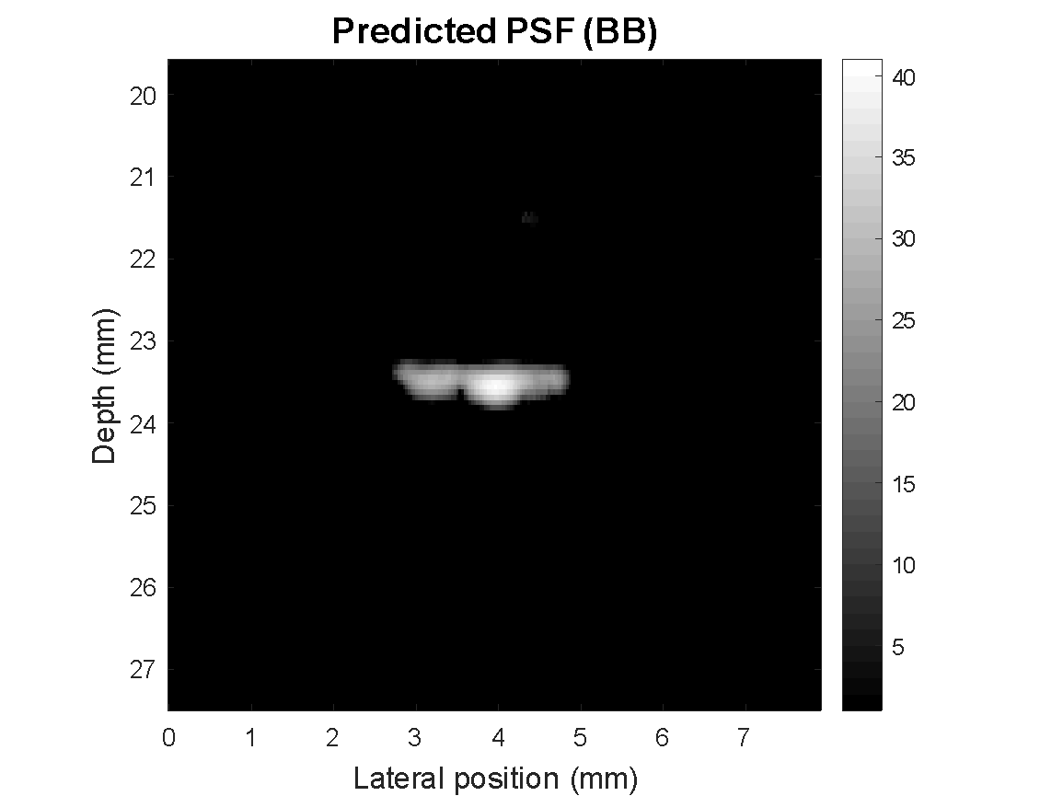

**Fig 1. For visualization purpose, figures are displayed in B-mode with a dynamic range of 40dB. Column 1 and 2: model input, ultrasound beamformed patch, and ground-truth phase-aberrated PSF respectively, they are either RF or baseband determined by the model. Column 3: estimated PSF using RF patch. Column 4: estimated PSFs using baseband patch. This sample has maximum phase error $\frac{π}{4}$ at the imaging center frequency.**