Deep Learning in Biomedical Image 110061622 林祐安

1.

|  |  |  |
| --- | --- | --- |
| epoch | accuracy | Test accuracy |
| 10 | 0.9097 | 0.8820 |
| 20 | 0.9354 | 0.8865 |
| 30 | 0.9472 | 0.8842 |
| 50 | 0.9641 | 0.8879 |
| 100 | 0.9803 | 0.8863 |

As the epoch increases, both training and testing accuracy are higher as well. In my opinion, the increment of epoch makes loss decrease and frequently updates parameters in filters. Hence, our model can explore more elegant features. However, at the expense of robust, we can observe that testing accuracy seems to achieve saturation. It says our model may be overfitting.

2.

We are required to do data augmentation, image flipping, for the training data. Here, np.flip is used to flip image horizontally. Concatenating flipped images with original training data gives rise to a double size one.

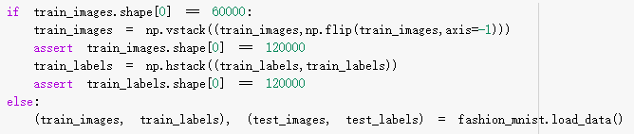

Now, only 10 epochs the new model runs. Although training accuracy and testing accuracy are only 0.8287 and 0.8169 respectively, it seems worse than the original model. But the 12-nd image, sneaker, is predicted correctly. Data augmentation is designed to mitigate overfitting or expand dataset.

Theoretically, testing accuracy should higher than the original one at the same situation, while the same situation is difficult to reach unless parameters are the same during each epoch.

Note that run all file again must have different result due to distinct parameters.

3.

My ten images are under the directory images. Since they are directly shot by camera, resolution is too large to predict label. Resizing image is necessary to suffice the input size, (28,28) of model. However, it blurs all images and even hardly can be recognized. For instance, the 6th and 7th picture which are sneaker and t-shirt respectively, both are drawn from MS Paint. After resizing, they are dreadful! The resultant is a little unsatisfactory. Obviously, original data is small but clear, neat, and with fully white background. In contrast, our 10 images are rough and too large.

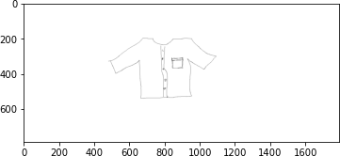

(7.jpg - original)

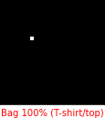

(7.jpg – gray scale and resize)

