Deep Learning in Biomedical Image 110061622 林祐安

1.

2.

Function FCNN returns model which has one , two or three hidden layers determined by the input argument ‘layer_num’. In details, optimizer is Adam, a common optimizer used in any model. It includes the pros of momentum and adaptive learning rate. For loss function, since we are doing a classification job, cross-entropy is most suitable. Especially, the output of sparse categorical cross-entropy has been one-hot encoder. We can easily calculate the distance or loss between target and prediction.

|  |  |  |
| --- | --- | --- |
| # of hidden layers | Training accuracy (loss) | Testing accuracy |
| 1 | 0.9779 (0.0812) | 0.9779 |
| 2 | 0.9780 (0.0958) | 0.9780 |
| 3 | 0.9798 (0.0846) | 0.9798 |

According to above table, we observe that

1. accuracy is Not proportional to declining loss
2. more hidden layer would have better performance

one-hidden layer:

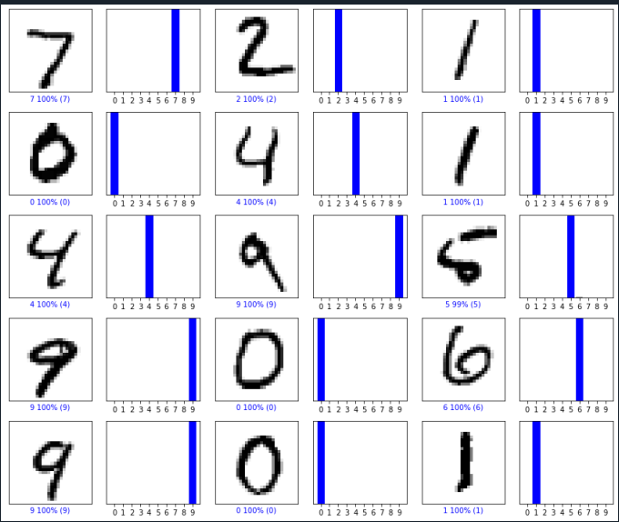

two-hidden layer:

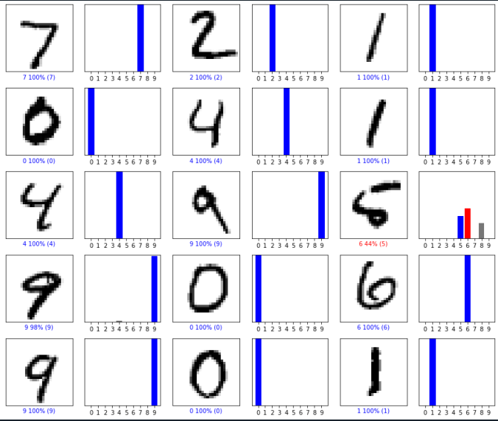

three-hidden layer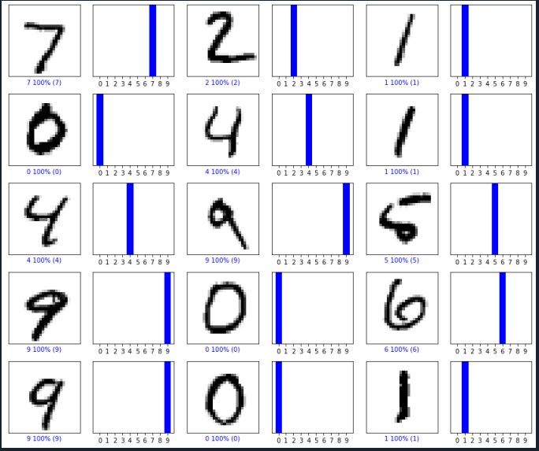

3.

One-hidden layer:

two-hidden layer:

three-hidden layer:

Seen in the above three figure I drew. They almost have equivalent performance. Our digit is skinny and regular, but it seems not to be helpful. Although our model only has dense layer which isn’t too complicated, I don’t expect it can work robustly. Maybe convolution layer or deeper network would help us to improve its performance.