Deep Learning in Biomedical Image Analysis Project 2 林祐安

|  |  |
| --- | --- |
| Dataset | Cats_vs_dogs |
| Number of conv. layers | 5 |
| Number of full connected layers | 3 |
| Kernel size | 3*3 |
| Input shape | 256*256*3 |
| Number of training images | 2000 |
| Number of testing images | 300 |
| epochs | 20 |

Data preprocessing

1. the first 3000-th images are set as training set and the 3001-st to 3300-th images are set as testing set.

2. images are reshaped into 256*256

loss curve

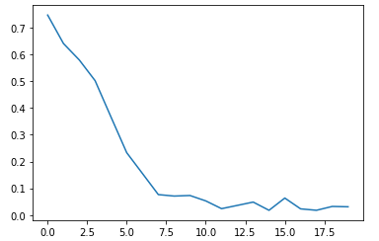

x-direction : epoch

y-direction: loss

testing set

1. loss: 1.7002

2. accuracy: 71%

Although we add some dropout layers to avoid overfitting, it seems not to work well. Some advanced skills like L1 or L2 regularization would be taken into account.