Digital signal processing HW1 110061622 林祐安
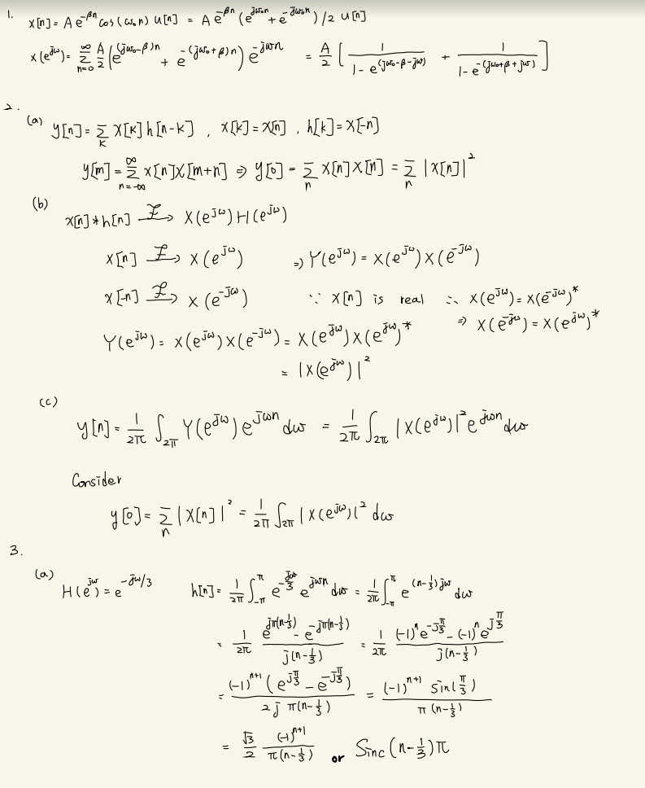

(b)
Similar to a sinc function.
(c)
We know a sinc function applied Fourier transform is a square function (ideal). However, now the signal is finite, in other words, the finite signal can be viewed as an infinite sinc function multiplied by a window in time domain. Hence, in frequency domain, it equivalently convolves with a sinc function, so we can see some ripples in the following picture and lengt of exp(-jw/3) is always equal to 1 or 0 dB.
That is, the slope of the phase spectrum can be derived from

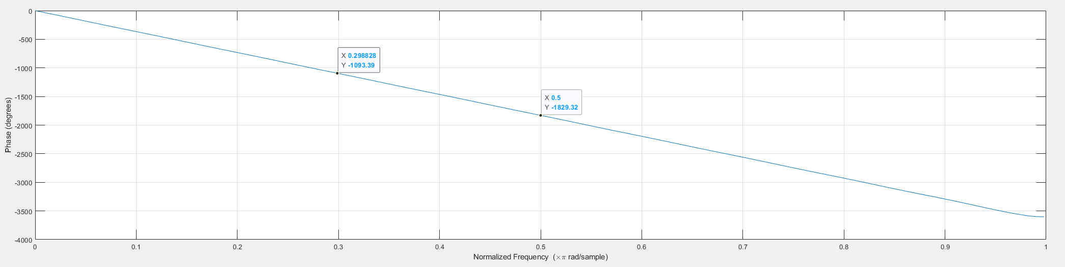
4.
(a)
The first one is more terse and loses some tunes. The second one and the third one are similar to the original tune. I can’t even hear their difference.
(b)
Although they are slightly different, I think it can’t be noticed easily due to our degenerate hearing.
(c)
I can hear the difference for resampled music with half and one fourth sampling rate. The letter one is sounds like muffled and seems to lack high frequency components.

