Numerical analysis and applications HW1 B063012054 林祐安
note: I had been updated Latex symbol in figure titles after finishing the report.
- Proof the centered finite-difference approx. of the first derivative.
By the forward and backward Taylor series, we know that
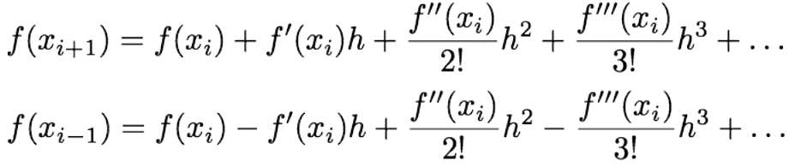
subtracting the second equation from the first,
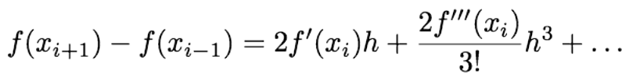
finally dividing the above equation by h,
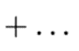
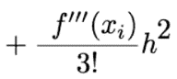
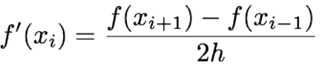
or
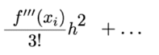
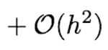 where O(h²) =
Q.E.D
2.
(a)See fig.1-function, obviously, there are 6 roots involved in the range. Using graphical method evaluates where the sign of f(x) changes.
Approximately, $x≈$-2.0597,-1.7838,-1,-0.3179,0.3045,1.(fig.1-roots) Moreover, the highest power of the function is six, which implies that there does NOT any other root exist outside the interval.
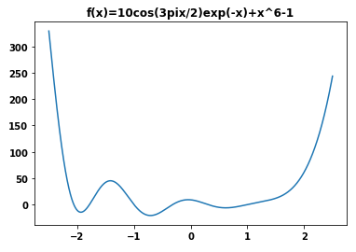 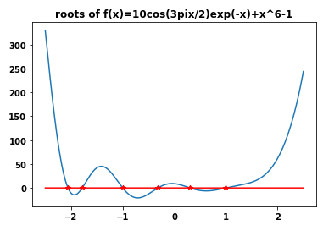b
(function) (roots)
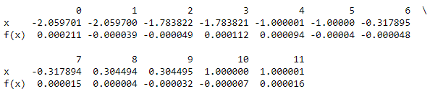
(fig 1)
(b) first, we use bisection method to find roots, replacing x_{l} or x_{u} with x_{r} , depending on the sign of f(x_{r}).
if it equals to f(x_{l}) , x_{l} is substituted for x_{r} ,otherwise, x_{u} is substituted for x_{r} until satisfying the condition $\left|ε_{a}\right|<ε_{s}$ .
If there is a root in the range,$ε_{a}$converges to zero(fig.2).
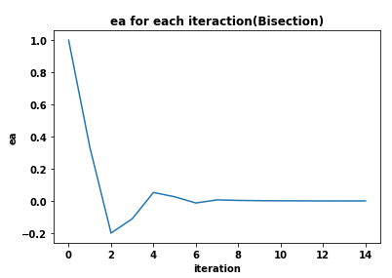
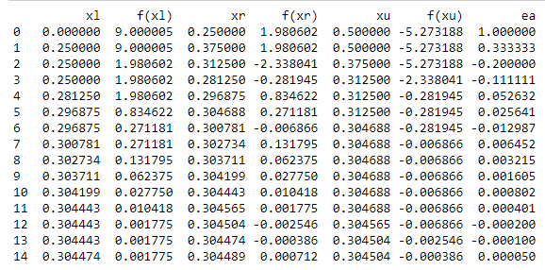
(fig. 2 $root≈0.3045$)
In another way, we are required to use false position method to find roots. For the same reason, replacing x_{l} or x_{u} with x_{r} depends on the sign of f(x_{r}). We do that until satisfying the condition based on the problem. If there is a root in the range,$ε_{a}$ converges to zero(fig.3).
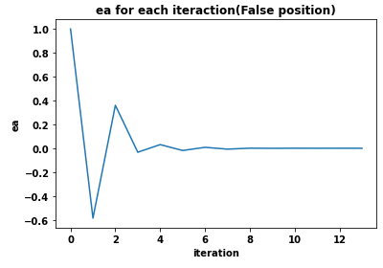
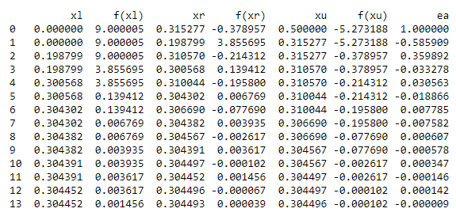
(fig. 3 $root≈0.3045$))
(c) Redo problem 2-(b),we find an exact root = 1.
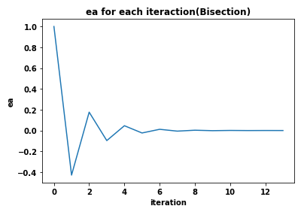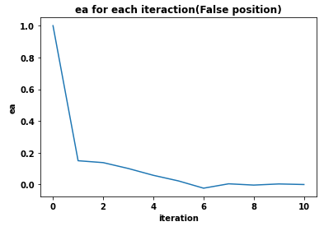
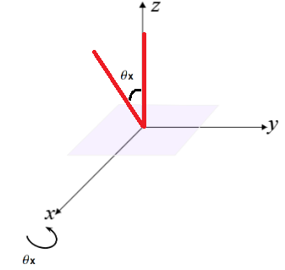
3.
(a)
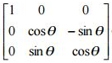

(b)(C)(d)
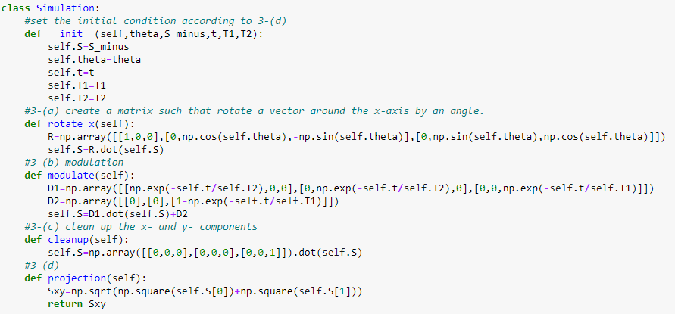
(e) See fig.4, we know that there are two local maximum .Use graphical method to determine the global
maximum.
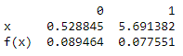
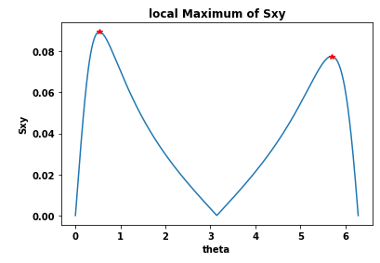
(fig 4.)
In detail, we conclude that local maximum is the largest one among 3-nearest neighbors.
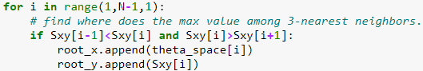
Hence, Two points are selected after searching where we are intrested in(fig 4. right-side).
Obviously, f(x) at x=0.53 is larger than one at x=5.69,
$$θ_{opt}≈0.53\left(rad\right)≈30.37(deg)$$
To my surprise, if N is growing to larger and larger,in other words,increasing precision of sample, f(x) of
each one becomes more and more similar. It means that $θ_{opt}$ happens at 0.53 and 5.69 (rad), however, professor said the rotation degree is only in the range of [0,90] in practical on March 31.
(f) Roots are approximately 0.534, 3.141, 5.687(the resolution is too low because N isn’t large enough.)
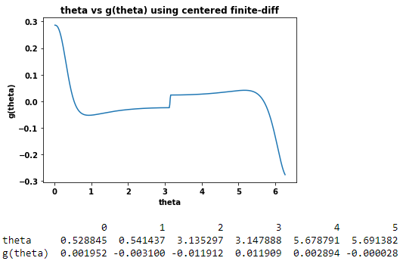
(g) Graphical method can help us to find bracket,hence,we decide to search for roots in the range of [0.1,1.5].
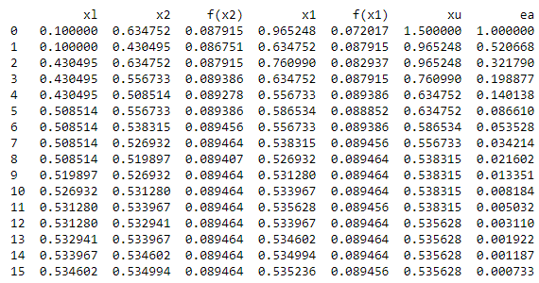
$$root≈0.5354$$
(h)
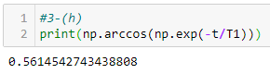
How to improve? Increase N,i.e. sampling resolution.
N | Graphical method | Centered finite | Golden-seciton | $$θ_{opt}$$
500 | 0.5288(5.8%) | 0.534(4.9%) | 0.5354(4.6%) | 0.5615
5000 | 0.5581(0.61%) | 0.5585(0.53%) | 0.5585(0.53%) | 0.5615
50000 | 0.5611(0.07%) | 0.5611(0.07%) | 0.5612(0.05%) | 0.5615
500000 | 0.5614(0.02%) | 0.5614(0.02%) | 0.5619(0.07%) | 0.5615
*( ):$error ratio=\frac{\left(value-θ_{opt}\right)}{θ_{opt}}$
Because we have more points to approch a continuous function, x and f(x) can be more close to the exact values.

