Numerical analysis and applications HW1 B063012054 林祐安
- Proof the centered finite-difference approx. of the first derivative.
By the forward and backward Taylor series, we know that
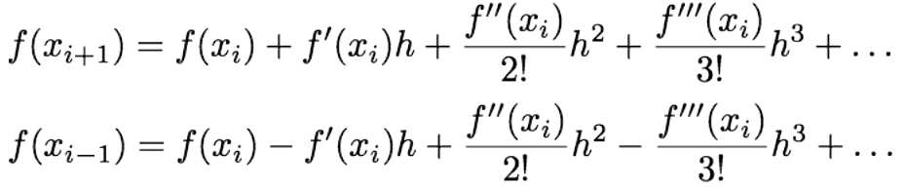
Subtract two equations,
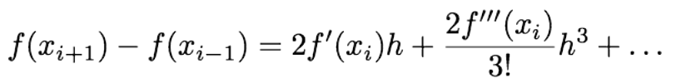
divided by h,
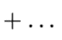
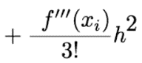
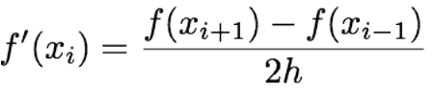
or
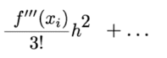
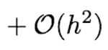 where O(h²) =
Q.E.D
2.
(a)See fig.2-(a) for the question, obviously, there are 6 roots involved in the range.
Approximately, x=-2.0597,-1.7838,-1,-0.3179,0.3045,1.Moreover, the highest power of the function is six, so there does NOT any other root exist outside the interval.
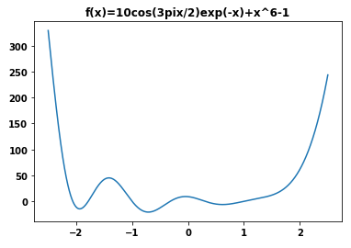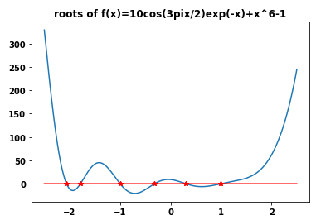
(function) (roots)
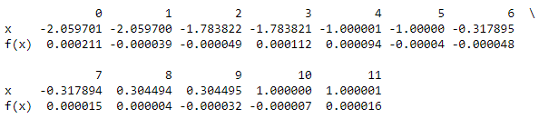
(fig 2-(a))
(b)

