Introduction to numerical methods and applications final report B063012054 林祐安
Table of contents
- Purpose
- The curse of dimensionality
- Principal component analysis
- Singular value decomposition
- Applications
- Reference

- Purpose
To be a data scientist or machine learning engineer, data analysis is important for businesses. Because most of engineers do NOT need to spend much time to build a model, there has been many complete modules and algorithm in python. But the fact of the matter is how to adapt your data to modules.

Garbage in, Garbage out! Data’s quality will affect your model to make decisions. In practical, data is always very complicated, at least hundreds of variables (dimension) or more. How can we decide which features are necessary? That is a trade-off between efficient training and the risk of losing relevant information.

- The curse of dimensionality ^{[1]}
- overfitting
Consider a famous classification task, cats and dogs from Kaggle, in which we want to build a classifier to distinguish them. To do so, we need to select some features, such as color or weight, to discriminate these two classes. For example, red color, blue color, and green color, then we get three features. Of course, we can add more features to improve our classifier. More and more features, it seems intuitive to obtain higher accuracy. But in fact, fig. 1 indicates that
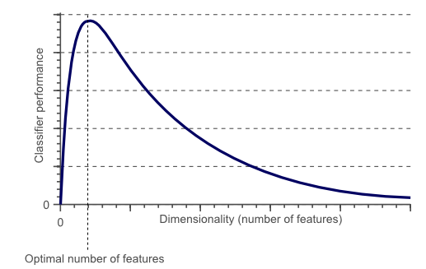(fig. 1)
as the dimensionality increases, the classifier’s performance increases until the optimal number of features is reached. Further increasing the dimensionality without increasing the number of training samples results in a decrease in classifier performance.

To explain it, let’s initially consider a simple case in 1-D space, which means only one features, e.g. red, is interested.
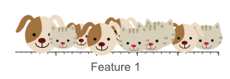
(fig. 2) Obviously, a single feature can’t be designed a well-performed classifier.
Hence, we add another feature, such as green, to improve it.
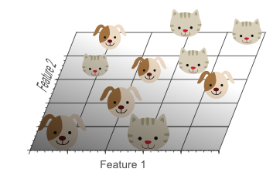
(fig. 3) Cats and dogs still can’t be separated by a single line.
Finally, a third feature is added.
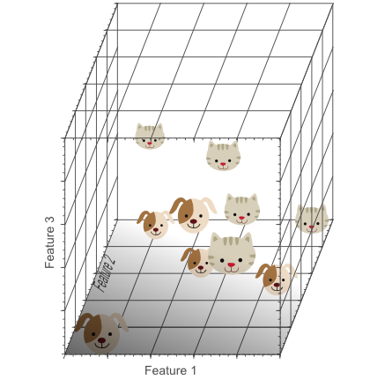(fig. 4)
We can now find a plane that separates dogs from cats (fig. 5).
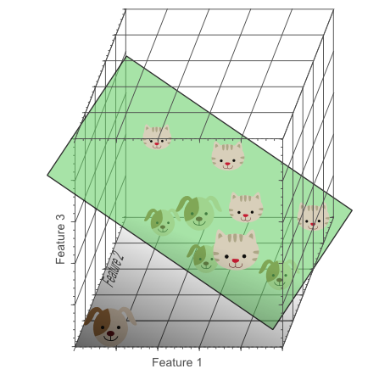(fig. 5)
Our model learns more information when we add more and more features, but that may be useless like noise instead of useful features (color).
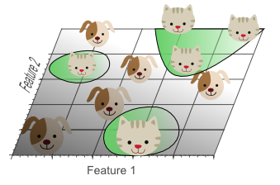(fig. 6)
Hence, our model may give rise to overfitting (fig. 6), one of well-known effects of the curse.
- sparseness
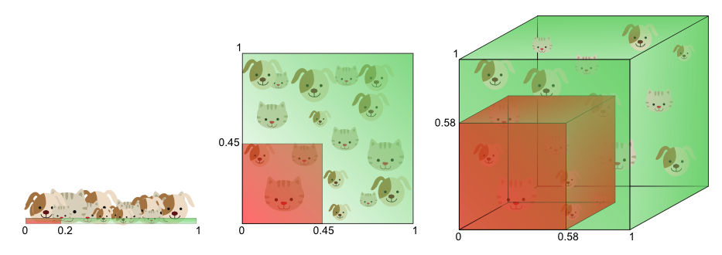(fig. 7)
Let’s set the range of feature values from 0 to 1. For only one feature, 1D space, if our training data is required to cover 20% of this range, then the amount of training data needed is 20% of the complete population. (training data is used to find a discrimination) For 2D space, that is if we add another feature. To cover 20% of the 2D feature range, as per conversation, we need to obtain 45% of per feature. (0.45*0.45 = 0.2) In the 3D case, we need 58% (0.58*0.58*0.58 = 0.2).
Fig. 7 indicates the situation, sparseness, which affects our model to fit a decision boundary. Samples in the corners are more difficult to classify than that near the center of the feature space. In later session, we will discuss the ‘uncorrelated’ features. The more training features are needed, the lager dataset is required. Unfortunately, it’s an exponential growth. In other words, if we have sufficient samples and use more and more features, the running time of searching is also an exponential growth named combinational explosion ^{[2]}.
This sparseness is not uniformly distributed over the search space.
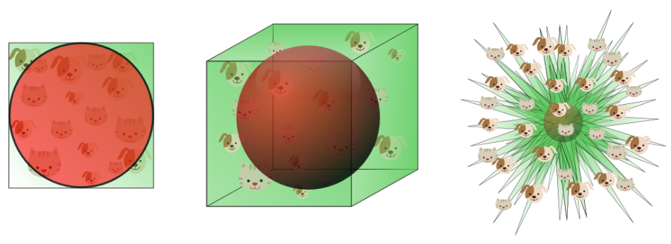(fig. 8)
Fig. 8 describes the red region is our searching space, as the dimension increases, that covers a fewer proportion of the feature space. It can be calculated by the volume of inscribing hypersphere as: $V\left(d\right)=\frac{π^{\frac{d}{2}}}{Γ(\frac{d}{2}+1)}{0.5}^{d}$
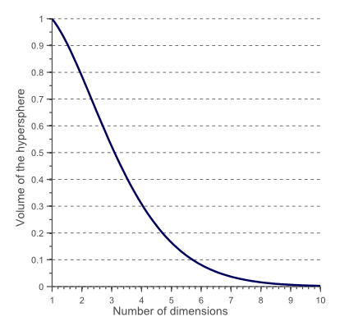(fig. 9)
As seen in fig. 8 and fig. 9, the search space approaches to zero when we select too many features. It means that we cannot use most distance measures, such as K nearest neighbor (KNN), to classify our data. (In fact, some special distance measures can solve it, e.g. shared nearest neighbor.) ^{[3]}

- Principal component analysis [4][5][6][7]
- projection
Let’s cite the example from reference 5. Consider this simple case, we want to reduce the dimension from 2 to 1(fig. 10).
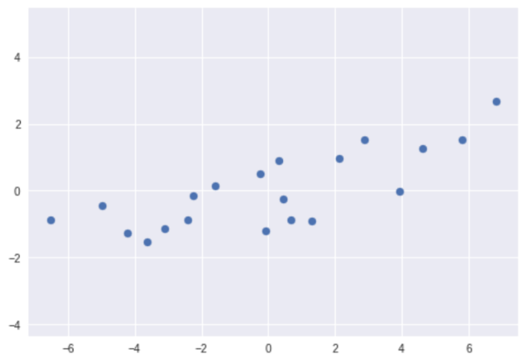
(fig. 10)
Obviously, the two features are positively correlated, and the covariance is greater than zero. We can easily find a linear regression as a unit vector $\vec{v}$ , then project each point onto the vector (fig. 11). Is the result our desired?
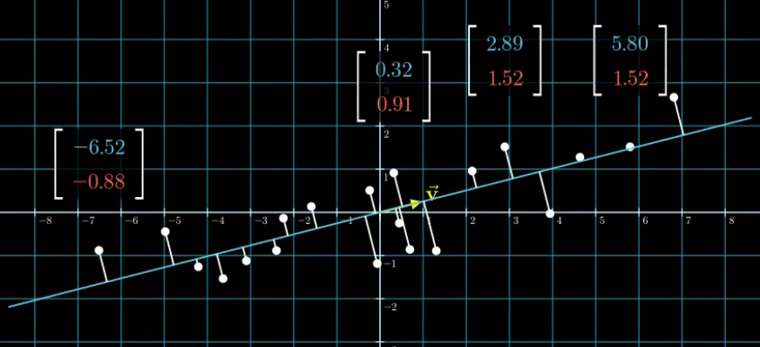
(fig. 11)
After projection, all of points lie on the 1D space,$\vec{v}$, hence we successfully reduce feature dimension from 2D, spanned by $\left[\begin{matrix}1 \\ 0\end{matrix}\right]and \left[\begin{matrix}0 \\ 1\end{matrix}\right]$, to 1D, spanned by $\left[\begin{matrix}1 \\ 0\end{matrix}\right]$.(fig. 12)
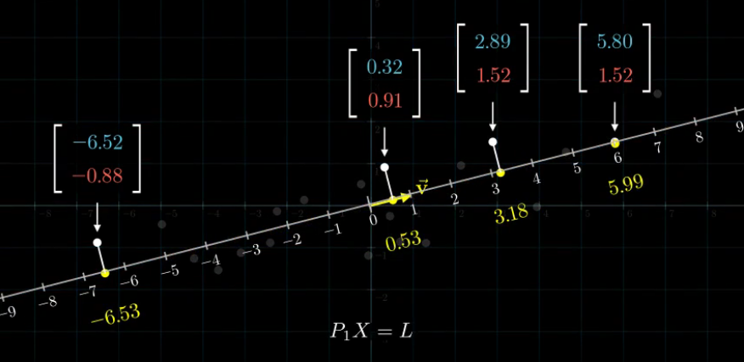
(fig. 12 Projection is a way to linearly reduce dimension)
The purpose of PCA is to find one or more than one K-by-1(K<N) vectors representing original N-dimensional data. An ideal representation can be defined:
- Maximum variance: new data transformed after reducing dimension has the largest variance. The reason is that entangled data usually makes model training harder and difficult to be classified.
- Minimum error: new data reconstructing original N-dimensional data has the minimum reconstructed errors. Furthermore, the error is defined the sum of the distance between each projection point and original point in this case.
In this case, $\vec{v}={\left[0.97 0.25\right]}^{T}$. The two components imply useful information:
- The gradient of original two features is the same direction and positively correlated.
- The spread of x-direction is wider than that of y-direction in original data.

$\vec{v}$ just suffices the two above definitions, so we may conclude the representative vectors will point into the direction of the larger spread of data. Accordingly, we can use PCA to preserve most information because representative vectors have minimum reconstructed errors and that contains both the spread and orientation.

- Covariance matrix
A 2-by-2 covariance matrix is defined: $Σ=\left[\begin{matrix}Var(x) & Cov\left(x,y\right) \\ Cov\left(y,x\right) & Var\left(y\right)\end{matrix}\right]$. Since $Cov\left(x,y\right)$ is equal to $Cov\left(y,x\right)$, hence covariance matrix is a symmetric matrix. Let’s see some examples(fig. 13):
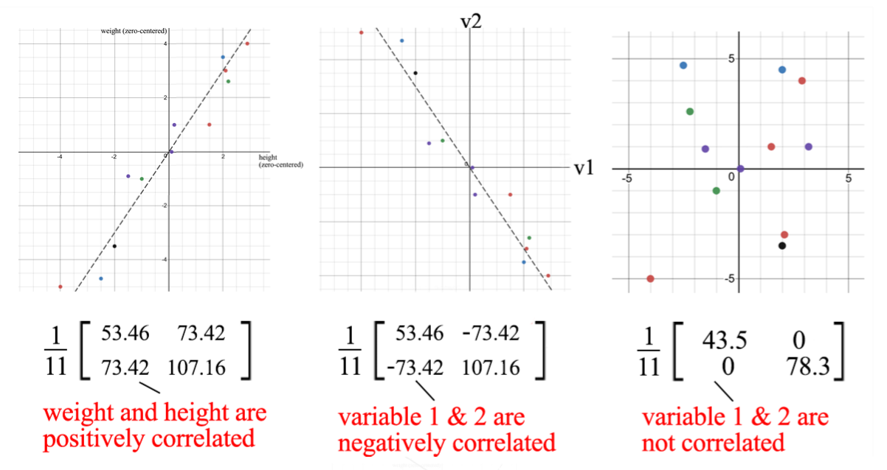(fig. 13)
When the two features are positively correlated, the covariance on the off-diagonal is greater than zero, otherwise, it has a negative value or even 0. As your observation, the covariance matrix defines both the spread (variance of each feature direction) and the orientation (covariance between different features) of our data. Furthermore, eigenvectors and eigenvalues for a covariance matrix are, respectively, the orientation and spread. (reference 4 deeply discusses the relationship.) As a result, we can calculate the eigenvectors for covariance matrices to find the principal components of data and then reduce the feature dimension.
- Singular value decomposition [7][8]
$A ϵ R^{m×n}, then A=UΣV^{T}=σ_{1}u_{1}v_{1}^{T} +…+σ_{r}u_{r}v_{r}^{T}(let σ_{1}>…>σ_{r})$.
This formularization of SVD says that a m-by-n array of entangled data can be broken down into r components. Since $u_{i}$ and $v_{i}$ are unit vectors, we can even ignore these small terms ($σ_{i}u_{i}v_{i}^{T}$ if $σ_{i}$is small). The principal component is $σ_{1}$, the second component is $σ_{2}$, and so on. As a result, the same as PCA, we can preserve most information of original data, the larger $σ$ terms, and remove other trivial ones.
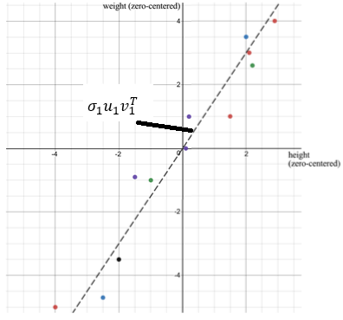
(fig. 14, For example, if $σ_{1}≫{10}^{-4}>σ_{2}>…$, we can use $σ_{1}u_{1}v_{1}^{T}$ to represent A)

Recall a covariance matrix $Σ$is symmetric, according to spectral theorem, that a symmetric matrix can be decomposed:
$$A=QΛQ^{-1} where Q is a orthogonal matrix and Λ is a diagonal matirx$$
Let’s combine the two concepts, $A=QΛQ^{-1}=UΣV^{T}$, then we obtain $Q=U=V$and
$Λ=Σ$. As a result, both of SVD and PCA as dimension-reduced methods, they perform the same thing, projection and scale. (reference 8 discuss in detail what SVD do.)
- Applications
- Reference
- Original author:
https://www.visiondummy.com/2014/04/curse-dimensionality-affect-classification/
Chinese version:
https://zhuanlan.zhihu.com/p/26945814

- A survey on unsupervised outlier detection in high-dimensional numerical data, Arthur Zimek , Erich Schubert and Hans-Peter Kriegel, 2012;
- Spatial ordering and encoding for geographic data mining and visualization, Diansheng Guo, Mark Gahegan, 2006, page10;
- PCA: Eigenvectors and Eigenvalues, Valentina Alto, 2019;
https://towardsdatascience.com/pca-eigenvectors-and-eigenvalues-1f968bc6777a
- 世界上最生動的PCA:直觀理解並應用主成分分析,LeeMeng,2020;
https://leemeng.tw/essence-of-principal-component-analysis.html
- 機器/統計學習:主成分分析(Principal Component Analysis, PCA), Tommy Huang, 2018;
https://chih-sheng-huang821.medium.com/%E6%A9%9F%E5%99%A8-%E7%B5%B1%E8%A8%88%E5%AD%B8%E7%BF%92-%E4%B8%BB%E6%88%90%E5%88%86%E5%88%86%E6%9E%90-principle-component-analysis-pca-58229cd26e71
- Machine Learning — Singular Value Decomposition (SVD) & Principal Component Analysis (PCA) , Jonathan Hui, 2019;
https://jonathan-hui.medium.com/machine-learning-singular-value-decomposition-svd-principal-component-analysis-pca-1d45e885e491
- You Don’t Know SVD (Singular Value Decomposition), Hussein Abdullatif,2019;
https://towardsdatascience.com/svd-8c2f72e264f

