--------- Observing Tips -------

Let’s see below.

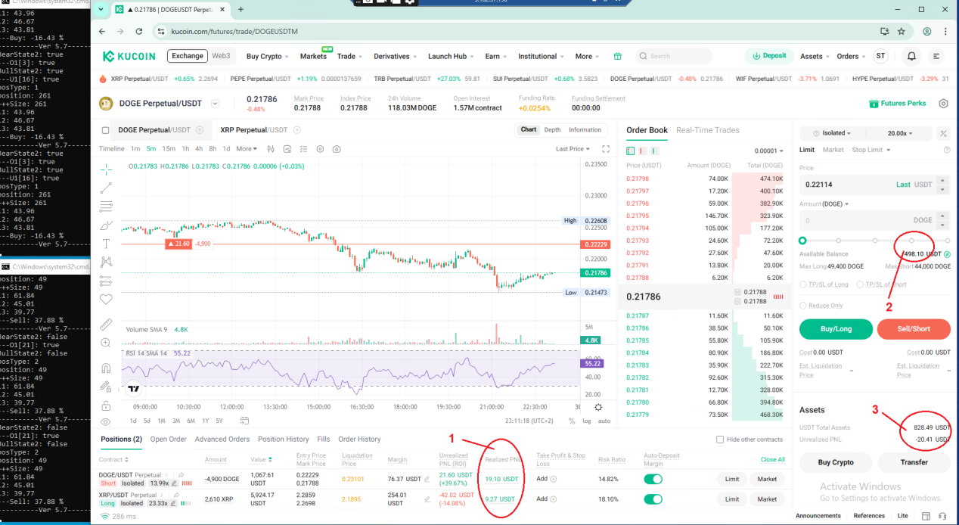

1. Realized PNL

The [Realized PNL] is real profit.

1. Avilable Balance

This is surplus amount that can be used for making new position and adding margin to danger position.

1. USDT Total Assets and Unrealized PNL

When Unrealized PNL is minus, the real total Assets is the sum of USDT Total Assets and abs(Unrealized PNL).

1 is about 0.5 ~ 3% daily and 2 is enough always.

Because 2 is enough at any time, the position is safe although the Unrealized PNL is minus.