Week 2 Homework
Back to Week 2
Class Homework Quiz
- IoT Professional Class
- Week 2 — Business Vision Board
- Homework
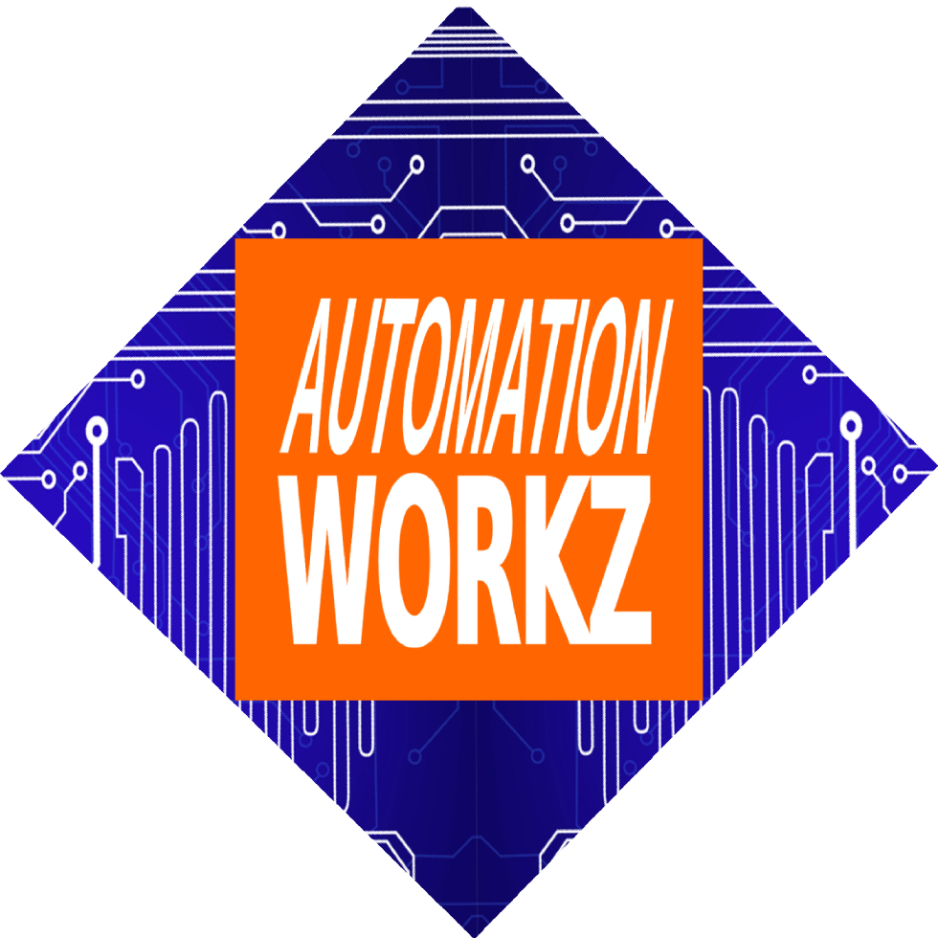

Automation Workz
Homework Assignment

Week 2 Homework

Homework Assignment

From Complete Picture to Action Plan
Use your 3 data points—Big 5 OCEAN assessment, Business Vision Board, and Tech Readiness score—to create a strategic 1-year roadmap that closes the gaps between where you are and where you want to be.

Why This Homework Matters
In class, you gathered three critical data points. Now you'll use AI to analyze them together and identify the gaps between your current reality and your 12-month vision:
🧠
OCEAN Profile
Your leadership style
🎨
Vision Board
Where you want to be
💻
Tech Readiness
Your current capabilities

Assignment: Gap Analysis & Roadmap (100 points)
Complete all 5 parts below

Part 1: Complete & Screenshot Your Vision Board
Finalize your business vision board in SenseiiWyze and take a screenshot.
Your Vision Board should include:
- • 🧠 Personal Identity & Self-Leadership
- • 💎 Core Values & Mission
- • 🎯 Vision & Goal Alignment
- • 👤 Ideal Customer/Client Persona
- • 🎨 Brand Identity & Imagery
- • 👥 The "Dream Team"
- • 💪 Leadership Skills to Develop
- • 📊 Actionable Metrics & Growth
Open SenseiiWyze

Part 2: Document Your OCEAN Profile & Tech Readiness
From your in-class activities, document your results:
🧠 Big 5 OCEAN Profile
- • Your top personality traits
- • Your conflict style
- • How you respond under pressure
- • Key leadership strengths
💻 Tech Readiness Score
- • Your final score from Senseii Games
- • Technical strengths identified
- • Skills that need development
- • Future-of-work readiness level

Part 3: Gather Your Business Website Info
Identify your current business website address and review how it represents your business today.
Document:
- • Your business website URL
- • What services/products are currently featured
- • What messaging is currently displayed
- • What's working well on your site
- • What's missing or outdated

Part 4: Run the Gap Analysis Prompt in 3 AI Tools
Use this prompt in ChatGPT, Claude, AND Perplexity:
"I am uploading my business vision board screenshot and my current business website: [YOUR WEBSITE URL]
My Profile Data:
• Big 5 OCEAN traits: [LIST YOUR KEY TRAITS]
• Tech Readiness Score: [YOUR SCORE/LEVEL]
• Leadership strengths: [YOUR TOP STRENGTHS]
• Technical skills to develop: [AREAS FOR GROWTH]
Please analyze:
1. Where my business is TODAY based on my website
2. Where I want my business to BE based on my vision board
3. How my OCEAN profile affects my ability to achieve this vision
4. What tech skill gaps exist between my current level and my vision
5. Create a 1-YEAR ROADMAP to close these gaps
Format the roadmap by quarters (Q1, Q2, Q3, Q4) with:
• Leadership development actions
• Tech skill building activities
• Business growth milestones
• Specific metrics for each quarter"
Run this prompt in all 3 AI tools:
ChatGPT Claude Perplexity

Part 5: Reflect & Document Your Results
Answer these reflection questions:
Reflection Questions:
- Which AI gave the most practical roadmap? Why?
- What surprised you about the gap between your current reality and vision?
- What leadership gaps did the analysis reveal? (emotional intelligence, conflict resolution, team management)
- What tech skill gaps must you address to achieve your vision?
- Which quarterly milestone are you most excited about?
- What's the #1 action item you'll implement first?

Submission Requirements
- Submit as a Word doc, Google Doc, or PDF
- Maximum 3 pages
- Include your vision board screenshot
- Include your OCEAN profile summary & Tech Readiness score
- Include all 3 AI-generated roadmaps (summarized)
- Include your reflection answers

Need Assistance?
Contact your instructor if you have questions about the assignment.
Miranda Boyd
miranda@autoworkz.org

Week 2 Materials
Class Activities Week 2 Quiz

Pro Tips
- 💡 Include specific details about your OCEAN traits—the more specific, the better the roadmap
- 💡 Upload a clear, complete screenshot of your vision board
- 💡 Compare all 3 roadmaps to find the best leadership AND business ideas from each
- 💡 Focus on gaps you can realistically close in 12 months
Back to Class Activities Take the Quiz
IoT Professional Class | Automation Workz
© 2024 Automation Workz. All rights reserved.

