Week 3 Homework
Back to Week 3
Class Homework Quiz
- IoT Professional Class
- Week 3 — Prompt Engineering Mastery
- Homework
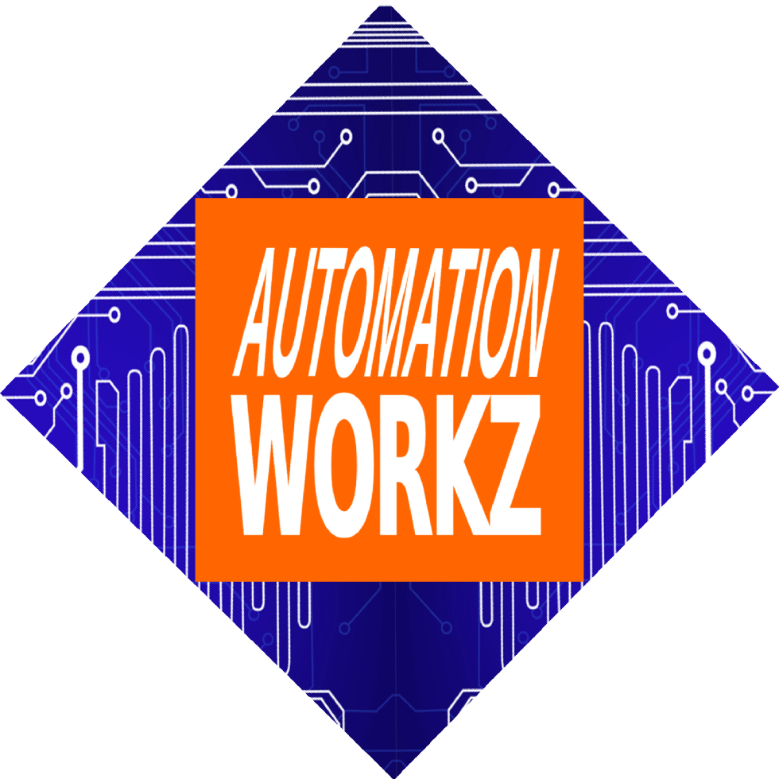

Automation Workz
Homework Assignment

Week 3 Homework

Homework Assignment

Prompt Engineering Mastery
Apply what you learned about the RCTFC framework to complete these assignments. Remember: the quality of your output depends on the quality of your input.

Part 1: Strategic AI Thinking
Choose ONE question. Write 3-5 sentences.

Option A AI & Decision Making
Think about a decision you made recently. How might AI have helped you make it faster, with more confidence, or with better data?

Option B Automation Opportunity
What's one area where you spend too much time on repetitive tasks? How could automation or AI reduce that burden?

Part 2: Hands-On Practice
Complete BOTH tasks below.

Task 1: Customer Follow-Up Checklist
Go to ChatGPT, Copilot, or Gemini and enter this exact prompt:
"Help me write a 3-step checklist to improve customer follow-up in my business."
Copy or screenshot the result and include it in your submission.
ChatGPT Copilot Gemini

Task 2: Identify an Automated System
Think about your home or workplace. Name one automated system you interact with regularly.
Examples:
- • Smart thermostat (adjusts temperature automatically)
- • Auto-reply email system
- • Automatic bill payments
- • Motion-sensor lights
Answer: How does this system save you time or improve accuracy?

Submission Requirements
- Submit as a Word doc, Google Doc, or PDF
- Maximum 1 page
- Include both Part 1 and Part 2 responses

Need Assistance?
Contact your instructor if you have questions about the homework assignment.
Miranda Boyd
miranda@autoworkz.org

Week 3 Materials
Class Activities Week 3 Quiz
Back to Class Activities Take the Quiz
IoT Professional Class | Automation Workz
© 2024 Automation Workz. All rights reserved.

