Week 3 Quiz
Back to Week 3
Class Homework Quiz
- IoT Professional Class
- Week 3 — Prompt Engineering Mastery
- Quiz
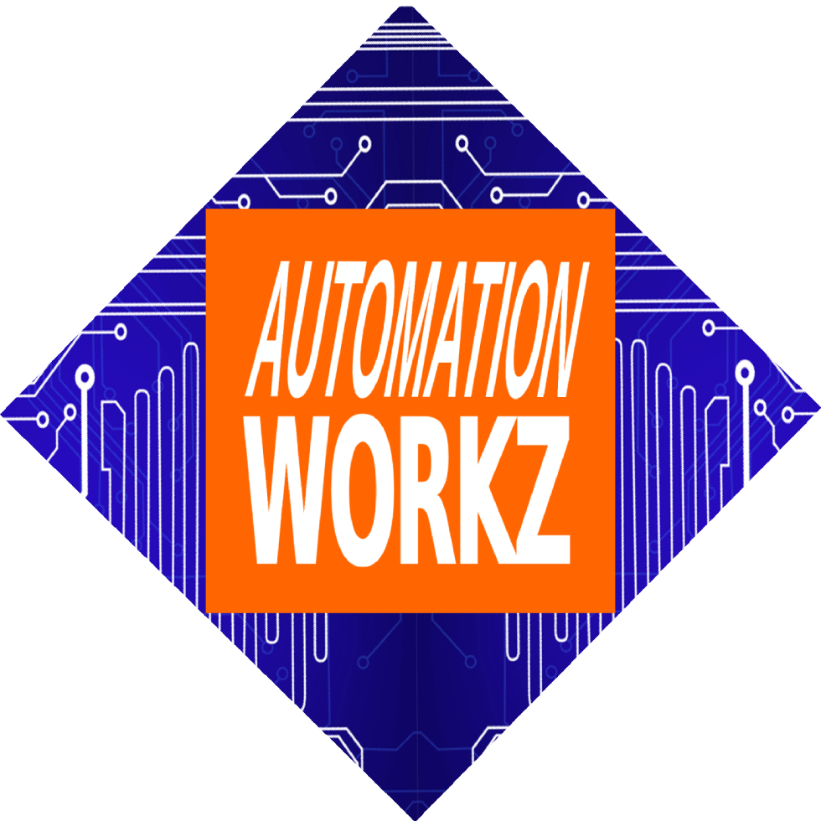

Automation Workz
Quiz - 100 Points

Week 3 Quiz

Prompt Engineering Mastery
Test your knowledge of the RCTFC framework, AI tool selection, and prompt engineering best practices. 10 questions worth 10 points each.
Score: 0 / 100

1 What does RCTFC stand for in prompt engineering?
Research, Create, Test, Format, Confirm Role, Context, Task, Format, Constraints Request, Clarify, Transform, Finalize, Check Review, Construct, Target, Focus, Complete

2 Which AI tool is best for getting cited sources?
ChatGPT Claude Perplexity They all provide the same citation quality

3 What is the "Role" component in the RCTFC framework?
The persona or expertise you want AI to adopt Your job title in the organization The type of AI model you're using The target audience for the output

4 Why is iteration important in prompt engineering?
It makes the AI work harder Great prompts rarely happen on the first try AI needs multiple attempts to understand you Iteration is not actually important

5 Which of the following is an example of a "Constraint"?
"Write in a friendly tone" "You are a marketing expert" "Don't mention competitors or use the word 'delicious'" "I run a small bakery"

6 What is a "Prompt Library"?
A personal collection of reusable prompts organized by category A database of AI-generated content A list of books about AI A subscription service for AI tools

7 How does your OCEAN personality profile connect to prompt engineering?
It determines which AI tool you should use Personality affects communication style and output preferences AI tools only work for certain personality types There is no connection between OCEAN and prompting

8 Which AI tool is best for nuanced reasoning and longer context?
ChatGPT Claude Perplexity All are equally good at reasoning

9 What is the main difference between vague and precise prompts?
Vague prompts lack context, specificity, and clear expectations Vague prompts are always shorter than precise prompts Precise prompts can only be used with ChatGPT There is no meaningful difference

10 Why should you test your prompts on multiple AI platforms?
To find which one is the cheapest Because one platform might be down Different AIs have different strengths—find the best tool for your need You should always stick to one platform for consistency
Submit Quiz
Reset

Quiz Results
0/100
Back to Homework Review Class Activities
IoT Professional Class | Automation Workz
© 2024 Automation Workz. All rights reserved.

