Week 4 Quiz
Back to Week 4
Class Homework Quiz
- IoT Professional Class
- Week 4 — AI for Business Goals
- Quiz
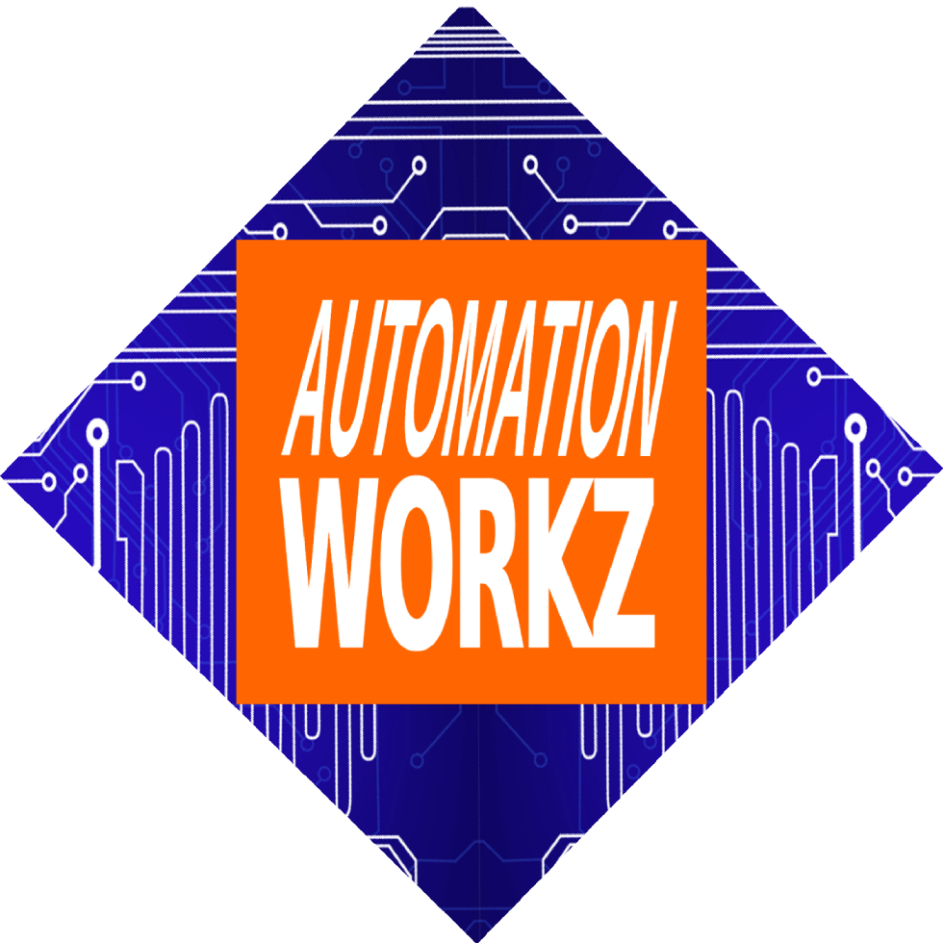

Automation Workz
Quiz - 100 Points

Week 4 Quiz

AI for Business Goals
Test your knowledge on business problem-solving with AI, the RCTFC framework, and evaluating AI solutions for practical implementation.
Score: 0 / 100

1 What is the first step in business problem-solving with AI?
Clearly define the problem before seeking solutions Choose the most advanced AI tool available Ask AI to generate all possible solutions Implement the first solution you find

2 What makes a good problem statement?
It should be broad enough to cover many issues Specific, important, and within your control It should require expensive technology to solve It should only focus on short-term issues

3 How does the RCTFC framework differ for business vs. personal use?
There is no difference in the framework Personal prompts are always more detailed Business prompts focus on ROI, efficiency, and stakeholders Business prompts don't need the Role component

4 What is OpenCode's primary purpose?
Generate code and automate tasks without programming knowledge Replace all other AI tools Create marketing content only Only for professional developers

5 Why should you iterate on AI outputs?
AI always produces incorrect results First responses rarely match exact needs—refinement improves quality It's required by all AI platforms Iteration is only needed for complex problems

6 What is the benefit of peer review in prompt crafting?
Peers will write the prompt for you It's only useful for advanced users External feedback identifies blind spots and improves clarity Peer review is not beneficial

7 When evaluating AI solutions, what should you consider?
Only the cost Only the time to implement Only the complexity Feasibility, cost, time, and alignment with goals

8 What is a common mistake in business AI use?
Asking for too many solutions Starting with the tool instead of the problem Using multiple AI tools Documenting the results

9 What role does context play in business prompts?
Context is optional for business prompts Context only matters for large corporations Provides AI with industry, size, constraints, and goals specific to your situation Context should be as brief as possible

10 How do you measure if a solution is successful?
Does it solve the problem? Is it implementable? Does it save time/money? Only by comparing to competitors By how complex the solution is Success cannot be measured
Submit Quiz
Reset

Quiz Results
0/100
Back to Homework Review Class Activities
IoT Professional Class | Automation Workz
© 2024 Automation Workz. All rights reserved.

