Week 2: Business Vision & Tech Readiness
Back to Course
Class Homework Quiz
- IoT Professional Class
- Week 2 — Business Vision Board
- In Class
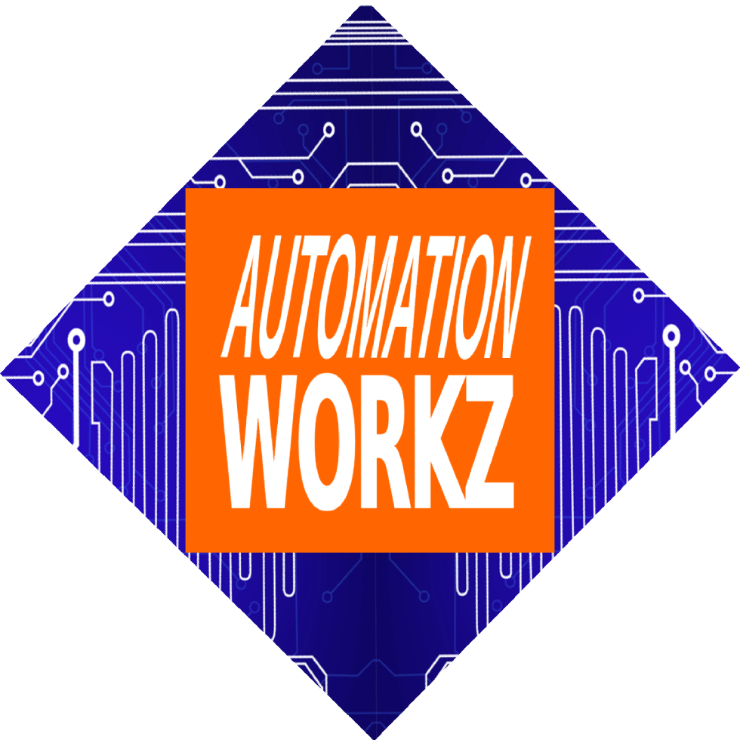

Automation Workz
In-Class Active

Week 2 In Class

In-Class Assignments:

Vision Board + Technical Skills Assessment
Two Activities to Assess Your Business Today & Where It Will Be in One Year
Activity 1: Create a Business Vision Board in SenseiiWyze to visualize your goals.
Activity 2: Complete 5 levels of Senseii Games to test your current technical skills.
Start Assignment Go to Homework

Strategic Takeaway
"A clear vision is the foundation of every successful business. When you can see it, you can achieve it."


Why Business Vision Boards Transform Leadership & Drive Revenue
A vision board isn't just inspiration—it's a strategic tool for leadership transformation from the inside out. When you align personal identity with business goals, you create authentic confidence that drives growth.
🧠

Self-Awareness First
Great leaders aren't just skilled—they're self-aware. Understanding your behavioral style and triggers builds resilience against stress, self-doubt, and burnout.
💎

Identity Alignment
Clarifying personal and professional vision reduces internal conflict. When who you are aligns with where you're going, you lead with authentic confidence.
💰

Clarity Attracts Revenue
When you can clearly articulate where your business is going, you make faster decisions, close deals quicker, and attract customers who align with your vision.
🎯

Focused Action = Faster Results
A vision board eliminates distractions. When your goals are visual and specific, every action moves you toward revenue-generating activities.
📊

Measurable Milestones
By defining specific revenue targets and growth metrics, you create accountability. What gets measured gets improved—and paid.
🤝

Know Your Ideal Customer
Visualizing your target audience helps you craft messaging that converts. Better targeting means more sales with less effort.
Revenue Impact: Business owners with clear, visualized goals grow 2-3x faster than those without.
Leadership Impact: Self-aware leaders navigate conflict with confidence and build psychologically safe, high-performing teams.

1 Activity 1: Business Vision Board
Progress:
0%
~5 min

Access SenseiiWyze
Log in to the SenseiiWyze platform and navigate to the Vision Board section.
Open SenseiiWyze
~25 min

Create Your Business Vision Board
Use the SenseiiWyze tools to create a visual representation of your business goals. Include these key elements:
🧠 Personal Identity & Self-Leadership
Who you are as a leader—your strengths, triggers, and how you show up under pressure
💎 Core Values & Mission
Images, colors, and words representing your foundational values (e.g., sustainability, innovation, integrity)
🎯 Vision & Goal Alignment
How your personal goals align with your business direction—reducing identity conflict
👤 Ideal Customer/Client Persona
Who you're serving—their demographics, pain points, and needs
🎨 Brand Identity & Imagery
The "look and feel" of your business—branding, website, workspace aesthetics
👥 The "Dream Team"
People needed to achieve your vision—hiring, outsourcing, team culture
💪 Leadership Skills to Develop
Emotional intelligence, conflict resolution, difficult conversations, team dynamics
📊 Actionable Metrics & Growth
Key performance indicators (KPIs) and growth milestones—not just abstract dreams

2 Activity 2: Technical Skills Assessment
Progress:
0%

Why Tech-Readiness Assessment Matters
Senseii Coaching includes Tech Change Readiness as a core leadership skill. Understanding your current technical abilities helps you adapt to rapidly evolving tools and build confidence in using complex technologies.
10X
Training ROI with tech skill coaching
58%
Higher employee retention
2.5X
Faster promotion rate
Know Your Starting Point: You can't improve what you don't measure. This assessment reveals your technical strengths and gaps.
Complete Picture: Combined with your Vision Board, this data shows where you are AND where you're going.
~2 min

Access Senseii Games
Log in to Senseii Games platform and navigate to the skills assessment area.
Open Senseii Games
~10 min

Complete Level 1 — Foundation
Begin with Level 1 to test your foundational tech readiness. This reveals how you adapt to new digital tools.
~10 min

Complete Levels 2 & 3 — Application
Progress through intermediate levels that test practical problem-solving and your ability to apply knowledge in context.
~10 min

Complete Levels 4 & 5 — Advanced
Tackle advanced levels that challenge your future-of-work mindset and readiness for complex technical environments.
~5 min

Reflect & Document Your Results
Review your score and identify your technical strengths and growth areas. This self-awareness is key to your development plan.
📋 Reflection Questions:
- • What technical skills came naturally to me?
- • Where did I struggle or need more time?
- • What tech skills should I develop to reach my vision?
📊 Screenshot your final score for your business analysis.

Your Complete Business Picture
Today's two activities give you three critical data points. Together, they reveal exactly where your business stands—and what gaps to fix in the next 12 months.
1

Big 5 OCEAN Assessment
Your behavioral profile from SenseiiWyze reveals:
- • How you lead under pressure
- • Your conflict style
- • Decision-making tendencies
- • Emotional resilience patterns
From SenseiiWyze
2

Business Vision Board
Your visual roadmap shows:
- • Where you want to be in 12 months
- • Revenue & growth targets
- • Team & brand vision
- • Leadership skills to develop
From SenseiiWyze
3

Tech Readiness Score
Your technical baseline reveals:
- • Current technical capabilities
- • Digital tool proficiency
- • Future-of-work readiness
- • Skills gaps to address
From Senseii Games

Finding & Fixing the Gaps
With these three data points, you can now see the gaps between where you are and where you want to be:

🔍 Leadership Gaps
If your OCEAN profile shows low emotional resilience but your vision requires building a team—there's a leadership development gap.

🔍 Tech Skill Gaps
If your vision includes AI-powered operations but your tech readiness score is low—there's a skill development gap.

🔍 Identity Gaps
If your core values don't align with your business direction—there's an identity conflict gap that causes internal stress.

🔍 Resource Gaps
If your vision requires a "dream team" but you lack leadership skills to manage people—there's a resource gap.
Your 12-Month Focus: Use these insights to create a development plan that closes the gaps between your current reality and your business vision. Small, consistent improvements compound into transformation.

Why Vision Boards Work

Visual Clarity
Seeing your goals visually helps your brain process and prioritize them more effectively than written lists alone.

Daily Motivation
A vision board serves as a daily reminder of what you're working toward, keeping you focused and motivated.

Strategic Alignment
When your goals are visual, you can more easily check if your daily actions align with your long-term vision.

Learning Outcomes
- Define clear business goals
- Visualize success using digital tools
- Communicate your vision to others
- Refine goals based on feedback

Need Assistance?
Contact your instructor if you have questions about creating your vision board.
Miranda Boyd
miranda@autoworkz.org

Before Next Week
- → Complete the homework assignment
- → Take the Week 2 Quiz
- → Review your vision board daily
Previous Lesson Go to Homework
IoT Professional Class | Automation Workz
© 2024 Automation Workz. All rights reserved.

