Week 3: In-Class Activities
Back to Course
Class Homework Quiz
- IoT Professional Class
- Week 3 — Prompt Engineering Mastery
- In Class
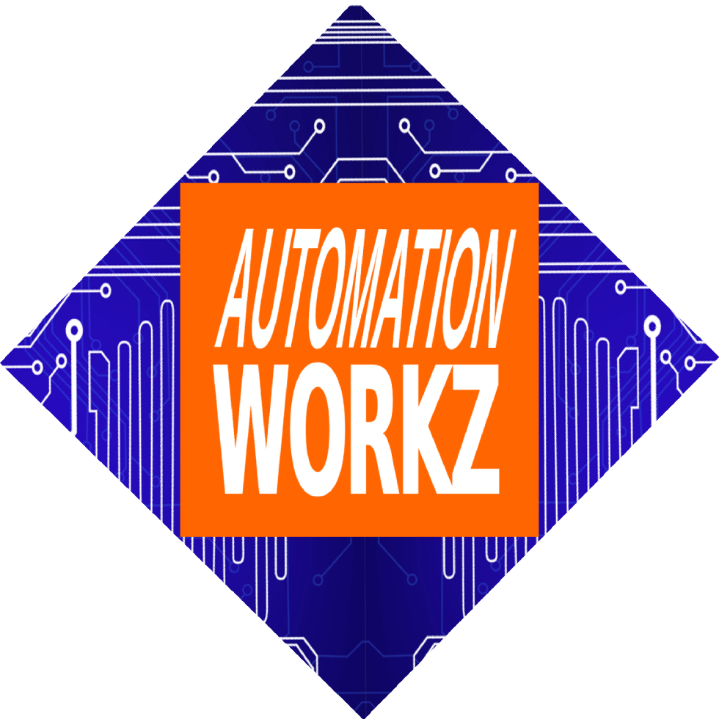

Automation Workz
In-Class Active

Week 3 In Class

In-Class Assignment:

Prompt Engineering Mastery
Learning to Speak AI's Language
Transform from AI user to AI whisperer. Learn the frameworks and techniques that turn vague requests into precise, powerful prompts that deliver consistent results across ChatGPT, Claude, and Perplexity.
Start Assignment Go to Homework

Strategic Takeaway
"The quality of your AI output is directly proportional to the quality of your input. Master the prompt, master the result."


1 In-Class Activity Steps
Progress:
0%
~20 min

The RCTFC Framework Demo
Watch instructor demonstrate transforming a vague prompt into a powerful one using Role, Context, Task, Format, and Constraints.
Example Transformation:
❌ "Write me a marketing email"
✅ "You are a conversion copywriter (Role). I run a small bakery targeting busy professionals (Context). Write a promotional email for our new lunch delivery service (Task). Use a friendly tone, keep it under 150 words, include a CTA (Format). Don't mention competitors (Constraints)."
~30 min

Prompt Engineering Lab
Using your problem from Senseii Games (Week 2), craft a RCTFC prompt. Test it on all three platforms:
ChatGPT Claude Perplexity
~25 min

Compare & Refine
Analyze the three responses. Which AI gave the best answer for your specific need? Refine your prompt and run it again.
💡 Pro Tip: Your OCEAN profile affects how you communicate. High Openness? You might prefer creative prompts. High Conscientiousness? You'll want structured outputs.
~15 min

Build Your Prompt Library
Start a personal "Prompt Library" document with template starters:
Template Starters:
- • Business: "You are a [role] helping a [business type]..."
- • Personal: "Act as my personal [coach/advisor]..."
- • Research: "Find and summarize [topic] with sources..."

Watch: Prompt Engineering Tutorial

An error occurred.
Unable to execute JavaScript.

Coding Tool Spotlight: OpenCode & Claude Code
These tools help automate repetitive tasks, build simple apps, and create custom AI workflows. You don't need to be a programmer—just know how to describe what you want (that's prompt engineering!). Deeper dive planned for Weeks 4-6.

Learning Outcomes
- Apply the RCTFC Framework to any prompt
- Choose the right AI for different task types
- Iterate and refine prompts effectively
- Start a personal prompt library
- Connect prompt style to OCEAN personality

Need Assistance?
Contact your instructor or the support team if you have questions about the RCTFC framework or AI tools.
Miranda Boyd
miranda@autoworkz.org

Before Next Week
- → Complete the homework assignment
- → Take the Week 3 Quiz
- → Build your prompt library with 3+ templates
Previous Lesson Go to Homework
IoT Professional Class | Automation Workz
© 2024 Automation Workz. All rights reserved.

