**Pre-Processing Workflow (ArcMap 10.8)**

*Note: See ‘Data_Sources_Metadata’ excel file to know specifics about data downloads*

Create Idaho boundary layer for clipping:

1. Downloaded USA State Boundaries layer
2. **‘Select by Attributes’ function:** selected and exported Idaho polygon
3. **‘Project’ tool:** converted to USA Contiguous Albers Equal Area Conic (which automatically converted datum to NAD1983 from WGS84)
   * Saved as idaho_boundary_prj in brook_beaver_data.gdb

Prep BRAT – Idaho data (Surveyed Beaver Dam Locations, Existing Dam Complex Size, Existing Dam Building Capacity, and Land Use Value):

1. Downloaded Existing Dam Complex Size, and Existing Dam Building Capacity shapefiles
2. **‘Project’ tool:** converted beaver dam complex size layer to USA Contiguous Albers Equal Area Conic
   * Saved as Ex_Dam_CompxSize_prj (deleted to prevent confusion with clipped layer)
3. **‘Clip’ tool:** clipped layer using idaho_boundary_prj
   * Saved as Ex_Dam_CompxSize_final
4. **‘Project’ tool:** converted beaver dam building capacity layer to USA Contiguous Albers Equal Area Conic
   * Saved as Ex_Dam_BldingCap_prj (deleted to prevent confusion with clipped layer)
5. **‘Clip’ tool:** clipped layer using Idaho_boundary_prj
   * Saved as Ex_Dam_BldingCap_final

Prep NHDPlusV2 Flowline Layers:

1. Downloaded VPU17 NHDFlowline and VPU16 NHDFlowline layers and necessary tables
2. **‘Project’ tool:** converted to USA Contiguous Albers Equal Area Conic
3. **‘Join Field’ tool:** joined the elevslope and EROM_MA0001 (Q0001C and V0001C fields only) tables to VPU17 NHDFlowline and VPU16 NHDFlowline
4. **‘Merge’ tool:** merged VPU17 NHDFlowline and VPU16 NHDFlowline
   * Save as VPU16_17_NHDFlowline_Merge
5. **‘Clip’ tool:** clipped VPU16_17_NHDFlowline_Merge using Idaho_boundary_prj
   * Saved as Idaho_NHDFlowline
6. **‘Select by Attributes’ function:** select FLOWDIR = 'With Digitized' from Idaho_NHDFlowline (removes Uninitialized rows with no values for the flow, elevation, etc.)
   * Save as NHDFlowline_clean
7. **‘Select by Attributes’** **function**: select V0001C >= 0 from NHDFlowline_clean to remove -9998 NULL values
   * Save as velocity_clean
8. **‘Select by Attributes’ tool:** select Slope > 0 from NHDFlowline_clean to remove -9998 NULL values
   * Save as slope_clean
9. **‘Select by Attributes’ tool:** select MAXELEVSMO > 0 from NHDFlowline_clean to remove -9998 NULL values
   * Save as MAXELEVSMO_clean

Prep mean August stream temperature layer:

1. Downloaded Mean August Temperatures (NorWeST Predicted Stream Temperature Lines)
2. **‘Project’ tool:** converted to USA Contiguous Albers Equal Area Conic
   * Saved as S_USA_NorWeSt_PredictedStreams_prj
3. **‘Clip’ tool:** clipped S_USA_NorWeSt_PredictedStreams_prj using idaho_boundary_prj
   * Saved as NorWest_mean_AUG_temp_idaho
4. ‘**Select by Attributes’ function:** select S1_93_11 > 0 to remove -9999 NULL values
   * Export/save selection as Aug_temp_avg

Prep gSSURGO soil layers:

1. Downloaded gSSURGO Idaho soil dataset
2. **‘Join Field’ tool:** Join ‘chorizon’ table with ‘component’ table using ‘cokey’ (only include mukey in join)
3. ‘**Delete Fields’ tool:** Remove unnecessary fields from chorizon and muaggatt tables
   * Keep brockdepmin, ksat fields, fraggt fields, and keys
4. **‘Join Field’ tool:** join the ‘chorizon’ table to the ‘MUPOLYGON’ layer using ‘mukey’
5. **‘Join Field’ tool:** join the ‘muaggatt’ table to the ‘MUPOLYGON’ layer using ‘mukey’
6. **‘Clip’ tool:** clip MUPOLYGON using Idaho_boundary_prj (set environmental settings output to USA Contiguous Albers Equal Area Conic)
7. **‘Spatial Join’ tool:** merge MUPOLYGON fields into Idaho_NHDFlowline reaches (mean values)
   * Saved as Soil_flowline_merge

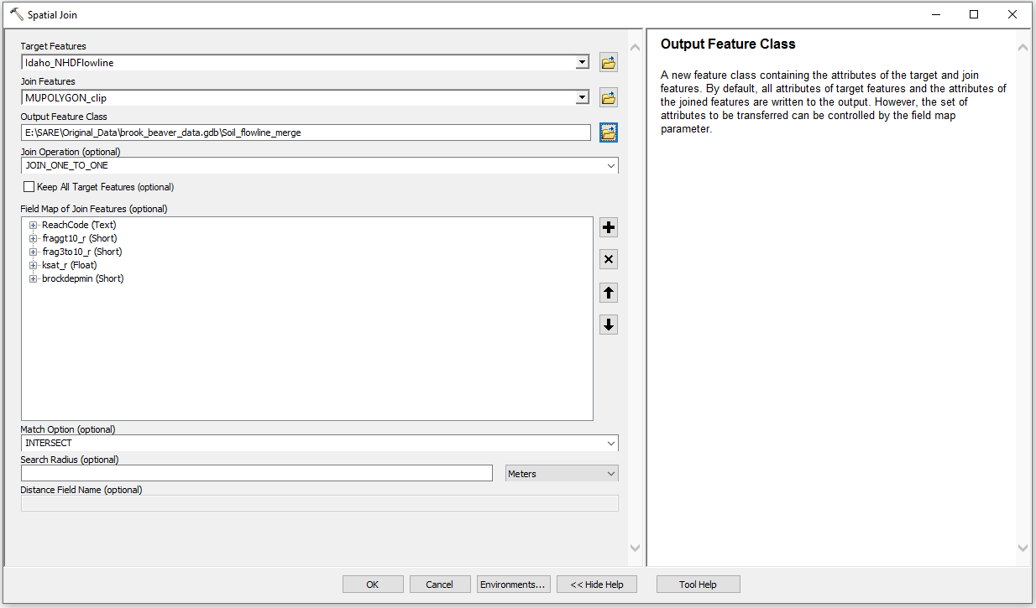

1. **‘Export’ function:** Create copy of Soil_flowline_merge
2. **‘Delete Field’ tool:** delete fraggt10_r. frag3to10_r, and ksat_r fields from Soil_flowline_merge
3. **‘Select by Attribute’ function:** select brockdepmin >=0
   * Exported/saved selection as brockdepmin_avg
4. **‘Select by Attribute’ function:** select Ksat_r > 0
   * Exported/saved selection as ksat_avg
5. Repeat process for fraggt10_r and frag3to10_r

Prep brook trout presence data from IDFG:

1. Download brook trout presence data that Leona sent
2. **‘Delete field’ tool:** Delete NULL fields from LSDB_BrookTroutPresence and VoucheredSpecimens_BrookTrout
3. **‘Merge’ tool:** merge the LSDB_BrookTroutPresence and VoucheredSpecimens_BrookTrout keeping only the fields that they have in common (WaterName, Lat, Lon, Species, and HUC4)
4. **‘Project’ tool:** converted to USA Contiguous Albers Equal Area Conic
5. **‘Clip’ tool:** clip IDFG_Brook_prj using Idaho_boundary_prj
   * Saved as IDFG_BrookTrout

**Creating Valley Confinement Layer Workflow**

*Note:**see* [*A Landscape Scale Valley Confinement Algorithm - Delineating Unconfined Valley Bottoms for Geomorphic, Aquatic, and Riparian Applications - Addendum for Using NHDPlus Version 2 Data (fs.fed.us)*](https://www.fs.fed.us/rm/boise/AWAE/projects/valley_confinement/downloads/RMRS-GTR-321_AddendumForUsingNHDPlusV2.pdf) *for more detailed explanation of the workflow*

1. Downloaded NHDPlusV2 Watershed boundaries for VPU 16 and 17
   * **‘Project’ tool:** converted to USA Contiguous Albers Equal Area Conic
   * **‘Dissolve’ tool:** dissolve based on HUC_8 field
   * **‘Split By Attributes’** = split by HUC_8 field
     + Select desired subbasins within the Idaho boundary before using this tool to limit the number of outputs
   * **‘Merge’ tool:** merge together the subbasins needed for Idaho boundary
     + Set environments coordinate system to USA Contiguous Albers Equal Area Conic
     + Save as merge_subbasins
   * ‘Project’ tool: project to UTM Zone 12
     + Save as merge_subbasins_utm
2. Downloaded USGS 30-meter DEM for the general area surrounding the state of Idaho

* **‘Mosaic to New Raster’ tool:** merged all the quadrants needed for Idaho subbasin boundaries
  + - Output: DEM_merge (no extension so it will be in GRID format)
    - Spatial reference for raster: USA Contiguous Albers Equal Area Conic
    - Number of Bands: 1
    - Pixel Type: 32_BIT_FLOAT
  + **‘Project’ tool:** project to UTM Zone 12
    - Save as dem_merge_utm
  + **‘Split Raster’ tool:** split rasters to correspond to subbasin areas
    - Bilinear resampling and TIFF format (because of bug issue)
  + Export dem split layers as GRID

1. Downloaded NHDPlusV2 VPU16 and VPU17 Waterbody shapefiles
   * **‘Project’ tool:** converted to USA Contiguous Albers Equal Area Conic
   * **‘Merge’ tool:** VPU16 and 17 NHDWaterbody projected layers
     + Saved as VPU16_17_NHDWaterbody_merge
   * **‘Project’:** project merge file to UTM Zone 12
   * **‘Split’ tool:** split waterbody layer using the HUC_8 field of the merge_subbasins_utm layer
     + Save into VCA_UTM
2. Download CumulativeArea table for both VPU17 and VPU16
   * **‘Merge’ tool:** merge the VPU17 and VPU 16 tables
     + Saved as CumulativeArea_merge_VPU16_17
   * **‘Join Field’ tool:** Added the CumulativeArea_merge_VPU16_17 to the VPU16_17_NHDFlowline_Merge (only added TotDASqkM field)
   * **‘Add Field’ tool:** add field named CUMDRAINAG (Float, Precision = 12 and Scale = 2)
     + Calculate CUMDRAINAG: CUMDRAINAG = TotDASqkM
   * **‘Project’ tool:** project to UTM Zone 12
   * **‘Split’ tool:** split VPU16_17_NHDFlowline_Merge layer using the HUC_8 field of the merge_subbasins layer
     + Save into ValleyConfinement_shapefiles
3. Downloaded average annual precipitation data from PRISM
   * **‘Project Raster’ tool:** converted to USA_Contiguous_Albers_Equal_Area_Conic
     + Saved as precip_prj (doesn’t look like it worked??)
   * **‘Raster Calculator’ tool:** convert precip_prj from inches to centimeters by multiplying by 2.54
     + Saved as precip_cm
   * **‘Project’ tool:** project to UTM Zone 12
   * **‘Split Raster’ tool:** split precip_cm_utm raster to correspond to subbasin areas (merge_subbasins_utm) using bilinear resampling and TIFF format (because of bug)
   * Access mean precipitation values in the layer properties

*Note: Average Precipitation for the entire state of Idaho is 1584.83 cm for reference to make sure values make sense*

1. Run ValleyConfinmentAlgorithm tool (Had to use ArcMap 10.5!)
   * Parameter values taken from [Valley Confinement Algorithm General Metadata (fs.fed.us)](https://www.fs.fed.us/rm/boise/AWAE/projects/valley_confinement/downloads/ValleyConfinementAlgorithmGeneralMetadata.pdf) values
2. Merge the created VCA layers and the publicly available VCA dataset for the rest of Region 17
   * **‘Merge’ tool:** merge VCA layers and VCA_Region_17
     + Saved as VCA_all in VCA_outputs
3. Join the Idaho_NHDFlowline and VCA_all
   * **‘Spatial Join’ tool**
     + Save as VCA_merge

**Converting Environmental Input Vectors to Rasters for Maxent**

1. **‘Polyline to Raster’ tool:** convert environmental layers to rasters
   * Specify TIFF format by putting .tif in output name (save in Maxent_Rasters_DiffExtent folder)
   * Use default settings

*Specifics for each layer:*

VCA:

* 2100-meter default cell size
* Value field = VB_CLASS (1 = Unconfined Valley Bottom)

ksat_avg:

* 2100-meter default cell size
* Value field = ksat_r (Saturated hydraulic conductivity of soil; um/s; micrometer/second)

Aug_temp_avg:

* 2100-meter default cell size
* Value field = S1_93_11 (Historical composite scenario representing 19-year average August mean stream temperatures for 1993-2011; Celsius)

brockdepmin_avg:

* 2100-meter default cell size
* Value field = brockdepmin (Mean depth to bedrock; cm; centimeters)

frag3to10_avg:

* 2100-meter default cell size
* Value field = frag3to101 [aka frag3to10_r… there was a glitch in one of the tools] (The percent by weight of the horizon occupied by rock fragments 3 to 10 inches in size; percentage %)

fraggt10_avg:

* 2100-meter default cell size
* Value field = fraggt10_r (The percent by weight of the horizon occupied by rock fragments greater than 10 inches in size; percentage %)

NHDFlowline_clean:

1. Mean Annual Flow
   * 2100-meter default cell size
   * Value field = Q0001C (Mean annual flow; cubic feet per second)

*Note: Should zero values exist for this attribute???*

1. Total Upstream Cumulative Drainage Area
   * 2100-meter default cell size
   * Value field = TotDASqKm (Total Upstream Cumulative Drainage Area, in square kilometers, at the downstream end of the NHDFlowline feature; km2)

*Note: Should zero values exist for this attribute???*

Velocity_clean:

* 2100-meter default cell size
* Value field = V0001C (Mean annual velocity; feet per second)

Slope_clean:

* 2100-meter default cell size
* Value field = Slope

MAXELEVSMO_clean:

* 2100-meter default cell size
* Value field = MAXELEVSMO (Maximum elevation [smoothed] in centimeters; cm)

Ex_Dam_CompxSize_final:

* 2100-meter default cell size
* Value field = mCC_EX_CT (Existing Dam Complex Size.; dams per kilometer)

Ex_Dam_BldingCap_final:

* 2100-meter default cell size
* Value field = oCC_EX (Existing Dam Building Capacity; dams per kilometer)

Ex_Dam_CompxSize_final:

* 2100-meter default cell size
* Value field = iPC_LU (The average land use value in a 100m buffer around the reach; Adjusted flow types by FHC = Urban, Agriculture, Riparian, No land use)

*Note: Found this land use variable in the BRAT data… may use???*

**2) ‘Clip’ tool:** clip each of the maxent rasters using the Idaho_boundary_prj

* + Make sure to check ‘Maintain Clipping Extent’ (the number of columns and rows will be adjusted and the pixels will be resampled to exactly match the clipping extent specified)
  + Save in Maxent_Raster_SameExtent folder

1. **‘Resample’ tool:** resample all of Maxent_Raster_SameExtent rasters to have square 2100m cell sizes
   * Save in Maxent_Raster_Resample as .tif file
   * Valley_Con = nearest resampling; remaining variables = bilinear resampling
2. **‘Reclassify’ tool:** reclassify Valley_Con so that values are 1 and 2
   * Save in Maxent_Raster_Resample (delete and replace original Valley_Con in this folder)

**Running Maxent in R**

*Note: See R workflow in the ‘Scripts’ folder*