**INTRODUCTION**

**PROJECT TITLE: COOK BOOK**

**TEAM MEMBERS**: S.HARINI (212205234)

K.NARKIS (212205268)

V.PATHISALU (212205273)

M.ROOBINI (212205289)

**TEAM MEMBERS ROLES:**

**S.HARINI –** PROGRAM OUTPUT RUNNER

**K.NARKIS –** VOICE OVER

**V.PATHISALU –**CONTENT PROVIDER

**M.ROOBINI –** DOCUMENTATION EDITOR

**PROJECT OVERVIEW**

**Purpose:**

* The purpose of this cookbook project is to create a comprehensive collection of recipes that serve as a practical and accessible guide for individuals looking to enhance their culinary skills, try new dishes, or explore different cuisines.
* The cookbook will not only provide instructions for preparing meals but will also include tips, techniques, and food-related insights that aim to educate and inspire readers to cook with confidence.

**Goal:**

The primary goal of the cookbook is to:

* Provide a diverse collection of recipes for a range of dietary preferences, cooking styles, and difficulty levels (beginner to advanced).
* Promote healthy eating habits by offering balanced and nutritious meal options.
* Foster culinary creativity by encouraging readers to experiment with new ingredients, flavours, and cooking methods.
* Enhance culinary knowledge by teaching cooking techniques, kitchen tips, and food science.
* Create a user-friendly resource that people can turn to for inspiration, meal planning, and special occasions.
* Make cooking enjoyable and accessible for individuals with various skill levels and backgrounds, from students to seasoned chefs.

**Features:**

**1. Introduction & Basics**

* Overview of the cookbook’s theme or purpose
* Cooking tips, techniques, and ingredient guides

**2. Recipe Sections**

* Categorized recipes (e.g., appetizers, main courses, desserts)
* Special dietary or cuisine-based sections

**3. Recipe Format**

* Title – Name of the dish
* Prep & Cook Time – Estimated time required
* Serving Size – Number of portions

**4. High-Quality Visuals**

* Photos of finished dishes .Step-by-step images (if applicable)

**ARCHITECTURES**

* Software architecture of a cookbook application (e.g., a recipe management system)?
* Physical book structure (e.g., how sections and components like recipes, ingredients, and instructions are organized in a cookbook)?
* UI/UX design for a digital cookbook or app?

**COMPONENT STRUCTURE:**

**1. Layout Components**

Header – Navigation menu, search bar.

Footer – Copyright info, quick links.

**2. Recipe Components**

Recipe Card – Displays a summary of a recipe.

Recipe Detail – Shows full details of a recipe.

**3. User Interaction Components**

Search Bar – Filters recipes by name or ingredients.

Favourites – Saves recipes for future reference.

Shopping List – Generates grocery lists from selected recipes.

**SETUP INSTRUCTION**

* **Gather Your Tools** – Make sure you have the necessary utensils, pots, and pans.
* **Prepare Ingredients** – Wash, chop, and measure everything before starting.
* **Organize Your Space** – Keep your workstation clean and clear.
* **Preheat & Prep** – If needed, preheat the oven or heat the pan.
* **Read the Recipe** – Go through all steps to avoid surprises.

**FOLDER STRUCTURE**

If you're organizing a digital cookbook, here's a simple and efficient folder structure:

Cookbook/

│── Introduction/

│ ├── Preface.txt

│ ├── Cooking_Tips.txt

│── Recipes/

│ ├── Appetizers/

│ │ ├── recipe1.txt

│ │ ├── recipe2.txt

│ ├── Main Courses/

│ │ ├── recipe1.txt

│ │ ├── recipe2.txt

│ ├── Desserts/

│ │ ├── recipe1.txt

│── Images/

│ ├── Appetizers/

│ ├── Main Courses/

│ ├── Desserts/

│── Resources/

│ ├── Ingredients_Guide.txt

│ ├── Cooking_Techniques.txt

│── Index.txt

This structure keeps recipes, images, and additional resources well-organized.

**RUNNING THE APPLICATION**

To start the cookbook application, follow these steps:

* Install Dependencies (if required)
  + npm install # For Node.js apps
  + pip install -r requirements.txt # For Python apps
* Start the Application
* npm start # For a web-based cookbook
* python app.py # For a Python-based app
* Access the Cookbook
* Open a browser and go to http://localhost:3000/ (or the specified URL).
* Browse recipes, search ingredients, and enjoy cooking!

**FRONT END:**

**1. Install Dependencies**

Navigate to the project folder and install required packages:

Cd cookbook-frontend

npm install # For React, Vue, or Angular projects

Yarn installs # if using Yarn

**2. Start the Development Server**

Run the application locally:

npm start # React

npm run serve # Vue

ng serve # Angular

The application will typically run on http://localhost:3000/ (React) or http://localhost:8080/ (Vue).

**3. Environment Setup (Optional)**

Configure API URLs in .env file:

REACT_APP_API_URL=http://localhost:5000/api

**4. Build for Production**

When ready to deploy, build the frontend:

npm run build

**COMPONENT DOCUMENTATION**

**1. Recipe Component**

Manages recipe details like title, ingredients, steps, and images.

Example:

{

"title": "Pasta Alfredo",

"ingredients": ["Pasta", "Cream", "Cheese"],

"steps": ["Boil pasta", "Prepare sauce", "Mix and serve"]

}

**2. Search Component**

Allows users to search for recipes by name, ingredients, or category.

**3. Category Component**

Organizes recipes into sections like Appetizers, Main Course, and Dessert.

**4. User Preferences Component (Optional)**

Saves favorite recipes, dietary preferences, or custom notes.

**KEY COMPONENTS**

* Key Component: A critical component that plays a central role in the application, often responsible for core functionality (e.g., a Navigation Bar, Main Layout, or Authentication Component).
* Key Component: Essential ingredients or techniques that define a dish (e.g., the dough in a pizza recipe, roux in a sauce, or stock in a soup).

**REUSABLE COMPONENTS**

* Reusable Component: Pre-prepared elements that can be used across multiple recipes (e.g., a base tomato sauce for pasta, a spice mix, or a marinade that works with different proteins).
* Reusable Component: A modular component designed to be used in multiple places, improving efficiency and maintainability (e.g., Buttons, Modals, Form Inputs, Cards).

**STATE MANAGEMENT**

**1. Global State (Centralized Store)**

Stores user preferences, recipe data, and app settings.

Managed using Redux (React), Vuex (Vue), or Context API.

**2. Local State (Component-Level)**

Handles UI-specific states like toggling favorite recipes or filtering categories.

**3. Persistent State (Storage)**

Saves data using Local Storage, IndexedDB, or a database to retain user selections.

Example (React + Redux)

const initialState = { favorites: [] };

const recipeReducer = (state = initialState, action) => {

switch (action.type) {

case "ADD_FAVORITE":

return { ...state, favorites: [...state.favorites, action.payload] };

default:

return state;

}

};

**USER INTERFACE**

**1. Home Screen**

Displays featured recipes and categories.

Search bar for quick access.

**2. Recipe Page**

Shows recipe title, ingredients, instructions, and images.

"Save to Favorites" and "Share" buttons.

**3. Categories & Filters**

Organizes recipes into sections (e.g., Appetizers, Desserts).

Filters by ingredients, cuisine, or dietary preferences.

**4. User Dashboard (Optional)**

Tracks favorite recipes and cooking history.

Allows personalization of meal plans.

A clean and intuitive UI ensures a smooth cooking experience!

**STYLING**

**1. Color Scheme**

Warm and inviting tones (e.g., beige, orange, or green) for a food-friendly look.

Dark mode for better accessibility.

**2. Typography**

Clear and legible fonts (e.g., serif for recipe titles, sans-serif for body text).

Proper font hierarchy (large headers, medium subheaders, readable body text).

**3. Layout & Spacing**

Grid-based layout for easy recipe browsing.

Well-spaced sections for better readability.

**4. Buttons & Icons**

Rounded buttons for a modern look.

Intuitive icons for actions like "Save," "Share," and "Print."

Example (CSS Snippet)

body {

font-family: 'Poppins', sans-serif;

background-color: #f8f5f2;

color: #333;

}

.recipe-card {

border-radius: 10px;

box-shadow: 0 4px 6px rgba(0, 0, 0, 0.1);

padding: 20px;

}

**TESTING**

**1. Unit Testing (Testing individual functions)**

Example: Checking if a recipe loads correctly.

Tools: Jest, Mocha, PyTest

test("Recipe title should be displayed", () => {

expect(getRecipeTitle({ title: "Pasta" })).to Be("Pasta");

});

**2. Integration Testing (Testing multiple components together)**

Example: Ensuring the search function returns correct results.

Tools: Cypress, Selenium

**3. UI/UX Testing**

Verifying responsiveness and usability on different devices.

Tools: Lighthouse, Browser Stack

**4. Performance Testing**

Ensuring recipes load quickly and images don’t slow down the app.

Tools: Google Page Speed, J Meter

**TESTING STRATEGY**

1. **Recipe Testing**: Ensuring the recipes are accurate, reliable, and clear for readers.
2. **Cookbook Application/Website Testing**: Testing a digital platform for functionality, usability, and performance

.

**3. Cookbook Content Testing:** Checking for language clarity, formatting, and consistency in a printed or digital cookbook.

**CODING STRATRGY**

**1. Modular Design:**

Break recipes into reusable functions (e.g., "mix_ingredients()", "bake()").

**2. Consistent Naming Conventions:**

Use clear, readable names for variables and functions (e.g., "preheat_oven()" instead of "p_ov()").

**3. Documentation and Comments:**

Provide clear explanations for each step in the recipe code.

**4. Error Handling:**

Implement error handling for incorrect inputs (e.g., alert if the temperature is too high).

**5. Version Control:**

Track recipe updates using Git or another version control system.

**SCREEN SHOTS AND DEMO**

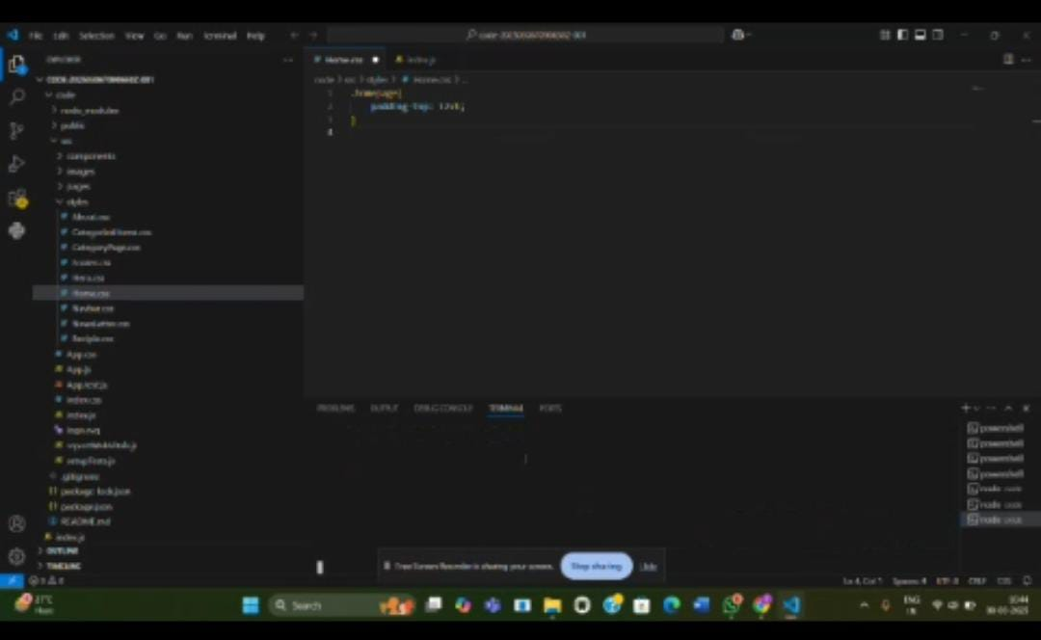

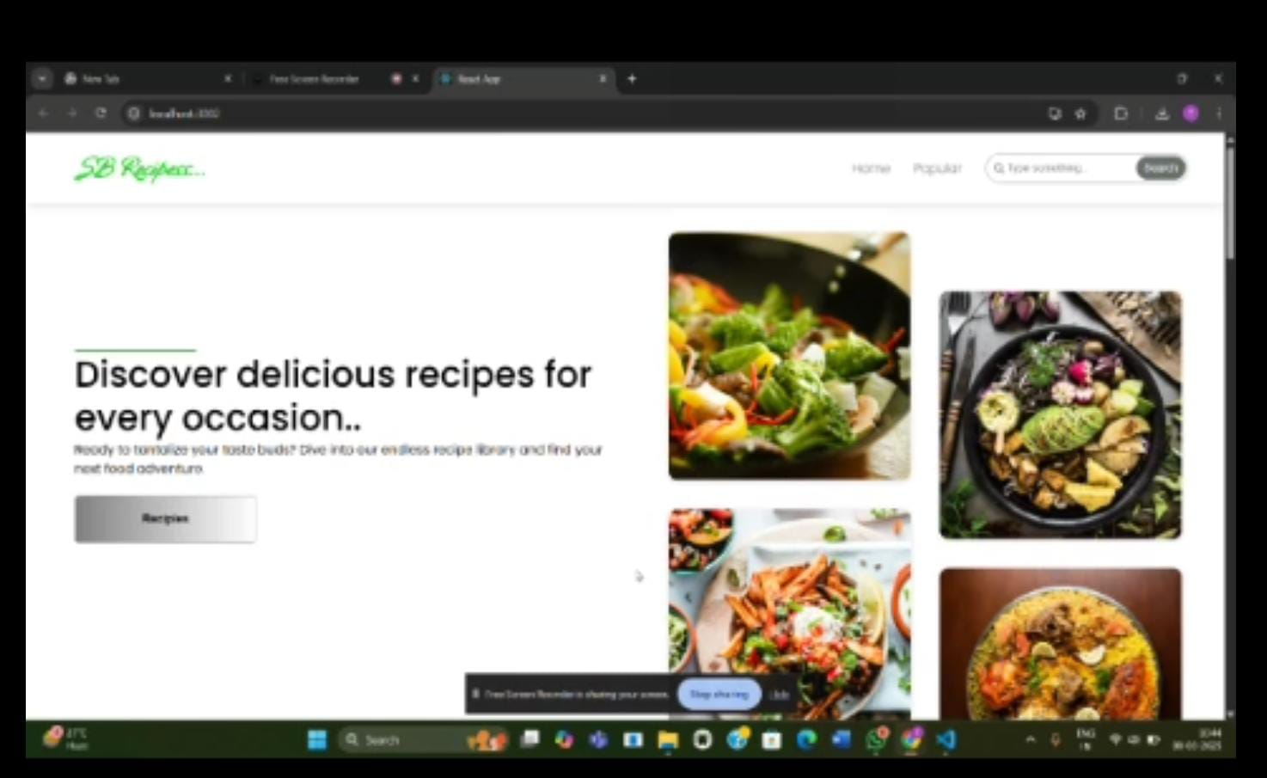

**KNOWN ISSUES**

**1. Recipe Search Delay**

Issue: Search results take longer to appear.

Cause: Large recipe database or inefficient filtering.

Fix: Optimize search queries and indexing.

**2. Image Loading Issues**

Issue: Recipe images load slowly or fail to display.

Cause: Large image files or slow server response.

Fix: Use optimized image formats (WebP, JPEG) and lazy loading.

**3. Missing Ingredients in Some Recipes**

Issue: Some recipes don’t display full ingredient lists.

Cause: Data entry errors or API failures.

Fix: Implement validation and fallback data handling.

**4. Mobile Responsiveness Bugs**

Issue: UI elements break on small screens.

Cause: Poor CSS styling or missing media queries.

Fix: Ensure proper responsive design with CSS Flexbox/Grid.

**FUTURE ENHANCEMENT**

**1. AI-Powered Recipe Suggestions**

Personalized recommendations based on user preferences and past searches.

**2. Voice Command Integration**

Hands-free navigation for reading recipes while cooking.

**3. Shopping List Generator**

Automatically creates a grocery list based on selected recipes.

**4. Meal Planning Feature**

Weekly meal planner with calorie tracking and diet customization.

**5. Video Tutorials & Step-by-Step Guides**

Embedded cooking videos for a more interactive experience.

**6. Multi-Language Support**

Translations for recipes to reach a global audience.

**7. Community & Social Sharing**

Users can share recipes, leave reviews, and join cooking groups.