PRELIMINARY DESIGN REPORT
Autonomous Catamaran Surface Vehicle (ASV)

1. Introduction and Mission Overview
This report documents the preliminary design of an autonomous surface vehicle (ASV).
The vehicle is constrained to a maximum design envelope of approximately 1 m × 1 m in x-y plane and a total mass budget of 9-10 kg (hulls, structure, battery, thrusters and electronics stack combined). This report captures three linked design decisions that follow directly from that problem statement and mass budget -
- The choice of hull configuration from options like monohull, trimaran, or catamaran.
- The principal hull dimensions and the hydrodynamic reasoning (Froude number, wave-resistance theory, planing-onset criteria) used to size them.
- The choice between a displacement-type and a planing-type hull section, and the propulsion/battery pairing (APISQUEEN U5 vs. U15) that follows from it.

2. Hull Configuration Trade Study: Monohull vs. Trimaran vs. Catamaran
Three hull configurations were evaluated against the mission drivers identified like transverse (roll) stability without ballast, low wetted-surface resistance at small scale, a usable flat payload area for the electronics stack, straightforward steering using twin thrusters rather than a rudder, and fabrication complexity consistent.

2.1 Option Summaries

Monohull
A single slender or semi-planing hull carrying the full displacement. Simplest to fabricate and the lowest wetted-surface option for a given length if beam is kept narrow, but at this scale a monohull has a small waterplane second moment of area, so transverse stability (metacentric height) is low unless beam is increased or ballast is added and in both cases the mass and footprint budget is increasing. Steering and station-keeping also require either a rudder or a single centreline thruster with limited yaw authority.

Trimaran
A slender main hull with two smaller amas (outriggers) connected by crossbeams or frames, providing stability without carrying the full displacement in a wide single hull. This gives good resistance characteristics at speed, but at 1 m scale the two sets of cross-beams needed (main-to-amas on both sides) add structural mass and joints relative to the size of the craft, the amas are usually only partially loaded so they are not natural locations for the main mass items (battery, thrusters), and mounting two thrusters for differential steering is also not possible because the amas are not normally where propulsion is placed. The payload area is also split across three hulls rather than concentrated on one bridge deck.

Catamaran
Two hulls of equal displacement, rigidly connected by a bridge-deck/frame. Because the two hulls are separated by a distance much larger than the beam of either hull, the waterplane second moment of area which therefore gives transverse stability by a large amount by just adding little more mass, without ballast. The bridge deck between the hulls is a grid shape frame for the electronics stack and payload support. Placing one thruster in (or immediately left of) each hull gives a wide thrust moment arm, so differential thrust alone provides strong, low-complexity yaw control with no rudder or servo needed. The main drawback is wave interference between the two hulls at certain speeds, and the need for a cross-structure connecting them; both are manageable through the separation ratio which we calculated and is shown in section 3.

2.2 Comparative Assessment
Criterion | Monohull | Trimaran | Catamaran
Transverse stability (no ballast) | Low – narrow beam | High – via amas | High – via hull separation
Wetted surface (resistance) | Low, if narrow | Low (main hull slender) | Moderate (2 slender hulls)
Payload + electronics stuff | Cramped, low freeboard | Split across 3 hulls | Open bridge deck between hulls
Steering with twin thrusters | Poor yaw arm | Awkward (amas off axis) | Excellent – wide thrust arm
Structural complexity | Lowest | Highest (2 sets of beams) | Moderate (1 cross-structure)
Footprint efficiency (1 m x 1 m) | Good | Poor – amas waste width | Good – uses full beam
Table 1. Qualitative trade-off between the three hull configurations considered.

2.3 What we Selected finally
The catamaran configuration is selected. It gives adequate stability without ballast, uses the full available beam productively (rather than losing width to outriggers as in a trimaran), places the electronics/battery stack on a single accessible bridge deck, and pairs naturally with a twin-thruster, rudderless steering scheme which is also the propulsion arrangement. The trade accepted is a higher wetted surface than an optimised trimaran main hull and the need to manage hull-to-hull wave interference which we also accounted later in this report.

2.4 Quantifying the Stability Advantage
Section 2.2 asserted that hull separation gives the catamaran high transverse stability “without ballast.” This can be shown directly using the standard metacentric-radius relation used to size initial stability in naval architecture:
BM = Iᴛ / ∇
where Iᴛ is the transverse second moment of area of the waterplane about the vessel's centreline and ∇ is the displaced volume. For a catamaran, Iᴛ is dominated by the parallel-axis term of the two hulls sitting a half-separation S/2 either side of the centreline, rather than by each hull's own (small) waterplane inertia:
Iᴛ ≈ 2 × [ A_{wp} × (S/2) ²] with A_{wp} = C_{wp}× L × B
Taking a waterplane coefficient C_{wp} ≈ 0.7, each demi hull’s waterplane area is A_{wp} = 0.7 × 0.95 × 0.10 = 0.0665 m². With S = 0.55 m, the parallel-axis term per hull is 0.0665 × (0.275) ² = 0.00503 m⁴, giving Iᴛ ≈ 2 × 0.00503 = 0.01006 m⁴. At the 9 kg baseline mass (∇ = 0.009 m³), this gives:
BM (catamaran) = 0.01006 / 0.009 ≈ 1.12 m
For comparison, a single hull carrying the same total waterplane area (i.e. no separation term at all, B_{eq} = 0.20 m so that L × B_{eq} × C_{wp} equals the catamaran's combined 0.133 m²) has Iᴛ ≈ (1/12) × L × B_eq³ = (1/12) × 0.95 × 0.20³ = 6.33 × 10⁻⁴ m⁴, giving BM (monohull-equivalent) = 6.33×10⁻⁴ / 0.009 ≈ 0.070 m.
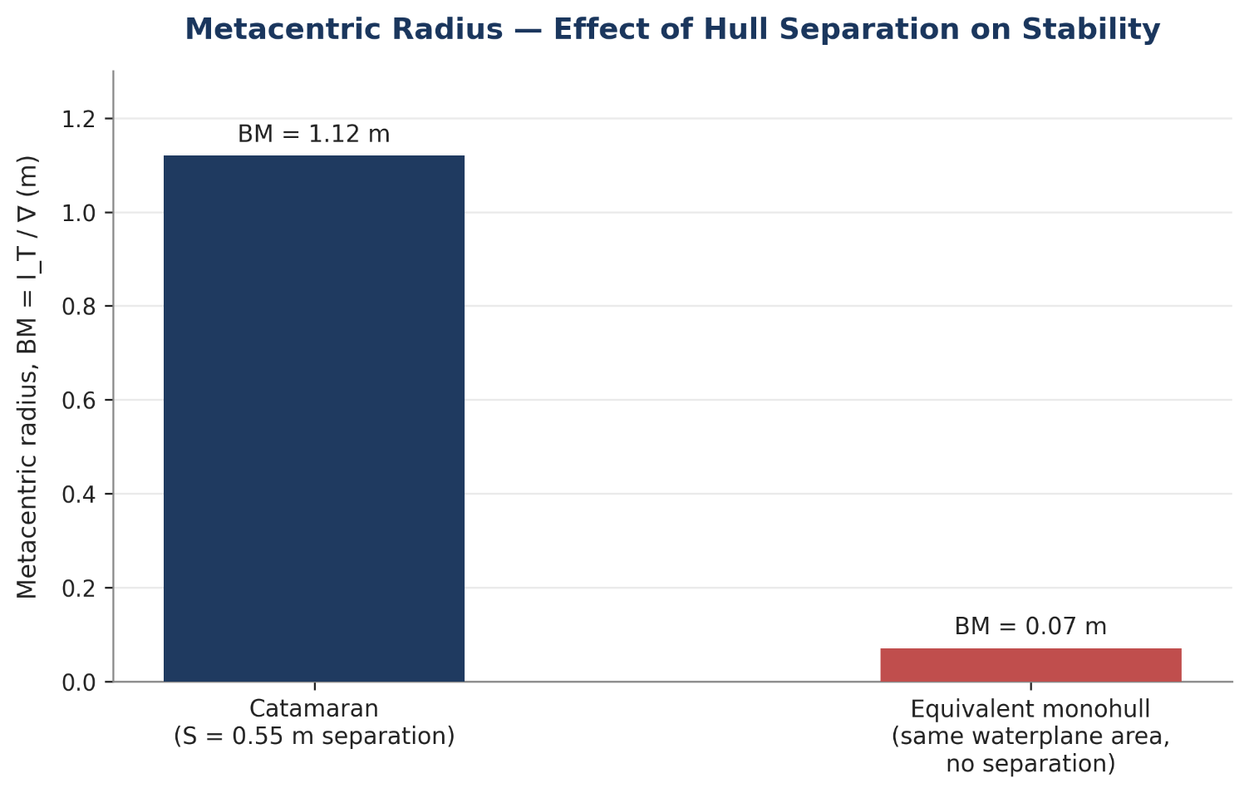
Figure 1. Metacentric radius, catamaran vs. an equivalent single hull with the same total waterplane area.
The catamaran's metacentric radius is ≈ 16× larger than the monohull-equivalent case, purely because of hull separation without adding extra material, ballast, or waterplane area. Since GM = KB + BM − KG, a larger BM gives a much larger righting-moment margin for the same vertical centre-of-gravity height, which is the quantitative basis for the qualitative stability claim in Section 2.2, and part of the reasoning behind keeping the electronics stack low in the frame (Section 6) gives a low KG combines with the already-large BM for a substantial GM.

3. Hull Principal Dimensions and Hydrodynamic Sizing
Working dimensions currently taken forward: hull (waterline) length L = 0.95 m, beam of each demi hull B = 0.10 m, and centreline-to-centreline separation between the hulls S = 0.55 m. This gives an overall beam of S + B = 0.95 m, fitting inside the 1 m x 1 m footprint constraint with margin for fenders/mounts.
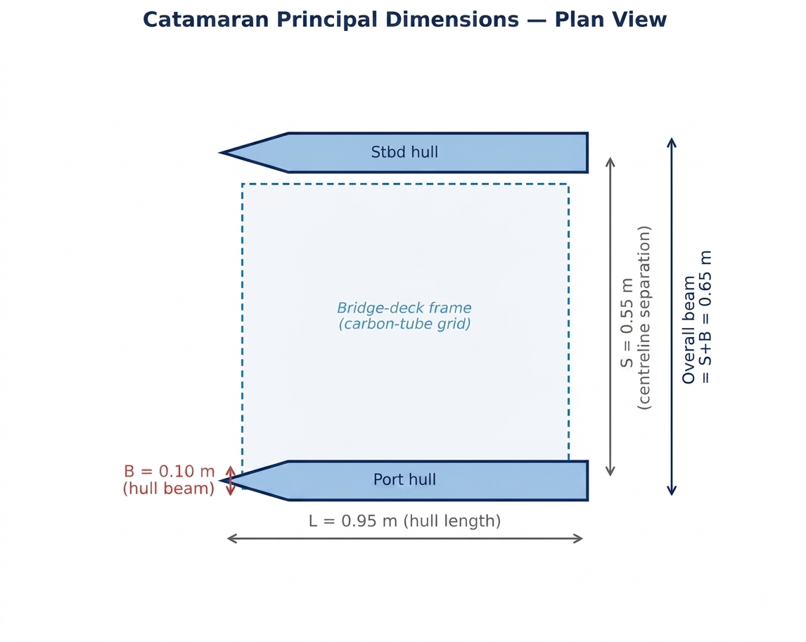

3.1 Slenderness and Hull-Separation Ratios
The Two non-dimensional ratios which we calculated before doing the speed calculations were:
- Demi hull slenderness, which is calculated by taking ratio of length of the hull to width of the hulls (L/B = 0.95 / 0.10 = 9.5). In the Multihull design, the demi hulls are typically designed in the range of L/B ≈ 8–15 to keep the resistance due to waves low; our ratio sits around 9.5 which is well under this band.
- Hull separation ratio, which is calculated by the ratio of distance between the centre line of both demi hulls by the length of the demi hull (S/L = 0.55 / 0.95 ≈ 0.58). In Published multihull designs practically the S/L > 0.3–0.4 to keep hull-to-hull wave interference small. Our ratio is well reasoned to keep it outside the range as our S/L is 0.58 the hulls are well outside the range where their wave systems reinforce each other destructively which will reduce our resistance, at the cost of using the full available beam an acceptable trade given the footprint limit is 1 m and this configuration still fits inside it.

3.2 Length Froude Number
The length Froude number, F_{n} = V / √(gL), indicates which resistance regime the hull is operating in. With L = 0.95 m, √(gL) = √ (9.81 × 0.95) = 3.05 m/s.
Thruster Configurations | V (m/s) (Approximately by stimulation) | Fn = V / √(gL) | Regime in which we can move according to the Fronde number
Twin Apis queen U5 configuration | 3.5 | 1.15 | Between planing and semi-planing regime
Twin Apis queen U15 configuration | 5.5 | 1.81 | Fully planing regime
Table 2. Length Froude number for the two propulsion configurations under study.
For comparison, a conventional displacement monohull is generally limited to F_{n} ≈ 0.4 (the classical “hull speed”), beyond which wave-making resistance rises very steeply unless the hull can generate dynamic lift and reduce its wetted length. Both propulsion options place this vehicle at F_{n} well above 1 which make us go outside the regime a pure displacement hull is efficient in, and inside the regime a planing or semi-planing hull is designed for. This is the primary hydrodynamic argument for treating the hull form as an open question between displacement and planing rather than defaulting to a displacement hull.

3.3 Wave Making Resistance
According to the Classical wave-resistance theory (thin-ship / Michell-type reasoning, and standard resistance curves for small craft) shows that the residuary resistance coefficient rising to a first local maximum (hump Regime) near Fn ≈ 0.4–0.5, and typically a second, usually smaller, hump near Fn ≈ 0.6–0.7, as successive transverse wave crests interfere constructively with the hull's own wave train. A craft that stays a pure displacement form and is pushed to Fn > 1 continues to fight this rising drag with no relief. A craft with a hull form capable of generating dynamic (planing) lift, on the other hand, rises and shortens its wetted length as speed increases through the hump band, which is what allows drag to fall again beyond Fn ≈ 1.0–1.2 rather than keep climbing. Because both candidate propulsion configurations sit at Fn = 1.15 and Fn = 1.81 which almost around or even beyond the hump band which means the resistance argument favours a hull that can generate lift at these speeds over one that cannot.
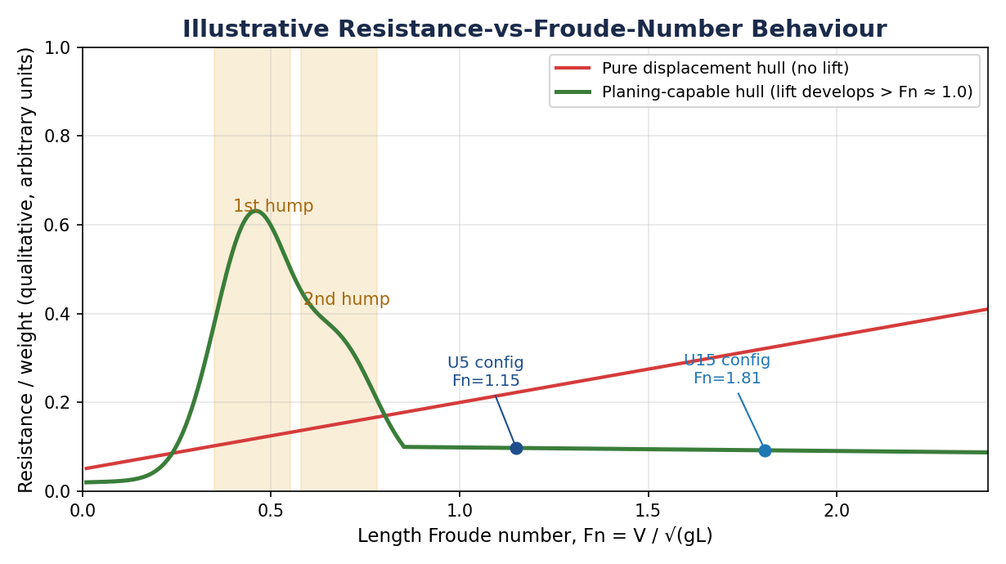

3.4 Planing-Onset Check (Beam Froude Number)
A second, independent check uses the beam Froude number, Fnᵦ = V / √(gB), which is closer to the parameter planing-hull theory (Savitsky-type criteria) uses, since dynamic lift scales with the wetted beam, not the length. With B = 0.10 m, √(gB) = √ (9.81 × 0.10) = 0.99 m/s.
Design speed | V (m/s) | Fnᵦ = V / √(gB)
Twin-U5 configuration | 3.5 | 3.53
Twin-U15 configuration | 5.5 | 5.56
Table 3. Beam Froude number
Both configurations sit far above the Fnᵦ ≈ 1.0–1.3 planing-onset threshold. A volumetric check gives the same conclusion as taking a baseline mass of 9 kg (mid-point of the 8–10 kg budget), displaced volume ∇ = 9 kg / 1000 kg/m³ = 0.009 m³, so ∇^{1/3} = 0.208 m and √(g·∇^{1/3}) = 1.43 m/s. The volumetric Froude number Fn∇ = V/√(g·∇^{1/3}) is then 2.45 at 3.5 m/s and 3.85 at 5.5 m/s, both comfortably above the Fn∇ ≈ 1.0–1.5 range where small craft are generally considered to transition onto the plane.
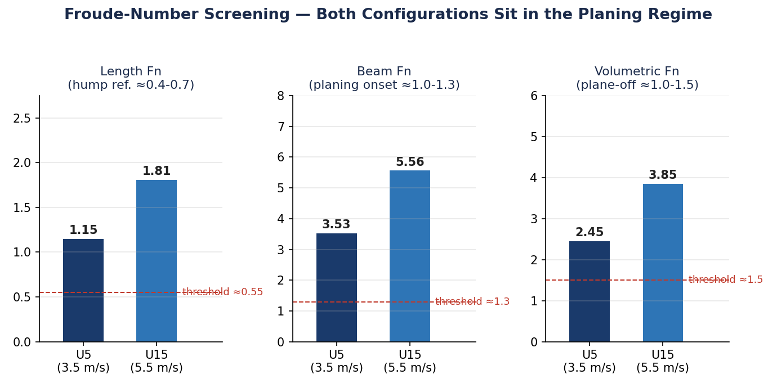

3.5 Displacement / Draft Check
Independently of which hull form is finally chosen, the hull must displace enough water at rest (zero speed, hovering/station-keeping) to float the vehicle. Approximating each demi hull as a prismatic form with block coefficient Cb ≈ 0.55 (typical for a small boat-shaped hull), the static draft is:
d = (M / 2000) / (L × B × Cb)
Total vehicle mass, M | Displaced volume per hull (taking density as 1000 kg/m³) | Static draft, d (Cb = 0.55)
8 kg | 4 L | 5.7 cm
9 kg (baseline) | 4.5 L | 6.6 cm
10 kg | 5 L | 7.6 cm
Table 4. Static draft across the 8–10 kg mass budget, per demi hull, at rest.
A static draft of roughly 8–10 cm against a demi hull beam of 10 cm means the hull sits nearly as deep as it is wide at rest, which is workable, but it leaves limited margin before freeboard is lost to wave action or trim. Two design responses follow directly from this: (a) hull depth (freeboard) should be sized at roughly 1.5–2× the static draft not just to the waterline, and (b) keeping total mass toward the lower end of the 8–10 kg budget directly reduces draft and improves freeboard margin which this is one of the reasons the lighter battery configurations remain attractive even though they carry less energy.

3.6 Constructive / Destructive Interference Between Hulls
Section 3.1 set the separation ratio S/L based on a standard rule of thumb (S/L > 0.3–0.4). That rule of thumb can be derived more directly from the transverse wave system each hull generates. In deep water, a hull moving at speed V generates a transverse wave train of wavelength:
λ = 2πV² / g
The two hulls' wave systems reinforce (constructive interference — added resistance) when the hull separation is close to an integer number of wavelengths, S ≈ nλ, and partially cancel (destructive interference — reduced resistance) near the half-integer case, S ≈ (n+½) λ. Substituting λ = 2πV²/g and Fn = V/√(gL), the first constructive condition (n = 1, S = λ) occurs at:
Fn* = √ (S / (2πL)) = √ (0.55 / (2π × 0.95)) = √0.1424 ≈ 0.31
This is, notably, almost exactly the classical first hump Froude number identified in Section 3.3 by hull-separation interference and the hull's own wave-making hump reinforce each other at the same speed for this geometry. At the operating speeds being used (3.5 and 5.5 m/s, Fn = 1.15 and 1.81), λ evaluates to 7.85 m and 19.36 m respectively which is both far larger than S = 0.55 m. Because λ grows with V², the separation-to-wavelength ratio falls monotonically past Fn ≈ 0.31, so no further constructive-interference speed is crossed on the way up to the design speed range and the vehicle passes through the one interference-critical speed during acceleration/hump transition and then operates well clear of it.

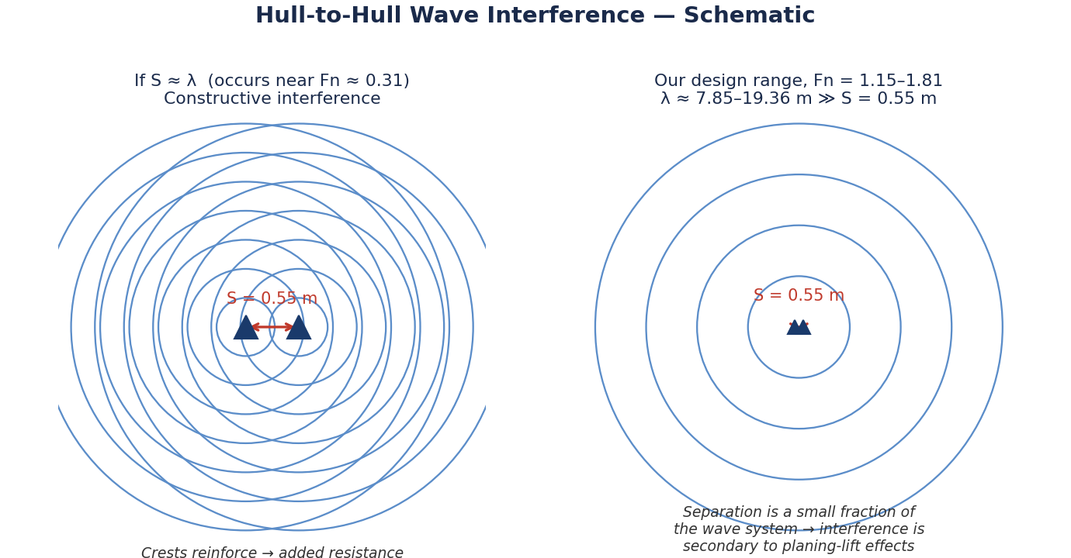
Figure 6. Left: hull separation comparable to the transverse wavelength (worst-case constructive interference, near Fn ≈ 0.31). Right: at the design speed range, wavelength greatly exceeds hull separation.
This gives a second, independent justification for S = 0.55 m beyond the qualitative S/L > 0.3–0.4 guidance in Section 3.1: the interference-critical speed it implies (Fn ≈ 0.31) coincides with the hump band the vehicle is deliberately designed to move past, rather than sitting inside the 3.5–5.5 m/s cruise range.

4. Hull Form Selection: Displacement vs. Planing Section
Previously, we showed that the operating speed range sits well beyond the classical displacement hull-speed limit for a 0.95 m waterline length, on three independent Froude criteria. This section lays out the displacement and planing options directly, since both are still under active consideration for the demi hull cross-section.

4.1 Displacement Hull
A rounded-bilge or semi-round hull section, designed to always be supported by buoyancy (Archimedean lift) rather than dynamic lift.
- Advantages: simplest to fabricate and to model; efficient and low drag at low Fn; motion is smooth and predictable, which is favourable for sensor stability during a survey; forgiving of small errors in weight estimation, since it does not depend on reaching a lift-off speed.
- Drawbacks: resistance rises steeply once pushed toward and through the hump band (Fn ≈ 0.4–0.7); at the Fn = 1.15–1.81 range implied by the thrusters already being costed, a pure displacement hull would be operating well outside its efficient range, demanding more thrust/power than necessary for the achieved speed, which shows up directly as reduced range for a given battery.

4.2 Planing Hull
A flat or shallow-deadrise hull section designed to generate dynamic lift and partially or fully rise out of the water above a threshold speed.
- Advantages: resistance falls (relative to weight) once fully planing, matching the high Fnᵦ and Fn∇ values calculated in Section 3.4; better suited to the higher-speed U15 configuration (5.5 m/s) where the craft is deep into the planing regime; shorter wetted length at speed reduces skin-friction drag as well as wave drag.
- Drawbacks: at low speed / at rest (station-keeping, start of each survey run) it behaves as a displacement hull and must still satisfy the draft/freeboard check; requires more thrust margin to get through the hump/transition band before lift develops; flat sections are less forgiving in chop and more sensitive to trim and centre-of-gravity placement, which constrains where the battery and electronics stack (Section 6) can sit; generally a harder hull to fabricate accurately at 1 m scale than a rounded displacement form.

4.3 Comparison
Criterion | Displacement hull | Planing hull
Efficiency at Fn < 0.5 | High | Low (form not yet lifting)
Efficiency at Fn > 1 (our range) | Low – drag keeps climbing | High – drag falls once on the plane
Fabrication complexity | Lower | Higher (flat panels, deadrise, chines)
CG / trim sensitivity | Low | High
Behaviour at rest / station-keeping | Native condition | Reverts to displacement behaviour
Match to U5 config (3.5 m/s, Fn 1.15) | Marginal | Good
Match to U15 config (5.5 m/s, Fn 1.81) | Poor | Very good
Table 5. Displacement vs. planing hull section, evaluated against the calculated Froude numbers.

4.4 Current Position
Both options remain open at this preliminary stage. The Froude-number evidence in Section 3 favours a planing or semi-planing (warped-bottom / shallow deadrise with a displacement-form bow) hull, particularly if the U15 configuration is selected, since a pure round-bilge displacement hull would be working against rising wave resistance across the entire operating speed range. The displacement hull remains the lower-risk fallback: it is simpler to build correctly at this scale, is not sensitive to CG placement, and is adequate if the lower-speed U5 configuration (Fn = 1.15, only just past the hump band) is the one carried forward. The recommendation for the next design phase is to proceed with a semi-displacement hull which is a moderately vied, hard-chine section with enough flat area aft to develop lift at 3.5–5.5 m/s, but retaining enough displacement-hull buoyancy forward and at rest to satisfy the draft/freeboard numbers in Table 4 and to confirm the choice with tank-test-scale resistance estimates once one propulsion configuration is locked in.

4.5 Hull Material Options
Independently of whether the section is displacement, planing, or semi-displacement, six hull material/construction routes are under consideration. No material has been locked in yet; the comparison below is what the decision will be made against.
Material | Approx. density | Fabrication | Repairability | Water resistance | Relative cost
Fibreglass (GRP laminate over a mould) | ≈1750 kg/m³ | Moderate (needs a mould/plug) | Good and patchable with resin | Excellent | Moderate
Marine plywood + GRP sheathing | ≈620 kg/m³ (core) | Easier (sheet construction) | Good | Good if sheathing intact | Low–moderate
3D-printed shell (PETG/Nylon) | ≈1270 kg/m³ | Easiest (direct from CAD) | Moderate (reprint sections) | Good (PETG); needs sealing | Low (in-house)
Aluminium sheet | ≈2700 kg/m³ | Harder (welding/riveting) | Moderate (needs welding) | Good if coated (else galvanic risk) | Moderate–high
HDPE / rotomolded plastic | ≈950 kg/m³ | Hard to prototype in-house | Good – weldable plastic | Excellent | High
Foam-filled floats / pontoons | ≈40 kg/m³ (foam core) | Simple (off-the-shelf floats) | Poor (hard to repair cleanly) | Excellent, inherently buoyant | Low
Table 6. Hull material/construction options under consideration (typical values; final selection pending).
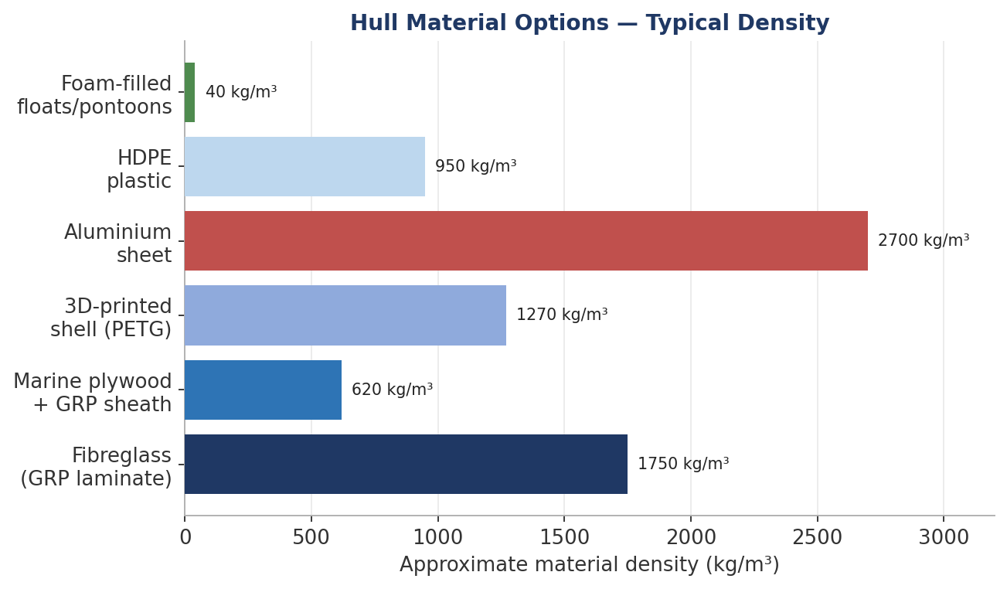
Figure 7. Density comparison across the six hull material options — directly affects the draft/freeboard result in Table 4.
Density matters here beyond raw material choice as a denser hull shell eats into the mass budget used for draft/freeboard in Section 3.5, so aluminium or a thick fibreglass laminate leave less mass margin for battery and payload than plywood, 3D-printed shells, or foam floats. Foam-filled floats and HDPE offer the best inherent buoyancy/corrosion combination but are the least practical to fabricate to the specific 0.95 m × 0.10 m demi hull shape in-house; fibreglass over a 3D-printed or foam plug is the current front-runner as a balance of shape control, water resistance, and repairability, but this is explicitly not yet decided.

4.6 Hull Manufacturing

We are currently favouring 3D-printed + fiberglass and 3D-printed reusable mould + fiberglass over aluminium, marine plywood, etc. because they offer low weight, easy manufacturing, and high geometric freedom.

Properties | 3D print + fiberglass | 3D mould + fiberglass
Final weight | ~0.9–1.6 kg/hull | ~0.8–1.3 kg/hull
Strength/weight | Good | Excellent
Stiffness/weight | Good | Excellent
Geometry | Excellent | Excellent
Impact resistance | Excellent | Good
Manufacturing | Simpler More | involved initially
Iteration | Very easy | Slower
Identical hulls | Good | Excellent
Internal features | Excellent | Moderate
Multiple hulls | Less attractive | Very attractive

3D print + fiberglass: print the complete hull, bond sections, then apply ~1–2 layers of 200 GSM fiberglass, with extra reinforcement at mounts. The plastic remains permanently inside, making it tougher and easier to build, but heavier.
3D mould + fiberglass: print the exact hull as a reusable mould, smooth/seal it, apply release agent, lay ~2–3 layers of 200 GSM fiberglass + epoxy, cure, remove the shell, and repeat. The plastic isn't part of the boat, giving a lighter, stiffer composite hull and highly identical hulls.
Current preference: for one-off/rapid prototyping, 3D print + fiberglass. For the final competition hulls, especially since we need two identical hulls, reusable 3D mould + fiberglass is the more performance-oriented option.

5. Propulsion Trade Study: APISQUEEN U5 vs. U15

5.1 Thruster Specifications
Manufacturer data for the two thruster models under consideration is summarised below.
Parameter | APISQUEEN U5 | APISQUEEN U15
Rated power | ≈800 W | ≈650 W
Voltage range | 12–24 V (up to 29 V charged) | 24–36 V
Thrust (single unit) | ≈5–7 kgf, voltage-dependent | Higher thrust/W; used at ≈9 kgf
Mass (single thruster, as used in range table) | ≈1.15 kg | ≈1.5 kg
Approx. unit cost | ≈₹8,000 | ≈₹13,500
Table 6. APISQUEEN U5 vs. U15 — key parameters used in the trade study (manufacturer listings; mass/cost figures cross-checked against whiteboard notes).
The design-session notes record that replacing a U5 pair with a U15 pair increases achievable runtime by a factor of ≈ 1.21x (17/14) for a comparable battery, i.e. the U15's higher propulsive efficiency (thrust delivered per watt at the speeds this vehicle operates at) more than offsets its lower rated power and higher unit cost and mass.

5.2 Battery and Propulsion Configuration Options
Six configurations were costed and weighed during the trade study, trading battery chemistry/capacity against thruster choice, achievable speed, endurance and cost.
S.No. | Battery | Mass | Capacity | Thruster | Endurance | Speed | Est. cost
1 | 1× LiPo | 2.6 kg | 22 Ah | 2× U5 (mini) | 39 min | 3.5 m/s | ₹17,400
2 | 2× LiPo | 5.2 kg | 44 Ah | 2× U5 (mini) | 78 min | 3.5 m/s | ₹34,800
3 | 2× LiPo | 4.8 kg | 32 Ah | 2× U5 (mini) | 56 min | 3.5 m/s | ≈₹32,840
4 | 2× Li-ion | 3.7 kg | 40 Ah | 2× U5 (mini) | 67 min | 3.5 m/s | ₹22,000
5 | 1× LiPo (10S) | 3.6 kg | 20 Ah | 2× U15 | 30 min | 6.5 m/s | ₹17,500
6 | 1× LiPo (10S) | 3.6 kg | 20 Ah | 1× U15 | 51 min | 4 m/s | ₹17,500
Table 7. Battery/propulsion configuration options from the initial trade study.

5.3 Range Sensitivity considering Two Batteries, Two Thrusters
A follow-on sensitivity study, holding the vehicle at two batteries and two thrusters, compared achievable one-way range and total system cost for the U5 (≈1.15 kg/thruster) and U15 (≈1.5 kg/thruster) options across four hull/loading variants. These figures are also transcribed from whiteboard notes and should be treated as indicative pending a written re-check.
Variant | U5 range | U5 cost | U15 range | U15 cost
1 | 8.15 km | ≈₹51.5k | 9.89 km | ≈₹62.5k
2 | 16.3 km | ≈₹51.5k | 19.79 km | ≈₹62.5k
3 | 11.76 km | ≈₹49k | 14.28 km | ≈₹60k
4 | 14 km | ≈₹60k | 17 km | ≈₹71k
Table 8. Range/cost sensitivity, 2-battery / 2-thruster configurations

5.4 Selection Guidance
The U5 pairing is the lower-risk, lower-cost option and, at 3.5 m/s (Fn = 1.15), sits just past the resistance hump rather than deep in the planing regime as it is compatible with either a displacement or a semi-displacement hull. The U15 pairing costs and weighs more per thruster but reaches 5.5 m/s (Fn = 1.81) and delivers materially better runtime for a given battery once past the transition band provided the hull is shaped to generate the lift the Section 4 analysis shows is available at that speed. Because the range and cost advantage of U15 only fully materialises with a hull that planes, the thruster decision and the hull-form decision in Section 4 should be finalised together rather than independently: U5 + semi-displacement hull is the conservative pairing; U15 + planing/semi-planing hull is the higher-performance pairing carried as the current preferred direction.

6. Upper Frame and Electronics Stack Concept
The superstructure connecting the two hulls (bridge deck) is currently planned as a lightweight spaceframe built from round carbon-fibre tube, with the electronics stack (ESCs, GPS/compass, and the main battery pack) mounted within the frame at the centreline, between the hulls.
Rationale for a carbon-round tube frame over a moulded or sheet bridge deck:
- High stiffness-to-weight ratio, keeping the added structural mass small relative to the 8–10 kg total mass budget.
- Corrosion resistance in the humid, over-water operating environment, unlike untreated aluminium or steel fasteners/frames.
- Round-tube construction can be assembled with simple clamped or 3D-printed node joints, which keeps fabrication accessible at this scale and allows the frame geometry to be revised quickly as the hull-form decision (Section 4) is finalised.
- An open lattice, rather than a closed deck, keeps the electronics stack ventilated and leaves the underside of the bridge deck clear of the water surface, reducing the risk of slamming loads onto electronics in chop.
- Mounting the heaviest single item (the battery) at the frame centreline, symmetric about both the longitudinal and transverse axes, keeps the vehicle's centre of gravity centred between the hulls and close to the design waterline which is important for trim control if the planing hull direction (Section 4) is confirmed, since planing performance is sensitive to CG position.
The frame geometry, tube diameter/wall thickness and node design have not yet been sized against a structural load case (impact, docking, and the thrust/moment reactions from the two thrusters) and are flagged as an open item for the next design iteration.
The superstructure connecting the two hulls (bridge deck) is currently planned as a lightweight spaceframe / grid structure, with the electronics stack (flight controller, ESCs, telemetry/RF, GPS/compass, and the main battery pack) mounted within the frame at the centreline, between the hulls. Four rod/tube materials are under consideration for the grid members; none is finalised.

6.1 Frame Material Options
Material | Density | Young's modulus, E | Specific stiffness E/ρ | Corrosion resistance | Ease of jointing
Carbon-fibre rod (pultruded) | ≈1600 kg/m³ | ≈130–230 GPa | Highest | Immune | Harder – clamps/adhesive
Aluminium rod (6061-T6) | ≈2700 kg/m³ | ≈69 GPa | Moderate | Good if anodised | Easy – weld/rivet/clamp
3D-printed rod/lattice (FDM PETG) | ≈1250 kg/m³ | ≈2 GPa | Low | Good (PETG) | Easy – printed nodes
Plastic rod (nylon/PVC) | ≈1150 kg/m³ | ≈2.5 GPa | Low | Immune | Easy – low load only
Table 10. Frame material options under consideration for the grid structure.
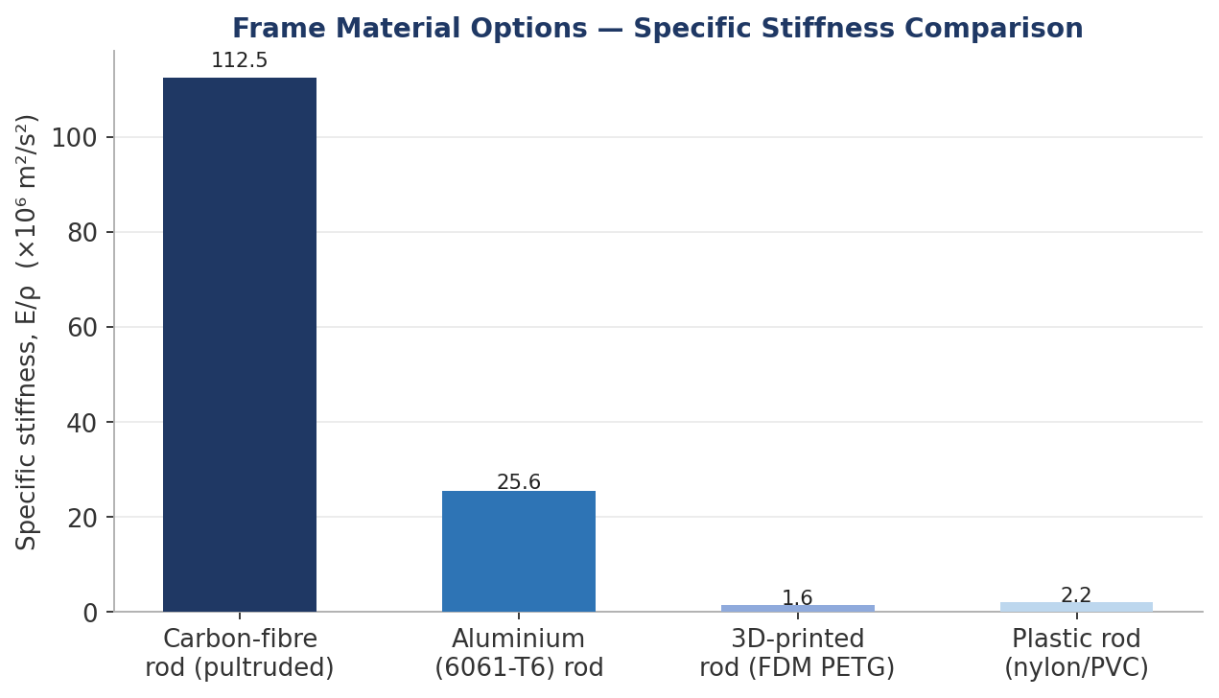
Figure 8. Specific stiffness (E/ρ) — carbon rod delivers roughly 3x the stiffness-per-unit-mass of aluminium and over 30x that of 3D-printed or plastic rod, which is the quantitative basis for preferring carbon for the primary grid members.
Carbon rod is the leading candidate for the primary load-bearing members on stiffness-per-mass grounds alone; aluminium remains a fallback where jointing simplicity or lower cost outweighs the stiffness penalty; 3D-printed and plastic rod are attractive for secondary, lightly loaded members (sensor mounts, cable trays, non-structural brackets) where their ease of fabrication and integrated-joint geometry matter more than raw stiffness.

7. Summary of Current Design Point and Open Items

7.1 Current Design Point
- Hull configuration: catamaran (Section 2).
- Principal dimensions: L = 0.95 m, B = 0.10 m per demi hull, S = 0.50 m centreline separation, overall beam 0.95 m (Section 3).
- Hull form: semi-displacement / semi-planing section recommended by the Froude-number analysis, with the final displacement-vs-planing call tied to the thruster decision (Section 4).
- Hull material: not yet decided, options in considerations are fibreglass, marine plywood + fibreglass sheathing, 3D-printed shell, aluminium, HDPE plastic, and foam-filled floats all remain open, compared qualitatively and by density in Section 4.4.
- Propulsion: APISQUEEN U5 (conservative) or U15 (performance) pairing, both catalogued with battery options in Section 5; U15 + planing hull is the currently preferred high-performance direction.
- Structure: grid-style space frame bridge deck (carbon rod preferred on specific-stiffness grounds; aluminium, 3D-printed, and plastic rod remain fallback/secondary options) carrying a centreline-mounted electronics/battery box that locks at the top rail and hangs low in the frame for a low CG (Section 6).

7.2 Open Items for Next Iteration
- Run a resistance estimate (e.g. Savitsky planing-resistance method for the planing case, and a standard series/regression method for the displacement case) at the actual candidate hull lines, rather than the Froude-number screening used here, to confirm the Section 4.4 hull-form recommendation.
- Lock the hull material (Section 4.4) once the hull-form decision is confirmed — material choice affects achievable shape (moulded vs. sheet vs. printed) as much as the reverse.
- Finalise total vehicle mass once a battery/thruster pairing is locked and re-run the draft/freeboard check in Table 4 against that mass.
- Finalise total vehicle mass once a battery/thruster pairing is locked and re-run the draft/freeboard check in Table 4 against that mass. Size the carbon-tube frame (diameter, wall thickness, joints) against thruster thrust/moment reactions and an assumed impact/docking load case.
- Confirm the coverage-pattern range calculation against the final site survey pattern and required overlap between tracks.

