

МІНІСТЕРСТВО ОСВІТИ І НАУКИ УКРАЇНИ

НАЦІОНАЛЬНИЙ ТЕХНІЧНИЙ УНІВЕРСИТЕТ УКРАЇНИ

“КИЇВСЬКИЙ ПОЛІТЕХНІЧНИЙ ІНСТИТУТ

імені ІГОРЯ СІКОРСЬКОГО”

Факультет прикладної математики

Кафедра програмного забезпечення комп’ютерних систем

**Лабораторна робота №** **6**

з дисципліни “Математичні та алгоритмічні основи комп’ютерної графіки”

|  |  |  |  |
| --- | --- | --- | --- |
| Виконав  студент III курсу  групи КП-82  Мельничук Олексій Геннадійович  (*прізвище, ім’я, по батькові*)  варіант № 12 |  |  | Зарахована  “____” “____________” 20___ р.  викладачем  Шкурат Оксаною Сергіївною (*прізвище, ім’я, по батькові*) |

Київ 2021

**Тема**:Анімація тривимірних об’єктів

**Мета**: Навчитися анімувати складні об’єкти тривимірної сцени.

**Завдання**

Виконати анімацію тривимірної сцени за варіантом.

**Код програми**

|  |
| --- |
| **man.java** |
| package lab6;  import javax.vecmath.*;  import com.sun.j3d.utils.universe.*;  import javax.media.j3d.*;  import com.sun.j3d.utils.behaviors.vp.*;  import com.sun.j3d.utils.image.TextureLoader;  import javax.swing.JFrame;  import com.sun.j3d.loaders.*;  import com.sun.j3d.loaders.objectfile.*;  import java.util.Hashtable;  import java.util.Map;  import java.awt.BorderLayout;  import java.awt.Color;  import java.awt.Dimension;  import java.awt.Toolkit;  import java.io.FileNotFoundException;  import java.io.FileReader;  import java.io.IOException;  import java.util.Enumeration;  public class Bruh extends JFrame {  public Canvas3D myCanvas3D;  static BranchGroup root;  static String assetPath = "D:\\eclipse_labs\\ffs\\src\\lab6\\resources\\";  static String modelName = "belca.obj";  static String bgName = "back.jpg";  static String sword = "sword.obj";  static String swordTex = "sword.png";  static String man = "test.obj";    Dimension screenSize = Toolkit.getDefaultToolkit().getScreenSize();    static Map<String, Shape3D> nameMap;    static Scene sceneMan;  static Scene[] sceneSwords = new Scene[8];  static SimpleUniverse universe;    private void configureWindow() {  setTitle("Car Animation Example");  setSize(1280, 640);  setDefaultCloseOperation(JFrame.EXIT_ON_CLOSE);  }  private void configureCanvas() {  myCanvas3D = new Canvas3D(SimpleUniverse.getPreferredConfiguration());  System.out.printf("heigth: %s\n", SimpleUniverse.getPreferredConfiguration().getBounds().getHeight());  myCanvas3D.setDoubleBufferEnable(true);  myCanvas3D.setSize(screenSize);  getContentPane().add(myCanvas3D, BorderLayout.CENTER);  }  private void configureUniverse() {  root = new BranchGroup();  universe = new SimpleUniverse(myCanvas3D);  universe.getViewingPlatform().setNominalViewingTransform();  }    public Bruh() {  //механізм для закриття вікна та виходу з програми  this.setDefaultCloseOperation(JFrame.EXIT_ON_CLOSE);  //параметри перегляду сцени за замовчанням  myCanvas3D = new Canvas3D(SimpleUniverse.getPreferredConfiguration());  //створення SimpleUniverse (віртуального всесвіту)  SimpleUniverse simpUniv = new SimpleUniverse(myCanvas3D);  //положення глядача за замовчанням  simpUniv.getViewingPlatform().setNominalViewingTransform();  //створення сцени  createSceneGraph(simpUniv);  //додання світла у сцену  addLight(simpUniv);    //наступні рядки дозволяють навігацію по сцені за допомогою миші  OrbitBehavior ob = new OrbitBehavior(myCanvas3D);  ob.setSchedulingBounds(new BoundingSphere(new Point3d(0.0,0.0,0.0),Double.MAX_VALUE));  simpUniv.getViewingPlatform().setViewPlatformBehavior(ob);  //параметри вікна програми  setTitle("idk get a job");  setSize(700,700);  getContentPane().add("Center", myCanvas3D);  setVisible(true);  }    public static void main(String[] args)  {  Bruh alarmAnimation = new Bruh();  }  public static Scene getSceneFromFile(String location) throws IOException {  ObjectFile file = new ObjectFile(ObjectFile.RESIZE);  file.setFlags(ObjectFile.RESIZE | ObjectFile.TRIANGULATE | ObjectFile.STRIPIFY);  return file.load(new FileReader(location));  }    //в цьому методі створюються об'єкти та додаються до сцени  public void createSceneGraph(SimpleUniverse su)  {  BoundingSphere bs = new BoundingSphere(new Point3d(0.0,0.0,0.0),Double.MAX_VALUE);  BranchGroup root = new BranchGroup();  Background bg = new Background(new Color3f(-1.0f,-1.0f,1.0f));  ObjectFile f = new ObjectFile(ObjectFile.RESIZE);  sceneMan = null;  try  {  for (int i = 0; i<8; i++)  {  sceneMan = getSceneFromFile(assetPath + man);  sceneSwords[i] = f.load(assetPath + sword);  }  }  catch (Exception e)  {  System.out.println("File loading failed:" + e);  }    Hashtable manParts = sceneMan.getNamedObjects();    addAppearance(sceneMan);  Shape3D[] swordsShapes = new Shape3D[8];  Transform3D[] tfSwords = new Transform3D[8];  for (int i = 0; i<8; i++)  {  addAppearance(sceneSwords[i]);  swordsShapes[i] = (Shape3D) sceneSwords[i].getNamedObjects().get("sword");  tfSwords[i] = new Transform3D();  }    float squared = 0.353f*5;  float length = 0.5f*5;    tfSwords[0].setTranslation(new Vector3d(length, 0.0f, 0.0f));  tfSwords[1].setTranslation(new Vector3d(squared,0.0f,squared));  tfSwords[2].setTranslation(new Vector3d(0.0f, 0.0f, length));  tfSwords[3].setTranslation(new Vector3d(-squared,0.0f,squared));  tfSwords[4].setTranslation(new Vector3d(-length, 0.0f, 0.0f));  tfSwords[5].setTranslation(new Vector3d(-squared, 0.0f,-squared));  tfSwords[6].setTranslation(new Vector3d(0.0f,0.0f,-length));  tfSwords[7].setTranslation(new Vector3d(squared,0.0f,-squared));    TransformGroup[] tgSwordsTranslate = new TransformGroup[8];  TransformGroup[] tgSwordsRotate = new TransformGroup[8];  TransformGroup[] tgSwordsRotate2 = new TransformGroup[8];                                    int movesCount = 100; // moves count  int movesDuration = 500; // moves for 0,3 seconds  int startTime = 0; // launch animation after timeStart seconds    Alpha swordRot = new Alpha(movesCount, Alpha.INCREASING_ENABLE, startTime, 0, movesDuration,0,0,0,0,0);    Transform3D taleRotAxisSmall = new Transform3D();  taleRotAxisSmall.set(new Vector3d(0.0, 0.0, 0.0));//rotation axis location  taleRotAxisSmall.setRotation(new AxisAngle4d(0.0, 0.0, 0.0, Math.PI/8));    for (int i = 0; i<8; i++)  {//  tgSwordsTranslate[i] = new TransformGroup();  tgSwordsRotate[i] = new TransformGroup();  tgSwordsRotate2[i] = new TransformGroup();  tgSwordsTranslate[i].setCapability(TransformGroup.ALLOW_TRANSFORM_WRITE);  tgSwordsRotate[i].setCapability(TransformGroup.ALLOW_TRANSFORM_WRITE);  tgSwordsRotate2[i].setCapability(TransformGroup.ALLOW_TRANSFORM_WRITE);      tgSwordsRotate2[i].addChild(swordsShapes[i].cloneTree());        tgSwordsRotate[i] = rotate(tgSwordsRotate2[i], swordRot, taleRotAxisSmall);    tgSwordsTranslate[i].setTransform(tfSwords[i]);  tgSwordsTranslate[i].addChild(tgSwordsRotate[i]);  }          TransformGroup swords = new TransformGroup();    for (int i = 0; i<8; i++)  {  swords.addChild(tgSwordsTranslate[i]);  }    //  TransformGroup whiteTransXformGroup = translate(  swords,  new Vector3f(0, 0, 0));//MOVE FROM AXIS  int movesCount2 = 100; // moves count  int movesDuration2 = 8000; // moves for 0,3 seconds  int startTime2 = 50; // launch animation after timeStart seconds      Transform3D taleRotAxisBig = new Transform3D();  taleRotAxisBig.set(new Vector3d(0.0, 0.0, 0.0));//rotation axis location  taleRotAxisBig.setRotation(new AxisAngle4d(0, 1, 0, Math.PI/2));  Alpha newa = new Alpha(movesCount2, Alpha.INCREASING_ENABLE, startTime2, 0, movesDuration2,0,0,0,0,0);  TransformGroup whiteRotXformGroup = rotate(whiteTransXformGroup, newa, taleRotAxisBig);  root.addChild(whiteRotXformGroup);      TransformGroup tgMan = new TransformGroup();      Shape3D head1 = (Shape3D) manParts.get("head");  Shape3D head2 = (Shape3D) manParts.get("helmet");  Shape3D head3 = (Shape3D) manParts.get("eyes");  TransformGroup tgHead = new TransformGroup();  tgHead.addChild(head1.cloneTree());  tgHead.addChild(head2.cloneTree());  tgHead.addChild(head3.cloneTree());    Transform3D locateHead = new Transform3D();  locateHead.setTranslation(new Vector3d(0.0, 1.3757, -0.1));  tgHead.setTransform(locateHead);  TransformGroup movedHead = new TransformGroup();  movedHead.addChild(tgHead);    Alpha headAlpha = new Alpha(1, Alpha.INCREASING_ENABLE, startTime, 0, 5000 ,0,0,0,0,0);  Transform3D headRotAxis = new Transform3D();    headRotAxis.set(new Vector3d(0.0, 1.3757, -0.05));  headRotAxis.setRotation(new AxisAngle4d(0.0, 0.0, 1.0, Math.PI/2));    RotationInterpolator headRotat = new RotationInterpolator(headAlpha, movedHead, headRotAxis, 0.0f,(float) Math.PI/32);  headRotat.setSchedulingBounds(bs);  movedHead.setCapability(TransformGroup.ALLOW_TRANSFORM_WRITE);  movedHead.setTransform(headRotAxis);  movedHead.addChild(headRotat);        tgMan.addChild(movedHead);          Shape3D hand1 = (Shape3D) manParts.get("hands");  Shape3D hand2 = (Shape3D) manParts.get("palms");  TransformGroup tgHands = new TransformGroup();  tgHands.addChild(hand1.cloneTree());  tgHands.addChild(hand2.cloneTree());  TransformGroup movedHand = new TransformGroup();  Transform3D locateHand = new Transform3D();  locateHand.setTranslation(new Vector3d(0.0, 1.2957, -0.10));  movedHand.setTransform(locateHand);  movedHand.addChild(tgHands);      Alpha handAlpha = new Alpha(2, Alpha.INCREASING_ENABLE, startTime, 0, 5000 ,0,0,0,0,0);  Transform3D handRotAxis = new Transform3D();  handRotAxis.setRotation(new AxisAngle4d(0.0, 0.0, 1.0, Math.PI/2));  RotationInterpolator handRotat = new RotationInterpolator(handAlpha, tgHands, handRotAxis, 0.0f,(float)Math.PI * 2);  handRotat.setSchedulingBounds(bs);  tgHands.setCapability(TransformGroup.ALLOW_TRANSFORM_WRITE);  tgHands.addChild(handRotat);    tgMan.addChild(movedHand);            Shape3D boots = (Shape3D) manParts.get("boots");  Shape3D chest = (Shape3D) manParts.get("chest");  Shape3D skirt = (Shape3D) manParts.get("skirt");  TransformGroup tgboots = new TransformGroup();  TransformGroup tgchest = new TransformGroup();  TransformGroup tgskirt = new TransformGroup();  tgboots.addChild(boots.cloneTree());  tgchest.addChild(chest.cloneTree());  tgskirt.addChild(skirt.cloneTree());  tgMan.addChild(tgboots);  tgMan.addChild(tgskirt);  tgMan.addChild(tgchest);  root.addChild(tgMan);              root.compile();  su.addBranchGraph(root);    }      private TransformGroup translate(Node node, Vector3f vector){  Transform3D transform3D = new Transform3D();  transform3D.setTranslation(vector);  TransformGroup transformGroup =  new TransformGroup();  transformGroup.setTransform(transform3D);  transformGroup.addChild(node);  return transformGroup;  }  private TransformGroup rotate(Node node, Alpha alpha, Transform3D taleRotAxis){  TransformGroup xformGroup = new TransformGroup();  xformGroup.setCapability(  TransformGroup.ALLOW_TRANSFORM_WRITE);  RotationInterpolator interpolator =  new RotationInterpolator(alpha,xformGroup, taleRotAxis, 0.0f, (float) Math.PI*2);  interpolator.setSchedulingBounds(new BoundingSphere(  new Point3d(0.0,0.0,0.0),1.0));  xformGroup.addChild(interpolator);  xformGroup.addChild(node);  return xformGroup;  }      private TextureLoader getTextureLoader(String path) throws IOException {  ClassLoader classLoader = Thread.currentThread().getContextClassLoader();  var textureResource = classLoader.getResource(path);  if (textureResource == null) {  throw new IOException("Couldn't find texture: " + path);  }  return new TextureLoader(textureResource.getPath(), myCanvas3D);  }    private void addAppearance(Scene s){  nameMap = s.getNamedObjects();  for (String name : nameMap.keySet()) {  Shape3D car = nameMap.get(name);    Appearance carAppearance = new Appearance();  carAppearance.setTexture(getTexture(assetPath + "png//" + name + ".png"));  TextureAttributes texAttr = new TextureAttributes();  texAttr.setTextureMode(TextureAttributes.COMBINE);  carAppearance.setTextureAttributes(texAttr);  carAppearance.setMaterial(getMaterial());    car.setAppearance(carAppearance);  }  }      Texture getTexture(String path) {  TextureLoader textureLoader = new TextureLoader(path, myCanvas3D);  Texture texture = textureLoader.getTexture();  texture.setBoundaryModeS(Texture.WRAP);  texture.setBoundaryModeT(Texture.WRAP);  texture.setBoundaryColor(new Color4f(1.0f, 1.0f, 0.0f, 0.0f));  return texture;  }  private void addOtherLight() {  Color3f directionalLightColor = new Color3f(Color.BLACK);  Color3f ambientLightColor = new Color3f(Color.WHITE);  Vector3f lightDirection = new Vector3f(-1F, -1F, -1F);  AmbientLight ambientLight = new AmbientLight(ambientLightColor);  DirectionalLight directionalLight = new DirectionalLight(directionalLightColor, lightDirection);  Bounds influenceRegion = new BoundingSphere();  ambientLight.setInfluencingBounds(influenceRegion);  directionalLight.setInfluencingBounds(influenceRegion);  root.addChild(ambientLight);  root.addChild(directionalLight);  }    Material getMaterial() {  Material material = new Material();      Color3f ambient = new Color3f(1.0f, 1.0f, 1.0f);  Color3f diffuse = new Color3f(1.0f, 1.0f, 1.0f);  Color3f specular = new Color3f(1.0f, 1.0f, 1.0f);    // material.setAmbientColor(new Color3f(new Color(221, 221, 221)));  // material.setDiffuseColor(new Color3f(new Color(200, 200, 200)));  // material.setSpecularColor(new Color3f(new Color(200, 200, 200)));    material.setAmbientColor(ambient);  material.setDiffuseColor(diffuse);  material.setSpecularColor(specular);  material.setShininess(1f);  material.setLightingEnable(true);  return material;  }        //метод для генерації зовнішньої поверхні  public static void setToMyDefaultAppearance(Appearance app, Color3f col)  {  app.setMaterial(new Material(col,col,col,col,150.0f));  }    //метод для додавання освітлення  public void addLight(SimpleUniverse su)  {  BranchGroup bgLight = new BranchGroup();  BoundingSphere bounds = new BoundingSphere(new Point3d(0.0,0.0,0.0), 100.0);  Color3f lightColour1 = new Color3f(1.0f,1.0f,1.0f);  Vector3f lightDir1 = new Vector3f(-1.0f,0.0f,-0.5f);  DirectionalLight light1 = new DirectionalLight(lightColour1, lightDir1);  light1.setInfluencingBounds(bounds);  bgLight.addChild(light1);  su.addBranchGraph(bgLight);  }  } |

# 

|  |
| --- |
| **firstmainclass.java** |
| package lab5;  import com.sun.j3d.utils.universe.*;  import java.awt.Color;  import javax.media.j3d.*;  import javax.media.j3d.Material;  import javax.vecmath.*;  import javax.media.j3d.Background;  import com.sun.j3d.loaders.*;  import com.sun.j3d.loaders.objectfile.ObjectFile;  import com.sun.j3d.loaders.lw3d.Lw3dLoader;  import com.sun.j3d.utils.image.TextureLoader;  import java.awt.*;  import java.io.FileReader;  import java.io.IOException;  import java.util.Map;  import javax.swing.JFrame;  public class FirstMainClass extends JFrame {  static SimpleUniverse universe;  static Scene scene;  static Map<String, Shape3D> nameMap;  static BranchGroup root;  static Canvas3D canvas;  static String assetPath = "C:\\Users\\datru\\Desktop\\study2021\\maokg\\lab5\\res\\";  static String modelName = "camaro2.obj";  static String bgName = "garage.jpg";    static TransformGroup wholeCar;  static Transform3D transform3D;  public FirstMainClass() throws IOException {  configureWindow();  configureCanvas();  configureUniverse();  addModelToUniverse();  setCarElementsList();  addAppearance();  addImageBackground();  addLightToUniverse();  addOtherLight();  ChangeViewAngle();  root.compile();  universe.addBranchGraph(root);  }  private void configureWindow() {  setTitle("Car Animation Example");  setSize(760, 640);  setDefaultCloseOperation(JFrame.EXIT_ON_CLOSE);  }  private void configureCanvas() {  canvas = new Canvas3D(SimpleUniverse.getPreferredConfiguration());  canvas.setDoubleBufferEnable(true);  getContentPane().add(canvas, BorderLayout.CENTER);  }  private void configureUniverse() {  root = new BranchGroup();  universe = new SimpleUniverse(canvas);  universe.getViewingPlatform().setNominalViewingTransform();  }  private void addModelToUniverse() throws IOException {  scene = getSceneFromFile(assetPath + modelName);  root = scene.getSceneGroup();  }  private void addLightToUniverse() {  Bounds bounds = new BoundingSphere();  Color3f color = new Color3f(96 / 255f, 96 / 255f, 96 / 255f);  Vector3f lightdirection = new Vector3f(0f, -1f, 0f);  DirectionalLight dirlight = new DirectionalLight(color, lightdirection);  dirlight.setInfluencingBounds(bounds);  root.addChild(dirlight);  }  private void printModelElementsList(Map<String, Shape3D> nameMap) {  for (String name : nameMap.keySet()) {  System.out.printf("Name: %s\n", name);  }  }  private void setCarElementsList() {  nameMap = scene.getNamedObjects();  // Print elements of your model:  printModelElementsList(nameMap);  wholeCar = new TransformGroup();  transform3D = new Transform3D();  transform3D.setScale(new Vector3d(1, 1, 1));  wholeCar.setTransform(transform3D);    for (String name : nameMap.keySet()) {  root.removeChild(nameMap.get(name));  wholeCar.addChild(nameMap.get(name));  wholeCar.setCapability(TransformGroup.ALLOW_TRANSFORM_WRITE);  }  root.addChild(wholeCar);  }  Texture getTexture(String path) {  TextureLoader textureLoader = new TextureLoader(path, canvas);  Texture texture = textureLoader.getTexture();  texture.setBoundaryModeS(Texture.WRAP);  texture.setBoundaryModeT(Texture.WRAP);  texture.setBoundaryColor(new Color4f(0.0f, 1.0f, 0.0f, 0.0f));  return texture;  }  Material getMaterial() {  Material material = new Material();      Color3f ambient = new Color3f(1.0f, 1.0f, 1.0f);  Color3f diffuse = new Color3f(1.0f, 1.0f, 1.0f);  Color3f specular = new Color3f(1.0f, 1.0f, 1.0f);    // material.setAmbientColor(new Color3f(new Color(221, 221, 221)));  // material.setDiffuseColor(new Color3f(new Color(200, 200, 200)));  // material.setSpecularColor(new Color3f(new Color(200, 200, 200)));    material.setAmbientColor(ambient);  material.setDiffuseColor(diffuse);  material.setSpecularColor(specular);  material.setShininess(1f);  material.setLightingEnable(true);  return material;  }  private void addAppearance() throws IOException {  for (String name : nameMap.keySet()) {  Shape3D car = nameMap.get(name);    Appearance carAppearance = new Appearance();  carAppearance.setTexture(getTexture(assetPath + "png//" + name + ".png"));  TextureAttributes texAttr = new TextureAttributes();  texAttr.setTextureMode(TextureAttributes.COMBINE);  carAppearance.setTextureAttributes(texAttr);  carAppearance.setMaterial(getMaterial());    car.setAppearance(carAppearance);  }  }  private void addColorBackground() {  Background background = new Background(new Color3f(Color.CYAN));  BoundingSphere bounds = new BoundingSphere(new Point3d(0.0, 0.0, 0.0), 100.0);  background.setApplicationBounds(bounds);  root.addChild(background);  }  private void addImageBackground() {  TextureLoader t = new TextureLoader(assetPath + bgName, canvas);  Background background = new Background(t.getImage());  background.setImageScaleMode(Background.SCALE_FIT_ALL);  BoundingSphere bounds = new BoundingSphere(new Point3d(0.0, 0.0, 0.0), 100.0);  background.setApplicationBounds(bounds);  root.addChild(background);  }  private void ChangeViewAngle() {  ViewingPlatform vp = universe.getViewingPlatform();  TransformGroup vpGroup = vp.getMultiTransformGroup().getTransformGroup(0);  Transform3D vpTranslation = new Transform3D();  Vector3f translationVector = new Vector3f(0.0F, 0.0F, 6F);  vpTranslation.setTranslation(translationVector);  vpGroup.setTransform(vpTranslation);  }  private void addOtherLight() {  Color3f directionalLightColor = new Color3f(Color.BLACK);  Color3f ambientLightColor = new Color3f(Color.WHITE);  Vector3f lightDirection = new Vector3f(-1F, -1F, -1F);  AmbientLight ambientLight = new AmbientLight(ambientLightColor);  DirectionalLight directionalLight = new DirectionalLight(directionalLightColor, lightDirection);  Bounds influenceRegion = new BoundingSphere();  ambientLight.setInfluencingBounds(influenceRegion);  directionalLight.setInfluencingBounds(influenceRegion);  root.addChild(ambientLight);  root.addChild(directionalLight);  }  public static Scene getSceneFromFile(String location) throws IOException {  ObjectFile file = new ObjectFile(ObjectFile.RESIZE);  file.setFlags(ObjectFile.RESIZE | ObjectFile.TRIANGULATE | ObjectFile.STRIPIFY);  return file.load(new FileReader(location));  }  // Not always works  public static Scene getSceneFromLwoFile(String location) throws IOException {  Lw3dLoader loader = new Lw3dLoader();  return loader.load(new FileReader(location));  }  public static void main(String[] args) {  try {  FirstMainClass window = new FirstMainClass();  AnimateCar carMovement = new AnimateCar(wholeCar, transform3D, window);  window.addKeyListener(carMovement);  window.setVisible(true);  } catch (IOException ex) {  System.out.println(ex.getMessage());  }  }  } |

# **Результати роботи програми**

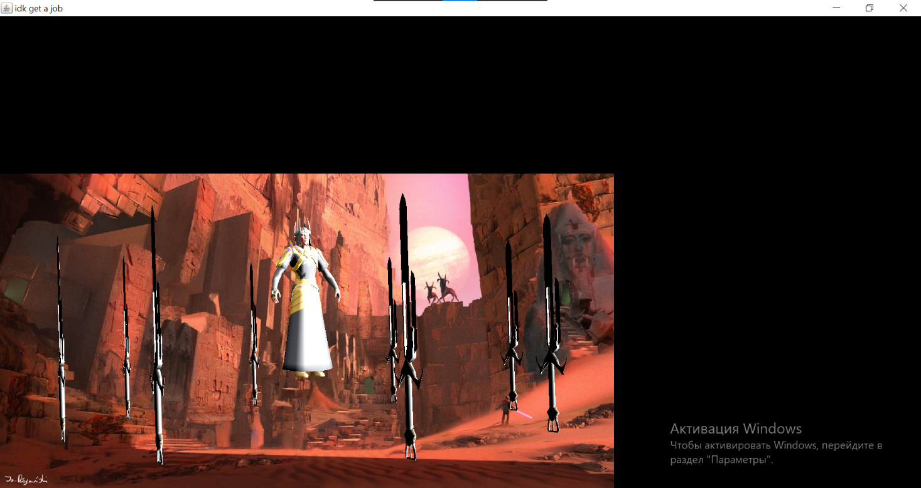

Рис.1. Мечі обертаються по колу

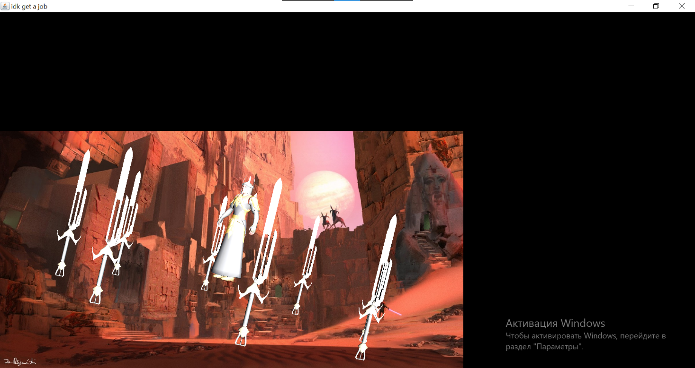

Рис.2. Мечі повертаються також по своїй осі, персонаж рухає головою

**Висновки**

Виконавши дану лабораторну роботу я навчився анімувати складні об’єкти тривимірної сцени, виділяти окремі об’єкти з .obj файлів.