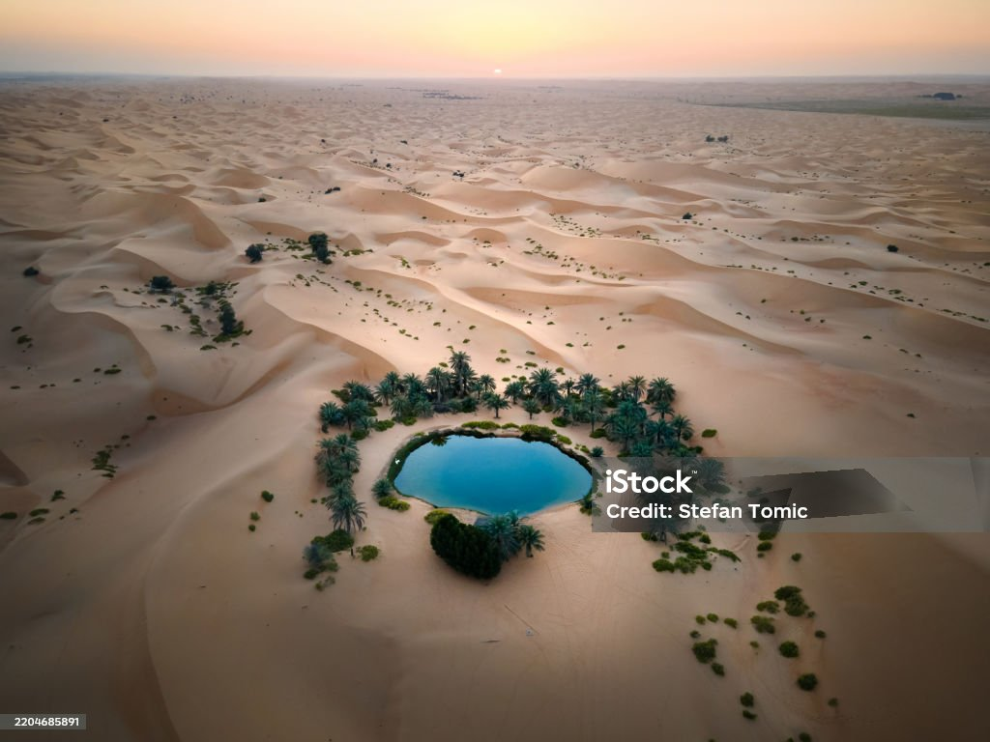
Description:
Al Ain Oasis is the largest oasis in the city of Al Ain within the Emirate of Abu Dhabi, United Arab Emirates. It is a peaceful, green expanse of vegetation and date palm trees that stands in striking contrast to the surrounding arid desert and vast golden sand dunes. This oasis has existed for thousands of years thanks to an ancient falaj irrigation system that channels water underground to irrigate the land. It covers around 1,200 hectares and contains over 147,000 date palms and many other plant varieties, offering cool shaded pathways for visitors. The oasis reflects traditional desert life and sustainability, and it is part of a UNESCO World Heritage Site, helping preserve cultural and agricultural history in the heart of the desert.

