Ada Wong

EC450

3/23/15

Homework 5

Picture: Schematic:

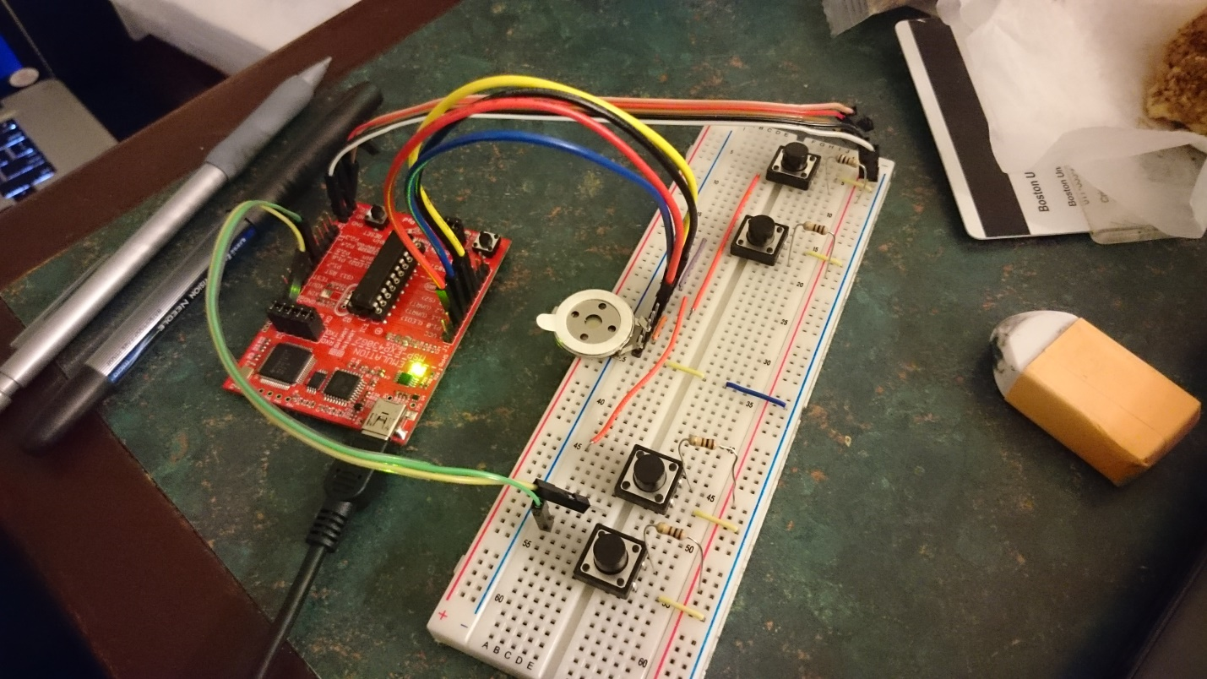 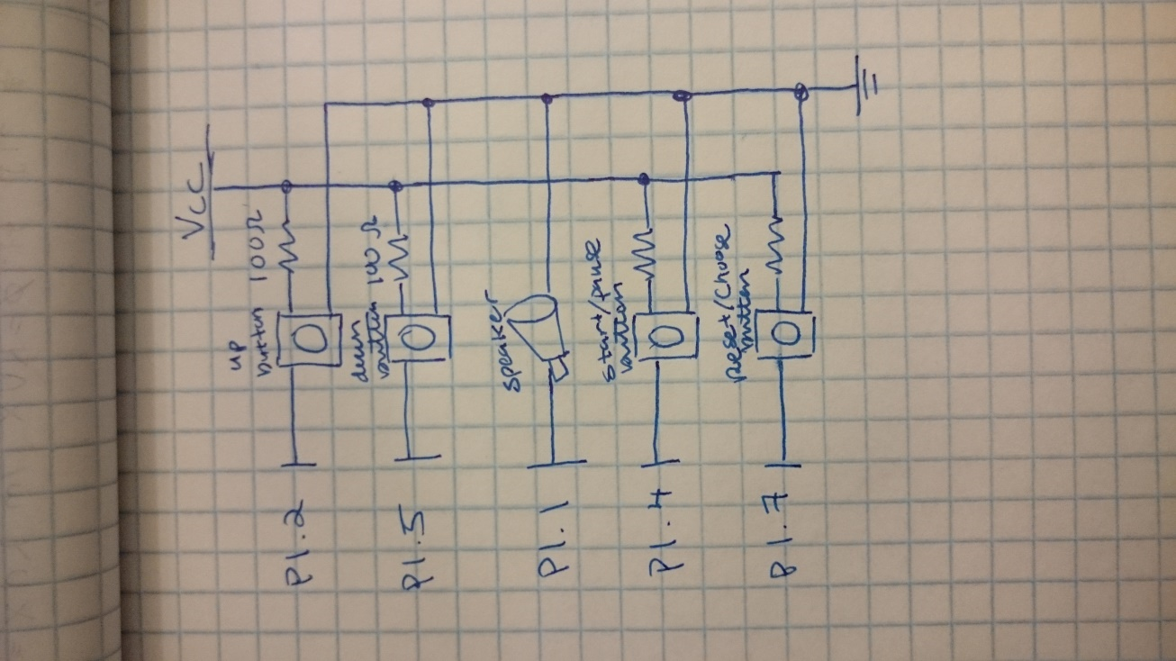

My design:

Hardware:

* On-board Red LED is on when song is playing, and off when paused.
* On-board Green LED is on when playing Joy to the World, and off when playing the second song, Chocobo Theme Song.

There are 4 buttons:

* First button is the Speed Up button. Speed up is limited to 10x faster . The only option available is to press it to increment the speed by 1x.
* Second button is the Speed Down button. Speed down is limited to 0.2x slower. The only option available is to press it to decrement the speed by 0.02x.
* Third button is the Start / Pause button. By pressing the button, if the song is playing, it’ll pause the song, and vice versa.
* Fourth button is the Reset / Switch button. If the current song has started playing already, pressing this button will act as a reset. Resetting will always set the song to “Joy to the World”. If the current song has not been started already, this button will switch the song to the other one.

Software:

* int array *tones* that has all the chords I need
* int array *joyTimes* that contains the duration of each note played in Joy of the World
* int array *joyIndex* that holds the index from *tones* that contains the chord for Joy of the World
* int array *chocoboTimes* is the same as *joyTimes* but for the Chocobo song
* int array *chocoboIndex* is the same as *joyIndex,* but for the Chocobo song
* I used the watchdog timer to check all 4 of the buttons
* Watchdog timer was also used to start and stop playing the song (like a conductor)
* Timer A was used for producing sound