BRACT’s

Vishwakarma Institute of Technology, Pune

Practical Implementation Sheet

Department: CSE-AI Semester: 5 Academic Year: 2026-27

Division: E Batch: 2 Practical No: 2

Roll no: 39 PRN No: 12414234 Name of Student: Rishi Gupta

Subject Name : Deep Learning

Problem Statement:
Design and implement a Multilayer Perceptron (MLP) for classification of the Iris or Wine dataset, and evaluate its performance using accuracy and a confusion matrix.

Algorithm:
- Import the required libraries for data handling, visualization, model building, and evaluation.
- Load the Iris dataset and separate it into input features (X) and target labels (y).
- Display the dataset information, statistical summary, and class distribution.
- Check the dataset for any missing values.
- Split the dataset into training and testing sets using an 80:20 ratio.
- Create an MLP (Multilayer Perceptron) classifier with two hidden layers and ReLU activation.
- Train the MLP model using the training data.
- Predict the class labels for the test data.
- Calculate the model's accuracy.
- Generate and display the confusion matrix as a heatmap.
- Display the classification report showing precision, recall, F1-score, and support.
- Compare the actual and predicted class labels to evaluate the model's performance.

Code:
- # import libraries import numpy as np import pandas as pd
import matplotlib.pyplot as plt import seaborn as sns

from sklearn.datasets import load_iris
from sklearn.model_selection import train_test_split

from sklearn.preprocessing import StandardScaler from sklearn.neural_network import MLPClassifier
from sklearn.metrics import accuracy_score, confusion_matrix, classification_report

- # loading the dataset iris = load_iris()
X = iris.data y = iris.target

df = pd.DataFrame(X, columns=iris.feature_names) df["Species"] = y

print(df.head())

- # dataset info print(df.info())

print(df.describe()) print(df["Species"].value_counts())
- #checking missing values print(df.isnull().sum())
- #training and testing splitting
X_train, X_test, y_train, y_test = train_test_split( X,
y, test_size=0.2,
random_state=42
)
- #create MLP model mlp = MLPClassifier(
hidden_layer_sizes=(10,10), activation='relu', solver='adam', max_iter=1000, random_state=42
)

- #training the model mlp.fit(X_train, y_train)

- #predicitng
y_pred = mlp.predict(X_test)

- #evaluating accuracy
accuracy = accuracy_score(y_test, y_pred)

print("Accuracy :", accuracy)

- #making a confusion matrix
cm = confusion_matrix(y_test, y_pred) plt.figure(figsize=(6,5))
sns.heatmap( cm, annot=True, fmt='d', cmap='Blues',
xticklabels=iris.target_names, yticklabels=iris.target_names
)

plt.xlabel("Predicted") plt.ylabel("Actual") plt.title("Confusion Matrix") plt.show()
- #classification report print(classification_report(
y_test, y_pred,
target_names=iris.target_names
))

- #actual vs predicted values results = pd.DataFrame({
"Actual": y_test, "Predicted": y_pred
})
print(results.head(15))

Output:
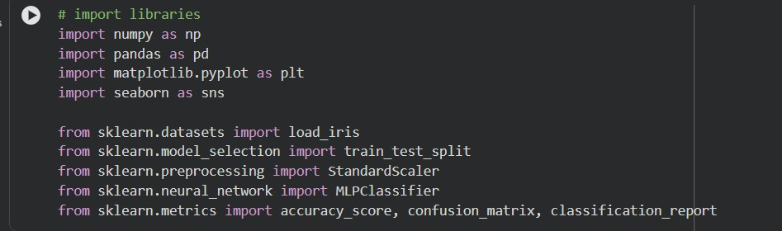
1]

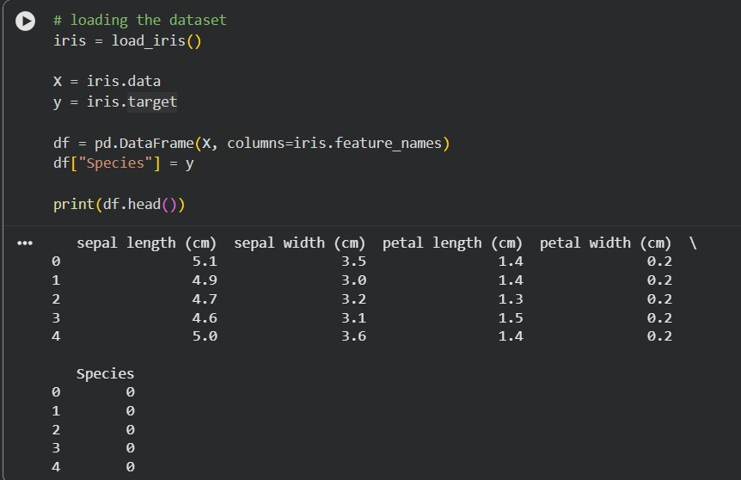
2]

3]
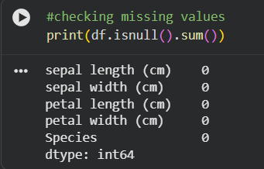

4]
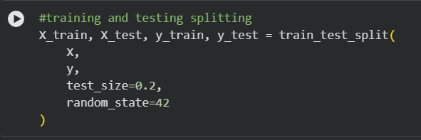

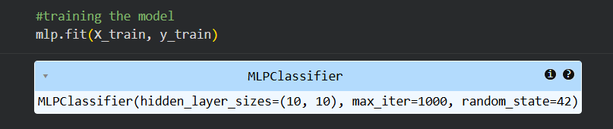
5]

6]
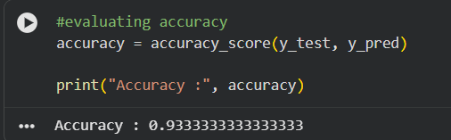

7]
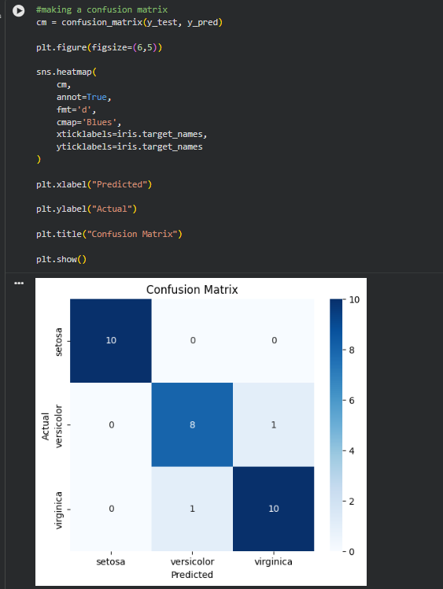

8]
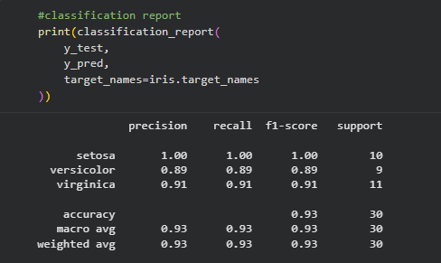

9]
