BRACT’s

Vishwakarma Institute of Technology, Pune

Practical Implementation Sheet

Department: CSE-AI Semester: 5 Academic Year: 2026-27

Division: E Batch: 2 Practical No: 3

Roll no: 39 PRN No: 12414234 Name of Student: Rishi Gupta

Subject Name: Deep Learning

Problem Statement:
Implement forward propagation and backpropagation using TensorFlow/Keras. Analyze the effect of different learning rates and the number of epochs on model performance.

Algorithm:
- Import Libraries: Import TensorFlow/Keras, Pandas, and Matplotlib for model creation, training, evaluation, and visualization.
- Load Dataset: Load the Fashion MNIST dataset containing 28×28 grayscale clothing images and display sample images with their class labels.
- Preprocess Data: Flatten each 28×28 image into 784 features and normalize pixel values from 0–255 to 0–1.
- Create Neural Network: Build a Sequential neural network with 128 and 64 ReLU hidden neurons and a 10-neuron Softmax output layer. Compile it using Adam and sparse categorical cross-entropy.
- Analyze Learning Rates: Train separate models using learning rates 0.1, 0.01, and 0.001 for 5 epochs. Evaluate and compare their test loss and accuracy.
- Plot Learning Rate Performance: Store the results in a DataFrame and plot Learning Rate vs Test Accuracy.
- Analyze Number of Epochs: Using a fixed learning rate of 0.001, train models for 5, 10, and 20 epochs and compare their test accuracy and loss.
- Plot Epoch Performance: Plot Number of Epochs vs Test Accuracy to observe the effect of training duration.
- Perform Forward and Backpropagation: During training, Keras performs forward propagation to generate predictions, calculates the loss, and uses backpropagation with the Adam optimizer to update network weights.
- Analyze Final Model: Train the model for 20 epochs and plot Training vs Validation Accuracy and Training vs Validation Loss to analyze model performance and possible overfitting.

Code:
- # Importing the required libraru=ies import tensorflow as tf
from tensorflow.keras.models import Sequential from tensorflow.keras.layers import Dense
from tensorflow.keras.optimizers import Adam import matplotlib.pyplot as plt
import pandas as pd
- (x_train, y_train), (x_test, y_test) = tf.keras.datasets.fashion_mnist.load_data() print("Training data:", x_train.shape)
print("Training labels:", y_train.shape) print("Testing data:", x_test.shape) print("Testing labels:", y_test.shape)

class_names = [
'T-shirt/top', 'Trouser', 'Pullover', 'Dress', 'Coat',
'Sandal', 'Shirt', 'Sneaker', 'Bag', 'Ankle boot'
]
plt.figure(figsize=(10, 5)) for i in range(10):
plt.subplot(2, 5, i + 1) plt.imshow(x_train[i], cmap='gray') plt.title(class_names[y_train[i]]) plt.axis('off')
plt.tight_layout() plt.show()

- # Preprocess the data and creating the neural network x_train = x_train.reshape(-1, 784) / 255.0
x_test = x_test.reshape(-1, 784) / 255.0

print(x_train.shape) print(x_test.shape)

# Creating the neural network def create_model(lr):
model = Sequential([
Dense(128, activation='relu', input_shape=(784,)), Dense(64, activation='relu'),
Dense(10, activation='softmax')
])

model.compile( optimizer=Adam(learning_rate=lr), loss='sparse_categorical_crossentropy', metrics=['accuracy']
)

return model
- learning_rates = [0.1, 0.01, 0.001] results = []
for lr in learning_rates:
print("Training with learning rate:", lr) model = create_model(lr)
model.fit( x_train, y_train, epochs=5,
batch_size=128, verbose=0
)
loss, acc = model.evaluate(x_test, y_test, verbose=0) results.append([lr, loss, acc])
- # Displaying the learning-rate results df = pd.DataFrame(
results,
columns=['Learning Rate', 'Loss', 'Accuracy']
)

print(df)
# plotting learning rate vs accuracy plt.plot(
df['Learning Rate'], df['Accuracy'], marker='o'
)

plt.xscale('log') plt.xlabel('Learning Rate') plt.ylabel('Test Accuracy')
plt.title('Effect of Learning Rate on Model Accuracy') plt.grid()
plt.show()

- # Testing with diff epochs and plotting an epoch vs accuracy graph epochs_list = [5, 10, 20]
epoch_results = []

for ep in epochs_list:
model = create_model(0.001)

model.fit( x_train, y_train,

validation_split=0.2, epochs=ep, batch_size=128, verbose=0
)

loss, acc = model.evaluate(x_test, y_test, verbose=0) epoch_results.append([ep, loss, acc])
edf = pd.DataFrame( epoch_results,
columns=['Epochs', 'Loss', 'Accuracy']
)
print(edf)

plt.plot(edf['Epochs'], edf['Accuracy'], marker='o') plt.xlabel('Number of Epochs')
plt.ylabel('Test Accuracy')
plt.title('Effect of Epochs on Model Accuracy') plt.grid()
plt.show()
- model = create_model(0.001) history = model.fit(
x_train, y_train,
validation_split=0.2, epochs=20, batch_size=128
)

# Accuracy graph plt.plot(history.history['accuracy']) plt.plot(history.history['val_accuracy']) plt.xlabel('Epoch') plt.ylabel('Accuracy')
plt.title('Training vs Validation Accuracy') plt.legend(['Train', 'Validation'])
plt.grid() plt.show()
# Loss graph plt.plot(history.history['loss']) plt.plot(history.history['val_loss']) plt.xlabel('Epoch') plt.ylabel('Loss')
plt.title('Training vs Validation Loss') plt.legend(['Train', 'Validation']) plt.grid()
plt.show()

Output:
1]
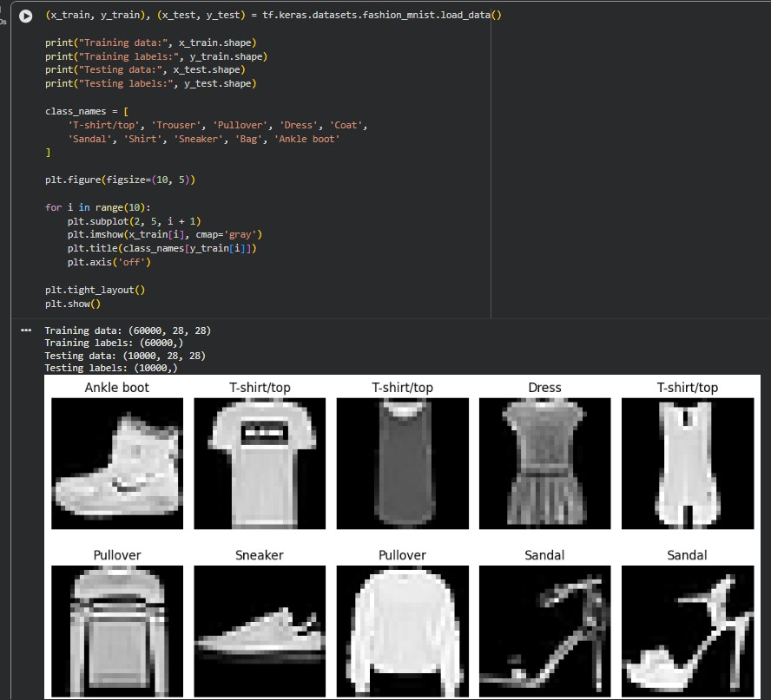

2]
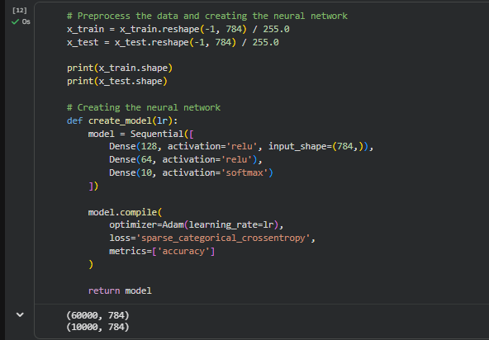

3]
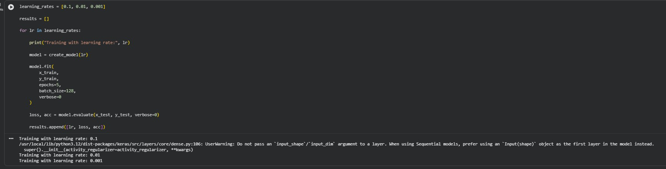

4]
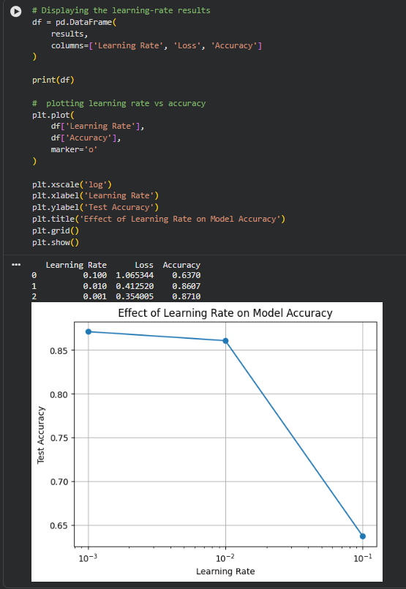

5]
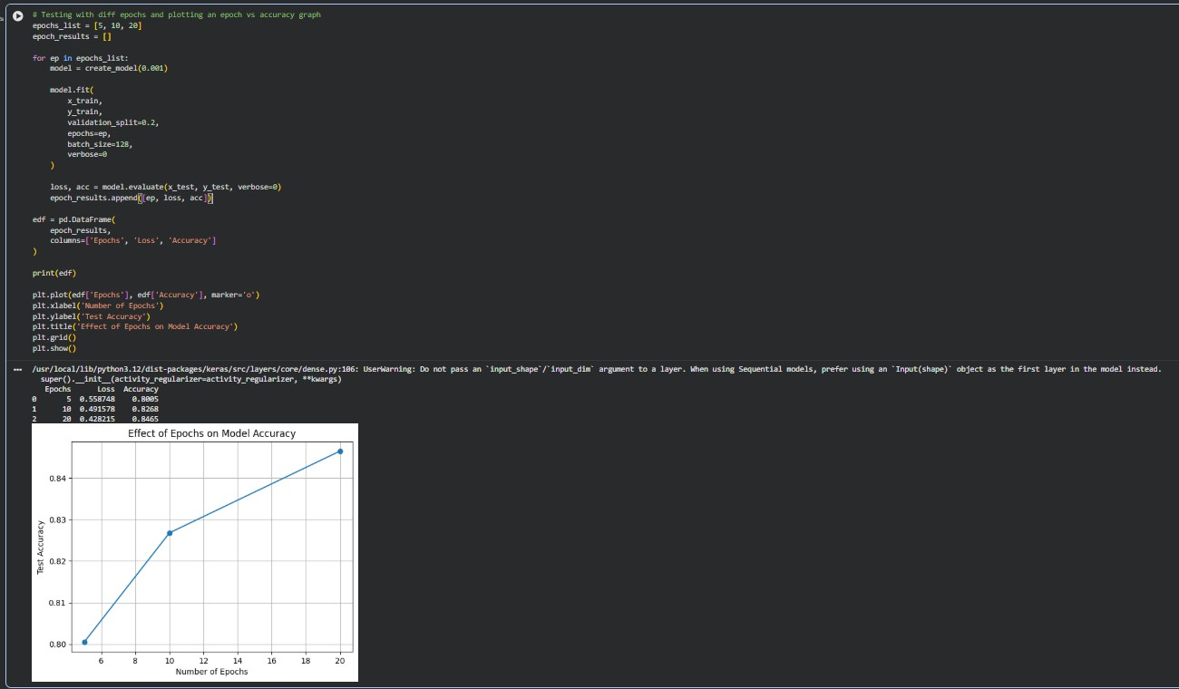

6]
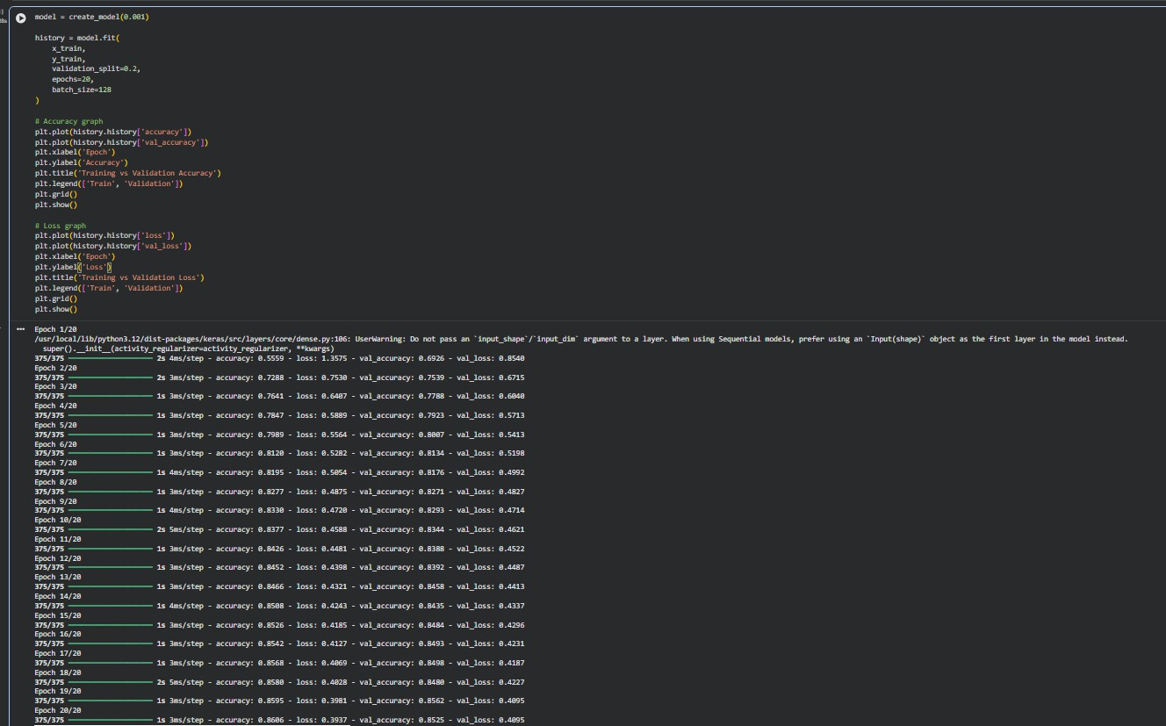

7]
