BRACT’s

Vishwakarma Institute of Technology, Pune

Practical Implementation Sheet

Department: CSE-AI Semester: 5 Academic Year: 2026-27

Division: E Batch: 2 Practical No: 4

Roll no: 39 PRN No: 12414234 Name of Student: Rishi Gupta

Subject Name: Deep Learning

Problem Statement:
Develop an LSTM-based model for time-series forecasting using stock price, weather, or sales datasets.

Algorithm:
- Import Libraries: Import TensorFlow/Keras, NumPy, Pandas, Matplotlib, and Scikit-learn for data processing, model creation, training, evaluation, and visualization.
- Load Dataset: Load the historical Apple (AAPL) stock price dataset containing daily Date, Open, High, Low, Close, and Volume values.
- Explore Dataset: Display the dataset shape, columns, sample records, and visualize the historical closing prices.
- Preprocess Data: Select the daily closing price as the target variable, handle missing values, and normalize the prices between 0 and 1 using MinMaxScaler.
- Create Time-Series Sequences: Create input sequences using the previous 60 trading days to predict the closing price of the following day.
- Split the Data: Divide the sequential data into 80% training and 20% testing sets while maintaining the chronological order of the time-series data.
- Create LSTM Model: Build a Sequential LSTM network with two LSTM layers containing 50 units each, Dropout layers for reducing overfitting, and a Dense output layer for predicting the next closing price. Compile it using the Adam optimizer and Mean Squared Error loss.
- Train the Model: Train the LSTM model for 20 epochs using a batch size of 32 and validate its performance using the testing data.
- Analyze Training Performance: Plot Training Loss and Validation Loss against the number of epochs to analyze the learning behavior and possible overfitting.
- Perform Prediction: Use the trained LSTM model to predict closing prices for the test dataset and transform the normalized predictions back to their original price scale.
- Evaluate the Model: Calculate Mean Absolute Error (MAE) and Root Mean Squared Error (RMSE) to measure the forecasting performance of the LSTM model.

- Plot Prediction Performance: Plot Actual vs Predicted stock prices to visually compare the forecasting results.
- Forecast Next Price: Use the most recent 60 trading days as input to the trained LSTM model to predict the next closing price.

Code:
- # Importing the required libraries import numpy as np
import pandas as pd
import matplotlib.pyplot as plt import tensorflow as tf
from sklearn.preprocessing import MinMaxScaler
from sklearn.metrics import mean_absolute_error, mean_squared_error from tensorflow.keras.models import Sequential
from tensorflow.keras.layers import LSTM, Dense, Dropout
- # Loading and exploring the AAPL stock dataset
url = "https://raw.githubusercontent.com/kristoffer-paulsson/stock-data/master/aapl.csv" data = pd.read_csv(url, sep=";")
data["date"] = pd.to_datetime(data["date"]) print("Dataset shape:", data.shape) print("Columns:", data.columns.tolist()) print(data.head())

- # Visualizing the historical closing price plt.figure(figsize=(12, 5)) plt.plot(data["date"], data["close"]) plt.title("AAPL Stock Closing Price") plt.xlabel("Date")
plt.ylabel("Closing Price") plt.grid()
plt.show()

- # Preprocessing and normalizing the closing prices prices = data[["close"]].dropna().values
scaler = MinMaxScaler(feature_range=(0, 1)) scaled_prices = scaler.fit_transform(prices) print("Number of prices:", len(prices)) print("Normalized data shape:", scaled_prices.shape)
- # Creating time-series sequences using the previous 60 days X = []
y = []
for i in range(60, len(scaled_prices)): X.append(scaled_prices[i-60:i, 0])
y.append(scaled_prices[i, 0]) X = np.array(X)
y = np.array(y)
X = X.reshape(X.shape[0], X.shape[1], 1) print("X shape:", X.shape)
print("y shape:", y.shape)
- # Splitting the data into training and testing sets split = int(len(X) * 0.8)
X_train = X[:split] X_test = X[split:] y_train = y[:split] y_test = y[split:]
print("Training samples:", len(X_train)) print("Testing samples:", len(X_test))

- # Creating the LSTM neural network model = Sequential([
LSTM(50, return_sequences=True, input_shape=(60, 1)),

Dropout(0.2),
LSTM(50),
Dropout(0.2), Dense(1)
])
model.compile( optimizer="adam", loss="mean_squared_error"
)
model.summary()
- # Training the LSTM model history = model.fit(
X_train, y_train, epochs=20, batch_size=32,
validation_data=(X_test, y_test), verbose=1
)

- # Plotting training and validation loss plt.figure(figsize=(10, 5))
plt.plot(
history.history["loss"], label="Training Loss"
)
plt.plot(
history.history["val_loss"], label="Validation Loss"
)
plt.xlabel("Epoch") plt.ylabel("Loss")
plt.title("Training vs Validation Loss") plt.legend()
plt.grid() plt.show()

- # Generating predictions on the test data predictions = model.predict(X_test)
predictions = scaler.inverse_transform(predictions) actual = scaler.inverse_transform(
y_test.reshape(-1, 1)
)
print("Predictions generated successfully")
- # Evaluating the LSTM model using MAE and RMSE mae = mean_absolute_error(
actual, predictions
)
rmse = np.sqrt( mean_squared_error(
actual, predictions
)
)
print("Mean Absolute Error (MAE):", mae) print("Root Mean Squared Error (RMSE):", rmse)
- # Plotting actual vs predicted stock prices plt.figure(figsize=(12, 5))
plt.plot(
actual, label="Actual Price"
)
plt.plot(
predictions, label="Predicted Price"
)

plt.xlabel("Trading Days") plt.ylabel("Price")
plt.title("AAPL Stock Price: Actual vs Predicted") plt.legend()
plt.grid() plt.show()
- # Predicting the next closing price last_60_days = scaled_prices[-60:] last_60_days = last_60_days.reshape(
1, 60, 1
)
next_price = model.predict( last_60_days
)
next_price = scaler.inverse_transform( next_price
)
print(
"Predicted next closing price: $", round(float(next_price[0][0]), 2)
)

Output:
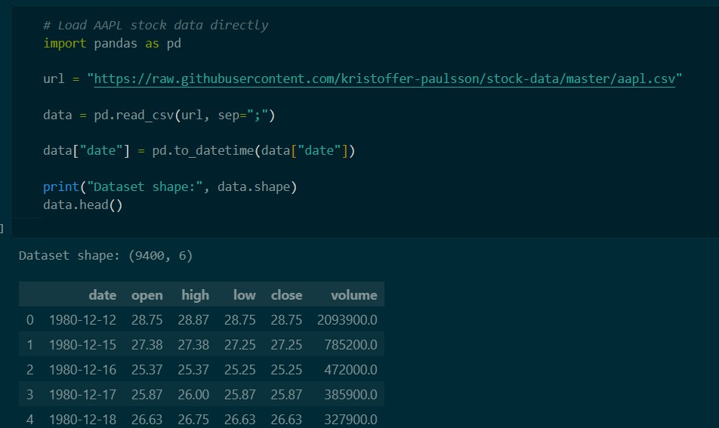
- Loading and exploring the AAPL stock price dataset.

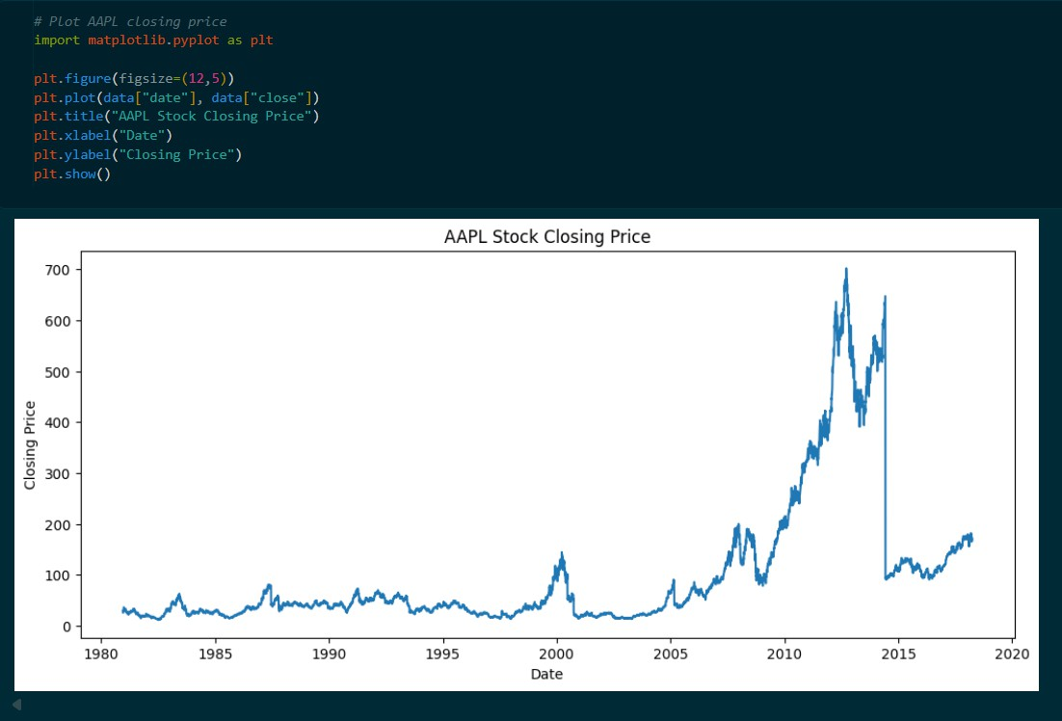
- Historical AAPL closing price visualization.

- Normalization of closing prices using MinMaxScaler.
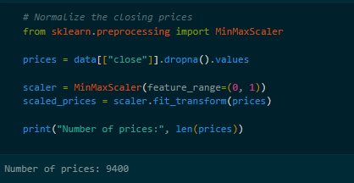
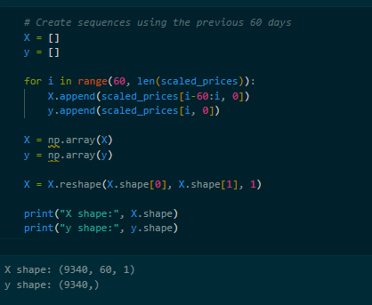

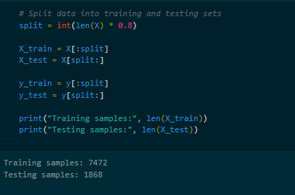

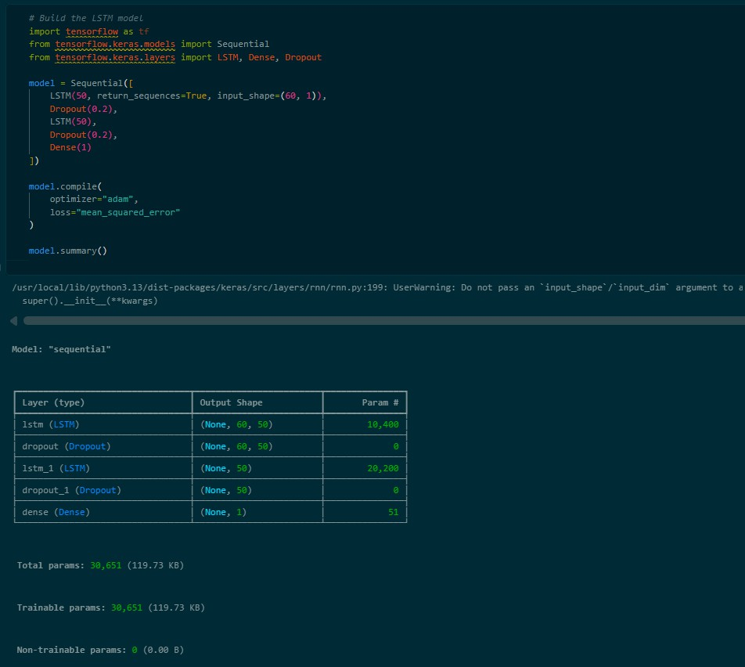
- Creation of 60-day time-series sequences for LSTM input.

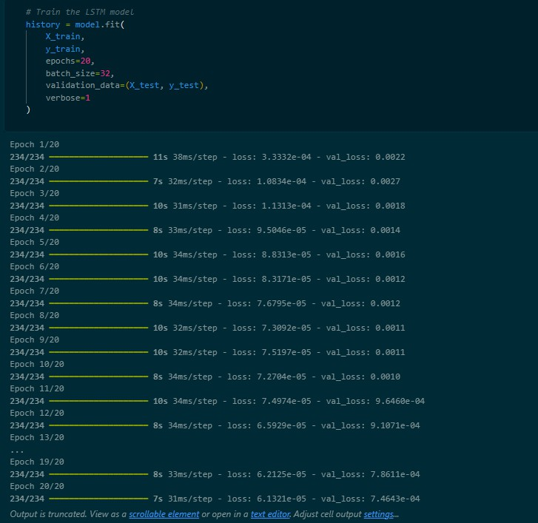
- Training of the LSTM model for 20 epochs.

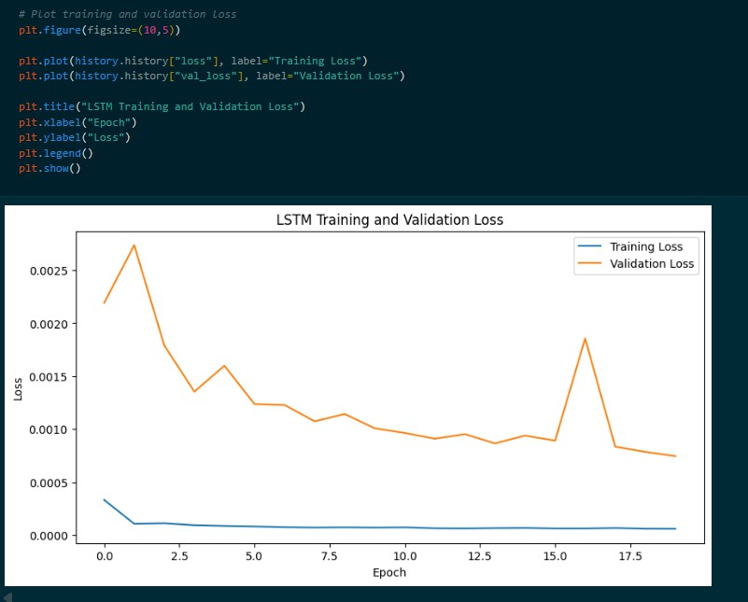
- Training and validation loss across epochs.

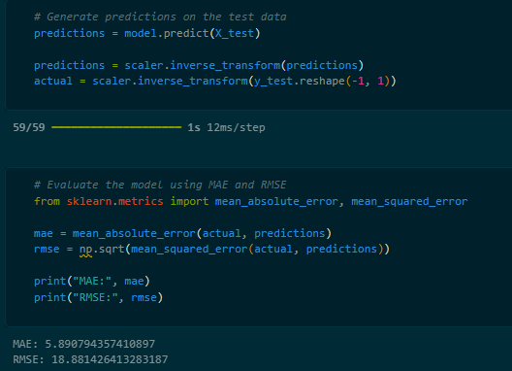
- Model evaluation using MAE and RMSE metrics.

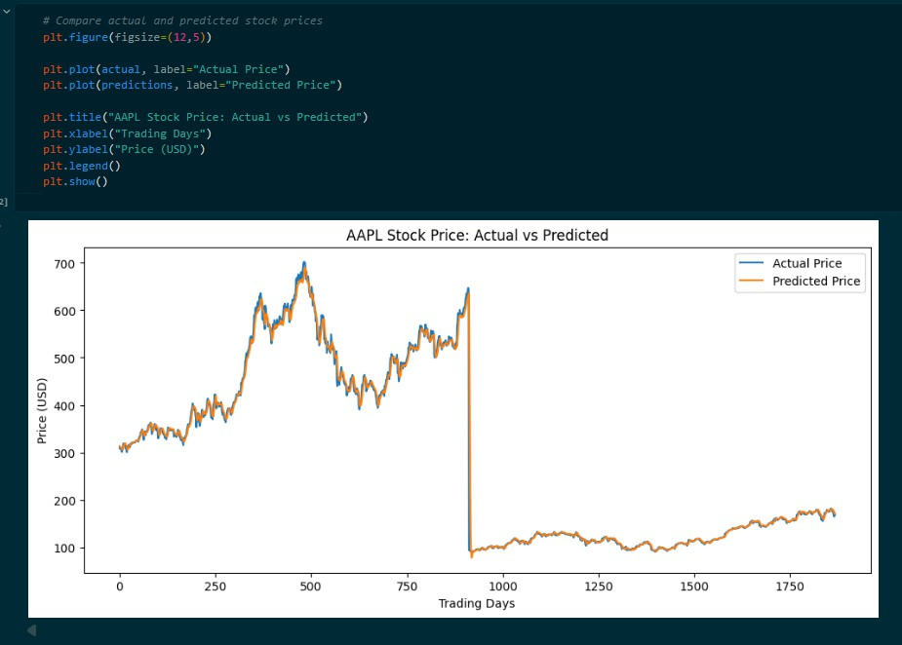
- Comparison of actual and predicted AAPL stock prices.

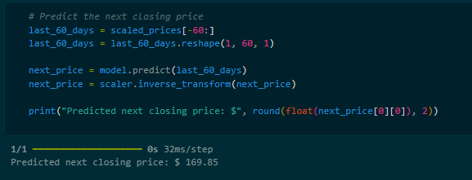
- Predicted next-day AAPL closing price.

