BRACT’s

Vishwakarma Institute of Technology, Pune

Practical Implementation Sheet

Department: CSE-AI Semester: 5 Academic Year: 2026-27

Division: E Batch: 2 Practical No: 6

Roll no: 39 PRN No: 12414234 Name of Student: Rishi Gupta

Subject Name: Deep Learning

Problem Statement:
Design and implement a Convolutional Neural Network (CNN) for image classification using the Tomato or Soybean disease dataset.

Algorithm:
- Import libraries for data handling, image processing, CNN modeling, hyperparameter tuning, visualization, and evaluation.
- Load the Rice Leaf Disease dataset and assign images to their corresponding disease classes.
- Explore the dataset, check class distribution, sample images, and missing values.
- Split the dataset into training, validation, and testing sets using a 70:15:15 ratio.
- Resize and normalize images and apply data augmentation to improve generalization.
- Define a CNN with convolution, pooling, dense, dropout, and softmax layers.
- Use Keras Tuner Random Search to optimize filters, CNN layers, dense units, dropout, and learning rate.
- Select and train the CNN configuration with the best validation accuracy.
- Evaluate the optimized model on the test dataset and calculate accuracy and loss.
- Plot training/validation accuracy and loss to analyze model performance.
- Generate the classification report and confusion matrix to evaluate disease-wise performance.
- Compare actual and predicted labels and save the optimized CNN model.

Code:
# 1. Import libraries import os
import numpy as np import pandas as pd
import matplotlib.pyplot as plt import seaborn as sns
import tensorflow as tf import keras_tuner as kt from PIL import Image

from tensorflow.keras import Sequential
from tensorflow.keras.layers import Input, Conv2D, MaxPooling2D, Flatten, Dense, Dropout from tensorflow.keras.preprocessing.image import ImageDataGenerator
from tensorflow.keras.callbacks import EarlyStopping from sklearn.model_selection import train_test_split
from sklearn.metrics import accuracy_score, confusion_matrix, classification_report

# 2. Loading the dataset dataset_dir = "rice_leaf_diseases"
print("Dataset exists:", os.path.exists(dataset_dir)) print("Classes:", os.listdir(dataset_dir))

# 3. Creating the dataset dataframe data = []
for class_name in os.listdir(dataset_dir):
class_path = os.path.join(dataset_dir, class_name) if os.path.isdir(class_path):
for file_name in os.listdir(class_path):
if file_name.lower().endswith((".jpg", ".jpeg", ".png")): data.append({
"filepath": os.path.join(class_path, file_name), "label": class_name
})
df = pd.DataFrame(data) print(df.head())
print("Total images:", len(df))

# 4. Dataset information print(df.info()) print(df.describe()) print(df["label"].value_counts())
# 5. Checking missing values print(df.isnull().sum())
# 6. Visualizing class distribution plt.figure(figsize=(8, 5)) sns.countplot(
data=df, x="label"
)
plt.xlabel("Disease") plt.ylabel("Number of Images")
plt.title("Rice Leaf Disease Class Distribution") plt.xticks(rotation=20)
plt.show()
# 7. Displaying sample images classes = df["label"].unique() plt.figure(figsize=(12, 5))
for i, class_name in enumerate(classes):
sample = df[df["label"] == class_name].iloc[0] image = Image.open(sample["filepath"]) plt.subplot(1, len(classes), i + 1) plt.imshow(image)
plt.title(class_name) plt.axis("off")
plt.tight_layout() plt.show()

# 8. Training, validation and testing splitting train_df, temp_df = train_test_split(

df, test_size=0.30,
stratify=df["label"], random_state=42
)
val_df, test_df = train_test_split( temp_df,
test_size=0.50, stratify=temp_df["label"], random_state=42
)
print("Training images:", len(train_df)) print("Validation images:", len(val_df)) print("Testing images:", len(test_df))

# 9. Image preprocessing and augmentation IMG_SIZE = (128, 128)
BATCH_SIZE = 16
train_datagen = ImageDataGenerator( rescale=1./255,
rotation_range=25, width_shift_range=0.15, height_shift_range=0.15, zoom_range=0.20, shear_range=0.15, horizontal_flip=True, fill_mode="nearest"
)
test_datagen = ImageDataGenerator( rescale=1./255
)

# 10. Creating image generators
train_generator = train_datagen.flow_from_dataframe( train_df,
x_col="filepath", y_col="label", target_size=IMG_SIZE, batch_size=BATCH_SIZE, class_mode="categorical", shuffle=True,
seed=42
)
val_generator = test_datagen.flow_from_dataframe( val_df,
x_col="filepath", y_col="label", target_size=IMG_SIZE, batch_size=BATCH_SIZE, class_mode="categorical", shuffle=False
)
test_generator = test_datagen.flow_from_dataframe( test_df,
x_col="filepath", y_col="label", target_size=IMG_SIZE, batch_size=BATCH_SIZE, class_mode="categorical", shuffle=False
)

# 11. Defining classes
class_names = sorted(train_df["label"].unique()) num_classes = len(class_names) print("Classes:", class_names)
print("Number of classes:", num_classes)
# 12. Creating the AutoTune CNN def build_model(hp):
model = Sequential() model.add(
Input(shape=(128, 128, 3))
)
num_conv_blocks = hp.Int( "num_conv_blocks", min_value=2, max_value=3,
step=1
)
for i in range(num_conv_blocks):

filters = hp.Choice( f"filters_{i}", values=[32, 64, 128]
)
model.add( Conv2D(
filters=filters, kernel_size=3, activation="relu", padding="same"
)
)
model.add( MaxPooling2D(pool_size=2)
)
model.add(Flatten()) dense_units = hp.Choice(
"dense_units", values=[64, 128, 256]
)
model.add( Dense(
dense_units, activation="relu"
)
)
dropout = hp.Float( "dropout", min_value=0.2, max_value=0.5, step=0.1
)
model.add( Dropout(dropout)
)
model.add( Dense(
num_classes, activation="softmax"
)
)
learning_rate = hp.Choice(

"learning_rate", values=[0.001, 0.0005, 0.0001]
)
model.compile( optimizer=tf.keras.optimizers.Adam(
learning_rate=learning_rate
),
loss="categorical_crossentropy", metrics=["accuracy"]
)
return model

# 13. Creating the AutoTune tuner tuner = kt.RandomSearch(
build_model, objective="val_accuracy", max_trials=8, directory="autotune_results", project_name="rice_leaf_cnn", overwrite=True
)
# 14. Running AutoTune tuner.search(
train_generator, validation_data=val_generator, epochs=10
)
# 15. Getting the best hyperparameters best_hp = tuner.get_best_hyperparameters(
num_trials=1
)[0]
print("Best Hyperparameters:")
for parameter, value in best_hp.values.items(): print(parameter, ":", value)

# 16. Getting the best CNN model best_model = tuner.get_best_models(
num_models=1
)[0]
best_model.summary()

# 17. Training the best model early_stopping = EarlyStopping(
monitor="val_loss", patience=7, restore_best_weights=True
)
history = best_model.fit( train_generator, validation_data=val_generator, epochs=30, callbacks=[early_stopping]
)

# 18. Evaluating accuracy and plotting results test_loss, test_accuracy = best_model.evaluate(
test_generator
)
print("Test Loss:", test_loss)

print("Test Accuracy:", test_accuracy) plt.figure(figsize=(8, 5))
plt.plot(
history.history["accuracy"], label="Training Accuracy"
)
plt.plot(
history.history["val_accuracy"], label="Validation Accuracy"
)
plt.xlabel("Epoch") plt.ylabel("Accuracy")
plt.title("Training vs Validation Accuracy") plt.legend()
plt.show() plt.figure(figsize=(8, 5)) plt.plot(
history.history["loss"], label="Training Loss"
)
plt.plot(
history.history["val_loss"], label="Validation Loss"
)
plt.xlabel("Epoch") plt.ylabel("Loss")
plt.title("Training vs Validation Loss") plt.legend()
plt.show()
# 19. Predictions, classification report and confusion matrix test_generator.reset()
y_prob = best_model.predict( test_generator
)
y_pred = np.argmax( y_prob,
axis=1
)
y_test = test_generator.classes
print("Accuracy:", accuracy_score(y_test, y_pred)) print("\nClassification Report:")
print(
classification_report( y_test,
y_pred, target_names=class_names, zero_division=0
)
)
cm = confusion_matrix( y_test,
y_pred
)
plt.figure(figsize=(7, 6)) sns.heatmap(
cm, annot=True, fmt="d", cmap="Blues",
xticklabels=class_names, yticklabels=class_names

)
plt.xlabel("Predicted") plt.ylabel("Actual") plt.title("Confusion Matrix") plt.show()
results = pd.DataFrame({
"Actual": [class_names[i] for i in y_test], "Predicted": [class_names[i] for i in y_pred]
})
print("\nActual vs Predicted:") print(results.head(15))

Output:

1]
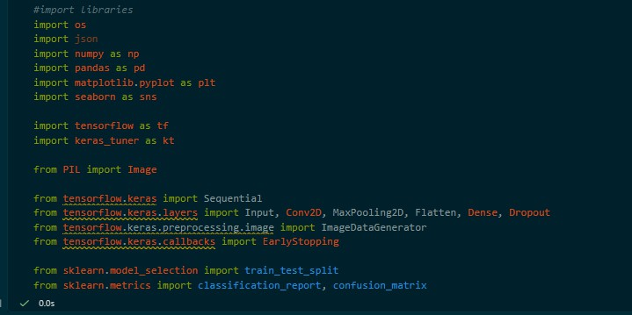

2]
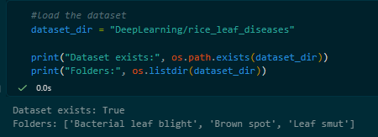

3]
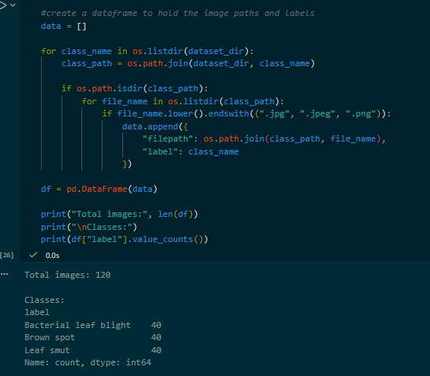

4]
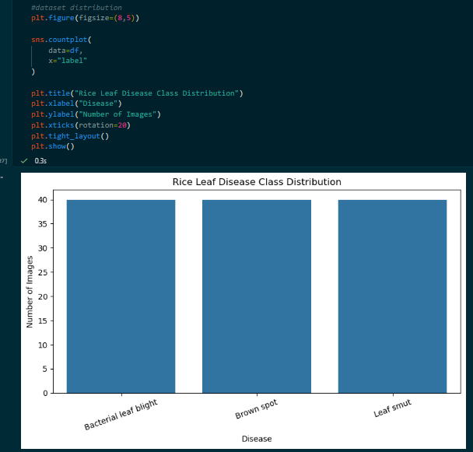

5]
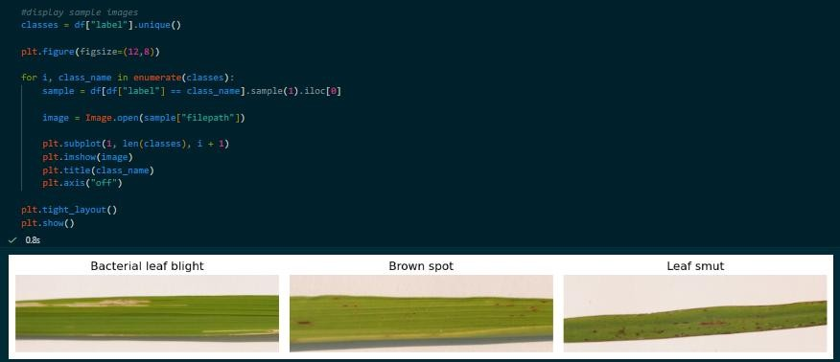

6]
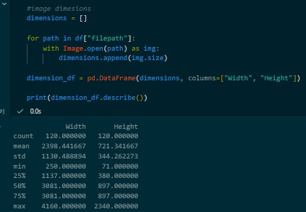

7]
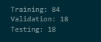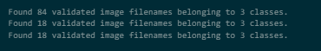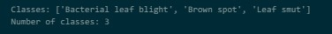

8] Building auto-tune CNN, creating a tuner and running the auto-tune
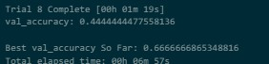

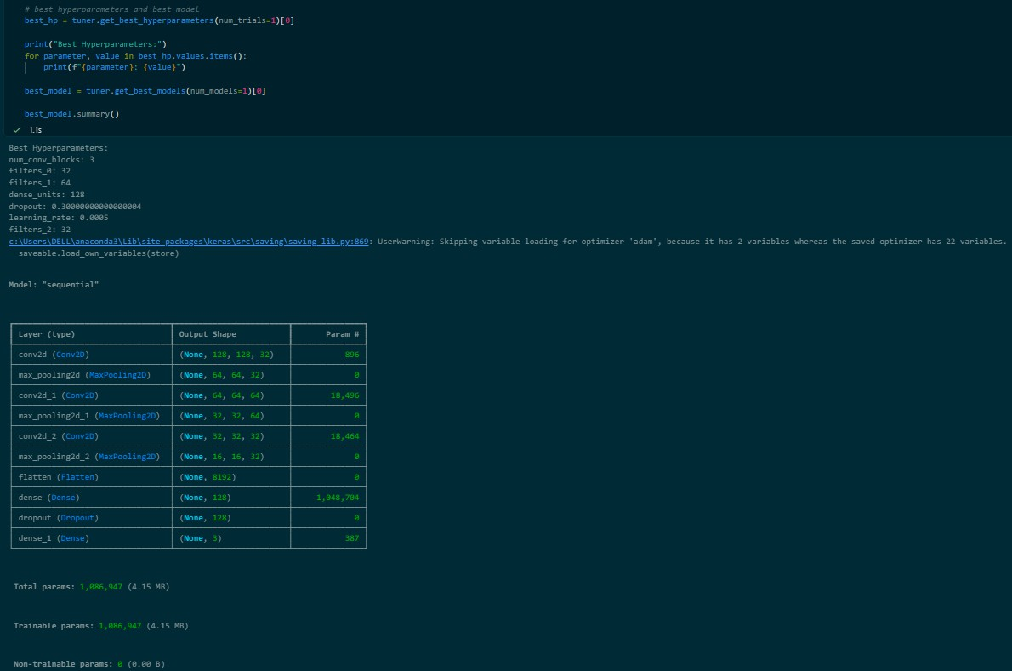
9]

- Training the best model
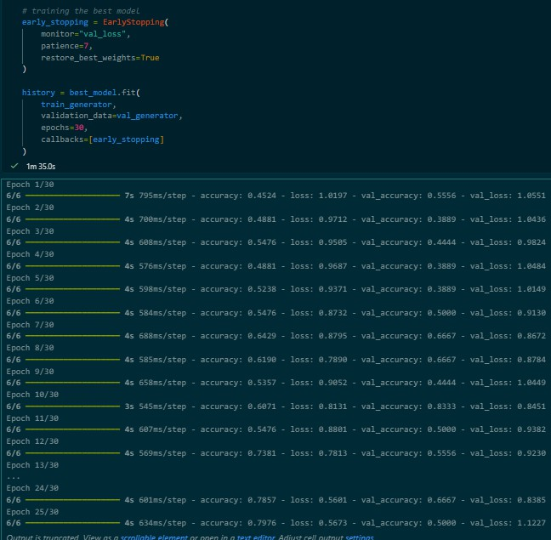

Accuracy and Loss graphs
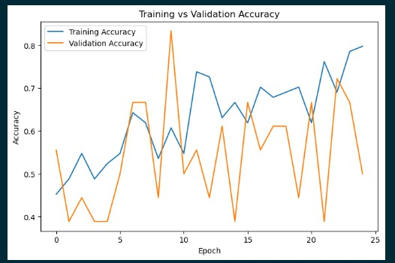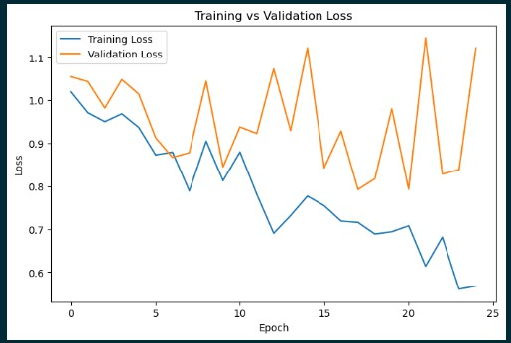

- Testing Evaluation + Classification Report
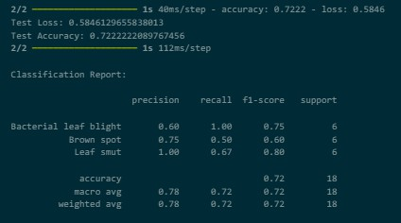

Confusion Matrix
