BRACT’s

Vishwakarma Institute of Technology, Pune

Practical Implementation Sheet

Department: CSE-AI Semester: 5 Academic Year: 2026-27

Division: E Batch: 2 Practical No: 7

Roll no: 39 PRN No: 12414234 Name of Student: Rishi Gupta

Subject Name: Deep Learning

Problem Statement:
Implement transfer learning using pre-trained AlexNet, VGG16, ResNet50, and EfficientNetB0 models for image classification, and compare their performance.

Algorithm:
- Import Libraries: Import PyTorch, Torchvision, NumPy, Pandas, Matplotlib, and Scikit-learn for dataset handling, model creation, training, evaluation, and visualization.
- Configure Device: Check GPU availability and use CUDA when available for faster model training.
- Load Dataset: Load the CIFAR-10 dataset containing 50,000 training images and 10,000 testing images belonging to 10 classes.
- Preprocess Data: Resize the CIFAR-10 images from 32×32 to 224×224 pixels and normalize them using ImageNet mean and standard deviation values.
- Load Pre-trained Models: Load ImageNet-pretrained AlexNet, VGG16, ResNet50, and EfficientNetB0 models using Torchvision.
- Freeze Pre-trained Layers: Freeze the parameters of the pretrained layers so that the learned ImageNet features are retained.
- Modify Classifiers: Replace the final classification layer of each model with a new layer containing 10 output neurons corresponding to the CIFAR-10 classes.
- Train the Models: Train the newly added classification layers using Cross-Entropy Loss and the Adam optimizer.
- Evaluate the Models: Test each trained model on the CIFAR-10 test dataset and calculate its classification accuracy.
- Compare Performance: Compare the accuracy and training time of AlexNet, VGG16, ResNet50, and EfficientNetB0.
- Visualize Results: Plot the accuracy comparison and test accuracy across epochs for all four models.
- Generate Classification Reports: Calculate precision, recall, and F1-score for each model using the CIFAR-10 test data.

Code:
# 1. Import libraries import os
import time
import numpy as np import pandas as pd
import matplotlib.pyplot as plt import seaborn as sns
import tensorflow as tf
from tensorflow.keras import layers, Model
from tensorflow.keras.applications import VGG16, ResNet50, EfficientNetB0 from sklearn.metrics import (
accuracy_score, confusion_matrix, classification_report
)
print("TensorFlow version:", tf. version )
# 2. Checking GPU availability
print("GPU available:", tf.config.list_physical_devices("GPU")) if tf.config.list_physical_devices("GPU"):
print("Using GPU") else:
print("Using CPU")
# 3. Loading the CIFAR-10 dataset
(x_train, y_train), (x_test, y_test) = tf.keras.datasets.cifar10.load_data() print("Training data shape:", x_train.shape)
print("Testing data shape:", x_test.shape) print("Training labels shape:", y_train.shape) print("Testing labels shape:", y_test.shape)

# 4. Defining CIFAR-10 classes class_names = [
"airplane", "automobile", "bird",
"cat",
"deer",
"dog",
"frog",
"horse",
"ship", "truck"
]
num_classes = len(class_names) print("Classes:", class_names) print("Number of classes:", num_classes)
# 5. Checking class distribution class_counts = np.bincount(
y_train.flatten(), minlength=num_classes
)
distribution = pd.DataFrame({ "Class": class_names, "Images": class_counts
})
print(distribution) plt.figure(figsize=(9, 5))

sns.barplot( data=distribution, x="Class", y="Images"
)
plt.xlabel("Class") plt.ylabel("Number of Images")
plt.title("CIFAR-10 Class Distribution") plt.xticks(rotation=20)
plt.show()

# 6. Displaying sample images plt.figure(figsize=(12, 6))
for i in range(10): plt.subplot(2, 5, i + 1) plt.imshow(x_train[i])
plt.title(class_names[y_train[i][0]]) plt.axis("off")
plt.tight_layout() plt.show()

# 7. Preprocessing and resizing the images IMG_SIZE = 224
BATCH_SIZE = 64
x_train = tf.image.resize( x_train,
(IMG_SIZE, IMG_SIZE)
)
x_test = tf.image.resize( x_test,
(IMG_SIZE, IMG_SIZE)
)
x_train = tf.cast( x_train, tf.float32
)
x_test = tf.cast( x_test, tf.float32
)
y_train = y_train.flatten() y_test = y_test.flatten()
print("Resized training data:", x_train.shape) print("Resized testing data:", x_test.shape)
# 8. Creating TensorFlow data pipelines train_dataset = tf.data.Dataset.from_tensor_slices(
(x_train, y_train)
)
test_dataset = tf.data.Dataset.from_tensor_slices( (x_test, y_test)
)
train_dataset = train_dataset.shuffle( 10000
).batch(
BATCH_SIZE
).prefetch( tf.data.AUTOTUNE
)
test_dataset = test_dataset.batch( BATCH_SIZE
).prefetch(

tf.data.AUTOTUNE
)
print("Training and testing pipelines created.")

# 9. Defining the transfer learning model function def create_model(model_name):
if model_name == "VGG16": base_model = VGG16( weights="imagenet", include_top=False,
input_shape=(224, 224, 3)
)
preprocessing = tf.keras.applications.vgg16.preprocess_input elif model_name == "ResNet50":
base_model = ResNet50( weights="imagenet", include_top=False, input_shape=(224, 224, 3)
)
preprocessing = tf.keras.applications.resnet50.preprocess_input elif model_name == "EfficientNetB0":
base_model = EfficientNetB0( weights="imagenet", include_top=False, input_shape=(224, 224, 3)
)
preprocessing = tf.keras.applications.efficientnet.preprocess_input elif model_name == "AlexNet":
# AlexNet is not available in standard tf.keras.applications. # Use a pretrained ImageNet-style AlexNet architecture. base_model = tf.keras.Sequential([
layers.Conv2D(96, (11, 11), strides=4, activation="relu", input_shape=(224, 224, 3)),
layers.MaxPooling2D((3, 3), strides=2),
layers.Conv2D(256, (5, 5),
padding="same", activation="relu"),
layers.MaxPooling2D((3, 3), strides=2),
layers.Conv2D(384, (3, 3),
padding="same", activation="relu"),
layers.Conv2D(384, (3, 3),
padding="same", activation="relu"),
layers.Conv2D(256, (3, 3),
padding="same", activation="relu"),
layers.MaxPooling2D((3, 3), strides=2)
])
preprocessing = lambda x: x / 255.0 else:
raise ValueError("Invalid model name") # Freeze pretrained layers base_model.trainable = False
# Add new classifier inputs = layers.Input(
shape=(224, 224, 3)
)
x = preprocessing(inputs) x = base_model(
x,

training=False
)
x = layers.GlobalAveragePooling2D()(x) x = layers.Dense(
256,
activation="relu"
)(x)
x = layers.Dropout(0.3)(x) outputs = layers.Dense(
num_classes, activation="softmax"
)(x)
model = Model( inputs, outputs
)
model.compile( optimizer=tf.keras.optimizers.Adam(
learning_rate=0.001
),
loss="sparse_categorical_crossentropy", metrics=["accuracy"]
)
return model
# 10. Training and evaluating all four models model_names = [
"AlexNet", "VGG16",
"ResNet50", "EfficientNetB0"
]
models_dict = {} histories = {} results = {}
for model_name in model_names: print("\n" + "=" * 60) print("Training:", model_name) print("=" * 60)
model = create_model(model_name) start_time = time.time()
history = model.fit( train_dataset, validation_data=test_dataset, epochs=5,
verbose=1
)
training_time = ( time.time() - start_time
) / 60
test_loss, test_accuracy = model.evaluate( test_dataset,
verbose=0
)
models_dict[model_name] = model histories[model_name] = history results[model_name] = {
"Accuracy (%)": test_accuracy * 100, "Training Time (min)": training_time
}
print(
f"\n{model_name} Test Accuracy: "

f"{test_accuracy * 100:.2f}%"
)
print(
f"{model_name} Training Time: " f"{training_time:.2f} minutes"
)

# 11. Comparing model performance results_df = pd.DataFrame(
results
).T
print("\nModel Performance Comparison:") print(results_df)
# 12. Plotting accuracy comparison plt.figure(figsize=(9, 5)) sns.barplot(
x=results_df.index, y=results_df["Accuracy (%)"]
)
plt.xlabel("Model") plt.ylabel("Test Accuracy (%)") plt.title(
"Transfer Learning Performance on CIFAR-10"
)
plt.xticks(rotation=15) plt.show()

# 13. Plotting accuracy across epochs plt.figure(figsize=(10, 6))
for model_name, history in histories.items(): plt.plot(
history.history["val_accuracy"], marker="o", label=model_name
)
plt.xlabel("Epoch") plt.ylabel("Validation Accuracy") plt.title(
"Validation Accuracy Across Epochs"
)
plt.legend() plt.grid() plt.show()

# 14. Generating classification reports
for model_name, model in models_dict.items(): print("\n" + "=" * 60)
print(model_name) print("=" * 60)
y_prob = model.predict( test_dataset, verbose=0
)
y_pred = np.argmax( y_prob,
axis=1
)
accuracy = accuracy_score( y_test,
y_pred
)

print(
"Accuracy:", accuracy
)
print("\nClassification Report:") print(
classification_report( y_test,
y_pred, target_names=class_names, zero_division=0
)
)
# 15. Plotting confusion matrices
for model_name, model in models_dict.items(): y_prob = model.predict(
test_dataset, verbose=0
)
y_pred = np.argmax( y_prob,
axis=1
)
cm = confusion_matrix( y_test,
y_pred
)
plt.figure(figsize=(8, 7)) sns.heatmap(
cm, annot=True, fmt="d", cmap="Blues",
xticklabels=class_names, yticklabels=class_names
)
plt.xlabel("Predicted") plt.ylabel("Actual")

plt.title(
f"Confusion Matrix - {model_name}"
)
plt.show()

# 16. Saving the final comparison results results_df.to_csv(
"CIFAR10_Transfer_Learning_Results.csv"
)
print(
"Results saved successfully."
)
print("\nFinal Results:") print(results_df)

Output:

Loading the CIFAR-10 training and testing datasets.
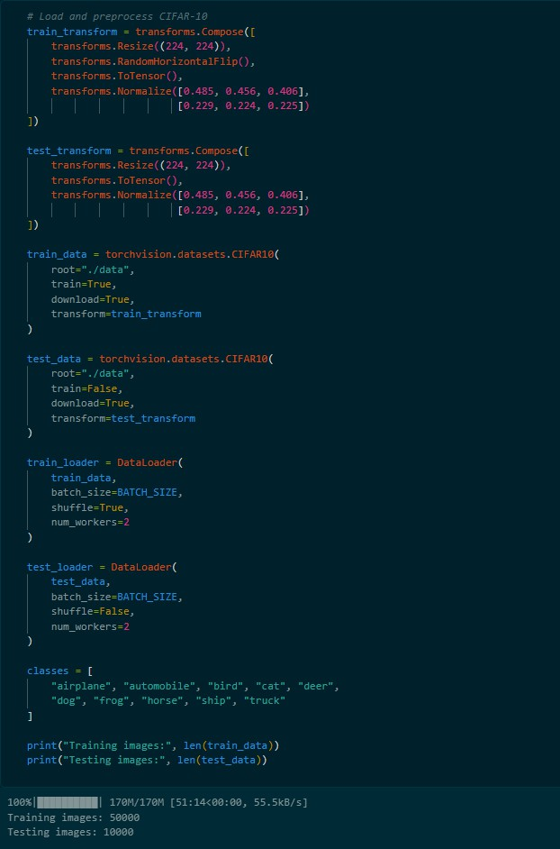

Loading the pretrained models.
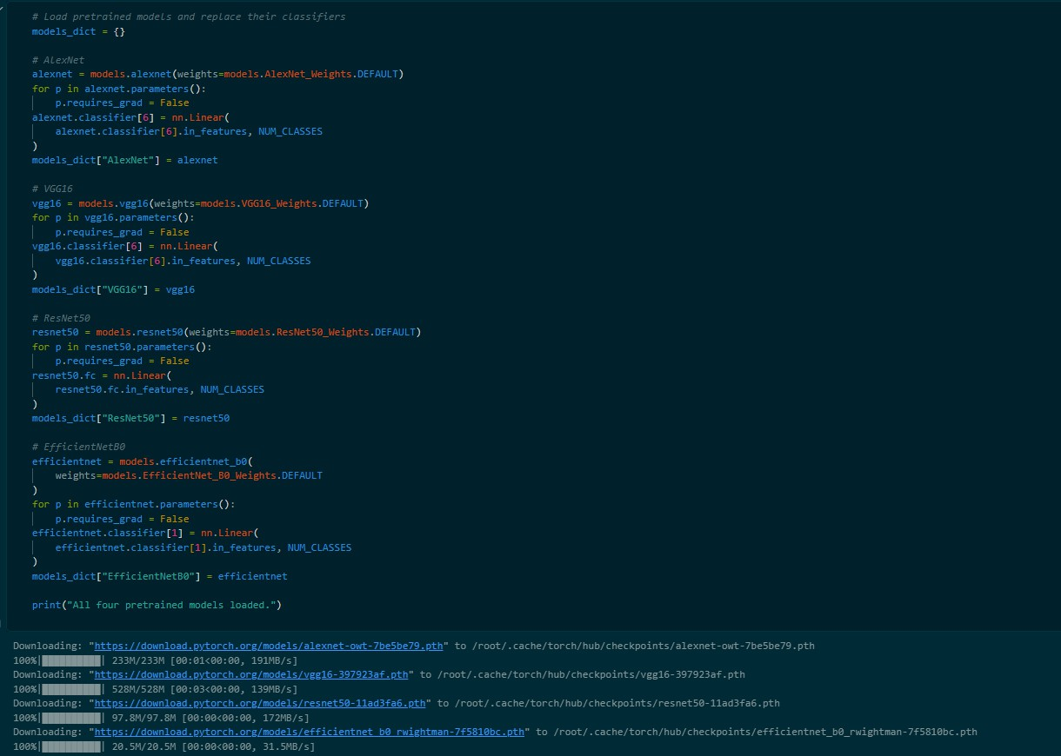

Training performance of AlexNet, VGG16, ResNet50, and EfficientNetB0 across five epochs.
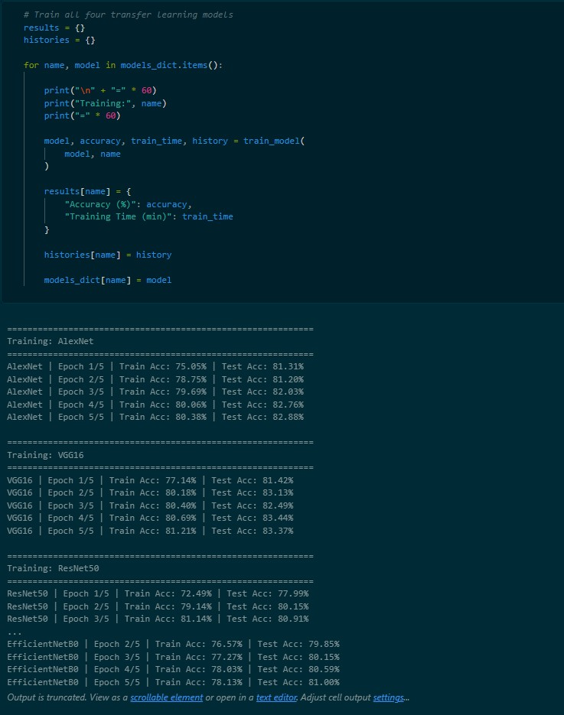

Comparison of test accuracy and training time for the four transfer learning models.
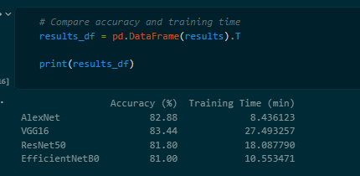

Plotting the comparison of accuracy
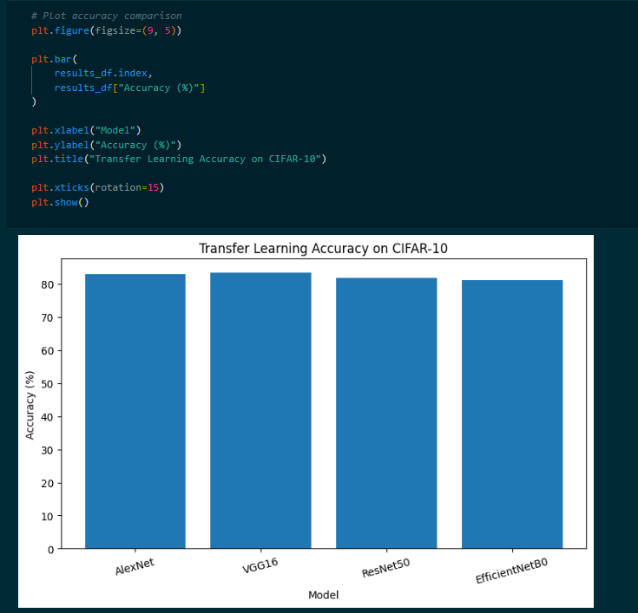

Test accuracy comparison of AlexNet, VGG16, ResNet50, and EfficientNetB0 on CIFAR-10.
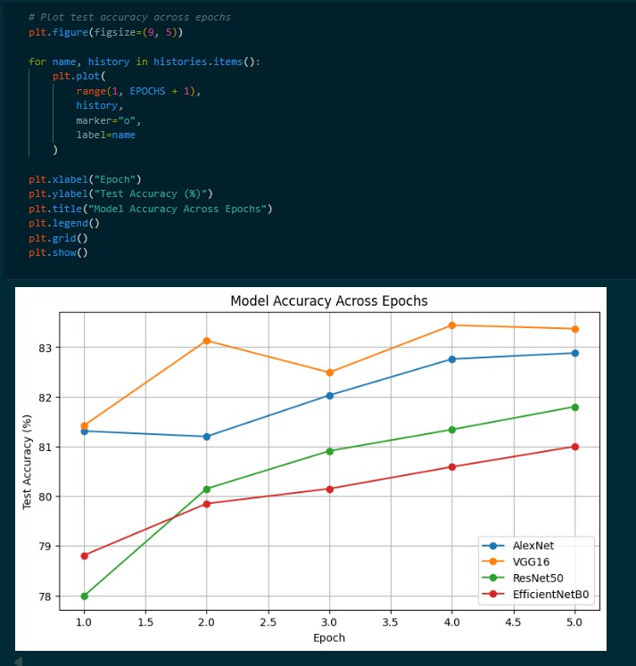

Generating classification reports for all models
