BRACT’s

Vishwakarma Institute of Technology, Pune

Practical Implementation Sheet

Department: CSE-AI Semester: 5 Academic Year: 2026-27

Division: E Batch: 2 Practical No: 9

Roll no: 39 PRN No: 12414234 Name of Student: Rishi Gupta

Subject Name: Deep Learning

Problem Statement:
Perform Image classification using Pretrained Vision Transformer model and compare its performance with CNN Model.

Algorithm:
- Import Libraries: Import TensorFlow, Transformers, Scikit-learn, NumPy, Matplotlib and other required libraries.
- Load Dataset: Load the CIFAR-10 dataset, containing 50,000 training images and 10,000 testing images.
- Preprocess Data: Normalize image pixel values to the range [0, 1] and define the ten image classes.
- Visualize Images: Display sample images from the CIFAR-10 dataset with their class labels.
- Build CNN Model: Create a Convolutional Neural Network using convolution, max-pooling, flattening and dense layers.
- Train CNN: Train the CNN on the full training dataset for five epochs, using 10% of the training data for validation.
- Evaluate CNN: Predict the classes of test images and calculate accuracy and classification metrics.
- Load Pre-trained ViT: Load the pre-trained Vision Transformer model and its image processor, replacing the original classification head with a ten-class output layer.
- Prepare ViT Data: Select 5,000 training images and 1,000 testing images. Resize and preprocess images in small batches to reduce memory usage.
- Fine-tune ViT: Compile and fine-tune the pre-trained ViT model on the selected training subset for two epochs.
- Evaluate and Compare: Evaluate ViT on the selected test subset and compare CNN and ViT using accuracy, precision, recall and F1-score. Visualize the accuracy comparison.

Code:
# Block 1: Install required libraries
!pip -q install tf-keras transformers scikit-learn
# Block 2: Import libraries import tensorflow as tf import tf_keras
from tensorflow.keras import layers, models
from transformers import ViTImageProcessor, TFViTForImageClassification from sklearn.metrics import accuracy_score, classification_report
from sklearn.metrics import precision_score, recall_score, f1_score import numpy as np
import matplotlib.pyplot as plt import pandas as pd
import math
# Block 3: Load and preprocess CIFAR-10 dataset
(x_train, y_train), (x_test, y_test) = tf.keras.datasets.cifar10.load_data() x_train = x_train.astype("float32") / 255.0
x_test = x_test.astype("float32") / 255.0 class_names = [
"airplane", "automobile", "bird", "cat", "deer",
"dog", "frog", "horse", "ship", "truck"
]
print("Training data:", x_train.shape) print("Testing data:", x_test.shape)
# Block 4: Visualize sample images plt.figure(figsize=(10, 4))
for i in range(10):
plt.subplot(2, 5, i + 1) plt.imshow(x_train[i]) plt.title(class_names[int(y_train[i][0])]) plt.axis("off")
plt.tight_layout() plt.show()
# Block 5: Build the CNN model cnn = models.Sequential([
layers.Conv2D(32, 3, activation="relu", input_shape=(32, 32, 3)), layers.MaxPooling2D(),
layers.Conv2D(64, 3, activation="relu"), layers.MaxPooling2D(), layers.Flatten(),
layers.Dense(128, activation="relu"), layers.Dense(10, activation="softmax")
])
cnn.compile( optimizer="adam",
loss="sparse_categorical_crossentropy", metrics=["accuracy"]
)
cnn.summary()
# Block 6: Train the CNN model cnn_history = cnn.fit(
x_train, y_train, epochs=5, batch_size=64,
validation_split=0.1
)
# Block 7: Evaluate the CNN model
cnn_loss, cnn_accuracy = cnn.evaluate(x_test, y_test, verbose=0) cnn_pred = np.argmax(cnn.predict(x_test, batch_size=64), axis=1) print("CNN Accuracy:", accuracy_score(y_test.flatten(), cnn_pred)) print(classification_report(

y_test.flatten(), cnn_pred,
target_names=class_names
))
# Block 8: Load the pre-trained Vision Transformer processor = ViTImageProcessor.from_pretrained(
"google/vit-base-patch16-224"
)
vit = TFViTForImageClassification.from_pretrained( "google/vit-base-patch16-224",
num_labels=10, ignore_mismatched_sizes=True
)

# Block 9: Prepare ViT images in small batches to reduce RAM usage batch_size = 4
def batch_generator(images, labels, batch_size=4, shuffle=False, repeat=False): while True:
indices = np.arange(len(images)) if shuffle:
np.random.shuffle(indices)
for start in range(0, len(images), batch_size): idx = indices[start:start + batch_size]
batch_images = (images[idx] * 255).astype(np.uint8) pixel_values = processor(
images=list(batch_images), return_tensors="np"
)["pixel_values"] yield (
pixel_values.astype(np.float32), labels[idx].astype(np.int32).reshape(-1)
)
if not repeat:
break
train_ds = tf.data.Dataset.from_generator( lambda: batch_generator(
x_train[:5000], y_train[:5000], batch_size=batch_size, shuffle=True, repeat=True
),
output_signature=(
tf.TensorSpec(shape=(None, 3, 224, 224), dtype=tf.float32), tf.TensorSpec(shape=(None,), dtype=tf.int32)
)
)
test_ds = tf.data.Dataset.from_generator( lambda: batch_generator(
x_test[:1000], y_test[:1000], batch_size=batch_size, shuffle=False
),
output_signature=(
tf.TensorSpec(shape=(None, 3, 224, 224), dtype=tf.float32), tf.TensorSpec(shape=(None,), dtype=tf.int32)
)
)
print("ViT training images:", 5000) print("ViT testing images:", 1000)
# Block 10: Fine-tune and evaluate the ViT model vit.compile(
optimizer=tf_keras.optimizers.Adam(learning_rate=5e-5), loss=tf_keras.losses.SparseCategoricalCrossentropy(from_logits=True), metrics=["accuracy"]
)

vit_history = vit.fit( train_ds, epochs=2,
steps_per_epoch=math.ceil(5000 / batch_size)
)

# Generate ViT predictions in batches all_logits = []

for pixel_values, labels in test_ds:
outputs = vit(pixel_values=pixel_values, training=False) all_logits.extend(outputs.logits.numpy())
vit_pred = np.argmax(np.array(all_logits), axis=1) test_lab = y_test[:1000].flatten()
print("ViT Accuracy:", accuracy_score(test_lab, vit_pred)) print(classification_report(
test_lab, vit_pred,
target_names=class_names
))
# Block 11: Compare CNN and ViT performance on the same 1,000 test images cnn_pred_subset = cnn_pred[:1000]
cnn_true = y_test[:1000].flatten() vit_true = test_lab
results = pd.DataFrame({ "Model": ["CNN", "ViT"],
"Accuracy": [
accuracy_score(cnn_true, cnn_pred_subset), accuracy_score(vit_true, vit_pred)
],
"Precision": [
precision_score(cnn_true, cnn_pred_subset, average="weighted", zero_division=0), precision_score(vit_true, vit_pred, average="weighted", zero_division=0)
],
"Recall": [
recall_score(cnn_true, cnn_pred_subset, average="weighted", zero_division=0), recall_score(vit_true, vit_pred, average="weighted", zero_division=0)
],
"F1-Score": [
f1_score(cnn_true, cnn_pred_subset, average="weighted", zero_division=0), f1_score(vit_true, vit_pred, average="weighted", zero_division=0)
]
})
print("\nCNN vs ViT Performance:") print(results.round(4))

# Plot the accuracy comparison plt.figure(figsize=(6, 4)) plt.bar(results["Model"], results["Accuracy"]) plt.title("CNN vs ViT Accuracy") plt.xlabel("Model")
plt.ylabel("Accuracy") plt.ylim(0, 1) plt.tight_layout() plt.show()

Output:
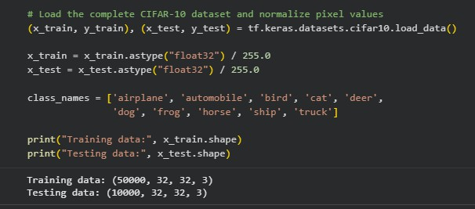
- Loading and normalizing the CIFAR-10 training and testing datasets.

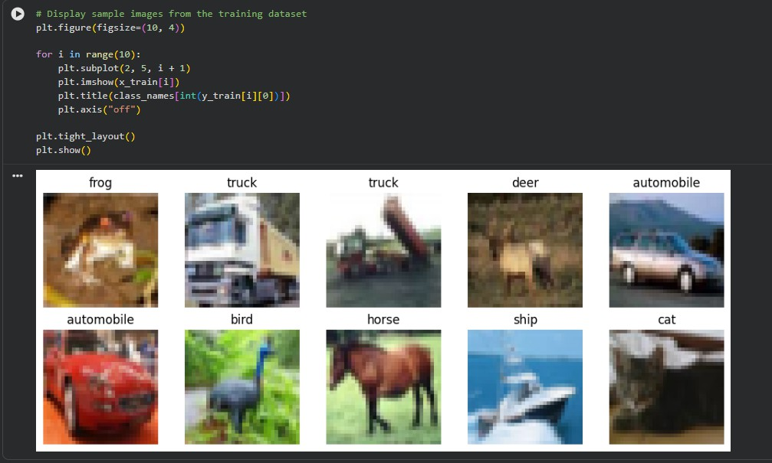
- Displaying sample CIFAR-10 images with their corresponding class labels.

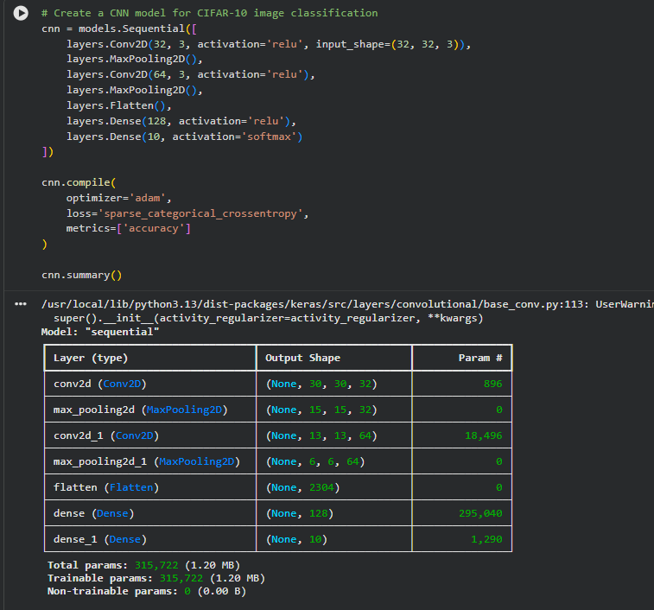
- Defining the CNN model and displaying its layer structure and parameter summary

.

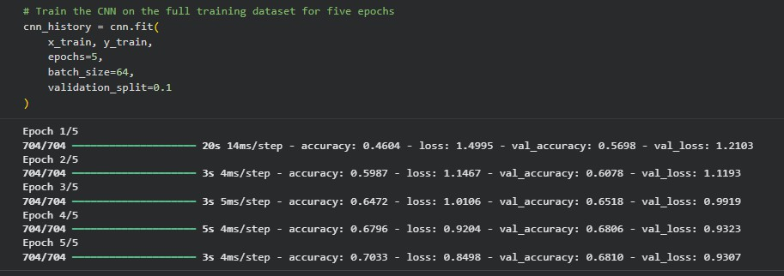
- Training the CNN for five epochs and monitoring training and validation accuracy.

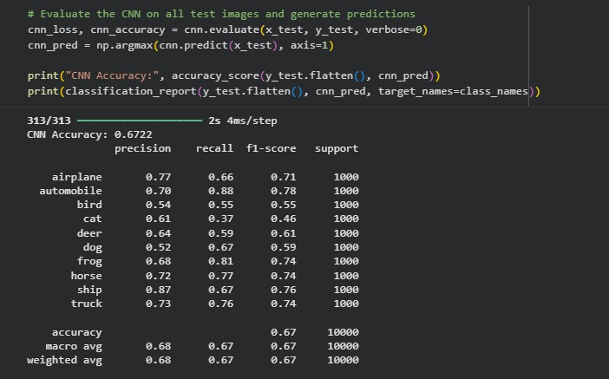
- Evaluating CNN performance on the test dataset using accuracy and classification metrics.

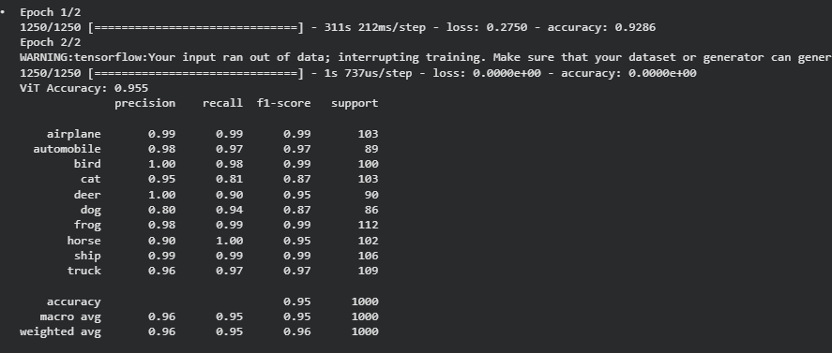
- Fine-tuning the pre-trained Vision Transformer and evaluating its classification performance.

8] Comparing CNN and ViT using accuracy, precision, recall, and F1-score, with a visual accuracy comparison.
