BRACT’s

Vishwakarma Institute of Technology, Pune

Practical Implementation Sheet

Department: CSE-AI Semester: 5 Academic Year: 2026-27

Division: E Batch: 2 Practical No: 1

Roll no: 39 PRN No: 12414234 Name of Student: Rishi Gupta

Subject Name : Deep Learning

Problem Statement:
Install and configure TensorFlow/Keras in Google Colab. Perform data preprocessing, normalization, train-test splitting, and data visualization on a sample dataset.

Algorithm:
- Import the required TensorFlow and Matplotlib libraries.
- Load the Fashion MNIST dataset into training and testing sets.
- Normalize the image pixel values from 0–255 to 0–1.
- Display the shape of the training and testing datasets.
- Visualize a few sample images from the training dataset.
- Display a single Fashion MNIST image with its corresponding label.
- Create a Sequential neural network with a Flatten layer, one hidden Dense layer (ReLU), and an output Dense layer (Softmax).
- Compile the model using the Adam optimizer, Sparse Categorical Crossentropy loss function, and Accuracy metric.
- Train the model on the training dataset for 3 epochs.
- Evaluate the trained model on the test dataset and display the test loss and accuracy.

Code:
- # import libraries import tensorflow as tf
import matplotlib.pyplot as plt

- # Load Fashion MNIST Dataset

(train_images, train_labels), (test_images, test_labels) = tf.keras.datasets.fashion_mnist.load_data()

- # Normalize the Data train_images = train_images / 255.0 test_images = test_images / 255.0 4] # Display Dataset Information
print("Training Images Shape:", train_images.shape) print("Testing Images Shape:", test_images.shape) print("Training Labels Shape:", train_labels.shape) print("Testing Labels Shape:", test_labels.shape)
- # Visualize Sample Images plt.figure(figsize=(6,6))
for i in range(9):

plt.subplot(3,3,i+1) plt.imshow(train_images[i], cmap="gray") plt.title(class_names[train_labels[i]]) plt.axis("off")
plt.tight_layout() plt.show()
- # Display One Image plt.imshow(train_images[7], cmap="gray") plt.title(class_names[train_labels[7]]) plt.axis("off")
plt.show()

- # Define Neural Network Model my_model = tf.keras.models.Sequential()

my_model.add(tf.keras.layers.Flatten(input_shape=(28, 28)))

my_model.add(tf.keras.layers.Dense(128, activation="relu")) my_model.add(tf.keras.layers.Dense(10, activation="softmax")) 8] # Compile the Model
my_model.compile( optimizer="adam",
loss="sparse_categorical_crossentropy", metrics=["accuracy"]
)

- # Train the Model history = my_model.fit(
train_images, train_labels, epochs=3
)

- # Evaluate the Model

test_loss, test_accuracy = my_model.evaluate(test_images, test_labels) print("Test Loss:", test_loss)
print("Test Accuracy:", test_accuracy)

Output:
1]
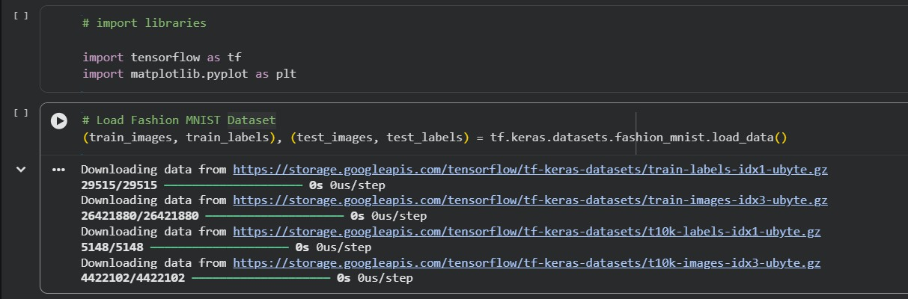

2]
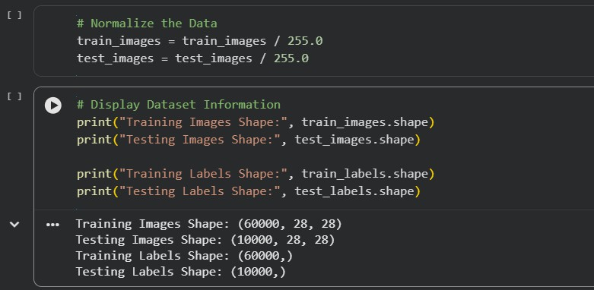

3]
