Fernwick Water Department: 2025 Water Quality Report
This report tells you where your water comes from and what our tests found in 2025. Your water met every federal and state drinking water standard.
Where your water comes from
Fernwick's water comes from three wells near the Fern River. We treat it with chlorine and test it every week.
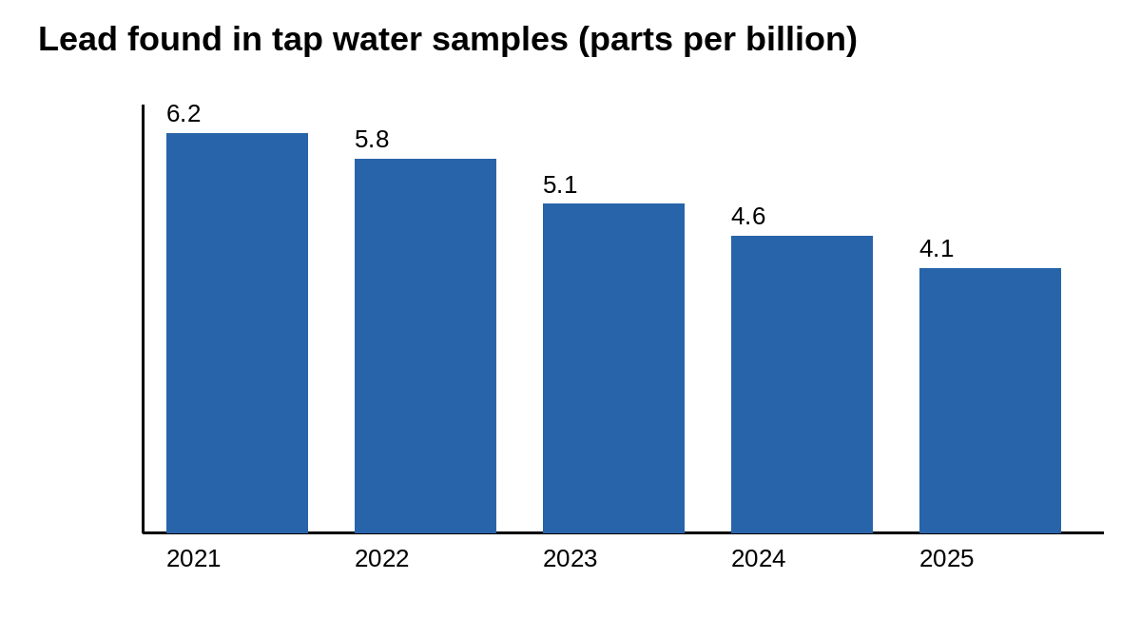
What we found
Substance | Highest level found | Allowed limit | Meets the standard?
Lead | 4.1 parts per billion | 15 parts per billion (action level) | Yes
Copper | 0.21 parts per million | 1.3 parts per million (action level) | Yes
Nitrate | 2.4 parts per million | 10 parts per million | Yes
Chlorine | 1.1 parts per million | 4 parts per million | Yes
Questions
Call the Water Department at (555) 010-0140, or come to a Town Council meeting.

