St Aidan's Church
Wrenford
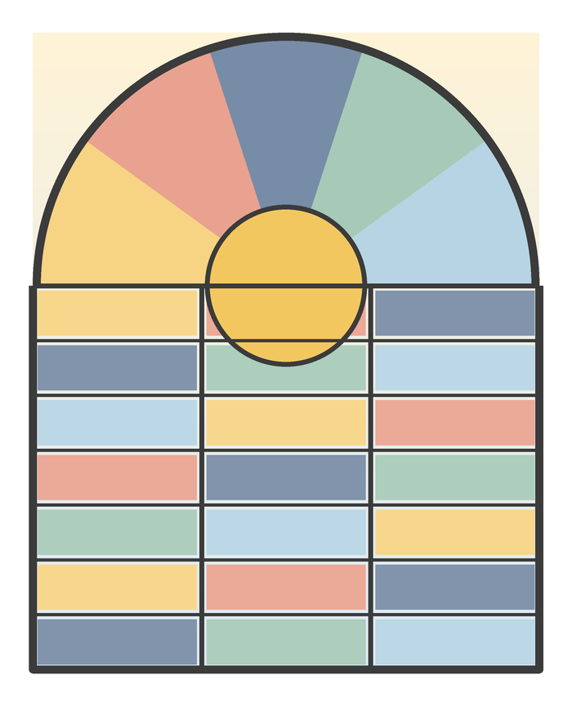
Mothering Sunday
Sunday 15 March 2026
10.00 am · All-Age Worship
Welcome to St Aidan's! Today we give thanks for mothers and for everyone who cares for others. If you are visiting, please make yourself known after the service. Large-print sheets and a hearing loop are available.
Leading: Revd Helen Marsh · Music: David Lowe

Order of Service
Words in bold are said by everyone. Please stand or sit as you are able.

We gather
Welcome Revd Helen Marsh
Hymn 192
Praise, my soul, the King of heaven
Please stand
God of love, you have gathered us as one family.
Welcome us, hold us, and send us out in your love.
We say together
Loving God, thank you for all who have cared for us: for mothers and grandmothers, carers and friends. Help us to care for others as you care for us. Amen.
Opening prayer Revd Helen Marsh

We listen
First reading 1 Samuel 1.20-28
Read by Margaret Bell
Psalm 34.11-20
Second reading Colossians 3.12-17
Read by Joshua Mensah
Gospel Luke 2.33-35
Children are invited to the Wrens corner during the talk. They return for the prayers.
Talk Revd Helen Marsh

We respond
Prayers Priya Shah
For all who have cared for us and taught us to love,
we give you thanks and praise.
The Peace
May the peace of God be with you all.
And also with you.
Please share a sign of peace with those around you.
Hymn 365
Now thank we all our God
The collection is taken during this hymn.
The children will give everyone a posy of spring flowers.

We go out
Blessing
Final hymn 16
All things bright and beautiful
Go out into the world with hope.
Thanks be to God.
Please stay for tea, coffee and simnel cake in the hall.

This week at St Aidan's
Mon | 7.30 pm | Church council, vestry
Tue | 10.00 am | Coffee morning, church hall
Wed | 9.15 am | Little Wrens toddler group
Thu | 2.00 pm | Lent study group, the vicarage
Sat | 10.00 am | Churchyard spring clean
Sun | 10.00 am | Fifth Sunday of Lent

Notices
- The heating appeal has reached £18,240. Thank you!
- Easter flowers: please add names to the list at the back by 22 March.
- The Palm Sunday procession leaves the village green at 9.45 am on 29 March.

Please pray for
Those who are unwell and those who care for them; families who are grieving; the children and staff of Wrenford Primary School.

Contact  Vicar: Revd Helen Marsh · 01632 960412  Office: office@example.org · Tue and Thu mornings  www.example.org  Give by card at the back of church, or online at example.org/give. | 

