Task 1: Network Design with MPLS Connectivity

1.0 Network Design Rationale and Subnetting Scheme
The report focuses on the scalability, efficiency, availability, redundancy, and security for the network infrastructure that connects the eight sites and the data centre, based on the 107.6.2.0/23 IP address block of the Agricultural Cooperative.
1.1 Design Considerations
The four principles of the design are:
- Scalability: It takes into account for the 20% growth for the next five years for all the sites, so two reserved subnet blocks as well as two reserved WAN links are created for this purpose.
- Efficiency: To make the system efficient, the design focuses on creating a Variable Length Subnet Masking (VLSM). This method creates subnets based on the needs of each site, which avoids wasting addresses [1].
- Availability and Redundancy: The network focuses on high availability and redundancy as the MPLS service is naturally resilient [3]. As a backup, console cables provide direct management access to the routers and switches. While MPLS provides resilience, it lacks native encryption. This is a major consideration and will be discussed elaborately in task 2.
- Security: The data centre is kept isolated, which creates an additional security layer. This is a key principle for protecting critical services in modern data centre design [4].
1.2 IP Subnetting Table
The resulting allocation of the 107.6.2.0/23 address space is detailed in the table below. The sites were arranged from largest to smallest to ensure the most efficient allocation of contiguous IP blocks.
Site | Users | 20% increment of Users | Maximum Users (excluding network and broadcast address) | CIDR Prefix | Subnet Mask | Network Address | Host Address Range | Broadcast Address
Site 1 | 30 | 36 | 2⁶−2=62 | /26 | 255.255.255.192 | 107.6.2.0 | 107.6.2.1 - 107.6.2.62 | 107.6.2.63
Site 4 | 29 | 35 | 2⁶−2=62 | /26 | 255.255.255.192 | 107.6.2.64 | 107.6.2.65 - 107.6.2.126 | 107.6.2.127
Site 6 | 28 | 34 | 2⁶−2=62 | /26 | 255.255.255.192 | 107.6.2.128 | 107.6.2.129 - 107.6.2.190 | 107.6.2.191
Site 7 | 27 | 33 | 2⁶−2=62 | /26 | 255.255.255.192 | 107.6.2.192 | 107.6.2.193 - 107.6.2.254 | 107.6.2.255
Site 5 | 13 | 16 | 2⁵−2=30 | /27 | 255.255.255.224 | 107.6.3.0 | 107.6.3.1 - 107.6.3.30 | 107.6.3.31
Future Site 1 | N/A | N/A | 2⁵−2=30 | /27 | 255.255.255.224 | 107.6.3.32 | 107.6.3.33 - 107.6.3.62 | 107.6.3.63
Future Site 2 | N/A | N/A | 2⁵−2=30 | /27 | 255.255.255.224 | 107.6.3.64 | 107.6.3.65 - 107.6.3.94 | 107.6.3.95
Site 2 | 8 | 10 | 2⁴−2=14 | /28 | 255.255.255.240 | 107.6.3.96 | 107.6.3.97 - 107.6.3.110 | 107.6.3.111
Site 3 | 8 | 10 | 2⁴−2=14 | /28 | 255.255.255.240 | 107.6.3.112 | 107.6.3.113 - 107.6.3.126 | 107.6.3.127
Data Centre | N/A | N/A | 2⁴−2=14 | /28 | 255.255.255.240 | 107.6.3.128 | 107.6.3.129 - 107.6.3.142 | 107.6.3.143
Site 8 | 5 | 6 | 2³−2=6 | /29 | 255.255.255.248 | 107.6.3.144 | 107.6.3.145 - 107.6.3.150 | 107.6.3.151
WAN Link 1 | N/A | N/A | 2²−2=2 | /30 | 255.255.255.252 | 107.6.3.152 | 107.6.3.153 - 107.6.3.154 | 107.6.3.155
WAN Link 2 | N/A | N/A | 2²−2=2 | /30 | 255.255.255.252 | 107.6.3.156 | 107.6.3.157 - 107.6.3.158 | 107.6.3.159
WAN Link 3 | N/A | N/A | 2²−2=2 | /30 | 255.255.255.252 | 107.6.3.160 | 107.6.3.161 - 107.6.3.162 | 107.6.3.163
WAN Link 4 | N/A | N/A | 2²−2=2 | /30 | 255.255.255.252 | 107.6.3.164 | 107.6.3.165 - 107.6.3.166 | 107.6.3.167
WAN Link 5 | N/A | N/A | 2²−2=2 | /30 | 255.255.255.252 | 107.6.3.168 | 107.6.3.169 - 107.6.3.170 | 107.6.3.171
WAN Link 6 | N/A | N/A | 2²−2=2 | /30 | 255.255.255.252 | 107.6.3.172 | 107.6.3.173 - 107.6.3.174 | 107.6.3.175
WAN Link 7 | N/A | N/A | 2²−2=2 | /30 | 255.255.255.252 | 107.6.3.176 | 107.6.3.177 - 107.6.3.178 | 107.6.3.179
WAN Link 8 | N/A | N/A | 2²−2=2 | /30 | 255.255.255.252 | 107.6.3.180 | 107.6.3.181 - 107.6.3.182 | 107.6.3.183
WAN Link 9 | N/A | N/A | 2²−2=2 | /30 | 255.255.255.252 | 107.6.3.184 | 107.6.3.185 - 107.6.3.186 | 107.6.3.187
WAN Link 10  (Reserve) | N/A | N/A | 2²−2=2 | /30 | 255.255.255.252 | 107.6.3.188 | 107.6.3.189 - 107.6.3.190 | 107.6.3.191
WAN Link 11  (Reserve) | N/A | N/A | 2²−2=2 | /30 | 255.255.255.252 | 107.6.3.192 | 107.6.3.193 - 107.6.3.194 | 107.6.3.195

2.0 Packet Tracer Implementation and Technology
The network was fully implemented in a Cisco Packet Tracer simulation to validate the design. Two additional subnets and WAN links (WAN link 10 and 11) were created for future sites in case of further expansion; it is not shown in the Packet Tracer.
2.1 MPLS Connectivity and Simulation
The client's requirement for a Multiprotocol Label Switching (MPLS) service is addressed in this design. MPLS is a highly effective technology for adding packet services to transport networks, as it allows for the exploitation of packet switching flexibility and can lead to better bandwidth allocation through statistical multiplexing [2]. This technology is a mature and widely deployed solution for traffic engineering in IP networks [5].
As Cisco Packet Tracer does not support MPLS, an interconnected mesh of 4 routers within a cluster is represented as the service provider cloud. This provides high availability and simulates an MPLS cloud's "any-to-any" connectivity. This is conceptually represented in Figure 1.
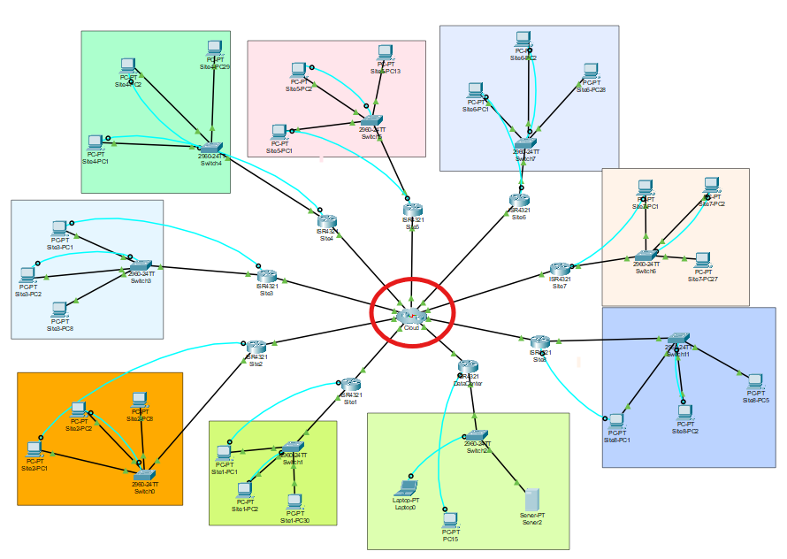 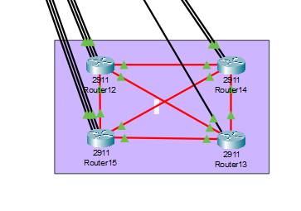
Figure 1: Conceptual MPLS Topology Figure 2: The routers simulating as SP cloud
inside cluster
2.2 Routing Protocol Selection and Justification
To enable communication across the network, a routing protocol is essential. While basic methods like Static Routing and RIP exist, they are unsuitable for a professional network of this size due to issues with scalability, manual configuration, and slow performance [1].
The client's specified technology is MPLS, which operates differently from traditional routing protocols. However, since Cisco Packet Tracer cannot simulate an MPLS service, a routing protocol was required to make the simulated network functional and to provide the necessary end-to-end connectivity.
For this reason, the Open Shortest Path First (OSPF) protocol was chosen for the simulation. OSPF is a modern and efficient protocol that dynamically builds a map of the network to ensure data travels along the fastest path. Its ability to support multiple equal-cost paths also aligns with the multipath capabilities inherent in a real-world MPLS network [5]. In this context, OSPF is the practical substitute in the Packet Tracer that an MPLS service would provide in a real-world scenario.
2.3 Justification of MPLS for Scalability, Performance, and Availability
Choosing an MPLS service is a key part of this design. It is the best option to make sure the network is scalable, fast, and reliable, and the research backs this up.
- Scalability: An MPLS network is designed to scale and grow. When the cooperative needs to add a new site, it plugs it into the provider's network. All the complicated routing in the background is managed by the provider, so clients can scale up their network without facing complexities. However, providers must take into account that they can handle the size as the network gets larger [6]. MPLS has specific designs that manage the network growth, such as creating LSP hierarchies. This technique allows the network to scale up easily by organizing the network's pathway efficiently and reducing the load on the core routers [6].
- Performance: MPLS utilizes smart implementation of bandwidth, a benefit that comes from "statistical multiplexing" [2] and eventually makes the network faster and efficient. It also groups similar types of traffic using "flow aggregation." This helps the core network run faster and more smoothly by reducing the number of table entries switches must manage [5]. The main goal of these features is to achieve better "optimisation of MPLS network traffic" [3].
- Availability: MPLS is reliable as it is designed to stay online by having backup routes already; that is possible because it supports "multipath transmission," meaning it can figure out several ways to get data from A to B [5]. In case the main path fails, MPLS can switch to a backup route. A standard routing protocol like OSPF would have to pause and calculate a new route, delaying the transmission process [1]. MPLS can handle any "changing network conditions" and keep the network running with minimal hindrance as the backup paths remain ready [5].

2.4 Packet Tracer IP Address Assignment
The subnet assignment from Table 1 was directly implemented in the Packet Tracer simulation. For each site, the first usable IP address from the host range was assigned to the LAN interface of the site router to serve as the default gateway.
The subsequent usable IP addresses were assigned to the end devices (PCs and the server) as detailed in Table 2. This approach ensures that no IP address conflicts and simplifies network management.
Table 1: End Device IP Assignments (PCs and Server)
This table shows the specific IP addresses for PC1, PC2, and PCn for each site:
Location | Device Name | IP Address | Subnet Mask | Default Gateway
Site 1 | Site1-PC1 | 107.6.2.2 | 255.255.255.192 | 107.6.2.1
 | Site1-PC2 | 107.6.2.3 | 255.255.255.192 | 107.6.2.1
 | Site1-PC30 | 107.6.2.31 | 255.255.255.192 | 107.6.2.1
Site 2 | Site2-PC1 | 107.6.3.98 | 255.255.255.240 | 107.6.3.97
 | Site2-PC2 | 107.6.3.99 | 255.255.255.240 | 107.6.3.97
 | Site2-PC8 | 107.6.3.105 | 255.255.255.240 | 107.6.3.97
Site 3 | Site3-PC1 | 107.6.3.114 | 255.255.255.240 | 107.6.3.113
 | Site3-PC2 | 107.6.3.115 | 255.255.255.240 | 107.6.3.113
 | Site3-PC8 | 107.6.3.121 | 255.255.255.240 | 107.6.3.113
Site 4 | Site4-PC1 | 107.6.2.66 | 255.255.255.192 | 107.6.2.65
 | Site4-PC2 | 107.6.2.67 | 255.255.255.192 | 107.6.2.65
 | Site4-PC29 | 107.6.2.94 | 255.255.255.192 | 107.6.2.65
Site 5 | Site5-PC1 | 107.6.3.2 | 255.255.255.224 | 107.6.3.1
 | Site5-PC2 | 107.6.3.3 | 255.255.255.224 | 107.6.3.1
 | Site5-PC13 | 107.6.3.14 | 255.255.255.224 | 107.6.3.1
Site 6 | Site6-PC1 | 107.6.2.130 | 255.255.255.192 | 107.6.2.129
 | Site6-PC2 | 107.6.2.131 | 255.255.255.192 | 107.6.2.129
 | Site6-PC28 | 107.6.2.157 | 255.255.255.192 | 107.6.2.129
Site 7 | Site7-PC1 | 107.6.2.194 | 255.255.255.192 | 107.6.2.193
 | Site7-PC2 | 107.6.2.195 | 255.255.255.192 | 107.6.2.193
 | Site7-PC27 | 107.6.2.220 | 255.255.255.192 | 107.6.2.193
Site 8 | Site8-PC1 | 107.6.3.146 | 255.255.255.248 | 107.6.3.145
 | Site8-PC2 | 107.6.3.147 | 255.255.255.248 | 107.6.3.145
 | Site8-PC5 | 107.6.3.150 | 255.255.255.248 | 107.6.3.145
Data Centre | Server | 107.6.3.130 | 255.255.255.240 | 107.6.3.129

Table 2: Site Router IP Assignments
Router Location | LAN Interface (Gateway) | WAN Interface (to SP Cloud)
Site 1 Router | 107.6.2.1 | 107.6.3.153
Site 2 Router | 107.6.3.97 | 107.6.3.157
Site 3 Router | 107.6.3.113 | 107.6.3.161
Site 4 Router | 107.6.2.65 | 107.6.3.165
Site 5 Router | 107.6.3.1 | 107.6.3.169
Site 6 Router | 107.6.2.129 | 107.6.3.173
Site 7 Router | 107.6.2.193 | 107.6.3.177
Site 8 Router | 107.6.3.145 | 107.6.3.181
Data Centre Router | 107.6.3.129 | 107.6.3.185

Table 3: Service Provider (SP) Cloud Router IP Assignments
SP Router | Interface Connection | IP Address
SP Router12 | To Site 3 | 107.6.3.162
 | To Site 4 | 107.6.3.166
 | To Site 5 | 107.6.3.170
 | To SP Router13 | 10.10.10.1
 | To SP Router14 | 10.10.10.5
 | To SP Router15 | 10.10.10.9
SP Router13 | To Site 8 | 107.6.3.182
 | To SP Router12 | 10.10.10.2
 | To SP Router14 | 10.10.10.13
 | To SP Router15 | 10.10.10.17
SP Router14 | To Site 6 | 107.6.3.174
 | To Site 7 | 107.6.3.178
 | To SP Router12 | 10.10.10.6
 | To SP Router13 | 10.10.10.14
 | To SP Router15 | 10.10.10.21
SP Router15 | To Site 1 | 107.6.3.154
 | To Site 2 | 107.6.3.158
 | To Data Centre | 107.6.3.186
 | To SP Router12 | 10.10.10.10
 | To SP Router13 | 10.10.10.18
 | To SP Router14 | 10.10.10.22

(For the routers simulating the central service provider cloud, for the interconnected mesh, IPv4 addresses separate from the given range was used as they don’t belong to the organization)
3.0 Testing and Verification
The functionality of the implemented network was rigorously tested. The following tests were conducted to verify full end-to-end connectivity:
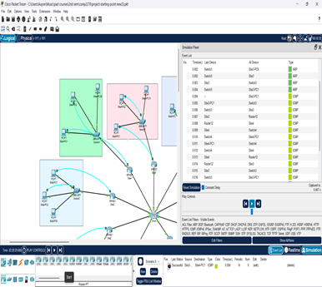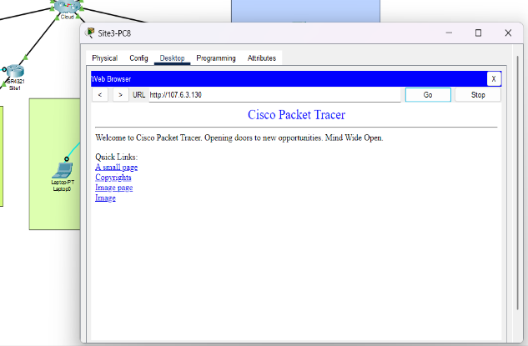
Figure 3: Successful Ping Tests Figure 4: Succesful loading of the server’s webpage
- Inter-Site Connectivity: Successful ping tests were performed between PCs in different remote sites (e.g., from Site 3 to Site 4), confirming that OSPF was operating correctly.
- Web Service Access: A PC from a remote site was used to access the web server in the data centre via its IP address (107.6.3.130). The successful loading of the server's webpage confirms that HTTP traffic is being routed correctly.
3.1 Acknowledging MPLS Security Limitations
Although MPLS service meets the client’s requirements for scalability, performance, and availability, there exist some significant security limitations. The major limitation is that the MPLS does not include native encryption. This limitation poses massive threats in modern networks and will be addressed comprehensively in Task 2.
4.0 Conclusion
The proposed network depicts a robust, scalable, and efficient infrastructure for the Cooperative. The VLSM ensures optimum use of IP addresses, keeping future expansion in mind. The simulated MPLS network shown by the OSPF routing protocol provides the required any-to-any connectivity, and the data centre is secured by isolating it. The design thoroughly addresses the current and future needs of the Cooperative.

Task 2: Network Security Risk Assessment and Controls
1.0 MPLS WAN Connectivity Design
The WAN connectivity design uses a provider-managed MPLS Layer 3 VPN, providing a foundational, high-performance, and private IP backbone [2]. The hub and spoke model was chosen over interconnected mesh for several reasons.
Analytical Justification:
- A full-mesh topology, while offering direct site-to-site connectivity, would create a complex security problem. It would require a distributed security policy on every edge router and would implicitly trust traffic moving laterally between sites.
- The chosen hub-and-spoke model is strategically superior for security. It forces all inter-site traffic to transit the central Data Centre hub. This centralisation creates a single, logical point for security inspection (a "choke point"), allowing the Next-Generation Firewall (NGFW) to apply a consistent security policy to all traffic. This design is a practical implementation of a Zero Trust principle, where inter-site traffic is not automatically trusted [10].
- Furthermore, this topology simplifies traffic engineering [3] and avoids the LSP (Label Switched Path) scaling-complexity issues that can arise in large full-mesh core networks [5].
2.0 Security Risk Assessment and Controls
The following risk analysis maps assets to threats and provides a critical justification for the selected controls.
Asset | Risks | Proposed Controls
Data Centre Server (Intranet) | 1. Unauthorized Access  2. Service Unavailability (DDoS)  3. Data Breach | 1. Next-Generation Firewall (NGFW): A traditional firewall is insufficient. An NGFW is mandated for its Layer 7 Application-ID capabilities, which are essential for a data centre [4]. This allows policies to be based on the application (e.g., allow HTTP) rather than just ports (e.g., allow TCP/80), preventing non-web protocols from co-opting the port.  2. High-Availability (HA) & Intrusion Prevention (IPS): A server cluster provides service-level redundancy. The NGFW's IPS module provides network-level protection, using signatures to block known exploits and anomaly detection to identify and mitigate attacks like DDoS [8].  3. Data-at-Rest Encryption (FDE): Full-Disk Encryption is a non-negotiable final control, ensuring that a physical breach of the data centre and theft of a server drive does not result in a data breach [1].
End-User PCs (Sites 1-8) | 1.Malware/Ransomware  2. Unauthorized Physical Access  3. Data Leakage | 1. Endpoint Detection & Response (EDR): Traditional antivirus is reactive. An EDR solution is specified because it is proactive; it monitors system behaviour (e.g., a Word doc attempting to encrypt files) and can stop zero-day threats [11].  2. Active Directory Group Policy (GPO): This is the most efficient control for enforcing user-level policies (e.g., password complexity, screen locking) and endpoint-level policies (e.g., disabling USB mass storage) at scale.
MPLS WAN Links | 1. Data Interception (Eavesdropping)  2. Service Unavailability | 1. Cryptography (IPsec-over-MPLS): The implementation of IPsec-over-MPLS represents a control solution that fixes the fundamental security vulnerability of MPLS networks. The analysis requires a fundamental evaluation between system performance and security measures.  • Analysis: The implementation of IPsec tunnels creates additional packet transmission delay and processing delays which negatively affect real-time traffic operations [7]. The performance degradation is considered tolerable by the system. The exact implementation scenario received academic evaluation which showed that VoIP services experience noticeable performance degradation through increased jitter and delayed transmission but still operate within acceptable performance ranges. The end-to-end confidentiality requirement demands this measurable performance cost [7].  Contractual Controls (SLA): The implementation of technical controls for provider failure remains impossible through technical means. The solution requires a strict Service Level Agreement (SLA) between the client and the provider that establishes performance guarantees for system availability and recovery duration.
Internal LAN (Switches/Routers) | 1. Unauthorized Device Access  2. Configuration Tampering | 1. IEEE 802.1X (Port-based NAC): IEEE 802.1X (Port-based NAC): This is specified over simple MAC-based port security. A MAC address can be easily spoofed, a well-documented vulnerability in both wired and wireless networks [9]. 802.1X provides true, credential-based authentication against a RADIUS server, ensuring only trusted devices can join the LAN.  2. TACACS+ for Device Administration: This is analytically superior to RADIUS for this purpose. RADIUS combines authentication and authorisation, while TACACS+ separates them, allowing for granular per-command authorisation [12].

3.0 Security Design Rationale
The security framework for the Agricultural Cooperative’s network is built on a Zero Trust model, a modern paradigm that dictates no traffic should be trusted by default, regardless of its origin [10]. This principle guides a multi-layered defence that protects the network from the physical port all the way to the data centre core. The following analysis provides a deeper look into how this architecture achieves resilience, secures the cooperative's data, and controls access at every critical juncture.
1. Ensuring Data Centre Availability and Resilience
This design highlights availability not as a single feature, but as a strong system engineered to counter two fundamentally different types of threats: internal system failures and external malicious attacks. To deal with internal failures, such as a server’s power supply failing or a critical software process crashing, the design specifies a high-availability (HA) active-passive server cluster. This setup provides an automatic and seamless failover. A primary server actively handles all live user requests while a secondary, identical server runs in standby mode, acting as a real-time mirror of the primary. The two servers are connected by a dedicated "heartbeat" link. If the primary server fails for any reason and its heartbeat signal stops, the secondary server detects this absence, promotes itself to the active role and takes over the primary’s virtual IP address. This entire process is automated and occurs within seconds, ensuring continuous service for users with minimal to no noticeable downtime.
To defend against external attacks, a Next-Generation Firewall (NGFW) is deployed at the data centre's edge, acting as a critical security gateway [4]. The NGFW provides robust protection through two key functions. First, its Intrusion Prevention System (IPS) actively inspects the content of incoming traffic, comparing it against a constantly updated database of known attack signatures. This allows it to identify and discard malicious packets, such as those attempting to exploit a known software vulnerability, before they can ever reach the server. Second, it leverages behavioural analysis to identify and block Distributed Denial of Service (DDoS) attacks. It recognizes harmful traffic patterns, like a flood of connection requests from thousands of sources, and can automatically absorb and drop this malicious traffic [8]. This preserves the server ‘s vital resources CPU, memory, and bandwidth for legitimate users. By combining the internal durability of the cluster with the external threat protection of the NGFW, the design creates a system that remains highly available under a wide range of failure and attack scenarios.
2. Protecting Intranet Traffic: Solving the MPLS Dichotomy
The central security challenge of this project is the inherent nature of the MPLS service: it provides excellent network isolation but offers no data confidentiality. The MPLS L3 VPN provides isolation through a mechanism called Virtual Routing and Forwarding (VRF). On the provider's routers, each customer is assigned their own unique VRF, which acts as a virtual router with its own independent routing table. This ensures that the Cooperative’s 107.6.2.0/23 network routes are never shared with other customers or advertised to the public internet. This segregation makes the internal network effectively invisible from the outside, which is a fundamental security benefit of MPLS [5].
However, this logical separation does not make the data secret. All customer traffic still travels across the provider's shared physical cables and hardware. This creates a risk that a malicious actor with access to the provider’s core network could potentially capture and read the Cooperative's data. To solve this, the design implements an IPsec-over-MPLS security overlay. This solution creates a secure, encrypted virtual private network that runs directly on top of the provider's private network.
The mechanism works by an IPsec tunnel in tunnel mode is established between each site's edge router and the central NGFW. When a user's PC sends a packet to the intranet server, the local edge router performs a critical security function: it takes the entire original IP packet, encrypts it using a strong algorithm like AES-256, and then encapsulates it inside a new packet called an Encapsulating Security Payload (ESP) packet [1]. A new, plain-text IP header is then added to this ESP packet, with the source and destination addresses being the public-facing IPs of the tunnel endpoints (the site router and the central NGFW). The provider's MPLS network only ever sees and routes this outer packet; the entire original packet including its contents and original source and destination IPs is completely hidden and unreadable.
While the process of encryption and encapsulation does introduce a minor performance hindrance, extensive academic studies on this exact scenario confirm that the impact on modern enterprise traffic, including real-time applications like VoIP, is well within acceptable tolerances [7]. Therefore, this slight performance cost is a necessary engineering consideration to add a layer of end-to-end confidentiality.
3. Mitigating Unauthorized Access and Data Leakage
The Zero Trust model [10] also states the strategy for mitigating access and data leakage risks by enforcing strict verification at every boundary and protecting data in all its states.
The design stops unauthorized access with a layered chain of robust controls. First, at the physical layer, IEEE 802.1X Port-Based Network Access Control prevents unknown and malicious devices from connecting to a network switch. A switch port will remain disabled until the device provides valid credentials to a central RADIUS server. This is an improvement over older methods like MAC-based filtering, which are vulnerable to simple spoofing attacks [9]. Second, TACACS+ is used to secure administrative access to the network devices themselves. It is analytically superior to alternatives like RADIUS for this purpose because it separates the functions of authentication, authorization, and accounting. This separation allows for granular, per-command control, meaning an administrator can be permitted to view a configuration but be denied the permission to change it [12]. Finally, Role-Based Access Control (RBAC) on the server itself ensures that authenticated users can only interact with the specific data and applications that are relevant to their job roles.
The design also protects data in its three distinct states. The IPsec tunnels protect data-in-transit from eavesdropping across the WAN [7]. Full-Disk Encryption (FDE) protects data-at-rest, ensuring that even if a server's hard drive is physically stolen, the data on it remains an unreadable, encrypted block without the key [1]. Finally, Active Directory Group Policies (GPO) are used to protect data-at-the-endpoint. By disabling the use of removable media like USB drives on all company PCs, this policy closes a common and often overlooked vector for intentional or accidental data exfiltration.

4.0 Conclusion
The assessment analyzes the main risk factors and develops a step-by-step solution for these risks. The backbone of the security policy is based on the "defense-in-depth" concept, supported by an end-to-end Zero Trust model [10] that also includes all risks at every level of the network [1]. The principal security concern of the design is that its inability to directly encrypt the underlying MPLS network has been recognized and mitigated. An IPsec over MPLS overlay provides confidentiality by encrypting all traffic. The answer is also derived from the academic study validating its efficacy and functionality [7]. It also gives the same protection and long life to the intranet server through a combination of high-availability server clustering and the protective capabilities of a Next-Generation Firewall (NGFW), which is essential for fending off modern cyber-attacks [4, 8]. The layered application of controls such as 802.1X [9] and TACACS+ [12] ensures that access is tightly controlled.
In short, the solution effectively converts the MPLS network away from exclusively a private and unencrypted service to one that is secure, reliable, and able to be defended at an enterprise scale so that the data and services of the Agricultural Cooperative remain secure.

References
[1] J. F. Kurose and K. W. Ross, Computer Networking: A Top-Down Approach, 8th ed. Pearson, 2021.
[2] P. Belotti, A. Capone, G. Carello, and F. Malucelli, "Multi-layer MPLS network design: The impact of statistical multiplexing," Computer Networks, vol. 52, no. 7, pp. 1291-1307, May 2008. doi: 10.1016/j.comnet.2008.01.005.
[3] M. Masood et al., "Enhanced optimisation of MPLS network traffic using a novel adjustable Bat algorithm with loudness optimizer," Results in Engineering, vol. 26, 104774, 2025. doi: 10.1016/j.rineng.2025.104774.
[4] S. Wang, "Optimal Design of Data Center Network Security Architecture," in ICBDA 2024: Proceedings of the 2024 9th International Conference on Big Data Analytics, 2024. doi: 10.2991/978-94-6463-546-1_43.
[5] Z. Duliński, G. Rzym, and P. Chołda, "MPLS-based reduction of flow table entries in SDN switches supporting multipath transmission," Computer Communications, vol. 151, pp. 365-385, 2020. doi: 10.1016/j.comcom.2019.12.052.
[6] S. Yasukawa, A. Farrel, and O. Komolafe, "An Analysis of Scaling Issues in MPLS-TE Core Networks," RFC 5439, Feb. 2009. [Online]. Available: https://www.rfc-editor.org/info/rfc5439.
[7] J. C. Mwape, "Performance Evaluation of Internet Protocol Security (IPsec) Over Multiprotocol Label Switching (MPLS)," M.Eng. dissertation, Dept. of ICT Security, Univ. of Zambia, 2024. [Online]. Available: https://dspace.unza.zm/items/076e8614-8f85-43c9-91d9-d716f9ce74f5
[8] N. Hachem, "MPLS-based mitigation technique to handle cyber-attacks," Ph.D. dissertation, Dept. of Informatics and Networks, Institut National des Télécommunications, 2014. [Online]. Available: https://theses.hal.science/tel-01126831/
[9] R. Banakh, A. Piskozub, and I. Opirskyy, "Detection of MAC Spoofing Attacks in IEEE 802.11 Networks Using Signal Strength from Attackers’ Devices," in Advances in Computer Science for Engineering and Education, Z. Hu, S. Petoukhov, I. Dychka, and M. He, Eds., vol. 754. Cham, Switzerland: Springer International Publishing, 2019, pp. 468–477. doi: 10.1007/978-3-319-91008-6.
[10] F. A. Qazi, "Study of Zero Trust Architecture for Applications and Network Security," in 2022 IEEE 19th International Conference on Smart Communities: Improving Quality of Life Using ICT, IoT and AI (HONET), 2022, pp. 248-254. doi: 10.1109/HONET56683.2022.10019186.
[11] Z. Bin Yusof, "Effectiveness of Endpoint Detection and Response Solutions in Combating Modern Cyber Threats," Journal of Advances in Cybersecurity Science, Threat Intelligence, and Countermeasures, vol. 8, no. 12, 2024.
[12] A. P. Paramitha et al., "Design and Implementation Network Administrators Account Management System Based on Authentication, Authorization, and Accounting Based on TACACS and LDAP," IOP Conf. Ser.: Mater. Sci. Eng., vol. 803, p. 012040, 2020. doi: 10.1088/1757-899X/803/1/012040

Appendix A: AI-Generated Content
The following prompts were used for grammar correction:
- "Check for grammatical errors and correct them."

