Nama : Heri Susanto

Nim : 11551101909

Mata Kuliah : Dasar Pemrograman

Kelas : K

Tugas : Pertemuan 3

1. Buatlah program untuk menghitung luas lingkaran berdasarkan pada flowchart yang anda buat pada tugas sebelumnya, kumpulkan beserta *output*-nya!

package pertemuan3;

import java.util.Scanner;

public class luas_lingkaran {

public static void main(String[] args) {

Scanner masukan = new Scanner(System.in);

float jari, kel, luas;

System.out.println();

System.out.println("-----------------------------------------------------");

System.out.println("|Selamat Datang di Program Menghitung Luas Lingkaran|");

System.out.println("-----------------------------------------------------");

System.out.println();

System.out.print("Masukan Nilai Variable Jari-Jari = ");

jari = masukan.nextFloat();

luas = (float) (3.14*jari*jari);

System.out.println();

System.out.println("Hasil Perhitungan ");

System.out.println("luas = " + luas);

System.out.println("");

System.out.println("");

System.out.println("@Copyright Heri Susanto.2019");

}

}

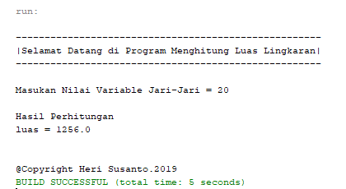

1. Buatlah program untuk menghitung volume tabung, kumpulkan beserta *output*-nya!

package pertemuan3;

import java.util.Scanner;

public class volume_tabung {

public static void main(String[] args) {

System.out.println();

System.out.println("----------------------------------------------------");

System.out.println("|Selamat Datang di Program Menghitung Volume Tabung|");

System.out.println("----------------------------------------------------");

System.out.println();

Scanner input = new Scanner(System.in);

double v, r, d, t;

double phi = 3.14;

System.out.print("Silahkan masukkan nilai diameter pada tabung : ");

d = input.nextDouble();

System.out.print("Silahkan masukkan nilai panjang pada tabung : ");

t = input.nextDouble();

r = d / 2;

v = (phi * r * r * t);

System.out.println("Berikut Hasil Volume Tabung : " + v);

System.out.println("");

System.out.println("");

System.out.println("@Copyright Heri Susanto.2019");

}

}

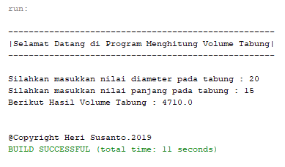

1. Buatlah program untuk menampilkan identitas anda, kumpulkan beserta *output*-nya!

package pertemuan3;

import java.util.Scanner;

public class identitas {

public static void main (String [] args) {

Scanner scan=new Scanner(System.in);

String nDepan, nBelakang, Almt, Kota, Lahir, Tgl, nim, jrs;

System.out.println();

System.out.println("-----------------------------------------------");

System.out.println("|Selamat Datang di Program Menampilkan Biodata|");

System.out.println("-----------------------------------------------");

System.out.println();

System.out.println("Masukkan data anda dengan benar!");

System.out.println();

System.out.print("Nama Depan :");

nDepan=scan.nextLine();

System.out.print("Nama Belakanng :");

nBelakang=scan.nextLine();

System.out.print("Alamat :");

Almt=scan.nextLine();

System.out.print("Kota :");

Kota=scan.nextLine();

System.out.print("Tempat Lahir :");

Lahir=scan.nextLine();

System.out.print("Tanggal Lahir :");

Tgl=scan.nextLine();

System.out.print("NIM :");

nim=scan.nextLine();

System.out.print("Jurusan :");

jrs=scan.nextLine();

System.out.println();

System.out.println("======================================");

System.out.println(" Biodata Anda ");

System.out.println("======================================");

System.out.println("Nama Lengkap : "+nDepan+" "+nBelakang);

System.out.println("Alamat :"+Almt+", "+Kota);

System.out.println("Tmpat/Tgl :"+Lahir+", "+Tgl);

System.out.println("NIM :"+nim);

System.out.println("Jurusan :"+jrs);

System.out.println("======================================");

System.out.println("");

System.out.println("");

System.out.println("@Copyright Heri Susanto.2019");

}

}

