Olden Benchmarks Suite
Power
Benchmark

Power Pricing Computation

Data Structures

1) Composite structure with C arrays and pointer-based linked lists
2) Composite structure built with C++ std::vector and std::list

Computational method

Performs an itera scientific computation on a tree-alike structure. Nodes of the structure

Implementation details

1) Standard library based implementation.

power.h
power.cpp

This implementaton is based on a complex structure laid out in a memory as an ensemble of objects of Root, Lateral, Branch and Leaf classes. The objects are linked with the help of STL std::vector and std::list containers. Scheme below illustrates the data structure.
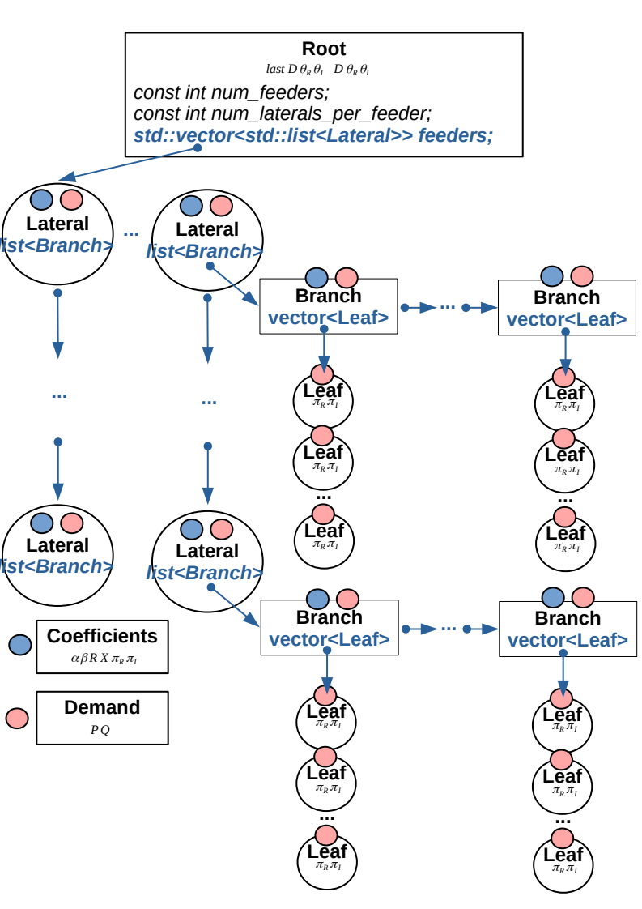
Computation starts with a call to Root::compute(). The method accumulates power demand Demand(P,Q) from all lists of Laterals. Accumulation starts with the end of each list. Each lateral accumulates its power demand from all its branches and the latter in turn accumulate power demand from all their leaves. The leaves call optimize_node() method, which does a chunk of scientific computations (gradients, vectors, etc.) which compute P and Q.

Root::compute() is called iteratively from a while loop of power_pricing_problem(). Iteration continues up until P and Q error becomes less than the required epsilon.

1) Original tree based implementation.

power_original.h
power_original.cpp
build.cpp
compute.cpp

Original implementation does the same computation, but uses regular C structs linked through pointer chains. The implementation calls compute() recursively through pointer links and invokes the same logic.

Feasibility study results

power original: 1.3899 seconds.
power: 0.419872 seconds.

