Olden Benchmarks Suite
Perimeter
Benchmark

Ring (R=2048, r=1024) perimeter computation

Computational method

The ring is mapped onto a grid of elements by painting all the grid elements inside the ring (r < x*x+y*y < R) as black and all grid elements outside of it as white. Then the grid is being traversed in two different (implementation dependant) ways and detects all flips of color (black to white and vise versa)

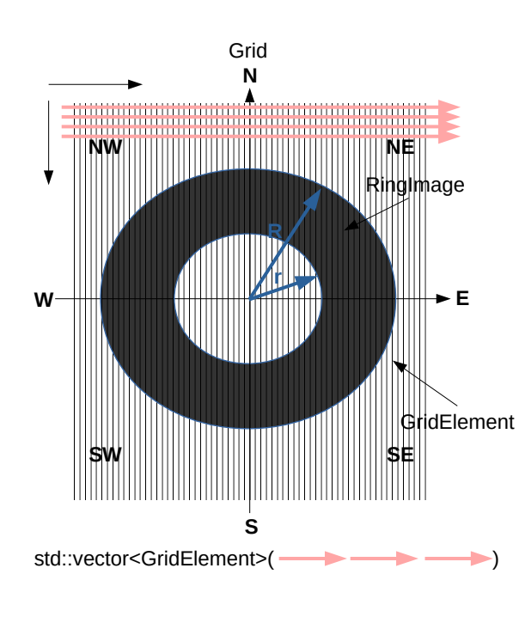
Implementation details

1) Quad-tree-based implementation

perimeter.cpp
perimeter.h

A bit tricky to understand

2) Array-based implementation (std::vector<>).

image.h
image.cpp

In this case perimeter computation is done in several steps:

1. Build the grid of surface elements. Surface elements are squares GridElement. Grid is a vector of GridElements. The elements of the grid are mapped onto the vector linearly row by row starting from

Point {
int x;
int y;
}

GridElement {
Point center;
Point nw, ne, sw, se;
double elementSize;
ElementColor color;
}

Grid {
std::vector<GridElement>
}

2. Map Ring image onto a grid by painting its GridElements in black and white.

3. Iterate over std::vector<GridElement> linearly.

The surface of

The Grid class contains std::vector<GridElement>.

Every GridElement is a square centered around center point and knows its size as well consists of

Feasibility results

Surprisingly, quad-tree-based implementation works faster than vector-based one. Probably this result is explained by the number of elements an algorithm is required to process. While an array-based grid consist of 4096*4096 GridElemets elements, quad-tree-based grid markup consists of only 18424 differently sized elements.

Compiled with OpenMP

quad tree build time: 0.006566, 0.001954, 0.006394 seconds
quad tree perimeter comp time: 0.00726, 0.002726, 0.009569 seconds
quad tree total time: 0.013826, 0.00468, 0.015964 seconds

comp grid image mapping time: 0.14743, 0.144366, 0.147884 seconds
comp grid perimeter comp time: 0.072108, 0.065267, 0.070578 seconds
comp grid total time: 0.219538, 0.209634, 0.218463 seconds

Compiled without OpenMP

quad tree build time: 0.002287, 0.002172, 0.003029 seconds
quad tree perimeter comp time: 0.002671, 0.002658, 0.002713 seconds
quad tree total time: 0.004959, 0.004831, 0.005743 seconds

comp grid image mapping time: 0.498745, 0.500027, 0.499099 seconds
comp grid perimeter comp time: 0.144013, 0.14257, 0.15443 seconds
array grid total time: 0.642758, 0.642598, 0.65353 seconds

