Olden Benchmarks Suite
Power
Benchmark

Power Pricing Computation

The data structure and the computation done on top of it precisely correspond to a well-known fold higher-order function. The computational pattern of the benchmark can be characterized by other names like reduce, accumulate, aggregate or inject. Typically, a fold is presented with a combining function, a top node of a data structure, and possibly some default values to be used under certain conditions. The fold then proceeds to combine elements of the data structure's hierarchy, using the function in a systematic way.

The hierarchical data structure the benchmark uses can be described as:

Root = array[] list-> Lateral
Lateral = list-> Branch
Branch = array[] Leaf
Leaf = scalar Demand(P,Q)

The abstract version of the computation done on top of it can be described as:

Root = reduce+=(array[]
fold(list->
fold(list->
reduce+=(array[]
compute(scalar Demand(P,Q))
)
)
)
)

The computation done on top of it can be described as:

Root.Demand(P,Q) = (0,0) // flush the main return value
Root.Demand(P,Q) = Root.array.reduce+=(Lateral.list.inject())

compute_root(Root r) {
Root.Demand(P,Q) = reduce+=(array[] Lateral root.laterals, compute_lateral)
return Root.Demand(P,Q)
}

compute_lateral(Lateral l) {
return fold<list-> Lateral>(l)
}

fold<list-> Lateral>(l) = fold<list-> Lateral>(l.next) + fold<list-> Branch>(l.branches)

fold<list-> Branch>(b) = reduce+=(array[] Leaf b.leaves, compute_leaf) + fold<list-> Branch>(b.next)

compute_leaf(Leaf l) {
P = Q = 0;
optimize_node(P,Q)
l.P,Q = P,Q
}

main() {

Root r;
compute_root(r);

}

A = inject(, list Lateral )

B=A.fold()
A=
fold(inject()
(list Lateral).inject()

Lateral.list.fold(B)
B=Lateral.list

Data Structures

1) Composite structure with C arrays and pointer-based linked lists
2) Composite structure built with C++ std::vector and std::list

Implementation details

1) Standard library based implementation.

power.h
power.cpp

This implementaton is based on a complex structure laid out in a memory as an ensemble of objects of Root, Lateral, Branch and Leaf classes. The objects are linked with the help of STL std::vector and std::list containers. Scheme below illustrates the data structure.
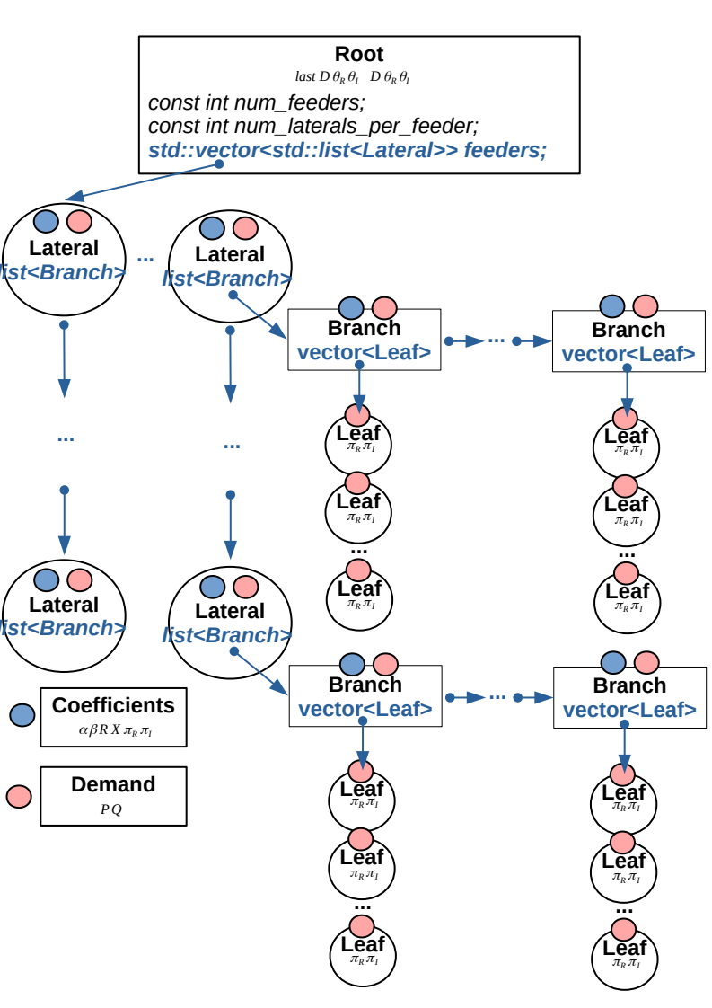
Computation starts with a call to Root::compute(). The method accumulates power demand Demand(P,Q) from all lists of Laterals. Accumulation starts with the end of each list. Each lateral accumulates its power demand from all its branches and the latter in turn accumulate power demand from all their leaves. The leaves call optimize_node() method, which does a chunk of scientific computations (gradients, vectors, etc.) which compute P and Q.

Root::compute() is called iteratively from a while loop of power_pricing_problem(). Iteration continues up until P and Q error becomes less than the required epsilon.

1) Original tree based implementation.

power_original.h
power_original.cpp
build.cpp
compute.cpp

Original implementation does the same computation, but uses regular C structs linked through pointer chains. The implementation calls compute() recursively through pointer links and invokes the same logic.

Feasibility study results

The C++ implementation with std::vector and std::list runs more than 3 times faster.

power original: 1.3899 seconds.
power: 0.419872 seconds.

