Olden Benchmarks Suite
Health
Benchmark

Columbian health care system simulation
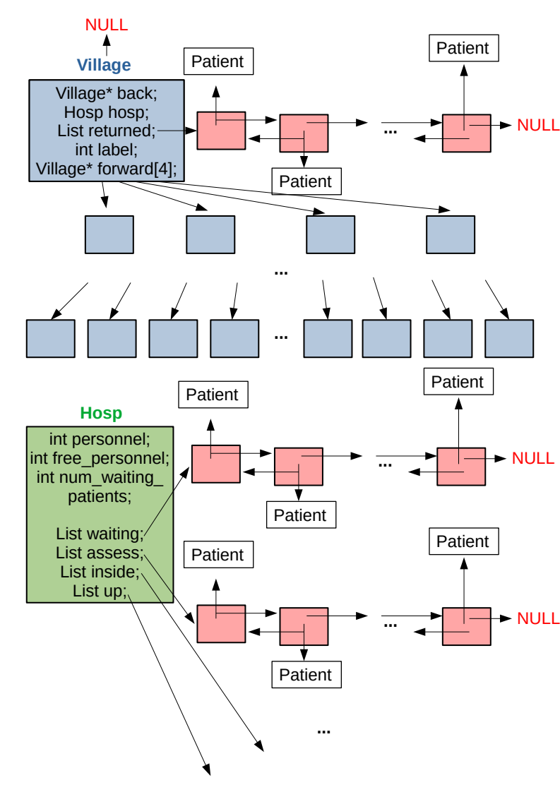
Data Structures

4-ary tree of adjacent villages as shown on the left

Computational method

./health max_level=3 max_time=15 seed=4

There are 4^{max_level} villages arranged in a complete 4-ary tree. Each village has its hospital and is connected to 4 adjacent child villages.

Simulation starts from the top (tree root) village and goes down all the tree branches recursively right to left. Every simulation step consists of several events:

1) Accept all patients from adjacent villages and put them in the local hospital for an initial assessment (3 time steps) and possibly for further hospitalization (10 time steps) inside the local hospital.

. If there is available staff at the local hospital then patients

2) Check patients who are inside the local hospital: once inside patients spend 10 time steps to recover and occupy 1 member of the staff throughout all time. If 10 time steps have passed then the patient is checked out and releases 1 personnel member.
3) Check patients on the assessment list. Patients require 3 time steps to be diagnosed. Each patient occupies 1 member of the staff throughout the whole assessment process. If patient is ill then he continues to occupy the same personnel member and goes inside the hospital for 10 time steps. If patient is healthy the the patient is checked out and releases 1 staff member.
4) Check patients on the waiting list.

Once a patient gets into the hospital he/she takes on 1 member of the staff if the personnel is available. If not, then the patient goes onto the waiting list. Patient passes through 2 phases: assessment (3 time steps) and hospitalisation (10 time steps). Each patient is being supervised by 1 member of the personnel starting from assessment and up until checking out of the hospital. If after assessment (3 time steps) a patient turns out to be healthy then the patient is checked out and a personnel member is returned back to available pool. If patient is confirmed ill, then the former is put inside the hospital and spends 10 more time steps (personnel member is

If there is free personnel in hospital

Patients fall ill at the will of random number generator.

Implementation details

Feasibility results

