Olden Benchmarks Suite
TSP
Benchmark

TSP – Travelling Salesman Problem

High-level benchmark algorithm overview

Benchmark generates a set of dots scattered on a 2D plane. Dots represent cities and are specified by (x,y) coordinates. The TSP problem is to visit all the cities and return to the city of origin having passed the minimal distance. In other words, the algorithm returns a cycled sequence of cities, where proximity of elements in the sequence in terms of order means their spatial proximity on the 2D plane.

The algorithm’s work resembles that of insertion sort. The sequence is divided into 2 parts. Ordered part and unordered part. At first ordered part consists of just 1 element. On every iteration the algorithm takes the next element out of unordered part, finds it a pairing element inside the ordered part (with the minimal distance between them) and inserts the element into the ordered subsequence next to its pair. The process is visualised on the left picture below. At the end we get the sequence with the property that closest dots stand the closest in the sequence.
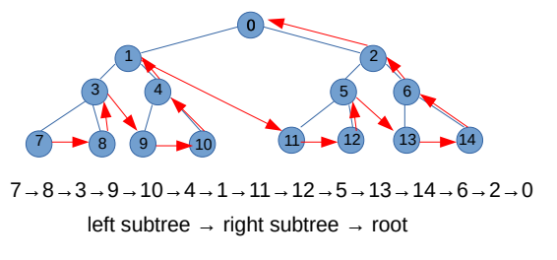
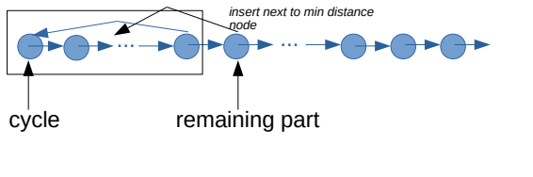

Data Structures

Binary tree being transformed into doubly linked list as picture on the right shows.

Computational method

1) A binary tree is built. Every node of the tree represents a city located on 2D plane with randomly generated (x,y) coordinates. The build_tree() method is written in a way to generate a uniform distribution of dots on the plane.

Implementation details

Feasibility results

