**PROJECT MANAGEMENT AND PLANNING**

NAME: Jasmine I. Sayyad

PRN: 22510033

TY CSE

**ASSIGNMENT 21 (GROUP 21)** : Creating a Sprint and Adding Issues

Objective: Understand the basics of sprint planning in JIRA.

Task:

1.Create a new sprint in your project.

2.Add 3 issues from the backlog to the sprint.

3.Start the sprint and move the issues through the board.

Complete the sprint and review the Sprint Report.

Here are the steps :

PROJECT NAME : **TENDERbus (Smart Tender Management System)**

**Step 1**: **Create a Project**

Login to Jira.

Click on “Projects” and then select “Create project.”

Choose “Scrum” as the project type.

Name your project “TENDERbus - Smart Tender Management System.”

Select a template and click “Create”.

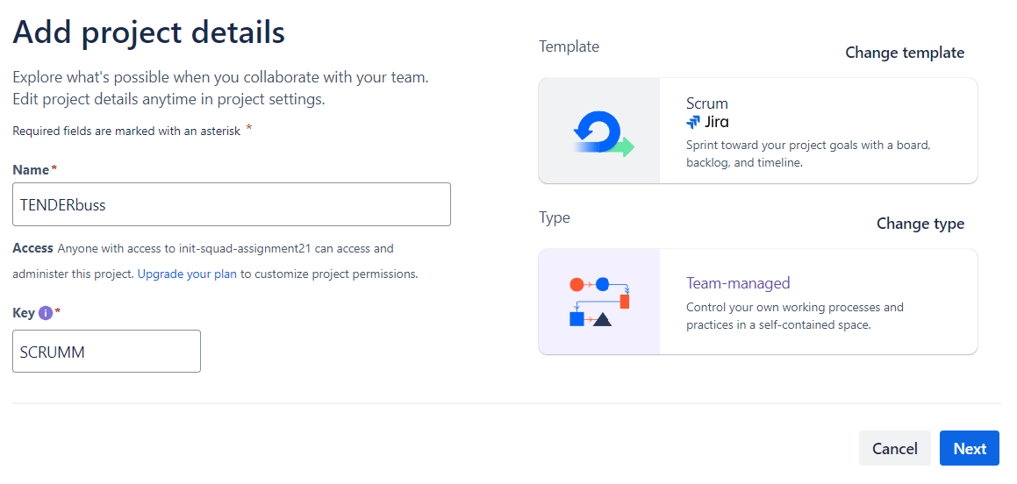

**Step 2: Create a Sprint**

Go to your project and click on “Backlog”.

Click on “Create Sprint” at the top.

Name your sprint “Sprint 1: Initial Setup & Core Features.”

Optionally, define start and end dates for the sprint.

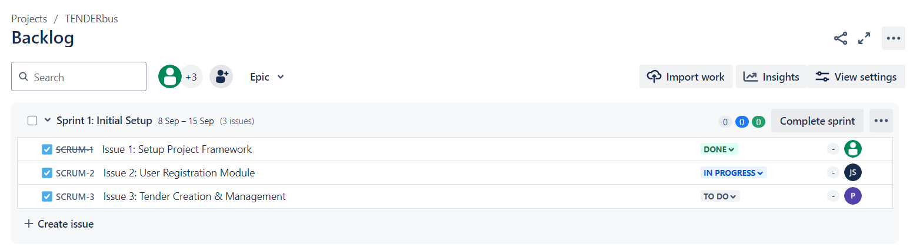

**Step 3**: **Add Issues to the Sprint**

In the backlog, either create new issues or drag existing ones into the sprint.

Create these 3 issues for the sprint:

Issue 1: Setup Project Framework

Type: Task

Description: Set up the project framework, initialize the repository, and configure basic dependencies.

Issue 2: User Registration Module

Type: Task

Description: Implement the user registration functionality for vendors and administrators.

Issue 3: Tender Creation & Management

Type: Task

Description: Build the module for creating and managing tenders, including form validation and database integration.

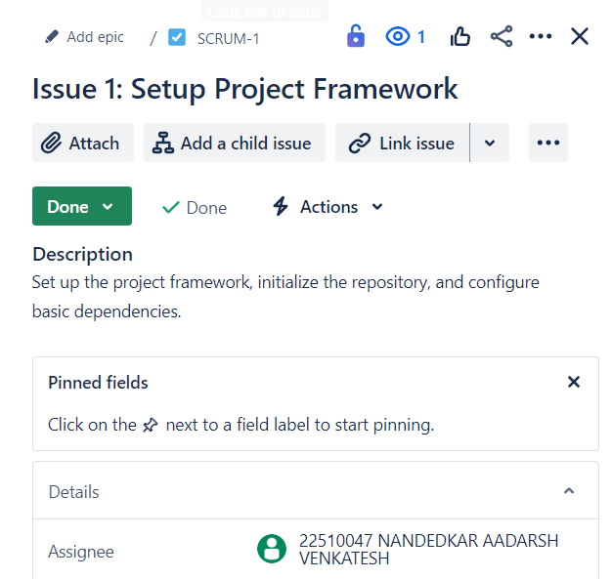 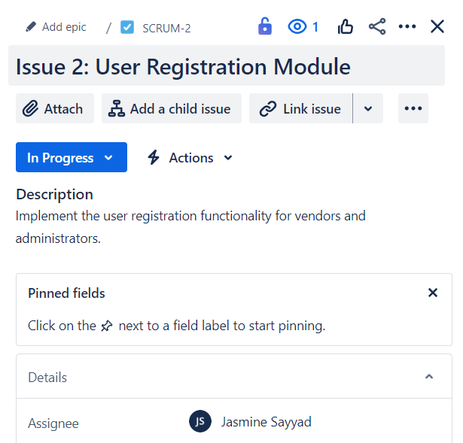

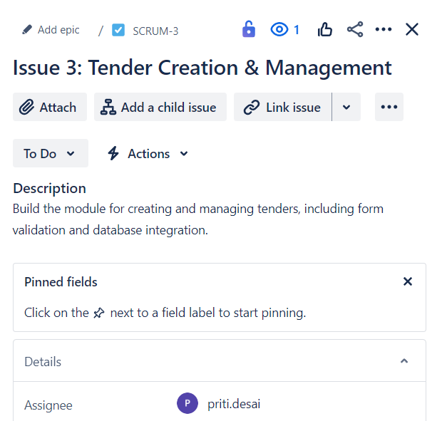

**Step 4: Start the Sprint**

Click “Start Sprint” near the top of the sprint view.

Confirm the sprint details and click “Start.”

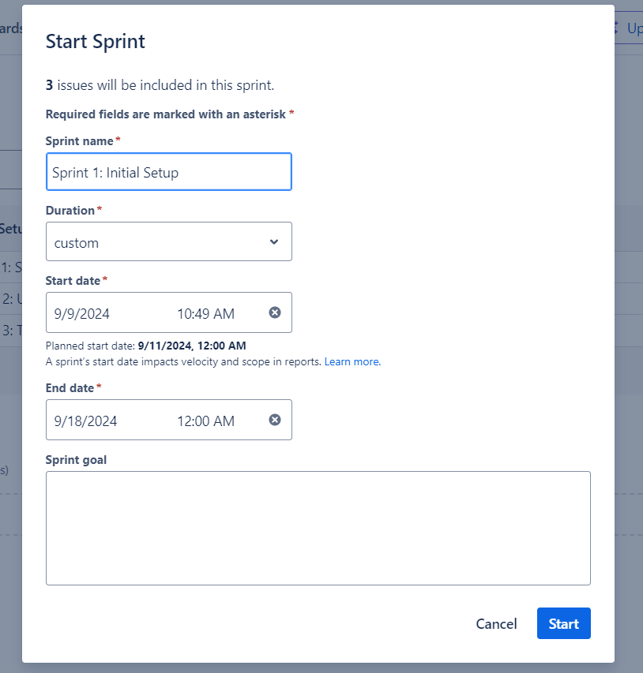

**Step 5: Move Issues Through the Board**

Go to “Active sprints” in the left sidebar.

Move issues from “To Do” → “In Progress” → “Done” as work progresses.

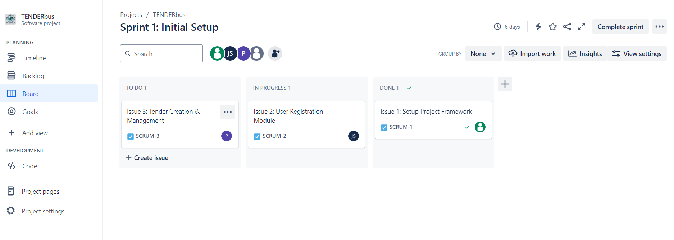

**Step 6: Complete the Sprint and Review Sprint Report**

Once all issues are completed, click “Complete Sprint” at the top right.

Review the Sprint Report to see the progress of the team.

Let me know if you need any further details!

