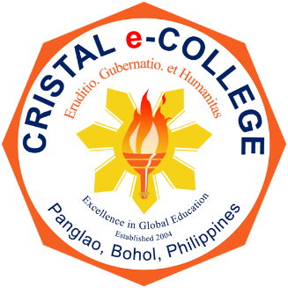
CRISTAL e-COLLEGE
Tawala, Panglao, Bohol 6340 Philippines

Quality Objectives
CRISTAL e-COLLEGE is committed to the development and implementation of effective operation of its quality standards as expressed in these objectives.
- Minimize employee’s turnover to 25% after two years.
- Reduce customer complaints by 20% annually.
- Increase local linkages to 50% and international linkages to 30% by 2024.
- Subject 1 department to accreditation by a local certifying body in the next 3 years.
- Design, implement, monitor and evaluate employees’ development program within 3 years.
- Increase employees’ Satisfaction Index by 1% annually.
- Increase customer Satisfaction Index by 1% annually.
- Create a culture of risk based thinking.
- Reduce non-conformances by 20% after one year.

