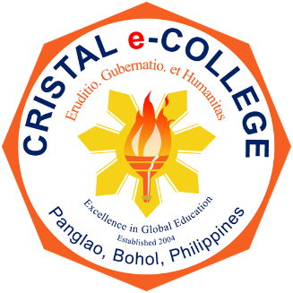
CRISTAL e-COLLEGE
Tawala, Panglao, Bohol 6340 Philippines

Philosophy of the College
The motto of CRISTAL e-COLLEGE is
Eruditio, gubernatio, et humanitas.
It is translated as knowledge, leadership, and humanity.
Knowledge is the anchor that brings about
essential qualities of leadership.
Enlightened leadership is a means toward achieving the
true essence of humanity.

Vision Statement
A leading institution of excellence in delivering
education and training in the Philippines and beyond.

Mission Statement
Deeply committed to promoting
knowledge, humaneness and leadership.

